From the Andes to the Outback: Acclimatising Alpacas in the British Empire
Abstract
This article examines attempts to naturalise the alpaca in the British Empire. In the nineteenth century Britain made concerted efforts to appropriate useful plants and animals and acclimatise them within its own colonies. The alpaca was a prime target for acclimatisers on account of its silken wool, which was manufactured into a range of luxury textiles. Its export was, however, banned by law in Peru and Bolivia, so the animals had to be smuggled out of the Andean states and shipped illegally to Britain and Australia. The article studies the circuits of exchange that facilitated the transfer of alpacas from one continent to another and considers how British subjects in places as diverse as Bradford, Liverpool, Sydney and Arequipa promoted and benefited from the naturalisation scheme. It situates alpaca acclimatisation within a wider discourse of agricultural ‘improvement’, bio-piracy and imperial adventure.

Keywords
alpaca, acclimatisation, Australia, animals, scientific networks, empire

In 1811 the first alpaca to be exhibited in Britain was put on show at Edward Cross’s menagerie in London. The animal, which had been a pet in its native Lima, was ‘remarkably tame’ and had ‘perforations in its ears in which ornamental rings had been placed’. It soon proved a great favourite with the British public, who admired its ‘graceful attitudes, gentle disposition and playful manners’ and expressed particular interest in its wool, which was thick, glossy and ‘about eighteen inches long’. One admirer, Lady Liverpool, was ‘so much…delighted with [the alpaca’s] beauty, the softness and brilliancy of its coat and its animated and beaming features that she kissed it as if it had been a child, and had it turned loose on her lawn, in order that she might witness its movements free from restraint’.
The arrival of the alpaca in the aftermath of Spanish American independence sparked British interest in the possibility of naturalising the species and using its wool for textile manufacture. Over the next four decades these plans were put into effect as increasing numbers of alpaca were imported into Europe. Several treatises were published on the subject of alpaca acclimatisation, some advising their naturalisation in Britain, where the Scottish Highlands and Ireland were identified as the most promising regions for the experiment, others suggesting their introduction to the colonies, particularly Australia. In 1858, British merchant Charles Ledger conducted a clandestine operation to smuggle alpacas out of Peru (which banned their exportation from 1845 onwards), shipping 322 animals from Chile to New South Wales.
This article examines attempts to naturalise the alpaca in the British Empire and situates these within the wider contexts of animal acclimatisation, commercial exchange and national identity. In the nineteenth century, Britain and other imperial powers made concerted efforts to appropriate useful animals and acclimatise them within their own colonies. In France, a special acclimatisation society was founded in 1854, with branches across the nation and, from 1860, an acclimatisation garden in the Bois de Boulogne. In Spain, the naturalist Mariano de la Paz Graells experimented with acclimatising camels, angora goats, gazelles and kangaroos, while in Britain acclimatisers took an interest in the South African eland, said to taste like veal with ‘a soupçon of the pheasant flavour’. The aim of all of these ventures was to diversify the nation’s natural resources and to ‘improve’ botanical and zoological acquisitions through the application of science.
Historians have recently paid increasing attention to the relationship between botany and empire, studying the introduction of tea, rubber and cinchona trees (the source of the febrifuge, quinine) to British colonies and highlighting the complex networks involved in botanical exchange. To date, less attention has been paid to animal acclimatisation, in part, no doubt, because it was less successful, yet this too was seen by its promoters as essential to economic growth and imperial expansion. Focusing on one particularly coveted species, the alpaca, this article considers why British subjects in the United Kingdom, Australia and South America came to see acclimatisation as desirable and how they went about achieving it. I emphasise scientific, commercial and social relationships that facilitated acclimatisation and show how British subjects in places as diverse as Bradford, Liverpool, Sydney and Arequipa assisted, and hoped to benefit from, the naturalisation programme.
Alpaca naturalisation needs to be seen within the context of British relations with South America. Following Spanish American independence in the 1820s, Britain exerted a significant influence over the continent’s new republics. British banks contracted loans with many of the new states; British companies invested heavily in mining operations, and, later, railway construction; British merchants traded manufactured goods for raw materials; and the British navy occasionally intervened militarily to protect British interests. Viewing these activities together, some historians have seen South America as forming part of Britain’s ‘informal empire’ in the period c.1810-1940, and occupying a role comparable to her formal colonies. Early proponents of this view emphasised Britain’s economic dominance, exercised through ‘the imperialism of free trade’. More recent research has focused on the cultural dimensions of imperial power, which extended to fields such as archaeology and natural history. Robert Aguirre, for instance, has argued that the British appropriation of pre-Columbian antiquities ‘became a crucial cultural arm of the larger political and economic strategy historians call informal imperialism’.
Occurring within the period traditionally associated with ‘informal empire’, the alpaca acclimatisation project illuminates aspects of this potentially exploitative relationship and shows how alpacas and their wool featured in wider debates about free trade and commercial exchange. On the one hand, British attempts to remove alpacas from their native soil and naturalise them within Britain’s formal empire could be seen – and were seen by the Peruvian Government – as an imperialistic act that threatened the future of an important sector of the Peruvian economy. On the other, the difficulties of carrying out the project - and its ultimate failure - expose the limitations of British power over Peru (and British knowledge about alpacas) and suggest that rhetoric differed considerably from reality. Through an analysis of the various naturalisation schemes, I assess the relationship between alpaca appropriation and imperial power and consider what the project meant for the different parties involved. I argue that alpaca acclimatisation was shaped not only by shifting international relations, but also by internal politics within Britain, Australia, Peru and Bolivia, as governments tried to satisfy the competing demands of Yorkshire weavers, New South Wales taxpayers, British merchants and Native American shepherds.

Acclimatisation in Britain
The alpaca (Vicugna pacos) originates from the Peruvian Andes. It is one of four South American members of the camel family, alongside the llama (Lama glama), the guanaco (Lama guanicoe) and the vicuña (Vicugna vicugna) and is now believed to be a domesticated variant of the latter (the llama is a domesticated guanaco). First domesticated around 6,000 to 7,000 years ago, the alpaca was extensively farmed by the Incas, who used its fleece to weave colourful textiles. In the nineteenth century alpaca wool became one of Peru’s main exports, together with sugar, cotton and guano, rising in value from £122,000 per year in 1845-49 to a peak of £489,000 per year in 1870-74.
The first living alpacas appeared in Britain in the 1810s, during the Spanish American Wars of Independence, and were exhibited as exotic curiosities. Edward Cross’s alpaca, as we’ve seen, created quite a stir when it was put on display in 1811. A white female alpaca featured in Ducrow’s circus, where it was ‘taught to gambol, kneel and lay down at the word of command’, while a third alpaca appeared in the Gardens of the Zoological Society in the 1820s. Alpacas were on show in regional zoological gardens by the 1830s and visited provincial towns regularly in travelling menageries. Ducrow’s alpaca even performed on stage in 1813, treading the boards at Covent Garden’s Theatre Royal in ‘The Popular Pantomime of the Red Dwarf’ (Fig.1).
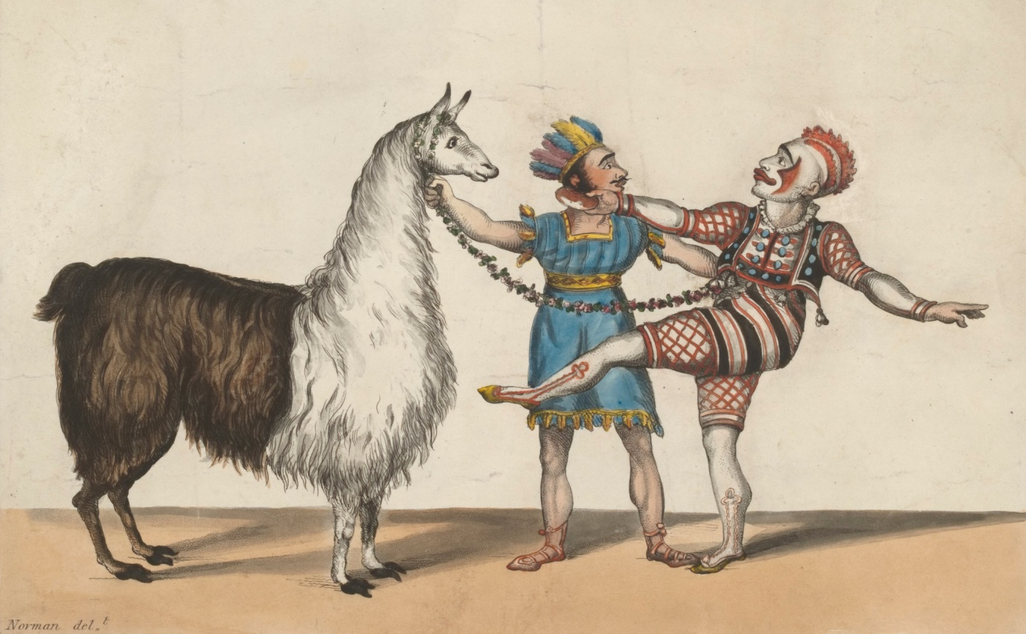
Figure 1: An alpaca performs in ‘the Popular Pantomime of the RED DWARF’ with the famous clown Grimaldi. R. Norman, 11 January 1813 (H. Beard Print Collection, Victoria and Albert Museum).

While living alpacas initially functioned as sources of entertainment, alpaca wool was making important inroads into British commerce. Highly prized for its quality and softness, alpaca was mixed with silk and cotton to make a variety of garments, mostly fashionable, high-end products. Dresses, shawls and umbrellas were all made from alpaca as were coat linings, cravats and the occasional Scottish tartan. Promoters of alpaca naturalisation viewed alpaca wool as a luxury material that would complement (but not replace) sheep’s wool and argued that alpaca clothing would be useful in ‘tropical climates’ such as India, Jamaica and Africa, where British expatriates were ‘thankful to possess a black coat which, while it has the appearance of broad cloth, is not a fourth of its weight’. Sourced from Indian communities in the southern highlands of Peru, alpaca wool was purchased by British merchants in the southern Peruvian city of Arequipa and shipped to Liverpool and (to a much lesser extent) London. From there, most of the wool passed to Bradford, already a major player in the worsted trade and now Britain’s primary site for spinning and weaving alpaca fabric. A total of 34,652,701lbs of wool was imported into Britain in the years 1834-59, rising from just 5,700 lbs in 1834 to a peak of 2,974,493 lbs in 1856 (Fig.2).

Figure 2: Alpaca Wool Imports from Peru into Britain, 1834-59. Data from George Bennett, The Third Annual Report of the Acclimatisation Society of New South Wales (Sydney: Joseph Cook, 1864), p.6.

Though alpaca wool was originally imported from Peru, plans arose in the 1840s to introduce the alpaca into Britain and thereby gain direct control over the trade. Advocates of the scheme anticipated multiple benefits. Firstly, the naturalisation of the alpaca would ensure a sufficient and continuous supply of its wool, at a time when demand was outstripping supply; as Figure 2 shows, imports fluctuated considerably from year to year, and high internal demand within Peru limited the amount that could be exported. Secondly, alpaca acclimatisation would permit British farmers to make better use of their land, since alpacas would be able to survive in inhospitable mountain terrain unsuitable for cattle or sheep (of which thirty million acres were believed to exist in the United Kingdom). Thirdly, alpacas could be easily looked after, their thick coats keeping them warm in the harshest winter and making it unnecessary ‘to smear [them] with tar and butter as the farmers are obliged to do with the flocks in Scotland’. Fourthly, the introduction of the alpaca would provide employment for labourers and artisans, maintaining individuals who would otherwise be ‘dependent on their parishes for support’, and fifthly, the alpaca might fulfil additional economic functions, its meat forming ‘an excellent ingredient for a pie’ and its ‘strong and pliant’ skin offering a suitable material for bookbinding. The naturalisation of the alpaca was presented as an important boost to the British textiles industry, a boon to agriculture and an antidote to social problems. Enthusiasts identified the Scottish Highlands, Shetland, Wales, the Cheviot Hills, Dartmoor and the mountains of Kerry and Wicklow as the most promising regions for alpaca introduction, the terrain and climate of these locations most closely resembling that of the Andes.
During the early 1840s, these ideas began to gain momentum, attracting the attention of some important local and national institutions. In 1840, the Tenth Annual Meeting of the British Association for the Advancement of Science featured a lecture by William Danson on the alpaca and its wool, during which samples of the wool and ‘living specimens’ were exhibited. In 1841, William Walton published an important article on the subject in the Polytechnic Journal, which he later revised and extended into a short book, while in 1844 the Highland and Agricultural Society awarded ‘a premium of Five Sovereigns and an honorary silver medal’ to Alexander Gartshore Stirling of Craigbarnet’ for ‘the best pair [of alpacas] born in the kingdom’. By the mid-1840s a number of improving landowners were rearing alpacas on their estates, some from mere curiosity but others with the intention of establishing a new line of business. Thomas Stevenson of Oban received several shipments of alpacas from his son in Peru. Joseph Hegan Charles Tayleure and the Earl of Derby farmed small flocks of alpacas in Cheshire (Fig.3), while Robert Bell of Listowel, Kerry, introduced alpacas to Ireland. The Queen’s consort, Prince Albert, was another high-profile alpaca fancier, keeping two of the animals on the royal estate at Windsor.
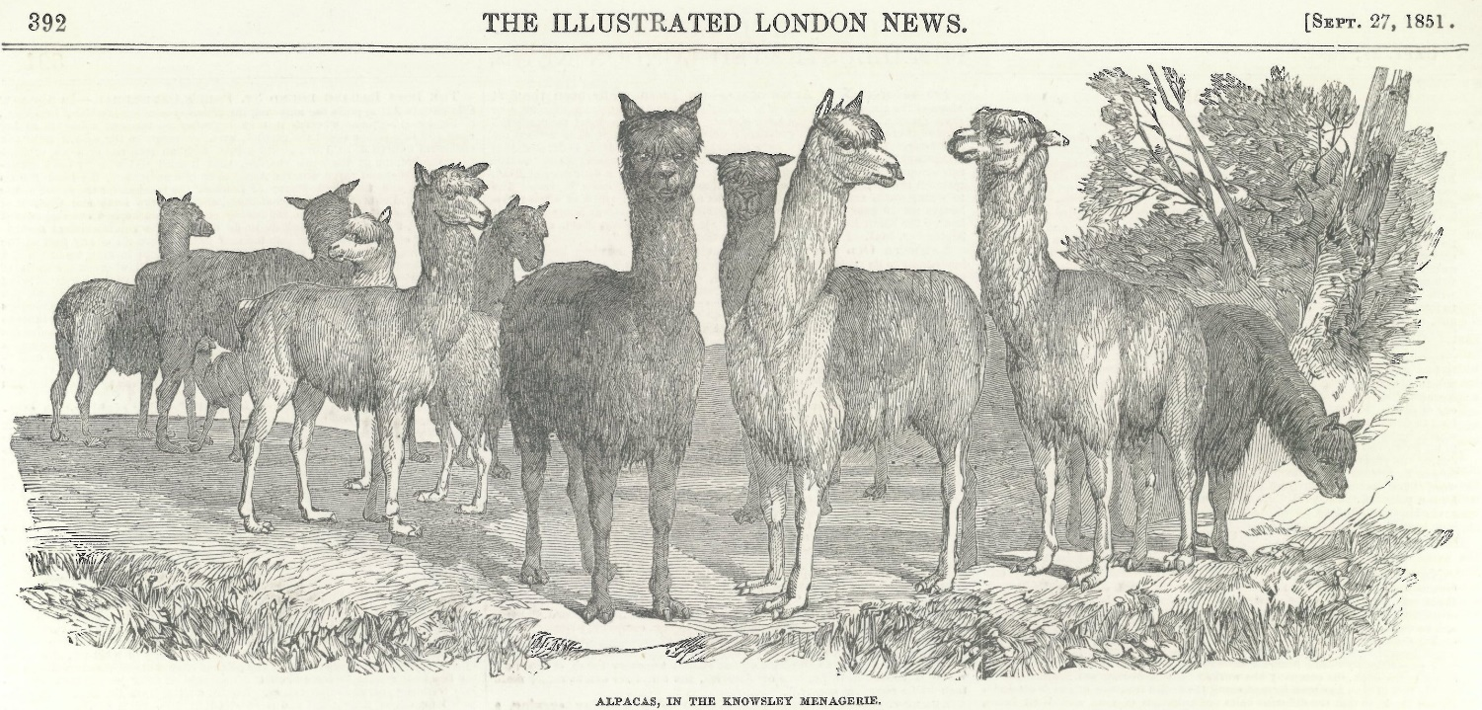
Figure 3: ‘Alpacas in the Knowsley Menagerie’, The Illustrated London News, 27 September 1851.

While the arrival of increasing numbers of alpacas boosted confidence in the prospects of naturalisation, the actual results of alpaca acclimatisation were rather mixed. On the positive side, many owners reported success in keeping their animals alive, raising hopes that British alpacas, with superior care and nourishment, would produce a better grade of wool than that imported from Peru. Menagerist Edward Cross claimed that ‘he noticed a visible improvement in the fleece of his alpaca, which he had shorn more than once, although the animal was kept under restraint and subjected to an unsuitable regimen, besides breathing the impure air of a populous town’. Robert Bell contended, similarly, that the wool of his Irish alpacas was ‘very much finer than any alpaca wool I have yet seen imported into England’, prompting alpaca enthusiast Walton to suggest that careful British husbandry would facilitate an improvement of the species, the ‘dirty and scurfy state’ of imported wool being due to ‘the deciduous habits of the Indian’, who allowed his animals to become diseased ‘through the want of seasonable shearing and the timely application of salve’. Such ideas were very much in keeping with contemporary livestock practices, which sought to raise the quality of animals through selective breeding and diet.
Despite such upbeat testimonies, however, the overall picture was much less rosy, and a large number of alpacas succumbed to mismanagement and accident. Of the dozen alpacas shipped to Thomas Stevenson by his son, only two, a male and a female, survived the voyage, despite an agreement made with the ship’s captain that ‘he was to receive a payment of freight one half of whatever number might arrive safe in England’. Another flock owned by Charles Tayleure was administered ‘too strong medicine’ by a shepherd, killing ‘the greater part of them’, while one of Bell’s alpacas perished from eating a poisonous weed. Most disastrously, what should have been the largest single importation of alpacas into Britain ended in tragedy in 1842 when the captain of the Sir Charles Napier stowed 274 of the animals above a cargo of guano, the ‘effluvia’ from the manure suffocating all but four of them. Negligent servants and ignorant sailors were blamed for these mistakes, reflecting ingrained class prejudices. Contemporaries also accused indigenous Peruvians of cheating British merchants by selling them old or diseased stock; according to General John O’Brien, Native Peruvians were reluctant to part with their animals, so the ones they offered to merchants were ‘almost always picked out of inferior, if not refuse stock, and, by an intelligent person, would scarcely have been deemed worth the shipping risk’. Such setbacks highlighted the practical difficulties of animal acclimatisation and pointed to the need for careful supervision and local knowledge. They did not, however, extinguish the hope that, with better planning and faster transportation, alpacas might be successfully introduced to the moors and highlands.
Alpacas in Australia
While early efforts to acclimatise the alpaca focused on Britain, attention shifted in the 1850s to British possessions overseas. This was in part a response to the limited success of programmes like Walton’s to rear the alpaca in Britain itself. It also reflected the growing importance of the colonies in this period, and an increasing desire to ensure their economic viability. Both Cape Colony and the Indian province of Scinde were contemplated as suitable sites for the experiment, but it was in Australia that the project came to fruition. Already a major exporter of wool, thanks to the successful introduction of the merino sheep, Australia was seen as a prime location for the rearing of alpacas, which could inhabit land unsuitable for other cattle. Colonial acclimatisation societies listed the alpaca as one of their most promising targets, anticipating significant economic benefits for their respective colonies. The South Australian Register confidently asserted that ‘hundreds of thousands of alpacas might roam among the mountain chains, or cover the elevated plains of Australia, neither trenching upon the sheep nor depasturing upon cultivated lands’. Another paper, the Sydney Morning Herald predicted that alpacas would ‘prove more profitable than the gold mines of Australia, and certainly more durable’.
Australian alpaca enthusiasts faced an additional hurdle, however, for in 1845 the Peruvian Government had enacted a decree banning the export of alpacas and llamas from the country. The ban was a response to pressure from indigenous herders, who following the deaths of the alpacas aboard the Sir Charles Napier, had ‘clamorously petitioned’ Congress to prevent further exports, holding meetings in the regions of Puno, Arequipa and Cusco (the prime alpaca farming areas) and refusing to sell alpaca wool until action had been taken. Reacting to their concerns, the Government put in place legislation making it illegal to transport camelids ‘within a distance of…120 miles of the sea, and threatening offenders with the ‘confiscation of the animals…[and] ten years’ hard labour on the Guano Islands’. Any subsequent attempts to extract alpacas from Peru would therefore require either subterfuge or a special dispensation, converting alpaca export into a form of bio-piracy.
While the export ban posed a major obstacle to alpaca acclimatisation, Australians remained interested in the project. A range of individuals – many with previous connections to Peru – penned letters to colonial newspapers suggesting ways in which to evade the prohibition, and two states, Victoria and New South Wales, managed to obtain significant numbers of the animals. In the first of these, Victoria, the local acclimatisation society took the initiative. Led by Thomas Embling, a member of the colonial assembly, and Edward Wilson, a journalist, the society promoted the introduction of a range of new and useful animals to Australia, from camels to songbirds. Convinced that the alpaca was a worthy candidate for naturalisation, Embling used his position to lobby the colonial government for financial support, claiming that alpaca farming was ‘four times as profitable and at least only half the trouble of sheep farming’. Wilson, meanwhile, presented papers on the alpaca at the Philosophical Institute of Victoria and expatiated at length on the potential benefits of alpaca acclimatisation in the pages of the Melbourne Argus. In one article, he predicted that ‘within the lifetime of our present adults…the milder portions of our continent [might] pour forth an unlimited supply of this comparatively new and most valuable material [alpaca wool]’.
Early attempts to import alpacas directly to Victoria proved abortive, partly because of local scepticism, and partly because of the Peruvian export ban. In July 1858, however, when Wilson, then resident in London, heard that a flock of alpacas was up for auction in the British capital, he organised a campaign to raise funds for their purchase, requesting donations from fellow expatriate Australians and British manufacturers and using the letters pages of The Times to publicise his cause. By November sufficient money had been collected to buy ten of the alpacas and send them to Melbourne, where they were temporarily housed in the city’s Botanical Gardens. The Bradford industrialist Titus Salt donated a further two male alpacas from his private flock, raising the total number of animals to twelve, and providing two pure-bred males for breeding purposes. In 1863 a Birmingham gentleman, A.J. Duffield, set sail for Melbourne with a further 1,500 alpacas, collected in Bolivia with a special dispensation from the Government, though only one animal survived the journey.
At the same time as Wilson was sourcing alpacas from Britain, another budding entrepreneur, Charles Ledger, was nearing the end of a decade-long project to introduce the species into New South Wales. A British merchant based in Tacna, Peru, Ledger had become interested in the alpaca business while employed by the firm Naylor’s, who entrusted him with ‘the purchase of alpaca’s and sheep’s wool’. His job consisted of ‘receiving from the Indians the different lots as they arrived from the interior…sorting the qualities and colours previous to packing…and finally shipping them, principally for account of Messrs. Christopher and James Rawdon, of Liverpool’. Knowing how popular alpaca wool was in Europe, Ledger conceived the idea of introducing the Peruvian animal to Britain or one of its colonies and visited Sydney in 1852 to assess the feasibility of the scheme. The trip convinced him that ‘the country was most admirably adapted for the alpaca’, and he proceeded to assemble a large flock of alpacas and llamas at his estate at Chulluncayani near Peru’s southern border, smuggling the animals across the Andes into the Argentine Confederation to avoid the Peruvian government’s camelid export ban (Figs.4 and 5). After several months in Laguna Blanca accustoming the animals to their shipboard ‘rations of dry alfalfa’, Ledger re-crossed the Andes in perilous conditions and shipped them to Australia from the Chilean port of Caldera. Of the 322 animals stowed aboard the Salvadora in July 1858, 256 survived the voyage, disembarking in Sydney four months later.
The story of Ledger’s quest to naturalise the alpaca reads like a classic Victorian adventure, replete with heroism, tragedy and adversity. At one point, two hundred of his flock perished from drinking the water of a lake ‘infested with leeches’. On another occasion he lost half of his animals in a violent storm in the Andes; on a third, two hundred alpacas died due to ‘the negligence of one of the Indians’. As well as enduring ‘the hardships, personal danger and exhaustion suffered from cold, fatigue and privation’ in the sierra, Ledger was repeatedly hounded by the Peruvian and Bolivian authorities, who arrested him on two occasions and threatened to destroy his flock. With the courage and guile typical of the plucky Victorian entrepreneur, he managed, on both occasions, to outwit his captors, the first time by ‘exercising his medical skills in the cure of the wife of the detaining prefect’ and the second by slipping a dose of laudanum into his gaoler’s ‘grog’. The setbacks, however, cost him seven years of his life and the entirety of his £7,000 fortune and though he ultimately succeeded in bringing alpacas to Australia he never fully recouped the money he had spent on the venture. Indeed, the farmers who had six years earlier expressed interest in Ledger’s scheme now proved cautious about the experiment, declining to buy the alpacas at auction. The colonial government was forced to step in and purchase the animals, arranging pasture for them at Sophieburgh, Arthursleigh and Wingello respectively and paying Ledger an annual salary of £1,300 to superintend their continued care. Ledger thus benefited little from the introduction of the alpaca to Australia, and, despite early successes in cross-breeding his animals, soon found their numbers declining. By 1865 most of the original alpacas had died, and their progeny were suffering from a form of mange, leading the colonial government to terminate its funding of the project and auction off the alpacas to the highest bidders. As in Britain, alpaca acclimatisation had fallen short of expectations, an outcome blamed, by turns, on inappropriate terrain, a severe drought in 1862-3, breeding from the females at too young an age and excessive (or, according to some, insufficient) government interference.
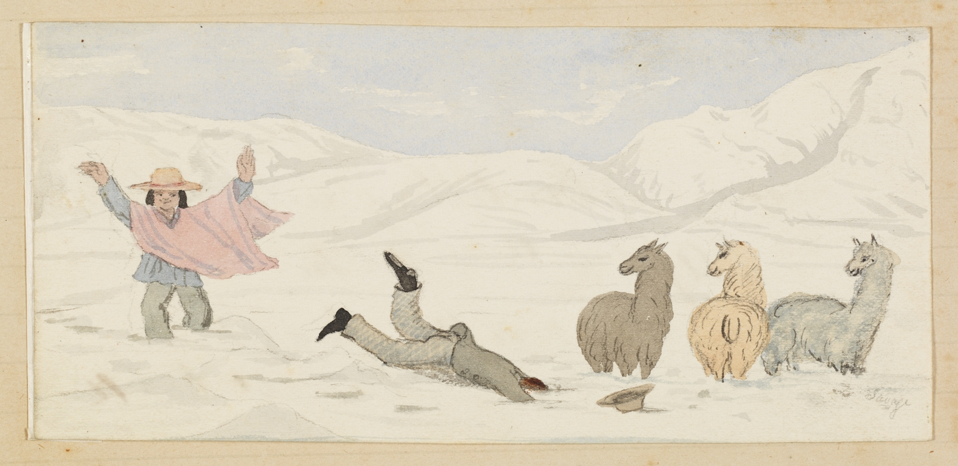
Figure 4: ‘Passage of Cordillera into Chile’. Annotated watercolour sketches by Santiago Savage, 1857-1858, being a record of Charles Ledger's journeys in Peru and Chile. State Library of New South Wales MLMSS 630/1.

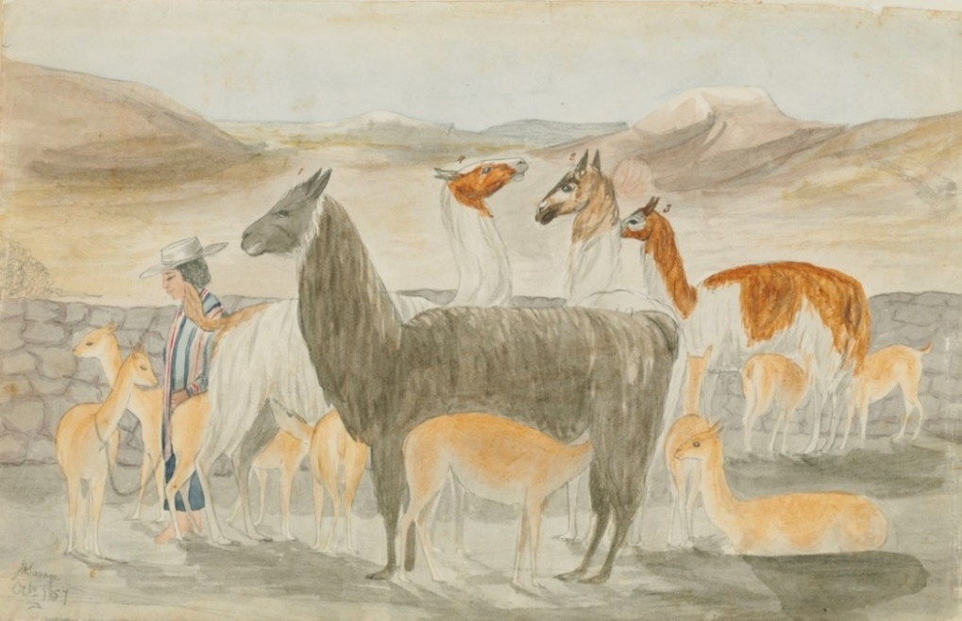
Figure 5: Ledger also experimented with rearing tame vicuñas in the Andes. He paid local llama hunters to supply him with the animals and assigned mother llamas to suckle them. This sketch ‘represents the four llama nurses ‘Burra’, ‘Sarea’, ‘Cacho’ and ‘Chucara’, each with two ‘vicuñitas’. Annotated watercolour sketches by Santiago Savage, 1857-1858, being a record of Charles Ledger's journeys in Peru and Chile. State Library of New South Wales MLMSS 630/1.

Circuits of Exchange
Recent work in the history of science has emphasised the communal and collaborative nature of natural knowledge and the crucial role played by go-betweens or intermediaries. Though often portrayed as the product of individual genius and heroism, the collation, analysis and transmission of information and objects often relied on a complex set of relationships and networks which facilitated their transfer. Friendship, sociability and personal contacts were vital to this process of exchange, the latter often created and sustained through letters of introduction and written correspondence. Context and place were also important in explaining how specific forms of knowledge arose and how they were communicated to other localities.
The alpaca naturalisation scheme clearly reflects the social and spatial dimensions of nineteenth-century science and illustrates some of the diplomatic, commercial and scholarly networks that connected Britain and Latin America. Though not part of Britain’s formal empire, the newly independent states of South America were closely integrated into British trade routes and were soon staffed with a regiment of British consular officials, many of whom furthered the study of natural history by shipping native plants and animals to British institutions. Former soldiers who had gone to Spanish America to fight in the Wars of Independence often remained in the region for some time, while British merchants travelled to the continent to sell manufactures and purchase raw materials, establishing important connections with local people and sometimes marrying into creole families. A host of naturalists also descended on South America in the years after independence, some taking up positions at local museums and universities, others conducting research on behalf of scientific institutions back in Europe. Individuals from all of these backgrounds played a role in the alpaca naturalisation project – some willingly, others less so - offering up their zoological, social and technological expertise on both sides of the Atlantic (and indeed Pacific). The drive to naturalise alpacas in Britain and its colonies thus elucidates the complexity of British connections with South America in the post-independence period, and the varieties of knowledge necessary to transport a valuable zoological commodity across the globe.
Firstly, alpaca importers relied heavily on the knowledge and experience of indigenous Peruvians, whose long contact with the animals made them experts on their needs and behaviour. Though Native Americans were often accused of failing to exploit the full potential of the alpaca and of duping gullible foreigners into buying old or diseased beasts, their expertise in farming alpacas was grudgingly acknowledged. William Walton, for instance, advocated enlisting Peruvian keepers to bring alpacas to Britain, on the grounds that they knew best how to handle them – and would themselves be ‘improved’ by absorption into British culture (a view reflective of the racial assumptions of the era).
I should…advise that each shipment, if large, be accompanied by a Peruvian llanero, or shepherd, one accustomed to manage these animals, acquainted with their tempers and experienced in the cure of their diseases. Young men of this class might easily be had at a trifling expense; and, if Indians, a little tuition and intercourse with Europeans would change their disposition and induce them to improve their habits.
Charles Ledger likewise relied on the expertise of Native Americans, hiring twelve Bolivian shepherds to care for his flock en route to Australia. The men remained with the alpacas until 1860, when they returned to Peru, and were assigned the task of shearing the Australian flock in 1859 due to their intimate connection with the animals. As the Sydney Morning Herald explained:
It was thought desirable that these men, though rather clumsy manipulators, should do the work in preference to regular [sheep] shearers, as their long familiarity with the animals has imparted to them a degree of docility and quietness while in the hands of their own keepers which they would not preserve in the presence of strangers; in addition to which the long connection of these men with the flock inclines them to use the shears more carefully, though less rapidly, than ordinary shearers.
Native Peruvians thus proved essential to alpaca relocation, though their knowledge was not always freely given or treated with respect. Ledger, for example, complained that his indigenous helpers would not shear pregnant female alpacas in the belief that they would miscarry – a view he attributed to superstition. In 1856, meanwhile, indigenous Bolivians murdered a young Frenchman named Mr Ibarnégaray while attempting to purchase some alpacas for export – a clear sign that many local people actively opposed the removal of their native livestock.
If Native American expertise helped with the day-to-day management of the alpacas, the collaboration of sailors in the British navy and merchant marine also proved critical in their successful relocation. This was recognised by proponents of acclimatisation, who offered detailed advice on how and where to ship alpacas with the most profitable results. Walton, for instance, conscious that a shorter crossing would improve the odds of keeping the alpacas alive, advised transporting the animals to Panama on a new line about to be set up by the Pacific Steam Navigation Company, allowing them to recuperate on the isthmus for six weeks and then shipping them to England from the Caribbean port of Chagre. Another alpaca enthusiast, in this case from Tasmania, suggested that ‘it might be possible for some of the vessels trading to San Francisco to procure a few [alpacas], by means of vessels from Chili, there being a considerable communication between San Francisco and Valparaiso’. The extension of British shipping to the Pacific in the wake of Spanish American independence and the increasing sophistication of steam-powered vessels in the mid-nineteenth century cut down journey times across the world’s oceans, making it more likely that animals would survive the long crossing to new lands. Some sailors also went the extra mile to look after their live cargo, further improving survival rates. In 1841, for example, Captain Bottomley of the Highlander took great care to convey nine alpacas from Valparaíso to Liverpool, feeding them on a diet of lucern and even ‘washing the mouths of the animals before eating and drinking’ to keep them healthy.
While indigenous Peruvians and British mariners played an important role in caring for transient alpacas, the impetus behind the acclimatisation schemes came largely from British subjects based in Spanish America. Commercial links were particularly important. Charles Ledger, as we have seen, was introduced to the alpaca through his job as a wool merchant, working first as a clerk for the house of Naylor’s and later operating his own business. He formed close relationships with Indian farmers, and in this way became aware of the potential value of alpaca wool. He also formed connections with fellow merchants, two of whom, Messrs. Waddington and Templeton and Co., bankrolled his acclimatisation scheme. Living in Peru for twenty-four years, Ledger developed an intimate knowledge of how alpaca were farmed and how their fleece was processed by the Indians. The Briton further ensconced himself in Peruvian society by ‘marrying into an influential family in Tacna’, forging important links with the local community. These connections, part social, part economic, enabled Ledger to carry out his alpaca smuggling scheme.
The contribution of another alpaca advocate, General John O’Brien, illustrates even more clearly the role of itinerant Britons in appropriating the alpaca. An Irishman by birth, from Baltinglass, County Wicklow, O’Brien travelled to South America in 1812 to open a merchant house in Buenos Aires, but ended up fighting at the battles of Chacabuco, Cancha Rayada and Maípo as General José de San Martín’s aide de camp. After the conflict concluded, O’Brien settled in Peru, engaged in mining ventures, and later in Argentina, where he worked to encourage Irish immigration. Upon returning to Britain some years later he became increasingly enthusiastic about the prospect of naturalising the alpaca in his native Ireland and initiated a correspondence with British alpaca enthusiasts Danson and Walton. Possessing not only direct personal knowledge of the alpaca, but also many useful contacts in Peru, O’Brien assisted the alpaca acclimatisation drive by writing a series of letters to his Peruvian friends, urging them to cooperate with Danson’s naturalisation scheme. One of O’Brien’s correspondents, Peter Murphy, HM Consul at Arica, was entreated to offer his ‘aid and assistance’ to ‘whatever person [Danson] may send out to this country’ to collect alpacas, with a view to conferring ‘a national gift’ upon ‘your dear old mountains of Wicklow’. Another correspondent, Michael Crawley, Prefect of the Department of Lampa, was requested, for the sake of ‘old friendship’, to help with selecting good quality alpacas and ‘conducting them to the coast’; a third, Don Mariano Toledo, was asked, in dubious Spanish, to give Danson’s agent ‘todo servicio en procurer los mejores animales’ and to do ‘cuento puede en facilitar sus proyectos’. The content of these letters, with its emphasis on friendship and service to one’s country, highlights the importance of social and professional networks in the study and exchange of zoological specimens and the value of personal contacts in furthering scientific and economic plans.
Back in Britain, the successful rearing and exploitation of the alpaca depended on input from three other communities of ‘experts’: men of science, engineers and zoo professionals. The first of these, men of science, conducted observations on alpacas and studied their anatomy and physiology. The famous comparative anatomist Richard Owen delivered a lecture on the ‘peculiar properties’ of alpaca wool at the Society of Arts in 1851, in which he noted its ‘glossy…silky’ quality. Another scientist, Alfred Higginson of the Natural History Society of Liverpool, dissected two alpacas, observing that ‘the water cells’ in their stomachs ‘were either empty or partly filled with masticated food in a semi-fluid state’. Anatomical findings helped acclimatisers to better understand the needs of the animal and the potential uses to which it might be put. Like the British botanists at Kew who used their knowledge of plants to classify, acclimatise and ‘improve’ the species earmarked for naturalisation in the colonies, nineteenth-century zoologists assessed the quality of alpaca wool and drew conclusions what kind of places they would thrive in and how best to farm them.
While zoologists debated the pros and cons of transporting and farming the alpaca, the use of alpaca wool for textile production was made possible by a series of technological developments, most of them the work of enterprising Yorkshire artisans. Since it was finer and longer than sheep’s wool, the fleece of the alpaca could not be spun using traditional machinery, but required specially adapted spinning apparatus. Initially, no such apparatus was available. In the 1830s, however, Benjamin Outram, ‘a scientific manufacturer of Gretland near Halifax’, designed a machine that could spin alpaca wool economically and effectively, giving rise to a new industry. Titus Salt installed Outram’s machinery in his worsted factories in Bradford in 1836, and was soon producing alpaca goods on an industrial scale. Further technological breakthroughs in subsequent years increased the quality and speed of the output, making the business yet more profitable; in 1847, for instance, Edward Waud ‘of Bradford, Yorkshire, spinner’, received a patent for ‘certain improvements in the construction of machinery for preparing and spinning alpaca, mohair, wool, flax and other fibrous materials’. The technical expertise of British artisans, who had perhaps never seen a living alpaca, thus played a crucial role in stimulating the demand for their wool, and, in time, the desire for their naturalisation.
Finally, in highlighting the communities that facilitated alpaca introduction, we ought to mention one last group: menagerists and zoo directors. When seeking advice on alpaca acclimatisation, alpaca advocates frequently invoked the practical knowledge of these individuals, whose direct experience of rearing alpacas in Britain made them the next best thing to native Peruvians when it came to learning about the animals’ diet and habits. Danson, for instance, collaborated with Thomas Atkins of Liverpool Zoological Gardens, compiling a circular to be issued to ships’ captains ‘for their guide in treatment of the animals during the voyage’. The Australian Edward Wilson consulted John Thompson, superintendent of London Zoo, on the llama-alpaca crosses and employed ‘a competent man from the Zoological Gardens Regent’s Park’ to care for his flock on their voyage to Australia. Walton, meanwhile quizzed Edward Cross, director of the menagerie at Exeter ‘Change, about the alpaca, citing the latter’s testimony that the animal in his possession subsisted on ‘dry food, such as hay, beans and oats’, that ‘it never drank anything the whole time I had it’, and that he cured it of a skin complaint (the ‘itch’) by ‘rubbing a little mercurial ointment on the spine’. Though Cross was a showman, and not a professional naturalist, Walton seems to have valued his opinions highly and was happy to rely on his expertise; ‘few men’, he remarked, ‘could be found more intelligent or more observant than Mr Cross’.
Even travelling menageries, usually perceived as mere sources of entertainment, could assist the alpaca acclimatisation project. When showmistress Mrs Wombwell exhibited a ‘jet black’ alpaca in Liverpool in 1853 the animal attracted considerable attention from local farmers, generating a series of letters to the Liverpool Mercury. The Mercury initiated the conversation, observing that the animal was ‘entitled to much attention, not merely from motives of curiosity, but from the immense mercantile advantages which would accrue to the agriculturalist as well as the manufacturer by its naturalisation in this country’. In the following weeks, letters appeared from readers concurring with this view. One correspondent, ‘G.G.’, who had seen the menagerie specimen, noted that the alpaca’s fleece typically weighed ‘from 12 to 14 lbs’, though ‘on the one before us at Wombwell’s (which, however, is singularly fine), we should imagine upwards of 20 lbs’. He went on to express his hope that the Mercury’s article would ‘induce the owners or holders of hilly or mountainous districts at once to consider’ the ‘practicability’ of domesticating the alpaca there. A second correspondent, ‘T.F.’, broadly agreed with these sentiments, requesting information on ‘where the breed may be obtained at a price commensurate with the great risk which must be run before any return can be expected’, and where he might find an ‘able treatise’ explaining how to avoid ‘accidents arising from ignorance of the habits of the animal’. While sailors, merchants and naturalists thus brought the first alpacas back to British shores, it was often travelling entertainers who introduced them to people in the provinces, and who, through long experience, understood best how to manage them.

Alpacas and Empire
If alpaca naturalisation illustrated the complex networks of exchange and expertise at work within and beyond the British Empire, it also exposed certain tensions in these relationships. Alpacas, it turned out, meant different things to different people. The British, the Australians and the Peruvians all invested these valuable animals with their own specific hopes and expectations, while even within Britain and its antipodean possessions there were varying regional and local interests at stake. These different aspirations were not necessarily mutually exclusive; what was good for farmers in New South Wales might also be beneficial to textile workers in Bradford. They do, nonetheless, betray different priorities and emphases, and, in the case of the Peruvians and Bolivians, opposing views as to where alpacas should be farmed.
Firstly, viewed from a British perspective, alpaca farming was seen as a way to promote the nation’s commerce and revitalise its agriculture by transforming barren and uncultivated regions into useful pastures. Supporters of acclimatisation believed that the introduction of alpacas would permit more effective use of Britain’s farmland, already exploited as far as possible by native species, and would enable the British to produce a fine and delicate fabric capable of competing with the best French silks. They hoped it would reduce Britain’s dependence on Peruvian imports of alpaca wool, which contemporaries considered insufficient to meet growing demand, and they even suggested it would facilitate British expansion overseas by providing a material suitable for clothing colonists in the tropics. To this extent, the acclimatisation project was a tangible reflection of Britain’s naval dominance and imperial reach, a demonstration of its technological and agricultural expertise and a testament to its commercial penetration of post-independence South America. By the same token, however, the desire to naturalise the alpaca was also an expression of British anxieties and economic vulnerability, at a time when contemporaries were worrying about foreign competition (Germany and the USA were beginning to industrialise) and the prospect of Civil War in the USA threatened cotton supplies. Some Britons feared that if they did not acclimatise the alpaca, European rivals would take the initiative, threatening the country’s dominance in the woollen trade and putting manufacturers out of work. As Walton expressed it:
In the stirring age in which we live, nations, like individuals, must compete with those who seek to outstrip them; and…in order to keep his ground in the foreign market, the manufacturer must vary his goods and adapt them to the prevailing taste, besides increasing the number of articles which he sends thither for sale.
British writers thus perceived alpaca naturalisation as a possible antidote to actual and potential national problems, as well as a marker of imperial dominance. The difficulties British subjects experienced in smuggling alpacas out of Peru, moreover, point to Britain’s limited influence over the region in the mid-nineteenth-century, and the vulnerability of would-be acclimatisers to shifts in local politics.
While alpaca acclimatisation was intended to benefit Britain as a whole, it is worth noting that specific regions and cities took particular interest in the project, developing their own local connections with the alpaca and sometimes pursuing distinctive regional agendas. The Irishman General O’Brien, for example, though happy to collaborate with British colleagues in bringing alpacas to the British Isles, appears to have been particularly interested in the benefits the scheme would confer upon his native Ireland. He certainly emphasised the latter in correspondence with fellow expatriate Irishman Peter Murphy, HM Consul at Arica, referring to the animals as ‘a national gift to your own dear mountains of Wicklow’. Similar sentiments were at work in Liverpool, where Danson and Atkins seem to have perceived alpaca importation as a source of local pride for one of Britain’s main trading hubs with South America, and another way of advertising the port city’s global reach and entrepreneurial spirit. In Bradford, meanwhile, alpaca wool contributed significantly to the city’s textile prosperity and earned the West Yorkshire town royal patronage in 1845 after local artisans converted the fleece of one of the Queen’s alpacas into an apron and ‘a striped and figured dress’. In April of the same year a public dinner was held at the Bradford Exchange Rooms at which ‘a painted representation of the Alpaca’ was displayed alongside Bradford’s coat of arms, and in 1851, when Salt constructed a special village for his employees, alpaca emblems were chiselled into several of the buildings, including the schoolhouse (Fig.6). By 1859 Bradford even boasted an ‘Alpaca Beer-house’ – further testimony of the animal’s local significance and its incorporation into popular culture. These cases suggest that there was a regional as well as a national dimension to alpaca naturalisation as different counties and cities sought specific benefits as farmers, importers and manufacturers of alpaca produce.

Figure 6: Alpaca motif on the schoolhouse in Saltaire, Bradford.

Shifting our focus to Australia, we find a further difference in emphasis, though also an awareness of the wider imperial and local circumstances noted above. On the one hand, acclimatisers viewed rearing the animals in the outback as good for the British Empire as a whole and beneficial in particular to textile-producing cities like Bradford. Wilson therefore appealed specifically to the manufacturers of Bradford to assist in raising money to purchase alpacas for shipping to Victoria, convinced that ‘the enormous advantages already derived by your town from alpaca wool will doubtless induce nearly the whole of your manufacturers and spinners to contribute to this interesting experiment’. On the other hand, the Australian alpaca programme had a specifically colonial dimension, and was deeply inflected with elements of local pride – sometimes broadly ‘Australian’, but in other instances confined to a single Australian state. Seeking contributions to his alpaca fund in The Times, Wilson expressed his hope that ‘Australians now in England’ would supply the money to buy the animals and recommended that the flock be sent to ‘Victoria, if possible’, thus benefiting his native Melbourne. Commenting on Ledger’s achievements, meanwhile, the Era concluded that ‘if there is a man who has done well for Australia it is Charles Ledger, and we trust the colony will mark its sense of his merit in a manner befitting a Government to bestow, and a public benefactor to receive’. When the Australians let Ledger down by failing to reimburse him adequately for his services, the same paper published a further article warning that
It would indeed be a disgrace to the country if Mr C. Ledger, after so far completing his hazardous and arduous enterprise, commenced on the faith of promises of handsome remuneration, should be allowed to depart to South America, and relate there…that an enterprise which had been highly extolled in England as likely to open a new era in British commerce, has been unrequited by the country which would chiefly benefit by it.
This prompted the opening of a public subscription in New South Wales, partly to reward Ledger for his efforts, partly to redeem the inhabitants of Sydney in British eyes by proving that ‘the high merit of Mr C. Ledger in opening up a new source of productive industry’ had been ‘properly appreciated’. Colonial and imperial pride were thus at stake in the alpaca exchange project, as British papers upbraided Australian subjects for failing to show due gratitude towards a metropolitan benefactor and the inhabitants of rival settlements competed for regional pride and economic advantage – all within the wider context of the British Empire. At the 1862 International Exhibition the Government of New South Wales received a medal for ‘the first alpaca wool grown in the colony, while Ledger himself ‘obtained honourable mention for excellence of quality of alpaca tallow and pomade’ – a source of pride for the nascent colony.
Finally, viewed through Peruvian and Bolivian eyes, alpaca acclimatisation had a very different complexion, though one still heavily imbued with national significance. For these two countries, the alpaca was an intrinsic part of the landscape and its fleece an important national export. Alpaca wool earned Peru and Bolivia significant sums of money in the post-independence period while alpacas themselves were also part of the region’s pre-Columbian heritage, appearing regularly on flags, coins and stamps (Fig.7). Indigenous people also maintained a close spiritual relationship with camelids, stretching back to before the Spanish conquest. According to Ledger (not, admittedly, an impartial witness), when news arrived in Peru of the death of the alpacas on the Sir Charles Napier, ‘the Indians flocked from all parts of the country to the capital of the department, the city of Puno, and from thence petitioned the Government to prohibit the exportation of Alpacas from the country’, attributing ‘every misfortune that had happened in the district for the year past’ to the animals’ ‘untimely death’. For both cultural and economic reasons, therefore, the Peruvian and Bolivian governments opposed the naturalisation of alpacas in other countries and issued legislation to protect this part of their national patrimony. The export of llamas and alpacas was prohibited in 1845 and further decrees in 1851 and 1868 reinforced the export ban, outlawing ‘the removal from Peruvian territory of alpacas and vicuñas, and of any species of animal that proceeds from the crossing of the two races’. British critics, frustrated by these impediments to free trade, repeatedly condemned this policy, referring disparagingly to the ‘intense jealousy’ and ‘absurd decrees’ of the Peruvian and Bolivian states and repeatedly preaching the virtues of free trade. Ledger’s brother, George, accused Peru of supreme selfishness, noting that the country had benefited from the introduction of Old World animals like the horse and the pig, and repaid ‘these gifts by the positive prohibition of its most valuable animal product…appropriating exclusively to itself a…blessing intended for the common benefit of mankind’. To Peruvians, however, the measures made eminent sense in the face of what we might see as a nineteenth-century form of bio-piracy. Moreover, as Peruvian legislators were quick to point out, the export ban, ‘cannot be considered in the present case as an odious restriction of trade, since the export of alpaca and llama wool is free’ – an interesting distinction which demonstrated their awareness of British critiques.
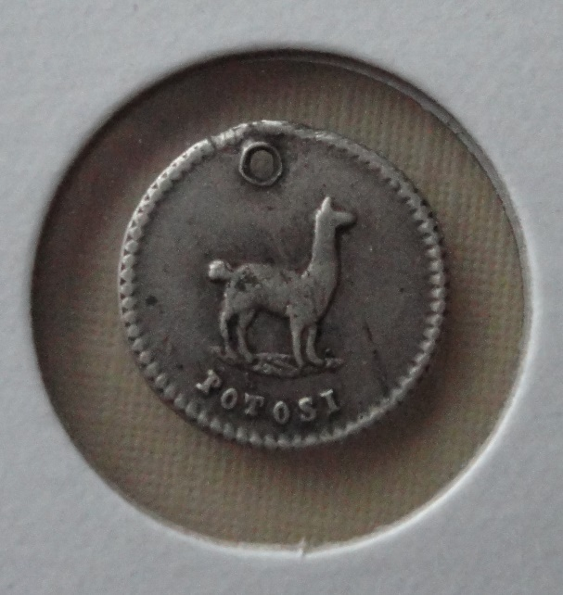
Figure 7: Bolivian coin featuring an alpaca, 1852.

Conclusion
The nineteenth century witnessed a surge of interest in the alpaca. The first imports of the animal’s wool started to arrive in Britain during the Spanish American Wars of Independence. New technological developments facilitated its use in high quality clothing, and alpaca dresses, jackets and umbrellas were soon rolling off the production lines. As the alpaca industry took off, ‘improving’ agriculturalists conceived the idea of naturalising the animal in the British dominions, initially in the mountainous regions of Britain itself, later in the Australian colonies. This was attempted through the activation of multiple networks of exchange and expertise, with contributions from former soldiers, expatriate merchants and travelling showmen. It was also attempted in direct contravention of Peruvian law, which, from 1845, prohibited the export of this precious natural resource.
Efforts to naturalise the alpaca formed part of a much wider programme of bio-piracy. The British wanted to control valuable natural resources, such as cinchona (quinine), rubber and tea. They believed that the best way to do so was to extract them from their native lands (Peru, Brazil, China) and cultivate them in suitable regions of the Empire. They justified their actions on the grounds that the current owners of these resources were not exploiting them to their fullest potential – a process that Fa Ti Fan refers to as ‘paternal imperialism’. In the case of the alpaca, it was alleged that Peruvian Indians wasted much of the wool through superstition and slovenly collecting practices, and that they could not meet growing foreign demand for the product. Naturalising the animal in Britain and Australia promised to remedy a potential shortage of raw material and would, through superior animal husbandry, improve the quality of the wool produced. The Acclimatisation Society of Melbourne, for example, accused ‘the South American Indian, one of the most un-improving of all the races of mankind’, of having failed to maximise the alpaca’s potential. It anticipated great improvements in the species now that the animal was ‘subjected for the first time to the same treatment that has effected such wonders with the Leicester, Lincoln or South Down sheep, the short-horn ox [and] the thorough-bred horse’.
Such claims were in fact untrue; the Peruvian Government was interested in the improvement of its camelid stock and took active measures in the nineteenth century to extend the geographical range of the alpaca and to protect and domesticate the wild vicuña. In 1845, for instance, the Government offered a reward of 250 pesos to anyone who introduced alpacas to the department of Junín, with a further 25 pesos for every 50 crias (baby alpacas) bred in the region. In 1846, meanwhile, it extended formal recognition to Juan Cabrera, priest of Macusani, who, after twenty years of experiments, succeeded in breeding a male alpaca with several female vicuñas, producing fourteen mixed-race offspring. The British, however, ignored these efforts and continued to perceive themselves as the only ones capable of effecting agricultural improvement.
Though it shared many features with contemporary botanical acclimatisation programmes, alpaca naturalisation differed from many of these in three key respects. Firstly – and most obviously - it involved an animal rather than a plant, which added to the difficulties of relocation. Secondly, it was not managed centrally from a single scientific institution, such as Kew, but promoted independently by a number of private individuals (the Zoological Society of London, though involved in the scheme, did not assume a comparable leading role). Thirdly the alpacas were relocated, not to a tropical colony, like most botanical seizures, but to Britain’s Celtic fringe and a white settler colony in the southern hemisphere, where they were to be farmed by British subjects or expatriates, not coerced indigenous labour. These factors gave the alpaca project a decentred complexion and meant that it was actively encouraged – rather than passively accepted – in the receiving countries, which anticipated concrete local benefits as well as wider imperial ones. In this way, British subjects in places as diverse as Bradford, Liverpool, Sydney and Hobart took a keen interest in the scheme, publishing articles on the subject, meeting locally to discuss it and often undertaking private initiatives to bring it to fruition.
The other key thing about alpaca acclimatisation was that it failed, or at least did not achieve the glorious results its supporters expected. Alpacas perished from ignorance or mismanagement. Indigenous Peruvians refused to share their knowledge with European acclimatisers, or deliberately misled them. Australian farmers got cold feet and declined to purchase alpacas at auction, while shifting economic and political conditions on both sides of the Pacific disrupted naturalisation efforts. Some vital forms of expertise, moreover, were lost or compromised en route from Peru to Australia. Ledger’s Bolivian shepherds, for instance, lacked the skill to shear the alpacas efficiently ‘as in South America the shearing, or rather the cutting off the wool…is done entirely by women’. Attempts to increase wool output in Australia by shearing alpacas annually rather than biannually, meanwhile, fell foul of technological constraints, the spinning and weaving machines in Bradford having been built to take wool of two year’s growth only. The naturalisation enterprise was also undermined by the unintentional transfer of disease-causing pathogens – in this case, mange, or ‘the scab’, which Australian farmers feared would infect their sheep. Alpaca naturalisation thus suffered from the non-transfer, or only partial transfer, of particular forms of knowledge and reflected the limitations of British science.
Despite its limited success, however, alpaca acclimatisation retained a certain romantic appeal, and was couched in the language of the military crusade or daring adventure. One contemporary paper characterised Ledger’s quest as a ‘pilgrimage’, the details of which ‘would compile a romance of the most extraordinary adventure’. Henry Swinglehurst, a Briton resident in Valparaíso, was even more effusive. Writing to a friend in Britain in 1858, shortly after he had dined with Ledger, Swinglehurst eulogised the merchant’s achievements and likened him to the most famous explorer of his generation:
He is Livingstone No. 2, and in other times will be looked upon as a hero of trials that few have known and hardly any equalled…Sometimes all but buried in mountain snows, with hungry men and flocks to protect; now chased by the police and again hunted by the angry natives in pursuit of the flock, and with all the privations of six years’ absence from his home and family and over a journey of 6,000 leagues with animals and men.
This was very much the stereotype of the courageous Victorian explorer, assailed by hazards on all sides but emerging triumphant through ingenuity and perseverance. It was also the reincarnation of the sixteenth-century privateer who raided South American ports in defiance of the Spanish Government and exemplified British pluck and daring. Three hundred years after Francis Drake preyed on Spanish ships in the Pacific, British merchants and naturalists were committing another, more modern form of piracy on Peruvian coasts, with camelids taking the place of silver as stolen treasure.

References
- Aguirre, Robert, Informal Empire: Mexico and Central America in Victorian Culture (Minneapolis: University of Minnesota Press, 2005)
- Allen, Thomas, A Guide to the Zoological Gardens and Museum; with a Brief Account of the Rise and Progress of the Zoological Society (London: Cowie and Strange, 1829)
- Anon., List of Animals in the Liverpool Zoological Gardens (Liverpool: Ross and Nightingale, 1839)
- Anon., Report of the Council and Auditors of the Zoological Gardens of London, 1853 (London: Taylor and Francis, 1853)
- The Argus
- Beckert, Sven, Empire of Cotton: A New History of Global Capitalism (London: Penguin, 2014)
- Bennett, George, The Third Annual Report of the Acclimatisation Society of New South Wales (Sydney: Joseph Cook, 1864)
- Bradford Observer
- Brockway, Lucille, Science and Colonial Expansion: The Role of the British Royal Botanic Gardens (New Haven: Yale University Press, 2002)
- Brown, Matthew, Adventuring through Spanish Colonies: Simón Bolívar, Foreign Mercenaries and the Birth of New Nations (Liverpool: Liverpool University Press, 2006)
- Brown, Matthew (ed.), Informal Empire in Latin America: Culture, Commerce and Capital (London: Blackwell, 2008)
- Caledonian Mercury
- Camerini, Jane, ‘Wallace in the Field’, Osiris 2nd Series, 11 (1996), pp.44-65
- Decreto Estableciendo la prohibición de extraer del territorio peruano las alpacas, vicuñas y animales que proceden del cruzamiento de ambas razas, 8 October 1868, Archivo Digital de la Legislación del Perú.
- El Comercio
- The Courier
- Cowie, Helen, Conquering Nature in Spain and its Empire 1750-1850 (Manchester: Manchester University Press, 2011)
- Crosby, Alfred, The Columbian Exchange: Biological and Cultural Consequences of 1492 (Westport: Greenwood Press, 1972)
- The Daily News
- Danson, William, Alpaca, the Original Peruvian Sheep before the Spaniards Invaded South America, for Naturalisation in other Countries (Liverpool: M. Rourke, 1852)
- Deville, M.E. Considérations sur les Avantages de la Naturalisation en France de l’Alpaca (Paris: Imprimerie de L. Martinet, 1851)
- Drayton, Richard, Nature’s Government: Science, Imperial Britain and the ‘Improvement’ of the World (New Haven: Yale University Press, 2000)
- Earle, Rebecca, The Return of the Native: Indians and Myth-Making in Spanish America, 1810-1930 (Durham: Duke University Press, 2007)
- The Era
- The Essex Standard
- Extraordinary Living Rarities, Exhibiting for a Few Days Longer at 236, Piccadilly, John Johnson Collection of Printed Ephemera (Animals on Show 2 (52)
- Fan, Fa Ti, ‘Victorian Naturalists in China: Science and Informal Empire’, British Journal for the History of Science 36:1 (2003), pp.1-26
- Flindell-Klarén, Peter, Peru: Society and Nationhood in the Andes (New York, 2000)
- Flores Ochoa, Jorge, Pastoralists of the Andes: The Alpaca Herds of Paratía (Philadelphia: Institute for the Study of Human Issues, 1979)
- Freeman’s Journal
- Gallagher, John, and Robinson, Ronald, ‘The Imperialism of Free Trade’, The Economic History Review 6.1, 1953, pp.1-15
- Grove, Richard, Green Imperialism: Colonial Expansion, Tropical Island Edens and the Origins of Environmentalismm, 1600-1860 (Cambridge: Cambridge University Press, 1995)
- Hoage, R.J., and Deiss, William A., New Worlds, New Animals: From Menagerie to Zoological Park in the Nineteenth Century (Baltimore: John Hopkins University Press, 1996)
- Hochadel, Oliver, ‘Watching exotic animals next door: “Scientific” observations at the zoo (ca. 1870–1910)’. Science in Context 24.02 (2011): 183-214
- Ipswich Journal
- Kadwell, Miranda, Wheeler, Jane, et al, ‘Genetic analysis reveals the wild ancestors of the llama and the alpaca’, Proceedings of the Royal Society, London 268 (2001), pp.2575-2585
- Kennedy, Dane, The Last Blank Places: Exploring Africa and Australia (Cambridge, Mass.: Harvard University Press, 2013)
- Launceston Examiner
- Ledger, George, The Alpaca: Its Introduction into Australia and the Probabilities of its Acclimatisation There. A Paper read before the Society of Arts, London. Republished by the Acclimatisation Society of Victoria (Melbourne: Mason and Firth, 1861)
- Leeds Mercury
- Liverpool Mercury
- Lloyd’s Weekly Newspaper
- Livingstone, David, Putting Science in its Place: Geographies of Scientific Knowledge (Chicago, 2003)
- Lloyd’s Weekly Newspaper
- Lund Simmonds, Peter, The Curiosities of Food, or The Dainties and Delicacies of Different Nations Obtained from the Animal Kingdom (Berkeley: Ten Speed Press, 2001)
- Maitland Mercury
- Markham, Clements, Travels in Peru while superintending the collection of cinchona plants and seeds in South America, and their introduction into India (London: John Murray, 1862)
- Melbourne Argus
- McCook, Stuart, States of Nature: Science, Agriculture and Environmentalism in the Spanish Caribbean, 1760-1940 (Austin: University of Texas Press, 2002)
- Mengoni Goñalons, Luis, ‘Camelids in ancient Andean societies: A review of the zooarcheological evidence’, Quaternary International 185 (2008), pp.59-68
- Miller, John, The Memoirs of General Miller (New York: AMS Press, 1973)
- The Morning Chronicle
- Museo Nacional de Ciencias Naturales, Madrid, Fondo Zoológico, Sección Sociedad de Aclimatación, 329/007
- Osborne, Michael, Nature, the Exotic and the Science of French Colonialism (Bloomington: Indiana University Press, 1994)
- El Peruano
- Raj, Kapil, Relocating Modern Science: Circulation and the Construction of Knowledge in South Asia and Europe, 1650-1900 (Basingstoke: Palgrave Macmillan, 2007)
- Ritvo, Harriet, The Animal Estate: The English and Other Creatures in the Victorian Age (Cambridge: Harvard University Press, 1987)
- Schaffer, Simon, Roberts, Lissa, Raj, Kapil and Delbourgo, James (eds.), The Brokered World: Go-Betweens and Global Intelligence, 1770-1820 (Sagamore Beach, 2009)
- Schell, Patience, The Sociable Sciences: Darwin and his Contemporaries in Chile (Basingstoke: Palgrave Macmillan, 2013)
- Schiebinger, Londa, Plants and Empire: Colonial Bio-Prospecting in the Atlantic World (Cambridge: Harvard University Press, 2004)
- Sivasundaram, Sujit, ‘Trading Knowledge: The East India Company’s Elephants in India and Britain’, The Historical Journal 48:1 (2005), pp.27-63
- South Australian Register
- Spary, Emma, Utopia’s Garden: French Natural History from Old Regime to Revolution (Chicago: University of Chicago Press, 2000)
- Suplemento al Peruano
- Sydney Morning Herald
- The Times
- Topik, Stephen, Marichal, Carlos, and Zephyr, Frank (eds.), From Silver to Cocaine: Latin American Commodity Chains and the Building of the World Economy, 1500-2000 (Durham: Duke University Press, 2006)
- Walton, William, The Alpaca: Its Naturalisation in the British Isles Considered as a National Benefit, and as an Object of Immediate Utility to the Farmer and Manufacturer (New York: Office of the New York Farmer and Mechanic, 1845)
- Walton, William, A Memoir addressed to Proprietors of Mountain and other Waste Lands and Agriculturalists of the United Kingdom, on the Naturalisation of the Alpaca (London: Smith, Elder and Co., 1841)

William Walton, The Alpaca: Its Naturalisation in the British Isles Considered as a National Benefit, and as an Object of Immediate Utility to the Farmer and Manufacturer (New York: Office of the New York Farmer and Mechanic, 1845), p.15; Extraordinary Living Rarities, Exhibiting for a Few Days Longer at 236, Piccadilly, John Johnson Collection of Printed Ephemera (Animals on Show 2 (52).
Sydney Morning Herald, 29 November 1858.
Michael Osborne, Nature, the Exotic and the Science of French Colonialism (Bloomington: Indiana University Press, 1994), p.11.
Museo Nacional de Ciencias Naturales, Madrid, Fondo Zoológico, Sección Sociedad de Aclimatación 329/007; Essex Standard, 2 February 1859; Peter Lund Simmonds, The Curiosities of Food, or The Dainties and Delicacies of Different Nations Obtained from the Animal Kingdom (Berkeley: Ten Speed Press, 2001), p.114.
Important studies of ‘economic botany’ include Lucille Brockway, Science and Colonial Expansion: The Role of the British Royal Botanic Gardens (New Haven: Yale University Press, 2002) (first published 1979); Richard Grove, Green Imperialism: Colonial Expansion, Tropical Island Edens and the Origins of Environmentalism, 1600-1860 (Cambridge: Cambridge University Press, 1995); Richard Drayton, Nature’s Government: Science, Imperial Britain and the ‘Improvement’ of the World (New Haven: Yale University Press, 2000); Emma Spary, Utopia’s Garden: French Natural History from Old Regime to Revolution (Chicago: University of Chicago Press, 2000); and Londa Schiebinger, Plants and Empire: Colonial Bio-Prospecting in the Atlantic World (Cambridge: Harvard University Press, 2004).
A notable exception is Osborne, Nature, the Exotic and the Science of French Colonialism. There is also a wider literature on the earlier (more successful) introduction of Old World animals into the Americas after 1492, which significantly shaped the ecology of the New World. See, for instance, See Alfred Crosby, The Columbian Exchange: Biological and Cultural Consequences of 1492 (Westport: Greenwood Press, 1972); and Elinor Melville, A Plague of Sheep: Environmental Consequences of the conquest of Mexico (Cambridge: Cambridge University Press, 1994).
The classic exposition of this view is John Gallagher and Ronald Robinson, ‘The Imperialism of Free Trade’, The Economic History Review 6.1, 1953, pp.1-15.
Robert Aguirre, Informal Empire: Mexico and Central America in Victorian Culture (Minneapolis: University of Minnesota Press, 2005), p.xv. Other scholars have questioned the notion of informal empire, arguing that the concept overplays British power in the region and underestimates the collusion of Latin American elites in the process. For a range of recent approaches to the issue, see Matthew Brown (ed.), Informal Empire in Latin America: Culture, Commerce and Capital (London: Blackwell, 2008).
Miranda Kadwell, Jane Wheeler et al, ‘Genetic analysis reveals the wild ancestors of the llama and the alpaca’, Proceedings of the Royal Society, London 268 (2001), pp.2575-2585.
Luis Mengoni Goñalons, ‘Camelids in ancient Andean societies: A review of the zooarcheological evidence’, Quaternary International 185 (2008), pp.59-68.
The guano boom was particularly profitable to Peru. It lasted from c.1841-1870, the same period in which alpaca naturalisation was attempted. See Rory Miller & Robert Greenhill, ‘The Fertiliser Commodity Chains: Guano and Nitrate, 1840-1930’, in Stephen Topik, Carlos Marichal & Frank Zephyr (eds.), From Silver to Cocaine: Latin American Commodity Chains and the Building of the World Economy, 1500-2000, Durham: Duke University Press, 2006, pp.228-270.
Peter Flindell-Klarén, Peru: Society and Nationhood in the Andes (New York, 2000), p.166.
William Walton, A Memoir addressed to Proprietors of Mountain and other Waste Lands and Agriculturalists of the United Kingdom, on the Naturalisation of the Alpaca (London: Smith, Elder and Co., 1841), p.22; John Miller, The Memoirs of General Miller (New York: AMS Press, 1973), Vol. I, p.234.
In 1839 an ‘Al pacha [sic]’ was exhibited at Liverpool Zoological Gardens, along with two llamas. List of Animals in the Liverpool Zoological Gardens (Liverpool: Ross and Nightingale, 1839), p.26.
William Danson, Alpaca, the Original Peruvian Sheep before the Spaniards Invaded South America, for Naturalisation in other Countries, Liverpool: M. Rourke, 1852, p.7.
George Ledger, The Alpaca: Its Introduction into Australia and the Probabilities of its Acclimatisation There. A Paper read before the Society of Arts, London. Republished by the Acclimatisation Society of Victoria (Melbourne: Mason and Firth, 1861), p.5.
Ibid. p.6.
Sydney Morning Herald, 21 August 1860. Wool merchant Charles Ledger estimated that 40,000,000lb of alpaca wool was used for domestic consumption.
Walton, The Alpaca, p.12.
Walton, Memoir, p.19.
Walton, The Alpaca, p.11 and pp.7-8.
Ibid., p.13; Danson, Alpaca, p.19.
Morning Chronicle, 30 September 1840.
Caledonian Mercury, 12 August 1844.
Walton, The Alpaca, pp.14-19.
Walton, Memoir, p.23.
Walton, The Alpaca, p.19; Walton, Memoir, p.23.
On the tradition of animal husbandry and the fashion for fat cattle in nineteenth-century Britain, see ‘Barons of Beef’ in Harriet Ritvo, The Animal Estate: The English and Other Creatures in the Victorian Age (Cambridge: Harvard University Press, 1987), pp.45-81.
Walton, The Alpaca, pp.16, 17 and 21.
Ibid., p.15.
Walton remarked that ‘the treatment which they [alpacas] have experienced from some owners has been cruel, if not murderous in the extreme…for all depends upon the whim of a servant – often with a wet and filthy bed under them, and not infrequently eating the offals of a green-grocer’s shop’. Ibid., pp.24 -5.
Ibid. p.27.
Walton advised sending agents to Peru with a good knowledge of the language and people of the country – ‘a man of address, intelligence and observation…who has some reputation at stake, and who from patriotic motives would feel disposed to devote his attention exclusively to the undertaking’. See Ibid., p.28.
Leeds Mercury, 22 March 1859.
South Australian Register, 10 February 1859.
Sydney Morning Herald, 21 August 1860.
El Comercio, 13 August 1845.
Sydney Morning Herald, 10 September 1860.
One writer, ‘M.F’, who had spent four years in South America, recommended contracting ‘a few gauchos’ to drive alpacas across the pampas. Another, ‘AN OLD PERUVIAN’, suggested the Liverpool firm, Jack Brothers, ‘one of the largest and most enterprising wool buyers in the interior of Peru’. See Argus, 28 March 1857 and Ibid. 14 October 1858.
The Melbourne Argus, 30 March 1858.
Linden Gillbank, ‘A paradox of purposes: acclimatization origins of the Melbourne Zoo’, in R.J. Hoage and William A. Deiss, New Worlds, New Animals: From Menagerie to Zoological Park in the Nineteenth Century (Baltimore: John Hopkins University Press, 1996), pp.76-79; Melbourne Argus, 13 October 1858.
The Times, 17 July 1858.
Daily News, 8 November 1858.
Lloyd’s Weekly Newspaper, 22 August 1858.
Bradford Observer, 28 July 1864.
Paper read by Charles Ledger to the Australian Agricultural Society, reprinted in Bradford Observer, 29 September 1859.
George Ledger, The Alpaca: Its Introduction into Australia, pp.11-13.
The Era, 20 February 1859.
Ibid., 25 September 1859.
Bradford Observer, 29 September 1859.
The Era, 12 February 1860.
Sydney Morning Herald, 28 June 1865.
Ibid., 29 February 1864.
Important contributions in this area include Simon Schaffer, Lissa Roberts, Kapil Raj and James Delbourgo (eds.), The Brokered World: Go-Betweens and Global Intelligence, 1770-1820 (Sagamore Beach, 2009); Jane Camerini, ‘Wallace in the Field’,Osiris 2nd Series, 11 (1996), pp.44-65; Fa Ti Fan, ‘Victorian Naturalists in China: Science and Informal Empire’, British Journal for the History of Science 36:1 (2003), pp.1-26; and Sujit Sivasundaram, ‘Trading Knowledge: The East India Company’s Elephants in India and Britain’, The Historical Journal 48:1 (2005), pp.27-63.
On the importance of friendships and correspondence in science, see Patience Schell, The Sociable Sciences: Darwin and his Contemporaries in Chile (Basingstoke: Palgrave Macmillan, 2013).
See, for instance, David Livingstone, Putting Science in its Place: Geographies of Scientific Knowledge (Chicago, 2003); and Kapil Raj, Relocating Modern Science: Circulation and the Construction of Knowledge in South Asia and Europe, 1650-1900 (Basingstoke: Palgrave Macmillan, 2007).
Henry Southern, HM Minister at Rio, presented the Zoological Society of London with a tapir in 1853. W.D. Christie, HM Minister to the Argentine Confederation, presented ‘a pair of pumas’ in 1857. See Report of the Council and Auditors of the Zoological Gardens of London, 1853 (London: Taylor and Francis, 1853), p.18; ibid, 1857, p.19.
For a detailed study of British and Irish ex-soldiers in Colombia, Venezuela and Ecuador, see Matthew Brown, Adventuring through Spanish Colonies: Simón Bolívar, Foreign Mercenaries and the Birth of New Nations (Liverpool: Liverpool University Press, 2006).
Walton, The Alpaca, p.28.
Sydney Morning Herald, 7 November 1859.
Ibid., 21 August 1860 and 20 September 1860.
Walton, The Alpaca, p.6.
Maitland Mercury, 20 March 1850.
Liverpool Mercury, 1 October 1841.
George Ledger, The Alpaca: Its Introduction into Australia, p.12.
Bradford Observer, 29 September 1859.
Clements Markham, Travels in Peru while superintending the collection of cinchona plants and seeds in South America, and their introduction into India (London: John Murray, 1862), p.527.
Danson, Alpaca, pp.12-14.
Ibid., p.20.
Walton, Memoir, p.20.
Walton, The Alpaca, p.11.
Liverpool Mercury, 3 December 1847.
Danson, Alpaca, p.19.
The Argus, 13 October 1858; Daily News, 8 November 1858.
Walton, The Alpaca, p.15; Walton, Memoir, pp.21-23.
Walton, Memoir, p.23. For an interesting discussion of the different forms of knowledge in play at the zoo, see Oliver Hochadel, ‘Watching exotic animals next door: “Scientific” observations at the zoo (ca. 1870–1910)’. Science in Context 24.02 (2011): 183-214.
Liverpool Mercury, 2 February 1853.
Ibid., 11 February 1853.
Ibid., 22 March 1853.
William Haines, chairing the meeting at which George Ledger advocated alpaca introduction into Australia, emphasised ‘the importance of promoting increased production of wool when our supply of cotton might be in danger’. See George Ledger, The Alpaca: Its Introduction into Australia, p.24. On the rise of cotton and its close links with imperial expansion, see Sven Beckert, Empire of Cotton: A New History of Global Capitalism (London: Penguin, 2014).
The French were, in fact, taking steps to acclimatise the alpaca, which they hoped would thrive in the mountains of the Pyrenees, the Alps and the Vosges, as well as in their new colony of Algeria.
Walton, The Alpaca, p.12.
Danson, Alpaca, pp.12-14.
Morning Chronicle, 14 December 1844.
Ibid., 14 December 1844; Leeds Mercury, 12 April 1845.
Leeds Mercury, 21 May 1859.
Bradford Observer, 29 July 1858.
The Times, 17 July 1858.
The Era, 25 September 1859.
Ibid., 12 February 1860.
Ibid., 12 February 1860.
Dane Kennedy makes a similar argument for competing civic and imperial interests in relation to mid-nineteenth-century Australian exploration. See Dane Kennedy, The Last Blank Places: Exploring Africa and Australia (Cambridge, Mass.: Harvard University Press, 2013), p.241.
George Bennett, The Third Annual Report of the Acclimatisation Society of New South Wales (Sydney: Joseph Cook, 1864), p.95.
El Comercio, 8 April 1851; Decreto Estableciendo la prohibición de extraer del territorio peruano las alpacas, vicuñas y animales que proceden del cruzamiento de ambas razas, 8 October 1868, Archivo Digital de la Legislación del Perú.
The Times, 17 July 1858; The Era, 20 February 1859. On the continued importance of camelids in Andean folklore and culture, see Jorge Flores Ochoa, Pastoralists of the Andes: The Alpaca Herds of Paratía, Philadelphia: Institute for the Study of Human Issues, 1979, pp.71-85.
Ledger (1861), p.14. This is a reference to what historian Alfred Crosby has called ‘The Columbian Exchange’ – the transcontinental interchange of plants, animals and microbes that occurred in the sixteenth century following the Spanish conquest of America. See Crosby, The Columbian Exchange.
El Comercio, 8 April 1851. The export ban on alpacas paralleled similar South American legislation prohibiting the removal of antiquities and prized natural history specimens from American soil. See Aguirre, Informal Empire, pp.31 and 98; Rebecca Earle, The Return of the Native: Indians and Myth-Making in Spanish America, 1810-1930 (Durham: Duke University Press, 2007), pp.134-8; and Helen Cowie, Conquering Nature in Spain and its Empire 1750-1850 (Manchester: Manchester University Press, 2011), pp.165-70.
See Brockway, Science and Colonial Expansion.
Fan ‘Victorian Naturalists in China’, p.25.
George Ledger, The Alpaca: Its Introduction into Australia, p.ii.
Suplemento al Peruano, 7 October 1845. On the application of science to agriculture in South America itself, see Stuart McCook, States of Nature: Science, Agriculture and Environmentalism in the Spanish Caribbean, 1760-1940 (Austin: University of Texas Press, 2002).
El Peruano, 9 September 1846. The Government awarded Cabrera a medal for his services to the nation and had his portrait ‘placed in the National Museum’ of Lima. It also decreed that prizes – in the form of exemption from the ‘contribution’ (a tax levied on the indigenous population) - be offered to ‘any Indian who presents to the Governor of his District with ten perfectly tame female vicuñas, along with either a male of the same species or a male alpaca’.
Sydney Morning Herald, 7 November 1859.
George Ledger, The Alpaca: Its Introduction into Australia, p.19.
Ledger denied that his alpacas posed a risk to sheep. He reported that ‘I had 700 sheep badly “bottled” in two flocks, that for a year…slept in the yards with the alpacas, and I never saw or heard of any sign of scan among them’. Sydney Morning Herald, 8 April 1863.
On the non-transmission of knowledge, and the reasons for it, see ‘Conclusion: Agnotology’, in Schiebinger, Plants and Empire, pp.276-241.
The Era, 31 October 1858.

