**Development of Antiferromagnetic Heusler Alloys for the Replacement of Iridium as a Critically Raw Material**

Atsufumi Hirohata,1 Teodor Huminiuc,2 John Sinclair,2 Haokaifeng Wu,2 Marjan Samiepour,1 Gonzalo Vallejo-Fernandez,2 Kevin O'Grady,2 Jan Balluf,3 Markus Meinert,3 Günter Reiss,3 Eszter Simon,4 Sergii Khmelevskyi,5 Laszlo Szunyogh,4,6 Rocio Yanes Díaz,7 Ulrich Nowak,7 Tomoki Tsuchiya,8 Tomoko Sugiyama,8 Takahide Kubota,8,9 Koki Takanashi,8,9 Nobuhito Inami 10 and Kanta Ono 10

1 *Department of Electronics, University of York, Heslington, York YO10 5DD, United Kingdom*

2 *Department of Physics, University of York, Heslington, York YO10 5DD, United Kingdom*

3 *Department of Physics, University of Bielefeld, Universitätsstraße 25, 33615 Bielefeld, Germany*

4 *Department of Theoretical Physics,* *Budapest University of Technology and Economics, Budafoki út 8, 1111 Budapest, Hungary*

*5 Center for Computational Materials Science, Institute for Applied Physics, Vienna University of Technology, Wiedner Hauptstrasse 8, A-1060 Vienna, Austria*

*6 MTA-BME Condensed Matter Research Group, Budapest University of Technology and Economics, Budafoki út 8., H-1111 Budapest, Hungary*

7 *Department of Physics, University of Konstanz, Postfach 674, 78457 Konstanz, Germany*

8 *Institute for Materials Research, Tohoku University, 2-1-1 Katahira, Sendai 980-8577, Japan*

9 *Center for Spinctronics Research Network, Tohoku University, 2-1-1 Katahira, Sendai 980-8577, Japan*

10 *Institute of Materials Structure Science, High Energy Accelerator Research Organization (KEK), 1-1 Oho, Tsukuba 305-0801, Japan*

**Abstract**

As a platinum group metal, iridium (Ir) is the scarcest element on the earth but it has been widely used as an antiferromagnetic layer in magnetic recording, crucibles and spark plugs due to its high melting point. In magnetic recording, antiferromagnetic layers have been used to pin its neighbouring ferromagnetic layer in a spin-valve read head in a hard disk drive for example. Recently, antiferromagnetic layers have also been found to induce a spin-polarised electrical current. In these devices, the most commonly used antiferromagnet is an Ir-Mn alloy because of its corrosion resistance and the reliable magnetic pinning of adjacent ferromagnetic layers. It is therefore crucial to explore new antiferromagnetic materials without critical raw materials. In this review, recent research on new antiferromagnetic Heusler compounds and their exchange interactions along the plane normal is discussed. These new antiferromagnets are characterised by very sensitive magnetic and electrical measurement techniques recently developed to determine their characteristic temperatures together with atomic structural analysis. Mn-based alloys are found to be most promising based on their robustness against atomic disordering and large pinning strength up to 1.4 kOe, which is comparable with that for Ir-Mn. The search for new antiferromagnetic films and their characterisation are useful for further miniaturisation and development of spintronic devices in a sustainable manner.

**I. Introduction**

The European Commission identified 14 critical raw materials (CRMs) in 2011 and revised to 20 CRMs three years later [1]. These include antimony, beryllium, borates, chromium, cobalt, coking coal, fluorspar, gallium, germanium, indium, magnesite, magnesium, natural graphite, niobium, phosphate rock, platinum group metals (PGMs), heavy rare earth elements, light rare earth elements, silicon metal and tungsten. Similar lists have been made also by other governments such as those of the USA, Japan and China. As a measure of criticality, a sustainability index (SI) has been introduced to assess the difficulty in substituting the material, scored and weighted across all applications. SI values are between 0 and 1, with 1 being the least substitutable. Among these CRMs, phosphate rock has the highest SI of 0.98, followed by the SIs of chromium, borates, germanium, beryllium and PGMs of 0.96, 0.88, 0.86, 0.85 and 0.83, respectively. Generally, the PGMs have a relatively high end-of-life recycling input rate of 35%, which is a measure of the proportion of metal and metal products that are produced from end-of-life scrap and other metal-bearing low grade residues in end-of-life scrap worldwide. Even so, among the PGMs, only 1~2% in Pt and Rh ore contains iridium and 87% of the Ir world supply (~5.8 t in 2011 [2]) is from South Africa. This makes Ir to be the scarcest element on the earth with the composition of 4×10-4 ppm, which is almost one (or more) order of magnitude less than the other PGMs, *e.g.*, Pt (3.7×10-3 ppm) and Ru (1×10-3 ppm).

In general, the PGMs have very high melting point (>1,800K) due to their crystalline stability. Especially, Ir has one of the highest melting points of 2,739K. Hence, due to its stability, Ir (and its alloys) has been used as a prototype kilogram, a prototype metre, and for spark plugs, dip pens, rings and tooth fillings. In addition to these traditional usages, electrical and electrochemical applications of Ir have been increasing over the last decades, resulting in the worldwide demand of 7.7 t in 2016 [3]. Such a high demand is responsible for the severe fluctuation in Ir price over the last decade as shown in Fig. 1 [4]. Until the beginning of 2007, the Ir price was almost stable to be approximately USD 5/g. However, it took the maximum of USD 35/g in 2011 with over 130% fluctuations. Since the middle of 2016, it has been monotonically increasing again to USD 30/g, approaching the maximum price. These fluctuations are caused by the above demand greater than the supply and the associated speculation.

Among the heavy demands, electrical and electrochemical applications are the two major sectors. For the electrical use (2.1 t worldwide in 2017), antiferromagnetic (AF) Ir-Mn alloys for magnetic memory and Ir-complex for organic electroluminescence (EL) are major applications. For organic EL, tridentate [5] and bidentate Ir-complex [6] are used to generate red, blue, yellow and green EL. To avoid the usage of Ir, carbazolyl dicyanobenzene has been demonstrated to exhibit EL with these colours with 100% efficiency [7]. For the electrochemical use (1.8 t worldwide in 2017), on the other hand, crucibles for sapphire glass production has been increasing the demands recently due to the sapphire glass usages for mobile phones and tablet computers. The used crucibles can be recycled by fragmentation of metal scraps [8]. The metal scraps are dissolved in aqua regia (HNO3+3HCl), followed by the introduction to PbO solvent and HNO3, NaHSO4 and Na2O2 in series. The residual solution is then purified as (NH4)3[IrCl6], which can be reduced by H2 gas to Ir. Hence, it is important to develop a replacement for Ir alloys used in magnetic memory industry, which has no sustainable solution to date.

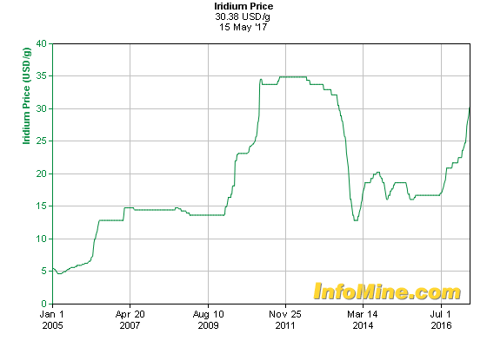

Fig. 1 Recent iridium price in USD/g [4].

In this paper, we review the recent development of AF materials consisting of abundant elements to replace Ir as a CRM. Due to the corrosion resistance for device applications, we focused on AF Heusler alloys. We have established correlations between their crystalline structures and magnetic properties, *i.e.*, antiferromagnetism. Heusler alloys consisting of elements with moderate magnetic moments require perfectly or partially ordered crystalline structures to exhibit AF behaviour. By using elements with large magnetic moments, even a fully disordered structure is found to show either AF or ferrimagnetic (FI) behaviour. The latter alloys may become useful for device applications by additional increase of their anisotropy and grain volume to maintain the AF behaviour above room temperature (RT).

**II. Antiferromagnetic Materials**

AF materials have been investigated intensively both theoretically and experimentally since the initial discovery by Louis Néel [9]. For example, Mn-O exhibits AF behaviour due to the antiparallel alignment of Mn magnetic moments [10] via their superexchange interactions [11]. Due to the antiparallel alignment of the moments with the same amplitude, it is very difficult to characterise the AF behaviour using macroscopic measurements. Accordingly, a ferromagnet (FM)/AF bilayer has been introduced to induce interfacial exchange coupling to pin the magnetisation of the FM layer. This results in a shift in the corresponding magnetisation curve, which is known as exchange bias field *H*ex, along a magnetic field applied [12]. In such a bilayer, the AF properties, *e.g.*, anisotropy and temperature dependence, can be indirectly characterised by measuring *H*ex due to the interfacial FM/AF coupling. From the device application point of view, *H*ex can pin one of the FM magnetisations in a FM/non-magnet (NM)/FM trilayer, providing a spin-valve structure [13]. The spin-valve is a basic building block for a read head of a hard disk drive (HDD), which is the most common data storage recording almost 85% of the information produced by human being. By replacing the NM layer with an insulating barrier, a magnetic tunnel junction (MTJ) can also be fabricated in a similar manner. Such MTJs are used as the latest HDD read head and a data bit cell of a magnetic random access memory (MRAM). Recently, by flowing an electrical current in an AF layer, spin polarisation has been demonstrated to be induced, leading to AF spintronics [14]. For these spintronic applications, an IrMn3 alloy has been predominantly used due to its corrosion resistance and robustness against device fabrication processes in nanometre-scale in both thickness and in-plane dimensions (see Table 1 for major AF materials).

Table 1 List of major AF materials and their Néel temperatures (*T*N). After Ref. [15],[16].

|  |  |  |  |  |  |
| --- | --- | --- | --- | --- | --- |
| AF materials | | *T*N [K] | AF materials | | *T*N [K] |
| III-IV: | FeO | 198 | I-VI-III-VI: | CuFeO2 | 11 |
|  | CoO | 291 |  | CuFeS2 | 825 |
|  | NiO | 525 |  | CuFeSe2 | 70 |
| III: | Cr | 308 |  | CuFeTe2 | 254 |
|  | FeMn | 493 | III-V: | FeN | 100 |
|  | NiMn | 797 |  | FeP | 115 |
|  | IrMn | 690 |  | FeAs | 77 |
|  | PtMn | 702 |  | FeSb | 220 |
| II-VI: | MnO | 122 |  | MnN | 660 |
|  | MnS | 152 |  | GdP | 15 |
|  | MnSe | 173 |  | GdAs | 19 |
|  | MnTe | 323 |  | GdSb | 27 |
|  | EuSe | 5 | II-V-IV-V: | MnSiN2 | 490 |
|  | EuTe | 10 | I-II-V: | LiMnSb | >RT |

In an AF material, the antiparallel alignment of the magnetic moments becomes random to transform into paramagnetism with increasing temperature above a magnetic transition temperature as known as the Néel temperature (*T*N). This can be explained by applying the Weiss field onto independent A and B sites, who have antiparallel alignment as shown in Fig. 2 (for x << 1) [17]. The magnetisation of these sites (*M*A and *M*B) can be determined as

$\left\{\begin{aligned}M_{A}=\frac{1}{2}Ngμ_{B}JB_{J}\left(x_{A}\right)=\frac{Nm^{2}}{6k_{B}T}H_{A}=\frac{C}{2T}H_{A} \\ M_{B}=\frac{1}{2}Ngμ_{B}JB_{J}\left(x_{B}\right)=\frac{Nm^{2}}{6k_{B}T}H_{B}=\frac{C}{2T}H_{B}\end{aligned}\right.$, (1)

where *N* is the number of magnetic moments, *g* is Lande’s g-factor, µB is the Bohr magneton in a unit volume, *J* is the angular momentum number, *B*J is the Brillouin function for *xA*(*B*) [=(*g*µB*J/k***B***T*)*HA*(*B*)], *m* is the magnetic moment, *k*B is the Boltzmann constant, *T* is temperature, *H* is the Weiss field and *C* is the Curie constant. This provides a total magnetisation as follows:

$M=M_{A}+M_{B}=\frac{C}{T}\left[\left(H-wM_{A}-w'M_{B}\right)+\left(H-w'M_{A}-wM_{B}\right)\right]$

$∴M=\frac{C}{T}\left[2H-\left(w+w'\right)M\right]$. (2)

Therefore, the corresponding magnetic susceptibility can be calculated as

$χ=\frac{M}{H}=\frac{C}{T+\frac{C}{2}\left(w+w'\right)}=\frac{C}{T+T_{N}}$. (3)

Here, *w* and *w*’ represent the Weiss field constants within the same site ad across the sites, respectively. At *T*=*T*N, *M* becomes zero. *T*N can be determined by measuring the temperature dependence of magnetic susceptibility. However, for AF thin films, this determination cannot provide an accurate determination of *T*N due to their small volumes.

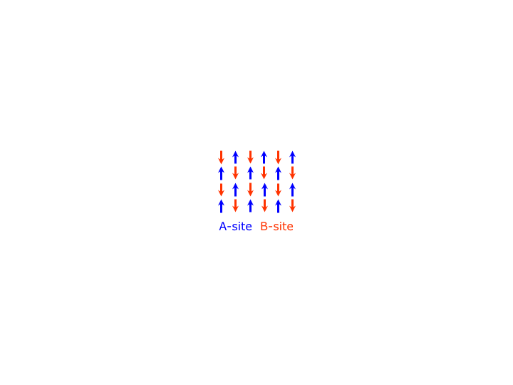

Fig. 2 Schematic AF configuration of magnetic moments.

To characterise an AF material, especially in its thin-film form attached to an FM layer, *H*ex has been commonly employed. First, Meiklejohn and Bean assumed a perfect AF/FM interface with uncompensated interfacial spins to induce exchange coupling but their calculations were orders of magnitude above measured values. AF domain walls were then considered at the interface to explain the reduced effective exchange coupling [18]. However, the domain-wall model assumed the rotation of moments along the plane normal, which cannot explain *H*ex for a thin AF film with a small moment deviation. Later, Malozemoff *et al.* considered the effect of interface roughness on an otherwise compensated AF/FM interface [19]. The roughness can lead to the formation of AF domains as long as their size is smaller than the AF grain size. Koon investigated the role of a so-called spin-flop coupling [20]. However, this coupling alone does not give rise to exchange bias. Defects in the AF, however, can lead to the formation of AF domains. Model calculations of the so-called domain-state model show qualitative agreement with many experimental results [21]. A model which focuses on polycrystalline AF samples was proposed by Fulcomer and Charap based on the Stoner-Wohlfarth theory [22]. Thermal fluctuations of the grain magnetisation was taken into account and energy distributions were calculated. By extending the Fulcomer-Charap model with time (*t*)-dependence, the York model of exchange bias has been proposed recently [23].

In polycrystalline films the AF is set below *T*N to avoid damage to the AF/FM structure. The AF layer is ordered by the exchange field from the FM layer. This is done by field annealing using thermal activation giving an ln(*t*) process. Temperature also causes parts of the AF to disorder and only the stable grains induce *H*ex. For Ir-Mn, where *T*N=690K, the setting of the AF layer is often incomplete. Using this macroscopic model, temperature dependence of the magnetisation curves can be reproducibly measured using the York protocol [23]. In the corresponding York protocol, the AF is set at the setting temperature (*T*SET) for 90 minutes, which is above the *T*N of the AF film but below the Curie temperature (*T*C) of the FM film. The sample is then cooled to the thermally activated temperature (*T*NA). The sample is heated to the activation temperature (*T*ACT) for 30 mins and is measured at *T*NA. A period of 30 min would reverse any activated grains to their original ‘set’ state. These times also negate any thermal activation that may occur during the temperature rise and fall. This procedure removes the first loop training effect and measuring at *T*NA ensures that slow thermal training does not occur. In polycrystalline systems, individual grains have their own blocking temperature (*T*B), which can be determined by increasing the activation temperature until the loop shift becomes zero. By continuously elevating *T*NA, *T*ACT becomes *T*SET, which represents the median value of *T*B (<*T*B>), which is the temperature when the reversed AF volume is equal to that of the initially set volume. <*T*B> is an indicative measure of *T*N.

More directly, the temperature dependence of electrical resistivity has been utilised to determine *T*N by detecting its gradient change [24]. Above *T*N, the moment alignment becomes random in the AF materials and changes the corresponding resistivity. As a reference, a single-crystal of Cr with dimensions 5×5×1 mm3 has been measured to confirm the applicability of the resistivity measurements to determine *T*N in a thin film form. A clear minimum is observed in the resistivity at 311K as shown in Fig. 3(a). It is important to note that the change in resistance at *T*N is of the order of µΩ. Measuring this change is only possible due to the low resistance of the crystal and it is unlikely that this technique can be applicable to thin polycrystalline films. 100-nm-thick epitaxial Ni2MnAl films have then been grown using magnetron sputtering and measured using the same technique [25]. A change in the gradient is observed between 265 and 280K dependant on their growth temperatures. These changes in the gradient are due to a magnetic phase change of Ni2MnAl as expected, allowing us to estimate *T*N with different growth temperatures. *T*N is found to increase with increasing growth temperatures and resulting crystalline ordering. Hence, the temperature-dependent resistivity measurement is a powerful technique to determine *T*N for epitaxial or highly-textured films. It should be noted that the changes in the resistivity among these samples are found to be 11% maximum, while those between epitaxial and polycrystalline films are measured to be over three orders of magnitude due to significant electron scattering at grain boundaries in the latter films.

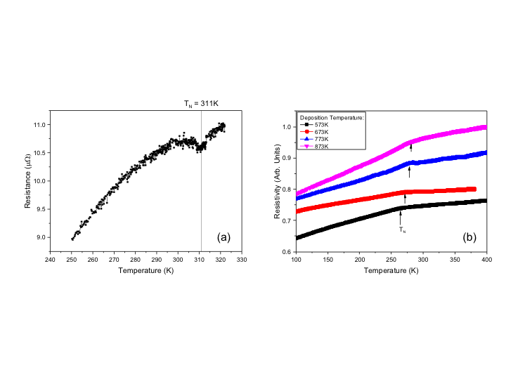

Fig. 3 Temperature-dependent resistivity of (a) a single-crystal Cr foil and (b) 100-nm-thick Ni2MnAl films.

In order to characterise the AF materials microscopically, synchrotron radiation has been widely employed. X-ray magnetic linear dichroism (XMLD) utilises a pair of linearly polarised soft X-ray beams with perpendicular polarisation axes, which is different from a pair of circularly polarised beams used in X-ray magnetic circular dichroism (XMCD) [26], [27]. Here, XMCD signals are proportional to the average value of a magnetic moment in a domain (<*M*>), while XMLD signals are proportional to <*M*2>. For an AF material, <*M*> is zero as *M*A=–*M*B within an AF domain in Eq. (2), resulting in no XMCD signal. However, <*M*2> is a finite value for an AF material, allowing AF domain imaging. For example for an Fe/NiO bilayer, NiO domain structures have been observed by taking a Ni *L*-edge, which is strongly affected by the exchange coupling between Fe and NiO (spin image), and by taking the O *K*-edge, which is originated from the intrinsic AF anisotropy due to the strong coupling with the Ni 3*d* orbital (twin image) [28]. For these domain imaging, a large uniform domain (>a few µm) is required, which makes it difficult to be used for an AF thin films.

Polarised neutron reflectivity (PNR) is another synchrotron-based technique to determine magnetic properties of bulk and layered materials [29]. Due to the magnetic moment of neutron beam interacting with magnetic materials to be observed, not only layer structures, such as thickness, density, composition and interfacial roughness, but also in-plane magnetic moments can be measured. The former structural analysis is similar to X-ray reflectivity (XRR) measurements but with higher accuracy in a shorter scanning period (<1 min.). The latter magnetic information can be obtained by detecting the neutron reflection with its spins interacted with those in an AF and/or FM layers.

In order to develop a replacement for Ir-Mn, RT antiferromagnetism needs to be achieved, which can be confirmed by the above techniques. To achieve this, three criteria needs to be satisfied: (i) *H*EB should be greater than 1 kOe at RT, (ii) <*T*B> should be above RT and (iii) the standard deviation of <*T*B> should be less than 0.3K. As listed in Table 1, however, the majority of the AF materials have *T*N near or below RT. Even though some oxides (*e.g.*, NiO) and sulphides (*e.g.*, CuFeS2) have *T*N>RT, they have very poor corrosion resistance and hence cannot be used for the Ir-Mn replacement. Manganese alloys (*e.g.*, NiMn and PtMn) and nitrides (*e.g.*, MnN and MnSiN2) also have *T*N>RT. However, NiMn has poor corrosion resistance and PtMn has very high crystallisation temperature, indicating that they cannot be used in commercially available devices as replacements for Ir-Mn. Therefore, new AF Heusler alloys [31], including nitride compounds in their wider definition, need to be developed for the Ir-Mn replacement.

**III. Development of Antiferromagnetic Heusler Alloys**

A list of major AF and compensated ferrimagnetic (CF) Heusler alloys is shown in Table 2. The Heusler alloys are categorised into two types: (i) full- and (ii) half-Heusler alloys. These alloys crystallise in (i) *L*21 phase with X2YZ composition and (ii) *C*1*b* phase with XYZ composition as shown in Fig. 4, respectively [50]. The half-Heusler alloys have an X-vacancy in the unit cell, making it to be susceptible to atomic displacement. Even for the full-Heusler alloys, the perfectly-ordered *L*21 phase can be deformed into the *B*2 phase by atomically displacing Y-Z elements, the *D*03 phase by X-Y displacements and the *A*2 phase by randomly exchanging X-Y-Z elements. The degree of crystallisation in the full-Heusler alloy films can be quantified based on the intensity and width of the (220) principal peaks in X-ray or electron-beam diffraction, indicating the formation of the *A*2 phase. The coexistence of both the (220) and (200) peaks can indicate the formation of the *B*2 crystalline ordering. The existence of the additional (111) peak confirms some degree of the formation of the perfectly ordered *L*21 crystalline phase.

Table 2 List of major AF and CF Heusler alloys and their Néel temperatures (*T*N), Curie temperatures (*T*C), average blocking temperatures (<*T*B>), exchange biases (*H*ex) and their forms, bulk, epitaxial (epi.) or polycrystalline (poly.) films or calculations (calc.). Simulated results using molecular dynamics (MF) are also shown.

|  |  |  |  |  |  |  |
| --- | --- | --- | --- | --- | --- | --- |
| Alloys | *T*N [K] | *T*C [K] | <*T*B> [K] | *H*ex [Oe] | Forms | Refs. |
| Pt2MnGa | 350 | – |  |  | Bulk | [31] |
| Ru2MnGe | 300 | – |  |  | Bulk | [32] |
|  | 320 |  |  |  | Simulations |  |
|  |  | – | 126 | >81 (100K) | Epi. Films | [33] |
|  | 365 | – |  |  | Calc. | [34] |
| Ru2MnSi | 313 | – |  |  | Calc. |  |
|  | 335 |  |  |  | Simulations |  |
| Ru2MnSn | 296 | – |  |  |  |  |
| Ru2MnSb | 195 | – |  |  |  |  |
| Ni2MnAl | 313 | – |  |  | Bulk (*B*2) | [35] |
|  | – | 375 |  |  | Bulk (*L*21) |  |
|  | 245 | – |  |  | Calc. (*B*2-I) | [36] |
|  | 350 | – |  |  | Calc. (*B*2-II) |  |
|  | – | 368 |  |  | Calc. (*L*21) |  |
|  | 340  372 | – |  |  | Calc. (*B*2-I)  MF Calc. | [37] |
|  | 220  352 | – |  |  | Calc. (*B*2-II)  MF Calc. |  |
|  | 285 | – |  |  | Calc. (*B*2-II) |  |
|  | 310 | – |  | >55 (10K) | Epi. Films | [25] |
| Mn2VAl | >600 | – |  |  | Bulk | [38] |
|  | >RT | – | ~200 | 120 (4K)  20 (RT) | Epi. Films |  |
|  | 360  636 | – |  |  | Calc.  MF Calc. |  |
| Mn2VSi |  | – | <100 | 34 (100K) | Poly. Films | [39] |
| Mn3Ga | 470 | – |  |  | Bulk | [40] |
|  | 648 | – | ~400 | 1.5k (RT) | Epi. Films | [41] |
|  |  | – | 235 | 430 (120K) | Poly. Films | [42] |
| Mn3.04Ge0.96 |  |  | 390 |  |  | [43] |
|  |  |  |  |  |  | [44] |
| Mn2.4Pt0.6Ga | – | ~90 |  | 33k (2K)  0 (90K) | Bulk | [45] |
| Mn1.8FeGa | – | ~350 |  | 12k (2K)  ~300 (RT) | Bulk |  |
| Mn2.5Co0.3Ga1.2 | – |  | >350 | 250 (RT) | Poly. films |  |
| MnN | 660 | – | 388 | 1475 (RT) | Poly. Films | [46] |
|  | 570 | – |  |  | Calc. |  |
| Fe2VAl |  |  |  |  | Calc. | [47] |
|  |  |  |  |  | Poly. films | [48] |
| Cr2MnSb | 342 |  |  |  | Calc. | [49] |

As shown in Fig. 5, the Heusler alloys can be formed with the X and Y atoms to be transition metals and the Z atom to be a semiconductor or a non-magnetic metal. These combinations provide more than 2,500 Heusler alloys. In addition, constituent elements in a Heusler alloy can be substituted by the other elements, offering great opportunity for the development of a new AF material [51]. In particular, by counting the total number of valence electrons, the atomic substitution is known to maintain the corresponding magnetic properties to satisfy the generalised Slater-Pauling curve. This allows the continuous engineering of the AF properties in the Heusler alloys with controlling their lattice constants and associated crystalline anisotropy.

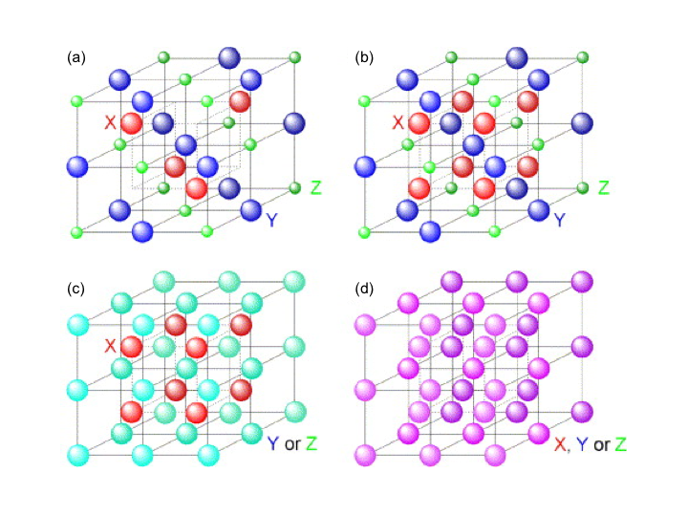

Fig. 4 Crystalline ordering of Heusler alloys: (a) half-Heusler alloy with the *C*1*b* phase and full-Heusler alloy with the (b) *L*21, (c) *B*2 and (d) *A*2 phases [48].

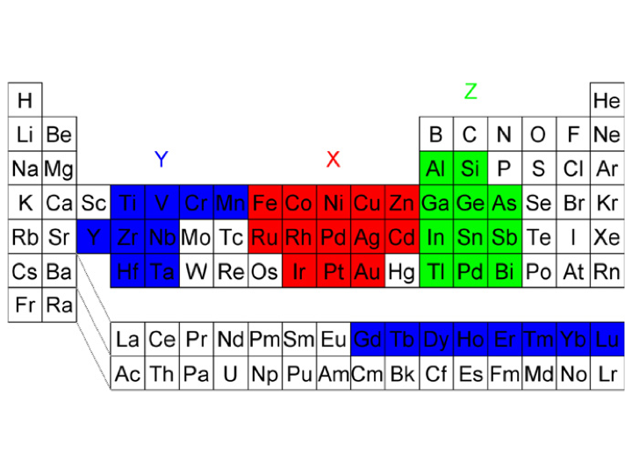

Fig. 5 Major combinations of Heusler alloys [50].

In Heusler alloys, half-Heusler alloys have low Néel temperatures in general. For example, CuMnSb [52], NdBiFe [53] and GdPdBi [54] have their *T*N to be 55, 2.18 and 13K, respectively. These are not suitable for Ir-Mn replacement in spintronic devices due to their low *T*N<RT and due to the use of rare materials in the latter two alloys. Therefore, full-Heusler alloys have been focused for the development of AF films with their *T*N>RT.

As listed in Table 2, Fe2VAl, where Y and Z elements can be substituted with any other elements as listed in Fig. 5, has been predicted to have a tendency to form a spin-glass (form AF ordering in Fe2.5V0.5Al) [47]. Mn2VAl is analogous to Fe2VAl but replaces the Fe with the very high moment Mn. These alloys can be further engineered by substituting some of Mn atoms with the other high-moment atoms to form (Co,Mn)2VAl for instance, which is analogous to the other two families with the exception that the element denoted X is now replaced by a mixture of two high moment atoms. By replacing V with Mn, low-moment-based alloys, *e.g.*, Ni2MnAl, are anticipated to have a high compensated moment. By utilising a heavier element as a base of the Heusler alloys, Ru2MnAl is expected to have the potential advantage of having both X and Y as the high moment atoms. These families are anticipated to exhibit AF ordering. For RT antiferromagnetism, the AF phase should be stabilised by introducing larger anisotropy and larger AF grain volume. Recently, perpendicularly magnetised FM has also been reported to be pinned by IrMn layer [55]. Hence, the introduction of the additional tetragonal distortion into the cubic Heusler alloys may be necessary for the development of a RT AF.

**1. Ru-based Heusler alloys**

Epitaxially grown Ru2MnGe films have a very small lattice mismatch of 0.5% on a MgO(001) substrate with the relationship, Ru2MnGe[100](001) || MgO[110](001) (*a*Ru2MnGe=0.5985 nm and *a*MgO=0.5957 nm). At a substrate temperature *T*sub>400°C, the formation of epitaxial films has been reported [33]. The optimum growth temperature has been reported to be *T*sub=500°C, where the diffraction peaks and their Laue oscillations are most pronounced. At higher temperatures, Mn starts to evaporate from the sample. The calculated lattice constant deduced from the (200) and (400) peak positions in X-ray diffraction (XRD) measurements is *c*=0.6041 nm. Considering a 1% tetragonal distortion induced by the compressive strain from the lattice mismatch, the lattice constant matches the prediction if the unit cell volume is held constant.

Figure 6 shows a series of hysteresis loops for a sample with an epitaxial Ru2MnGe/Fe bilayer measured following the same experimental procedure as used for a granular AF/FM system [23]. As can be seen, progressive thermal activation leads to a reversal of the exchange bias as shown in Figure 6(a). This allows for the distribution of *T*B to be calculated as shown by the line in Figure 6(b), showing <*T*B>=126K.

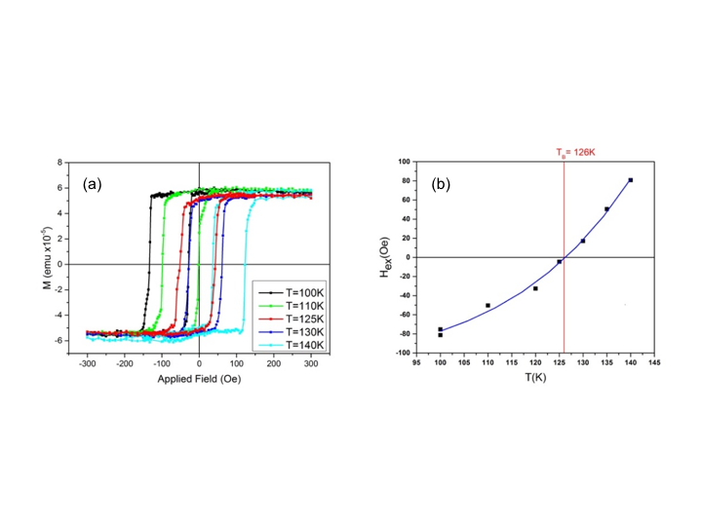

Fig. 6 (a) Hysteresis loops showing the reversal of exchange bias of Ru2MnGe/Fe sample. (b) *H*ex obtained for Ru2MnGe in a reversed cooling experiment as a function of temperature.

The optimum epitaxial Ru2MnGe/Fe bilayers have been imaged using cross-sectional transmission electron microscopy (TEM). Both substrate and FM layer interfaces confirm the lattice matching and crystalline quality. The thin FM layer does not offer enough contrast for TEM studies. The (220) and (200) reflections are observed for the (110) Heusler zone axis. The (222) reflections indicate the formation of the *L*21 phase.

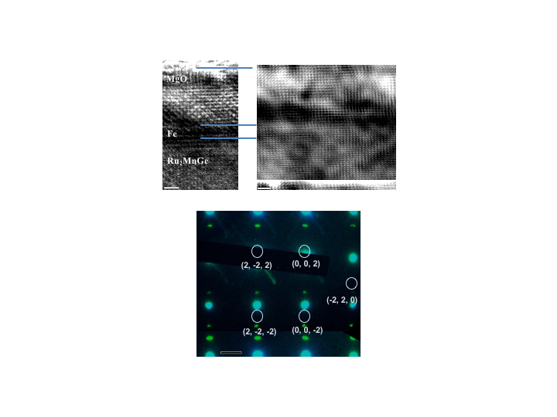

Fig. 7 Cross-sectional TEM images of epitaxial Ru2MnGe/Fe layers with the corresponding selected area electron diffraction (SAED) pattern.

The magnetic state and its dependence on the atomic disorder and chemical composition for Ru2MnGe have been investigated within a multi-scale approach [56] combining first principles calculations with advanced classical spin model simulations. Based on the first principles calculations, spin models were first parameterised and then, in a second step simulated by means of the stochastic Landau-Lifshitz-Gilbert equation of motion. Hysteretic as well as thermal properties of bilayers of Ru2MnZ/Fe (Z = Si or Ge) can thus be obtained.

The Ru-based bilayers show exchange bias in agreement with above measurements. This effect is much stronger than in the Ni-based bilayers as discussed in the following sub-section. As Figure 8 illustrates for a Ru2MnSi/Fe interface, exchange bias exists without structural disorder in the antiferromagnet, *i.e.*, for the *L*21 phase. Due to the strong FM coupling between the interface atoms, close to the interface, the Fe and Mn spins are oriented nearly parallel, and the direction of these spins is in-plane following the in-plane magnetic anisotropy. The hysteresis loop calculations show that the magnetisation curve is shifted vertically and horizontally, where the horizontal shift of the hysteresis loops is larger and indicates the *H*ex effect. Furthermore, simulations at finite temperature indicate a strong thermal dependence, where *H*ex at *T*=100K is less than a quarter of the corresponding value at *T*=0K. This also agrees with the relatively small *H*ex measured only at low temperature. The Ru2MnGe/Fe bilayers show a similar complex magnetic structure which is more sensitive to the presence of an applied field in comparison to the Ru2MnSi/Fe bilayer, in part because the on-site anisotropy is reduced. The exchange bias effect is smaller.

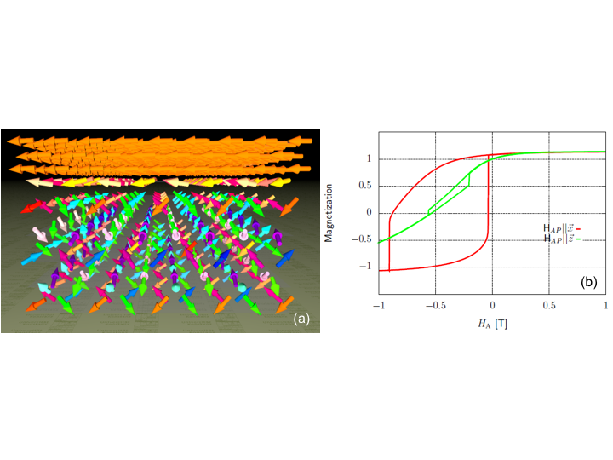

Fig. 8 (a) Sketch of the magnetic state after in-plane field-cooling for a Ru2MnSi (*L*21)/Fe interface. (b) In-plane and out-of-plane hysteresis loops of the Ru2MnSi (*L*21)/Fe bilayers at 0K [37].

These results confirm that the Ru-based Heusler alloys require to be in the *L*21 phase to exhibit AF behaviour. In order to increase the AF anisotropy and with that *H*ex, a lattice distortion was considered as well. The calculated spin moments and magnetic anisotropy energies (on-site: *K*os, two-site: *K*ts, the sum of them: magnetic anisotropy energy (MAE)), are listed in Table 3 for different *c/a* ratios in Ru2MnGe. Note that 1 meV equals to 8.21×106 erg/cm3. For Ir-Mn(110) MAE is measured to be 3.2×105 erg/cm3 and *H*ex=360 Oe [57], which is comparable to MAE for *c/a*>1.05. These calculated results suggest that tetragonal distortion (stretching) induces large uniaxial anisotropy in Ru2MnZ due to a combined effect of symmetry breaking and spin-orbit coupling. It should be noted that a similar AF behaviour has been reported for the other heavy-metal-based Heusler alloys, such as Pt2MnGa [31]. Therefore, for the heavy-metal-based Heusler alloys, high-moment element, *e.g.*, Mn, is necessary to induce AF behaviour. The AF anisotropy can be increased by introducing tetragonal distortion, leading to RT AF behaviour.

Table 3 Calculated magnetic moments (*m*Mn), *K*os, *K*ts and MAE for Ru2MnGe with tetragonal lattice distortion.

|  |  |  |  |  |
| --- | --- | --- | --- | --- |
|  | *m*Mn [μB] | *K*os [meV] | *K*ts [meV] | MAE=*K*os+*K*ts [meV] |
| *c/a*=1.00 | 2.91 | 9.7 × 10-5 | -2.7 × 10-4 | -1.8 × 10-4 |
| *c/a*=1.05 | 2.88 | 0.32 | 0.21 | 0.53 |
| *c/a*=1.10 | 2.79 | 0.54 | 0.41 | 0.95 |
| *c/a*=1.15 | 2.65 | 0.55 | 0.82 | 1.37 |
| *c/a*=1.20 | 2.49 | 0.43 | 0.80 | 1.23 |

**2. Ni-based Heusler alloys**

Ni2MnAl films grown on MgO(001) exhibit the superlattice (200) diffraction but no (111) peak in addition to the fundamental (220) diffraction using XRD, which suggests that the films are in the *B*2 phase [25]. The results of XRD φ-scans confirm that all films including the film deposited at RT satisfy the epitaxial relation, Ni2MnAl[100](001) || MgO [110](001). *H*ex of 55 Oe is obtained for the RT grown films, while no exchange bias (rather a weak FM signals) is detected for those grown at higher temperatures, *e.g.*, 600ºC as shown in Fig. 9.

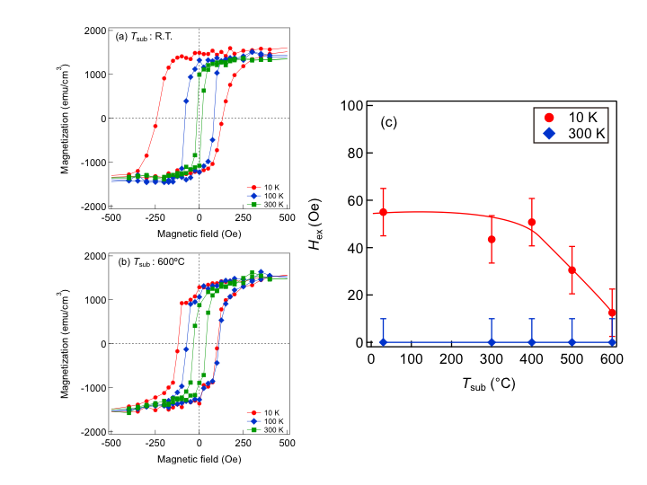

Fig. 9 Hysteresis loops showing the reversal of exchange bias of Ni2MnAl/Fe sample grown at (a) RT and (b) 600ºC. (c) *H*ex obtained for Ni2MnAl in a reversed cooling experiment as a function of temperature [25].

To identify the differences between these Ni2MnAl layers grown at RT and 600ºC, the Ni2MnAl epitaxial samples have been imaged using cross-sectional TEM. The epitaxially deposited Ni2MnAl/Fe bilayers exhibit good crystalline structure as seen in Fig. 10 with sharp interfaces which may exhibit less than three atomic planes in roughness. Here, the Ni2MnAl films grown at 600ºC are found to form the *L*21 phase confirmed by the presence of the (111) diffraction spots in their SAED image in Fig. 10. However, those grown at RT form the *B*2 phase without the (111) spots but with the (220) and (200) spots. By taking the above magnetisation measurements, Ni2MnAl requires the *B*2 ordering to exhibit AF behaviour. The Ni2MnAl layer shows a number of crystalline defects that define a fine granular-like structure due to the local breaking of symmetry within the atomic planes. The random distribution of crystalline boundaries may be detrimental to the thermal stability of AF, as the formation of small single domain structures of around 5 nm or less may lead to thermal instability of the material. A larger grain size and columnar growth are more desirable for increased thermal stability of the AF structure.

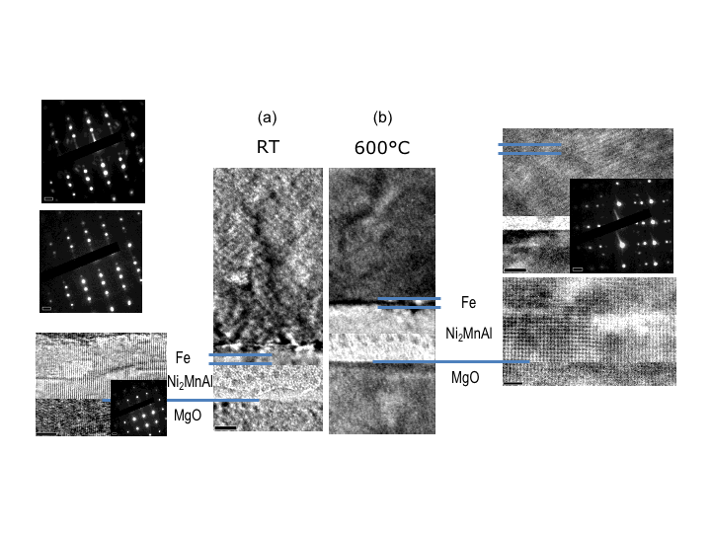

Fig. 10 Cross-sectional TEM images of epitaxial Ni2MnAl/Fe layers grown at (a) RT and (b) 600ºC with the corresponding SAED patterns.

In the case of the Ni-based AF in the crystallographically ordered *L*21 phase, the atomistic calculations confirm that no exchange bias occurs [58]. However, in that case a spin-flop coupling can lead to an enhanced coercivity and to the fact that one can switch the AF with an external field via the coupling to FM. For the partially disordered *B*2 phase of the Ni2MnAl, a small *H*ex has been found as shown in Fig. 11, which agrees with experiments as described above. The reason for the exchange bias effect is a combination of the disorder, which leads to uncompensated spin structures along the interface, with the anisotropy of AF. MAE has been calculated along the path between the ordered *B*2-I and *B*2-II structures as a function of Mn concentration on the Al sites (see Fig. 12). This confirms that short-range order can induce sizeable MAE for *B*2-II. Since the anisotropy is rather low (an order of magnitude smaller than that for the Ru-based Heusler alloys), *H*ex is rather small, and depends on the grain volume. It is furthermore rather unstable against thermal fluctuations with a maximum *T*B of below 100K as agreed with the experiment. In order to investigate a potential increase of *H*ex through a lattice distortion the MAE per unit cell has been calculated for several values of the *c/a* ratio in the *B*2 phase (see Table 4). Therefore, the Heusler alloys based with a transition metal with a small magnetic moment exhibits their AF phase when the high-moment Y atoms form antiparallel configuration between their second-nearest neighbours.

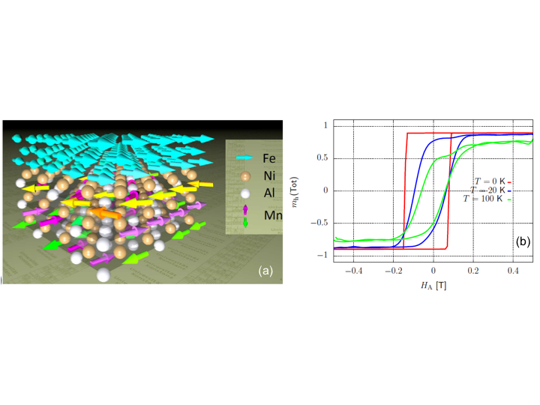

Fig. 11 (a) Sketch of the magnetic state after field-cooling for a Ni2MnAl (*B*2-II)/Fe interface. (b) In-plane hysteresis loops of the Ni2MnAl (*B*2)/Fe bilayers at T=0; 20 and 100 K [58].

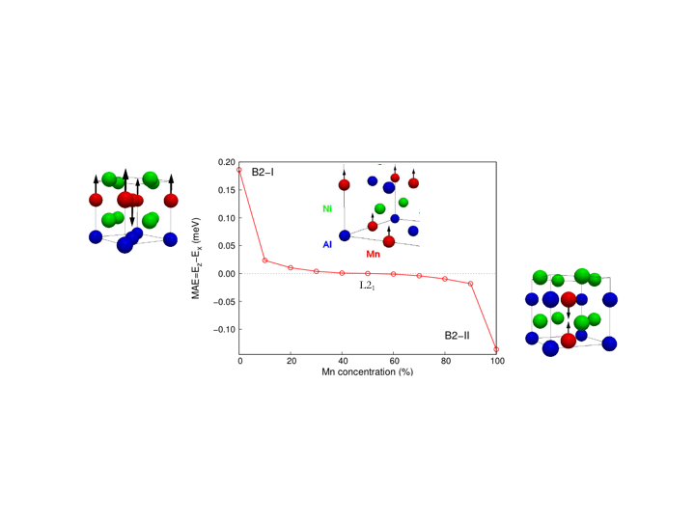

Fig. 12 MAE as a function of Mn concentrations in Ni2MnAl and the corresponding crystalline structures.

Table 4 Calculated MAE for Ni2MnAl with tetragonal lattice distortion.

|  |  |  |  |  |  |
| --- | --- | --- | --- | --- | --- |
|  | *c/a*=0.90 | *c/a*=0.95 | *c/a*=1.00 | *c/a*=1.05 | *c/a*=1.10 |
| MAE [meV] | 0.054 | 0.027 | 0.00 | -0.028 | -0.059 |

**3. Mn-based Heusler alloys**

As a Heusler alloy based with a transition metal with a high moment, Mn2VAl films have been grown onto MgO(001) single crystalline substrates. The superlattice diffraction of the (200) peak appears for the growth temperatures, *T*sub=500ºC and 600ºC. In addition, these samples exhibit the (111) superlattice diffraction in a pseudo-in-plane scan. These results indicate that the films are in the *L*21 phase for *T*sub≥500ºC. On the other hand, only the fundamental (400) diffraction appears for the other samples with *T*sub≤400ºC, suggesting that the films are in the *A*2 phase. SAED patterns are shown in Fig. 13 for *Ts*ub = 400ºC and 600ºC representing the *A*2 phase and *L*21 phase, respectively.

Figure 13 shows the *T*sub dependence of magnetisation values for Mn2VAl films measured at RT. The films exhibit saturation magnetisations of 190 and 220 emu/cm3 for *T*sub=500ºC and 600ºC, respectively. On the other hand, no FM (or FI) magnetic hysteresis loop appears for the other samples with the *A*2 phase, which suggests a possibility to be an AF or CF. The *T*sub dependence of the chemical phases and magnetization values are similar with those reported in a previous work [59]. By depositing the optimised Mn2VAl/Fe bilayer, *H*ex of 120 Oe at 10K has been measured [38], which decreases rapidly with increasing temperature but is maintained to be ~10 Oe at 200K. The corresponding <*T*B> has been estimated to be ~75K using the York protocol.

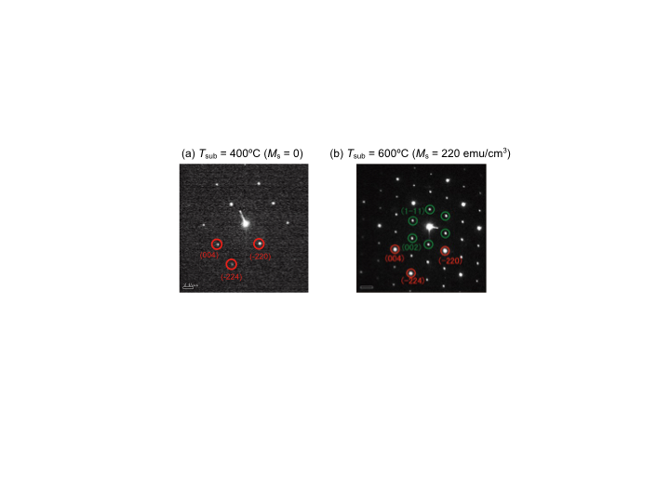

Fig. 13 SAED patterns of Mn2VAl films. (a) *T*sub=400ºC and (b) 600ºC.

PNR experiments has confirmed the presence of an AF phase at RT in a polycrystalline *A*2-ordered Mn2VAl bulk sample. The Mn2VAl sample show an AF peak at the (100) reflection of the *A*2 phase which disappears at around 500K on top of a broad nuclear reflection peak from the *L*21 phase [60]. From another set of neutron diffraction experiments on Mn2VAl epitaxial films, the film deposited at 400ºC is found to show AF *A*2 phase at RT, while those deposited at room temperature and 600ºC show *A*2 phase without AF ordering and *L*21 phase, respectively [38]. The corresponding magnetisation values as shown in Fig. 14 confirms the crystallisation of the AF (the growth temperature (*T*sub)<400ºC) and FI (*T*sub>400ºC).

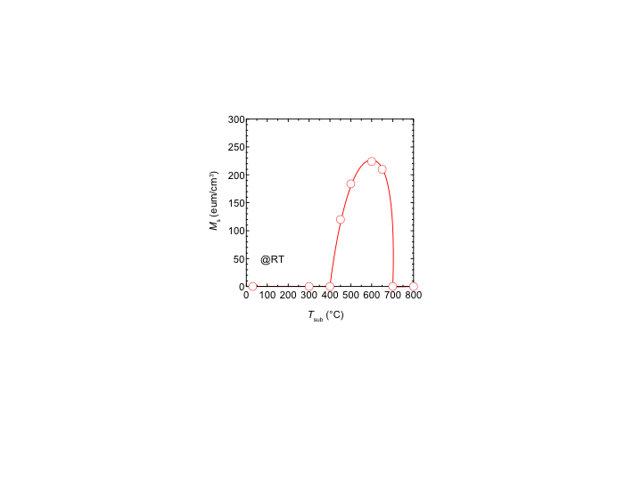

Fig. 14 Substrate temperature, *T*sub dependence of saturation magnetisation, *M*s for Mn2VAl films.

The ordered Mn2VAl alloy has a FI ground state with rather large V moments oriented opposite to the Mn moments. Here the strong antiparallel Mn-V couplings stabilise the FI state. In order to trace the effect of atomic disorder in the system, the *B*2 phase is calculated as shown in Fig. 15. Here, the AF coupling between in-plane first nearest neighbour Mn atoms is much weaker than those between out-of-plane Mn atoms, indicating the presence of out-of-plane anisotropy. The disorder between the V and Al atoms does not influence significantly the magnetic state as compared to the ordered *L*21 state. The fully disordered *A*2 phase is also studied as a random three-component alloy in terms of single site coherent potential approximation (CPA). The completely disordered *A*2 state is calculated to be non-magnetic at the same lattice constant as for the *L*21 phase. Only by increasing the lattice parameter by more than 8% a spontaneous FM state has been formed. The failure of obtaining an AF ground state (in fact, a magnetic ground state) at the experimental lattice constant indicates that magnetism collapses when a homogeneous atomic disorder is supposed like with the CPA and, most possibly, atomic short-range order (*e.g.*, clustering of Mn atoms) would stabilise the magnetic order in the system.

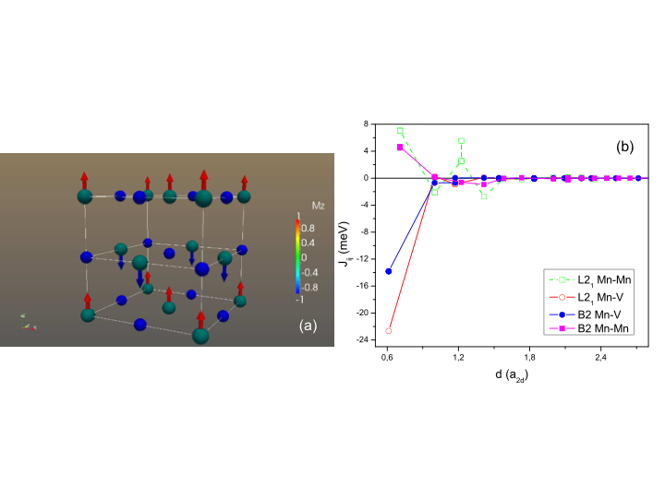

Fig. 15 (a) Sketch of the magnetic ground state of Mn2VAl (*L*21) bulk. (b) Calculated Mn-Mn and Mn-V exchange parameters for Mn2VAl as a function of the inter-atomic distance for the ordered *L*21 and the partially disordered *B*2 phases.

For the Mn-based Heusler alloys, off-stoichiometric compositions have also been investigated, which confirms the robustness of the Mn-based alloys against their atomic disorder. By taking two FI Heusler alloys, Mn3Ga and Mn2PtGa, their compensation point, Mn2.4Pt0.6Ga, has been calculated and demonstrated experimentally [45]. As shown in Fig. 16(a), a local FM domain can be exchange biased by a neighbouring AF domain within such compensated FI, inducing *H*ex of 33 kOe at 2K. In a similar system of Mn1.8FeGa, *H*ex is reported to survive to be ~300 Oe up to RT [see Fig. 16(b)].

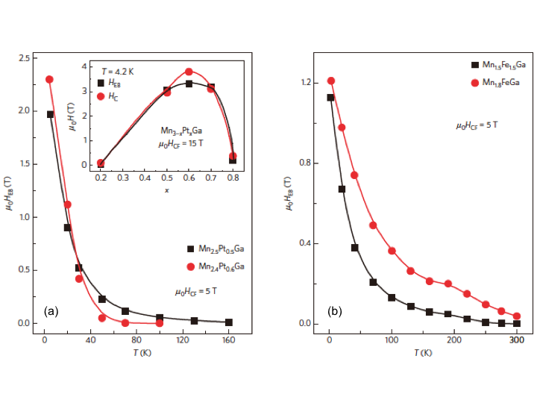

Fig. 16 (a) Temperature dependence of *H*ex for Mn2.4Pt0.6Ga and Mn2.5Pt0.5Ga. The inset shows the coercive field *H*C and *H*ex as a function of the Pt concentration *x* in Mn3-*x*Pt*x*Ga. (b) Temperature dependence of *H*ex for Mn1.5Fe1.5Ga and Mn1.8FeGa. The lines are guides to the eye [45].

By further substituting Y elements with Mn, binary Heusler alloys can be formed. One example is hexagonal Mn3Ge [44]. *H*ex of up to 520 Oe is measured at the boundaries between AF and FM domains as shown in Fig. 17. Similar off-stoichiometric AF Heusler alloys are reported as Fe2VAl and Cr2MnSb. Even though these results may not be directly compared with those for the AF/FM bilayers, these alloys may be used as new AF layers. A tetragonal Mn3Ga film has then been investigated to induce AF behaviour [40]. A bilayer of epitaxial Mn3Ga (10 nm)/Co0.9Fe0.1 (2.5 nm) is reported to show *H*ex of 1.5 kOe at RT. MAE and <*T*B> are estimated to be 3×106 erg/cm3 and ~400K, respectively. Recently, *H*ex of 430 Oe at 120K in polycrystalline Mn3Ga/Co0.6Fe0.4 bilayers, confirming the applicability of such binary Heusler alloys for the replacement of Ir-Mn.



Fig. 17 Variation of *H*ex with number of field cycles *n* measured at 2K. The line serves as a guide to the eye. The inset shows the training effect on the *M*(*H*) loops [44].

By further expanding the definition of the Heusler alloys to nitrides [32], MnN has been investigated. MnN films are grown using ultrahigh vacuum sputtering in N2 atmosphere to achieve Mn:N=1:1. A MnN/Fe bilayer has been reported to show *H*ex of 1.4 kOe at RT with <*T*B>=388K as shown in Fig. 18 [46]. This satisfies the requirements for the Ir-Mn replacement. However, the minimum thickness of MnN to induce the AF behaviour is 20 nm, which needs to be at least halved to be competitive against the 6-nm-thick Ir-Mn layer used in spintronic devices.

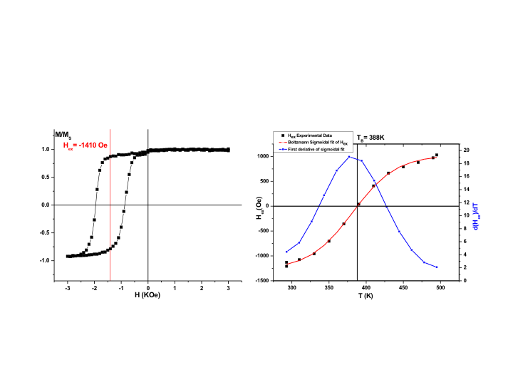

Fig. 18 (a) Hysteresis loops showing the reversal of exchange bias of MnN/Fe sample. (b) *H*ex obtained for MnN in a reversed cooling experiment as a function of temperature.

Therefore, high-moment-metal-based Heusler alloys display AF behaviour possibly due to the clustering of the high-moment metals even in their disordered *A*2 phase. MAE is demonstrated to be increased by introducing tetragonal distortion into the unit cell of the alloys. Further engineering in distortion and AF domain size can increase <*T*B> and *H*ex of these alloys, allowing the replacement for Ir-Mn alloys used in spintronic devices.

**IV. Conclusion**

Ru2YZ, Ni2YZ and Mn2YZ Heusler alloys have been found to exhibit AF behaviour in their *L*21, *B*2 and *A*2 crystalline ordering phases. By attaching a FM Fe layer to these AF layers, *H*ex of up to 600 Oe at 100K, 90 Oe at 100K and 30 Oe at 100K for Ru2MnGe, Ni2MnAl and Mn2VAl, respectively. Mn2VAl is found to maintain its AF properties at RT. These differences are found to be induced by the AF alignment of spin moments at the Y site in unique ordering phases. In the ordered *L*21 type Ru2MnZ (Z = Si, Ge, Sn or Sb), the complex AF ordering (2nd type) is a consequence of the frustrated exchange interaction between the Mn atoms. It is concluded that *T*N sharply depends on the Z element and that *T*N in Ru2MnGe can be increased by avoiding the disorder in the Mn-Z sub-lattice. For Ni2MnAl, the (checkerboard-like) AF order only exists in the chemically disordered *B*2 phase due to the large AF nearest neighbour Mn-Mn interaction. Decreasing the atomic disorder in the Mn-Al sublattice leads to non-zero total magnetisation (ferrimagnet). Moreover, the excess of Mn or Ni does not improve the quality of the AF state. From the device application point of view, Mn-based AF Heusler alloys are ideal due to their robustness against atomic disordering, especially at the interfaces against their neighbouring layers. These findings are useful for future implementation to replace iridium alloys in spintronic devices from their sustainability points of view.

**Acknowledgements**

The authors would like to thank Dr Asaya Fujita of AIST for fruitful discussion. This work was part-funded through a project, HARFIR (Heusler alloy replacement for Iridium), by the European Commission under the 7th Framework Programme (FP7-NMP-2013-EU-Japan, Grant Agreement No: NMP3-SL-2013-604398) and by the Japan Science and Technology Agency through its Strategic International Collaborative Research Program. A.H, G.V.F. and K.O.G. would also like to thank financial support from the UK EPSRC (EP/M02458X/1), while E.S. and L.S. acknowledges the support of the National Research, Development and Innovation Office of Hungary (Project No. K115575).

**References**

1. 2014 Communication on the review of the list of critical raw materials for the EU and the implementation of the Raw Materials Initiative (https://ec.europa.eu/growth/sectors/raw-materials/specific-interest/critical_en).
2. http://www.matthey.com/
3. http://www.platinum.matthey.com/documents/new-item/pgm%20market%20reports/pgm-market-report-may-2016.pdf
4. http://www.infomine.com/investment/metal-prices/iridium/all/
5. M. A. Baldo *et al.*, *Appl. Phys. Lett.* **75**, 4 (1999).
6. H. Konno, *Tech. Chem. Times*, **199**, 13 (2006).
7. H. Uoyama *et al.*, *Nature* **492**, 234 (2012).
8. Sumitomo Mining, *Japanese Patent* (2010-132144).
9. L. Néel, *Annales de Physique* **3**, 137 (1948).
10. C. G. Shull and J. S. Smart, *Phys. Rev.* **76**, 1256 (1949).
11. P. W. Anderson, *Phys. Rev.* **79**, 350 (1950).
12. W. H. Meiklejohn and C. P. Bean, *Phys. Rev.* **105**, 904 (1957).
13. R. E. Fontana, Jr. *et al.*, *US Patent* 5,701,223 (1997).
14. T. Jungwirth *et al.*, *Nature Nanotech.* **11**, 231 (2016).
15. T. Jungwirth *et al.*, *Phys. Rev. B* **83**, 035321 (2011).
16. F. Máca *et al.*, *J. Magn. Magn. Mater.* **324**, 1606 (2012).
17. S. Chikazumi, *Physics of Ferromagnetism* (Clarendon Press, Oxford, 1997), pp. 134-159.
18. D. Mauri *et al.*, *J. Appl. Phys.* **62**, 3047 (1987).
19. A. P. Malozemoff, *Phys. Rev. B* **35**, 3679 (1987); *ibid.* **37**, 7673 (1988).
20. N.C. Koon, *Phys. Rev. Lett.* **78**, 4865 (1997).
21. U. Nowak *et al.*, *Phys. Rev. B* **66**, 014430 (2002).
22. E. Fulcomer and S. H. Charap, *J. Appl. Phys.* **43**, 4190 (1972).
23. K. O'Grady *et al.*, *J. Magn. Magn. Mater.* **322**, 883 (2010).
24. K. Fukamichi, *Antiferromagnets* (Kyoritsu, Tokyo, 2014).
25. T. Tsuchiya *et al.*, *J. Phys. D: Appl. Phys.* **49**, 235001 (2016).
26. B. T. Thole *et al.*, *Phys. Rev. Lett.* **55**, 2086 (1985).
27. D. Alders *et al.*, *Phys. Rev. B* **57**, 11623 (1998).
28. T. Kinoshita *et al.*, *J. Phys. Soc. Jpn.* **73**, 2932 (2004).
29. J. A. C. Bland and B. Heinrich (*Eds.*), *Ultrathin Magnetic Structures I* (Springer, Berlin, 1994), pp. 305-343.
30. S. Singh *et al.*, *Nature Commun.* **7**, 12671 (2016).
31. J. Kübler, private communications.
32. S. Mizusaki *et al.*, *J. Alloys Comp.* **510**, 141 (2012).
33. J. Balluff *et al.*, *J. Appl. Phys.* **118**, 243907 (2016).
34. S. Khmelevskyi *et al.*, *Phys. Rev. B* **91**, 094432 (2015).
35. M. Acet *et al.*, *J. Appl. Phys.* **92**, 3867 (2002).
36. I. Galanakis *et al.*, *Appl. Phys. Lett.* **98**, 102514 (2011).
37. R. Yanes Díaz *et al.*, private communications.
38. T. Tsuchiya *et al.*, http://arxiv.org/abs/1707.06731.
39. H. Wu *et al.*, *J. Phys. D: Appl. Phys.* (in press).
40. E. Krén and G. Kádár, *Solid State Commun.* **8**, 1653 (1970).
41. H. Kurt *et al.*, *Appl. Phys. Lett.* **101**, 232402 (2012).
42. H. Wu *et al.*, *Appl. Phys. Lett. Mater.* (submitted).
43. G. Kadar and E. Kren, *Int. J. Magn.* **1**, 143 (1971).
44. J. F. Quian *et al.*, *J. Phys. D: Appl. Phys.* **47**, 305001 (2014).
45. A. K. Nayak *et al.*, *Nature Mater.* **14**, 679 (2015).
46. M. Meinert *et al.*, *Phys. Rev. B* **92**, 144408 (2015).
47. D. J. Singh and I. Mazin, *Phys. Rev. B* **57**, 14352 (1998).
48. T. Huminiuc *et al.* (in preparation).
49. I. Galanakis *et al.*, *Phys. Rev. B* **75**, 172404 (2007).
50. A. Hirohata *et al.*, *Curr. Opin. Solid State Mater Sci.* **10**, 93 (2006).
51. C. Felser and A. Hirohata (*Eds.*), *Heusler Alloys* (Springer, Berlin, 2016).
52. K. Endo, *J. Phys. Soc. Jpn.* **29**, 643 (1970).
53. R. A. Müller *et al.*, *Phys. Rev. B* **92**, 184432 (2015).
54. C. B. R. Jesus *et al.*, *Solid State Commun.* **177**, 95 (2014).
55. J. Y. Chen *et al.*, *Appl. Phys. Lett.* **104**, 152405 (2014).
56. R. Yanes Díaz *et al.*, Phys. Rev. Lett. **111**, 217202 (2013).
57. M. Takanashi and M. Tsunoda, *J. Phys. D: Appl. Phys.* **35**, 2365 (2002).
58. R. Yanes Díaz *et al.*, *Phys. Rev. B* (under review), http://arxiv.org/abs/1707.08651.
59. T. Kubota *et al*., *Appl. Phys. Lett.* **95**, 222503 (2009).
60. R. Y. Umetsu, private communications.