Developing a Value Framework: the Need to Reflect the Opportunity Costs of Funding Decisions

Mark Sculpher¹
Karl Claxton^{1,2}
Steven D. Pearson³

- Centre for Health Economics, University of York, York, UK
- Department of Economics, University of York, York, UK
- Institute for Clinical and Economic Review, Boston, USA

Concise summary
Economic evaluation, including value frameworks and multi-criteria decision analysis, needs to reflect an empirical estimate of opportunity costs to inform funding decisions appropriately.

Contact details: Mark Sculpher, mark.sculpher@york.ac.uk

Acknowledgements
Mark Sculpher receives funding from the National Institute for Health Research (NIHR) as a NIHR Senior Investigator. The Centre for Health Economics also receives funding from the NIHR for technology assessment reviews for the National Institute for Health and Care Excellence (NICE) and for the Policy Research Unit in Economic Evaluation of Health and Care (EEPRU). The views expressed in this paper, together with any errors, are those of the authors alone.

Abstract
A growing number of health care systems internationally use formal economic evaluation methods to support health care funding decisions. Recently, a range of organisations has been advocating forms of analysis that have been termed ‘value frameworks’. There has also been a push for analytical methods to reflect a fuller range of benefits of interventions through multi-criteria decision analysis. A key principle that is invariably neglected in current and proposed frameworks is the need to reflect evidence on the opportunity costs that face health systems when making funding decisions. The mechanisms by which opportunity costs are realised vary depending on the system’s financial arrangements, but they always mean that a decision to fund a specific intervention for a particular patient group has the potential to impose costs on others in terms of forgone benefits. These opportunity costs are rarely explicitly reflected in analysis to support decisions, but recent developments to quantify benefits forgone make more appropriate analyses feasible. Opportunity costs also need to be reflected in decisions if a broader range of attributes of benefit is considered, and opportunity costs are a key consideration in determining the appropriate level of total expenditure in a system. The principles by which opportunity costs can be reflected in analysis are illustrated using the example of the proposed methods for value-based pricing in the UK.
Introduction
All health care systems face choices about the scale of health expenditure and how it should be spent, but these choices manifest themselves in different ways. Some systems, such as the UK National Health Service (NHS), are publically-funded so the resources available for health care is a choice, made by government, mediated through a social democratic process. In other systems, which have a substantial privately-funded component, this choice is mediated in a number of ways: by clinicians and patients choosing interventions at the point of care, insurers constructing and pricing benefits packages and citizens choosing between alternative packages offering different benefits and costs.
In all cases, judgements about whether health expenditure is too low or too high requires some assessment of the amount of benefit that a health care system currently delivers with more or less resources; that is, a ‘supply-side’ evidence-based assessment of opportunity costs given actual levels of expenditure. Whether current levels of expenditure are considered appropriate requires a comparison of these opportunity costs (the supply-side) with a view of what the social value of the benefits of health care relative to other consumption opportunities ought to be (the demand-side).
An assessment of opportunity costs is also important when considering how these resources should be spent. For example, whether a new technology ought to be approved for use in a publically-funded system or added to a benefits package in a privately-funded one, a common assessment is needed: whether the improvement in benefits the new technology offers exceeds the improvement that would have been possible if the additional resources required had, instead, been made available for other health care activities. This assessment is required whether or not the additional costs of the technology must be found from existing commitments or whether additional health care resources would be made available to accommodate them.
Internationally, various health systems have established arrangements to provide analysis to support funding decisions, particularly relating to new technologies. Some countries make economic evaluation an explicit part of their recommended analytical methods – e.g. the UK, Canada and Australia [1],[2] [3]. Although this can be broadly defined as a formal assessment of the incremental costs and benefits of new interventions, there remains variation in recommended methods and their implementation. Some countries, such in the USA, have rejected this approach, but the challenge of how to provide evidence and analysis to guide inescapable funding decisions remains. New approaches have been advocated to fill the vacuum including multi-criteria decision making (MCDA) to replace more ‘standard’ methods [4]. Several organisations, mainly in the USA [5], have proposed ‘value frameworks’ to bring together information on a range of benefits, disbenefits and costs, either to inform individual decisions by patients and clinicians or to guide population-level decisions on coverage and pricing for new interventions.
The analytical frameworks that are currently employed internationally to support population- level funding decisions, as well as those proposed as adjuncts or alternatives to conventional methods, currently ignore the key consideration of an empirical assessment of opportunity costs. The National Institute for Health and Care Excellence (NICE) in the UK is one organisation that accepts the importance of opportunity cost in principle, and seeks to reflect this (in part at least) in its cost-effectiveness threshold [1], but has been criticised for not basing this on empirical evidence [6]. This paper argues that, without such an empirical assessment, there is inadequate support for funding decisions and for establishing an appropriate level of overall expenditure.
Opportunity costs
Key principles
Whenever funding decisions are taken by health care systems, opportunity costs are inevitably incurred. In systems where demand-side decisions regarding overall levels of expenditure are taken by government, supply-side decisions are required regarding, for example, whether to devote additional funding to a new intervention that is more costly than standard care for a particular patient group. Here, the relevant opportunity costs are incurred as a result of interventions for other patients being displaced to release financial resources for the new intervention, resulting in forgone benefits. There is often no explicit consideration of which services might need to be displaced to generate the funds to pay for the new intervention. For example, when the programme of technology appraisal at NICE recommends a new, more costly, technology it does not offer any guidance to the NHS regarding which interventions should be removed, delayed or down-scaled to generate the necessary funding.
Evidence and analysis to guide this type of decision requires empirical evidence on the relationship between changes in overall health system expenditure and changes in the relevant measure of benefit. This estimate of the system’s marginal productivity is the best measure of what is given up as financial resources are drawn away from other services. It also provides a means of estimating the benefits generated as a result of funding a new intervention that costs less than standard care. The demand-side decision of whether to increase total expenditure also needs to be informed by an empirical estimate of opportunity cost. Some information about how individuals are willing to forgo consumption for gains in health (willingness to pay) may inform this decision [7] although this is problematic [8], but knowledge of the benefits the system would generate with higher or lower expenditure provides key information to inform decisions about overall expenditure.
Some health care systems operate under different financial arrangements. In the USA, for example, it may be possible for an insurer to draw on additional resources through, for example, higher insurance premiums from patients or their employers. Here decisions about whether to fund a specific new intervention may be taken in the knowledge that additional resources will be made available without displacement of other health care services. In effect, demand- and supply-side decisions are being taken simultaneously: whether to fund a specific intervention and whether to make additional financial resources available to the system. In systems with these characteristics, however, opportunity costs remain entirely relevant to the analyses that inform these decisions. Unless the system has funded every intervention offering a marginal benefit over the appropriate standard of care for everyone, which would seem unlikely, there will be other options for the use of the additional funding that could generate benefits, and these represent opportunity costs which should be taken into account.
Again, these opportunity costs are appropriately estimated in terms of how the system translates changes in resources into changes in benefit. This would inevitably reflect the system’s current levels of productivity, which may be negatively affected by waste and inefficiency. Opportunity cost estimates can, therefore, change if inefficiencies are addressed; they can also vary over time in the face of changes in prices. In some systems, estimates would also need to reflect the impact of decisions to fund more expensive interventions on the costs patients incur through, for example, copayments and deductibles, and on levels of insurance premiums [8]. Externalising costs in this way can be expected to influence patients’ access and adherence to health care and to result in negative health effects which are opportunity costs of funding decisions.
By being explicit about opportunity costs, the concept of value (or ‘cost-effectiveness’) is brought together with that of affordability. To say that an intervention is cost-effective but not affordable must mean that the criteria used to judge cost-effectiveness does not reflect the scale and value of the opportunity costs. Fully reflecting these requires an assessment of the profile of total incremental cost in each period, how the opportunity costs of marginal changes in health expenditure are likely to evolve over this time profile and an appropriate discount rate to apply to opportunity costs occurring in each period. In addition, some assessment of how the expected health opportunity cost is likely to vary with the scale of the total incremental costs in each period is also required (i.e. the effect of non-marginal expenditure impacts) [9].
Reflecting opportunity costs analytically
The analytical requirements for reflecting opportunity costs are illustrated in the three parts of Figure 1, each of which shows a new intervention compared to standard care, with the latter located at the origin. The new intervention is more costly but also generates 2000 units of additional benefit in the relevant patient population. Opportunity costs are represented in terms of the diagonal dotted line through the origin, and here each additional $20,000 of cost for the new technology imposes 1 unit of forgone benefit. This can be seen as the benefits associated with either interventions displaced when $20,000 is imposed on the system, or not funding other potential options with that $20,000.
In Figure 1a the additional cost of the new intervention is $20 million, which represents $10,000 per additional unit of benefit generated by the new intervention compared to existing care, which is less than the opportunity cost ($20,000 per unit of benefit). This shows that, at this additional cost, the intervention offers a positive net benefit of 1000 units of benefit: it generates 2000 units in indicated patients but it incurs 1000 units as opportunity costs due to its $20 million additional cost. In Figure 1b, the new intervention imposes a higher additional cost of $40 million, perhaps due to a higher price. The opportunity costs imposed on other patients are, therefore, greater (2000 units ($40 million/20,000)), generating a zero net benefit. In Figure 1c, the additional cost of the new intervention is higher still, $80 million. Consequently, opportunity costs are now 3000 units of benefit ($60 million/$20,000), the net benefit of the new investment is negative (-1000) and a positive funding decision for the new intervention would reduce overall population benefits.
This analysis is consistent with the use of incremental cost-effectiveness ratios and cost-effectiveness thresholds [8]. However, as well as net benefits being more intuitive and analytically tractable [10], the term ‘threshold’ is a source of confusion as it has been used to reflect a range of considerations other than opportunity costs including demand side willingness to pay and funding aspirations [11].

Quantifying benefits and opportunity costs
Health effects
The effects of interventions that are considered benefits (and disbenefits) and how these are quantified is fundamental to analysis to support decisions. What is included in a benefit measure is ultimately a value judgement, and depends on what effects are considered to represent aspects of social value [8, 12]. However, the effects on individuals’ health are likely to be a central to any definition of the benefit of health care. Health measurement needs some key characteristics when used in a framework to inform funding decisions [13-15]. Two important considerations are worth emphasising. Firstly, despite the fact that health effects are inherently multi-dimensional, including impacts on survival duration and multiple aspects of health-related quality of life (HRQoL), funding decisions need to determine the magnitude of overall health effects, and whether they are positive or negative. Therefore, a single-dimensional measure of health is essential. A second consideration is the need to support decisions across diseases and health conditions implying a generic measure of health [16].
These considerations explain why the quality-adjusted life-year (QALY) is widely used in economic evaluation. The QALY remains controversial, as would any measure of health that explicitly trades-off different dimensions of health. Some analytical frameworks eschew such single-dimensional and generic health measures in favour of a range of separate clinical and, in some cases, HRQoL metrics. This leaves decision makers to make the necessary trade-offs between different aspects of health. The issue is, therefore, whether a measure such as the QALY, based on an explicit characterisation of health and the preferences of relevant individuals, provides more appropriate support to decisions than leaving decision makers to establish their own trade-offs implicitly, with likely overlap and double-counting and without transparency.
Health opportunity costs
Any analytical framework focussing on health benefits needs an evidence-based estimate of opportunity costs using the same measure [17]. Some authors have sought to do this by looking at the types of interventions that are invested in or displaced following increases or decreases in available resources [18-20]. There are several problems with this approach including establishing the full range of funding options that have been considered as a consequence of a change in overall funding and finding relevant evidence on their costs and health effects.
In contrast, an emerging area of research has generated estimates of health opportunity costs using the relationship between changes in health expenditure and health outcomes (marginal productivity) [20, 21]. There is a significant empirical literature on the expenditure-health outcomes relationship [22-24], and earlier work in the UK [25] provided the foundation for estimates of health opportunity costs in the NHS [20]. As well as generating an estimate of health opportunity cost in terms of QALYs (central estimate of one QALY gained (lost) per additional (reduced) £12,936 expenditure), it also indicates how those opportunity costs are made up, including the type of health effects and where these are likely to occur (e.g. which disease areas) [8, 20].
Table 1 illustrates how these estimates can be used to inform decisions based on the example of NICE’s appraisal of ranibizumab for macular oedema [8, 26]. The appraisal estimated an additional cost of ranibizumab of £80.6 million per annum (prior to commercial in confidence discounts), and improvements in patients’ HRQoL equivalent to 3225 QALYs gained. Based on the UK estimates of health opportunity costs, it is possible to quantify the health that would be forgone as a result of the additional cost of the product: 411 premature deaths, equivalent to 1864 life-years lost, and 6184 QALYs. In terms of net health benefit, therefore, funding ranibizumab at its initial price would have led to a reduction in population health of 2959 QALYs.
Extending benefits
Informing deliberative decision-making
Inevitably decision makers may want to consider more than the net health benefit of an intervention. Key additional considerations may, for example, be the characteristics of the relevant disease, such as its burden or severity, or the characteristics of relevant patients such as the impact of their health gain on their net productivity. Specifying how these other attributes might be traded-off against gains in health to provide a unidimensional measure of benefit to inform decisions is difficult [27]. Furthermore, if the measure of benefit used in formal analysis is expanded to include additional attributes, so too must the measure of opportunity cost.
Given these challenges, wider attributes of benefit considered relevant to decisions may not be formally incorporated into analysis [28]. The type of net health benefit analysis illustrated in Table 1 can, however, provide a starting point for the deliberations needed in all decision making contexts. For example, it may be the case that the burden of disease associated with macular oedema is considered so significant, that decision makers would fund ranibizumab despite its expected negative net health benefits. Such a decision would require some difficult judgements. Firstly, that the burden associated with macular oedema is greater than that characterising the diseases of patients who would forgo health benefits because of the additional cost of ranibizumab. If so, the second judgement would be that this positive effect on burden was sufficient in magnitude to justify the negative net health benefit of 2959 QALYs – i.e. that the trade-off between health gain and reduction in burden from funding ranibizumab is acceptable.
Reflecting additional attributes analytically
If the additional attributes of benefit are considered potentially relevant to a large proportion of decisions, there may be a strong case for their being formally reflected in the analytical framework to support explicit and transparent decision making. Any such framework would need the same features as when health is the sole concern: a unidimensional scale with explicit trade-offs between health outcomes and the additional attributes; and for opportunity costs to be estimated using the same measure of benefit. Although there are studies that have used preference information to establish how individuals trade-off health with various equity attributes such as disease burden and short life expectancy [29, 30], there are, as yet, few examples of where this has been implemented in analysis to guide decisions.
A broader concept of benefit than health gain alone was envisaged as part of the proposed value-based pricing (VBP) reforms in the UK [31], bringing in burden of disease and wider social benefits. Furthermore, research was undertaken with a view to expanding the type of analysis that could be used to support NICE decisions under VBP. This research and NICE proposals for VBP are detailed elsewhere [8, 17, 32, 33]; here key analytical steps are described to illustrate what would be needed for an extended measure of benefit. As part of VBP and NICE’s proposals [17, 33], disease burden was characterised as the expected prospective health loss resulting from a given disease: the difference in future QALYs between the general population and those with the disease matched by age and gender, expressed in absolute terms (absolute shortfall) or as a proportion of the remaining QALYs of those without the disease (proportional shortfall) [34]. Government proposals for VBP conceptualised and estimated wider social benefits in terms of the value of individuals’ formal and informal productive activities net of the value of their consumption of formal and informal care, private consumption and government services [17]. As with all attributes of benefit, how these were specified and quantified was controversial. In particular, the impact of age on estimates of burden and wider social benefits raises particular challenges in achieving agreement about specification.
As part of the research supporting VBP, disease burden and wider social benefits were incorporated into the NHS estimates of health opportunity cost [17]. For example, the absolute shortfall estimates of the burden for liver cancer and influenza were 10.7 and 0.19 QALYs, respectively. The wider social benefits associated with the average QALY gain in health for rheumatoid arthritis and pancreatic cancer were estimated to be £30,034 and -£53,860, respectively. The negative estimate for pancreatic cancer reflected the fact that patients were net consumers (negative net production). It was also possible to calculate the expected burden of the diseases associated with the estimated health forgone resulting from the additional costs imposed by the average NICE decision: 2.07 QALYs for absolute shortfall. The estimated effect on wider social benefits resulting from the additional costs imposed by the average NICE decision was £11,611.
Table 2 shows how the analysis of net health benefit of ranibizumab detailed in Table 1 could be extended to include these additional attributes. Disease burden is expressed in terms of absolute shortfall and the table shows the expected burden of macula oedema (2.68 QALYs), and the burden of those diseases where health is expected to be forgone due to the £80.6 million additional annual cost of ranibizumab (2.07 QALYs). In effect, there is a small net gain in terms of burden associated with the use of ranibizumab, which means that the benefit of a QALY gained by the use of the treatment could be considered greater than a QALY forgone through opportunity costs. Decision makers would, therefore, need to assess whether this small net gain in terms of burden would be sufficient to justify the net loss of 2959 QALYs from the funding of ranibizumab. Work was undertaken to elicit the societal preferences of a representative sample of the UK public regarding trade-offs between characteristics including prospective burden of disease and QALYs gained [32]. Using discrete choice methods, the research suggested a modest preference for QALY gains from treating higher burden diseases, but this would be insufficient to overturn the negative net health benefit from ranibizumab.
Table 2 also details the impact of ranibizumab on wider social benefits (net production). It shows the health benefits associated with the product would generate positive net production worth £88.4 million, but that the health opportunity costs resulting from ranibizumab’s £80.6 million additional cost would result in a reduction in net production valued at £71.8 million, leaving a positive net effect of £16.6 million. Again, decision makers would need to consider whether funding ranibizumab could be justified by the positive impact on net production despite the negative net health effect of the product given its additional cost. This could be informed by surveys of how the public trades-off gains in health against consumption costs. For the net QALY loss resulting from the funding of ranibizumab to be justified in terms of net gains in production, a QALY would need to be valued at less than £541 in terms of forgone consumption, which is unlikely based on existing evidence [35].
Conclusions
The methods of economic evaluation that have been used in some health systems, as well as MCDA and recently proposed value frameworks, have generally failed to incorporate appropriate empirical estimates of opportunity cost. Much debate has centred on what constitutes a relevant measure of benefit from interventions. However, whatever it includes, supporting specific funding decisions analytically requires an estimate of the magnitude of the benefits that could be generated from other options with the same funding. A measure of opportunity cost is needed in systems with centrally allocated budgets with limited flexibility in levels of overall expenditure. But also in systems, such as those in the USA, where overall resources can be expanded through, for example, increases in insurance premiums and deductibles. Furthermore, as well as being a key element in supply-side decisions on how to allocate existing resources to alternative interventions, understanding opportunity costs is necessary to inform demand-side decisions about what the appropriate level of overall expenditure.
Table 1: Quantifying net benefit in terms of health outcomes. Example of ranibizumab for diabetic macular oedema costing the NHS an additional £80.6 million per annum. Adapted from Drummond et al, 2015 [8].
Measure of benefit | Health gains from ranibizumab | Health opportunity costs | Net health benefits
Deaths | 0 | -411 | -411
Life-years | 0 | -1864 | -1864
Quality-adjusted-life-years | 3225 | -6184 | -2959
Table 2: Quantifying net benefit in terms of health outcomes, disease burden and wider social benefits. Example of ranibizumab for diabetic macular oedema costing the NHS an additional £80.6 million per annum. Adapted from Drummond et al, 2015 [8].
Measure of benefit | Benefits from ranibizumab | Opportunity costs | Net benefits
Health benefit (QALYs) | 3225 | -6184 | -2959
Disease burden – absolute shortfall in QALYs | 2.68 | 2.07 | 0.61
Wider social benefits | £88.4 million | -£71.8 million | £16.6 million

Figure 1. Estimating the net benefit of a new intervention against standard care. Fig 1a shows a positive net benefit; Fig 1b a zero net benefit; and Fig 1c a negative net benefit
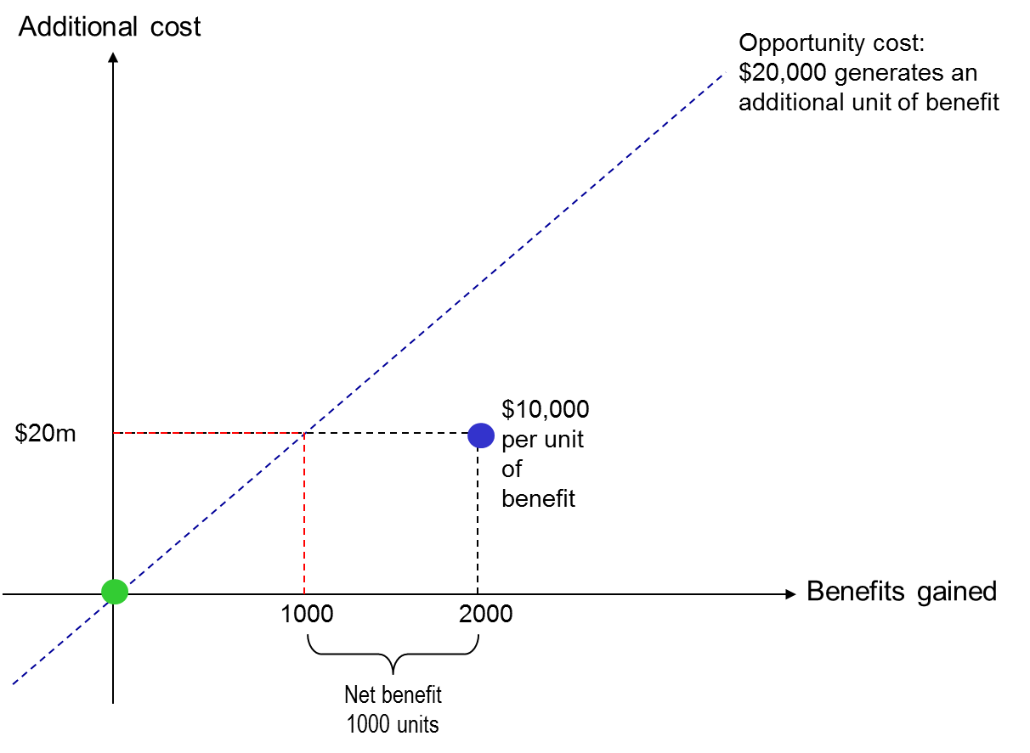a
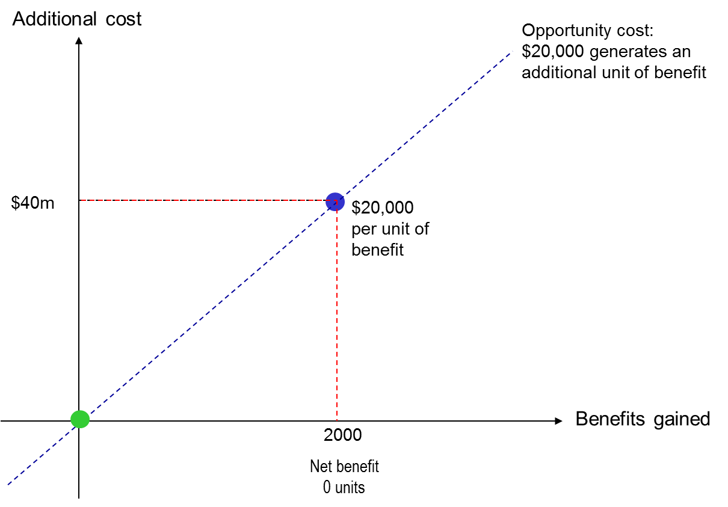b
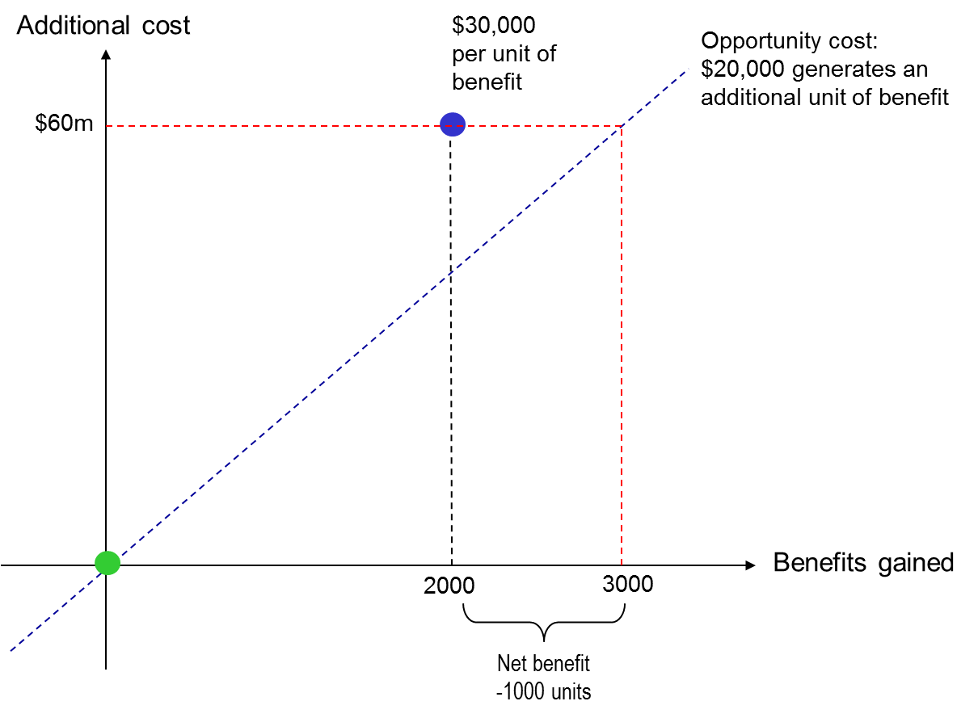c
References
1. National Institute for Health and Care Excellence. Guide to the Methods of Technology Appraisal. London: NICE; 2013.
2. Canadian Agency for Drugs and Technologies in Health (CADTH). Guidelines for the Economic Evaluation of Health Technologies: Canada (3rd edition). Ottawa, Canada: CADTH; 2006.
3. Australian Government DoH. Guidelines for preparing submissions to the Pharmaceutical Benefits Advisory Committee. Version 4.5. Canberra: Commonwealth of Australia; 2015.
4. Goetghebeur GM, Wagner M, Khoury H, Levitt RJ, Erickson LJ, Rindress D. Bridging health technology assessment (HTA) and efficient health care decision making with multicriteria decision analysis (MCDA): applying the EVIDEM framework to medicines appraisal. Medical Decision Making. 2012;32:376-88.
5. Neuman PJ, Cohen JT. Measuring the value of prescription drugs. New England Journal of Medicine. 2015;373:2295-7.
6. House of Commons Health Committee. National Institute for Health and Clinical Excellence: First report of the Health Committee 2007-2008. HC27-I. . London: Stationery Office; 2008.
7. Neumann PJ, Sanders GD, Russell LB, Siegel JE, Ganiats TG. Cost-Effectiveness in Health and Medicine. Oxford: Oxford University Press; in press.
8. Drummond MF, Sculpher MJ, Claxton K, Torrance GW, Stoddart GL. Methods for the Economic Evaluation of Health Care Programmes. 4th ed. Oxford: Oxford University Press; 2015.
9. Lomas J, Soares M, K. C. Cost-effective but unaffordable' paradox: estimating cost-effectiveness thresholds when changes in expenditure are non-marginal. Paper presented at the UK Health Economics Study Group meeting, Manchester, January. Centre for Health Economics, University of York, UK: Centre for Health Economics; 2016.
10. Stinnett A, Mullahy J. Net health benefits: a new framework for the analysis of uncertainty in cost-effectiveness analyses. Medical Decision Making. 1998 1998///;18:S68-S80.
11. Woods B, Revill P, Sculpher M, K. C. Country-level cost-effectiveness thresholds: initial estimates and the need for further research. Value in Health. In press.
12. Brouwer WBF, Koopmanschap MA. On the economic foundations of CEA. Ladies and gentlemen, take your positions! Journal of Health Economics. 2000;19:439-59.
13. Brazier J, Ratcliffe J, Solomon J, Tsuchiya A. Measuring and Valuing Health Benefits for Economic Evaluation. Oxford: OUP; 2007.
14. Patrick DL, Erickson P. Health Status and Health Policy. Allocating Resources to Health Care. New York: Oxford University Press; 1993.
15. Torrance GW. Measurement of health state utilities for economic appraisal - a review. Journal of Health Economics. 1986 1986;5:1-30.
16. Longworth L, Yang Y, Young T, Mulhern B, Hernández AM, Mukuria C, et al. Use of generic and condition-specific measures of health-related quality of life in NICE decision-making: a systematic review, statistical modelling and survey. Health Technology Assessment. 2014;18(9):1-254.
17. Claxton K, Sculpher M, Palmer S, Culyer AJ. Causes for concern: is nice failing to uphold its responsibilities to all NHS patients? . Health Economics. 2015;24(1):1-7.
18. Karlsberg Schaffera S, Sussex J, Walker A. Local health care expenditure plans and their opportunity costs. Health Policy. 2015;119:1237–44.
19. Appleby J, Devlin N, Parkin D, Chalkidou K, Buxton MJ. Searching for cost effectiveness thresholds in the NHS. Health Policy. 2009;91:239-45.
20. Claxton K, Martin S, Soares M, Rice N, Spackman E, Hinde S, et al. Methods for the Estimation of the NICE Cost Effectiveness Threshold. Health Technol Assessment. 2015;19(14):503.
21. Vallejo-Torres L, García-Lorenzo B, Serrano-Aguilar P. Estimating a cost-effectiveness threshold for the Spanish NHS. Paper presented at the Spanish Health Economics Study Group. 2016.
22. Cochrane A, St Leger A, Moore SF. Health service ‘input’ and mortality ‘output’ in developed countries. Journal of Epidemiology and Community Health 1978;32:200–5.
23. Cremieux P, Ouellette P, Pilon C. Health care spending as determinants of health outcomes. Health Economics 1999;8:627–39.
24. Moreno-Serra R, Smith PC. Broader health coverage is good for the nation's health: evidence from country level panel data. Journal of the Royal Statistical Society: Series A (Statistics in Society). 2015;178:101-24.
25. Martin S, Rice N, Smith PC. Does health care spending improve health outcomes? Evidence from English programme budgeting data. Journal of Health Economics. 2008;27:826–42.
26. National Institute for Health and Care Excellence. Ranibizumab for the treatment of diabetic macular oedema (TA237). London: National Institute for Health and Care Excellence (NICE); 2011.
27. Wailoo AJ, Tsuchyia A, McCabe C. Weighting must wait: incorporating equity concerns into cost-effectiveness analysis may take longer than expected. Pharmacoeconomics. 2009;27:983-9.
28. Culyer AJ, Bombard Y. An equity framework for health technology assessments. Medical Decision Making. 2012;32:428-42.
29. Shah KK, Tsuchiya A, Wailloo A. Valuing health at the end of life: an empirical study of public preferences. European Journal of Health Economics. 2014;15:389–99.
30. Donaldson C, Baker R, Mason H, Jones-Lee M, Lancsar E, Wildman J, et al. The social value of a QALY: raising the bar or barring the raise? DOI: 10.1186/1472-6963-11-8. BMC Health Services Research. 2011;11(8).
31. Department of Health. A New Value-Based Approach to the Pricing of Branded Medicines - a Consultation. London Department of Health; 2010.
32. Rowen D, Brazier J, Mukuria C, Keetharuth A, Risa Hole A, Tsuchiya A, et al. Eliciting societal preferences for weighting QALYs for burden of illness and end of life. Medical Decision Making. 2016;36:210-22.
33. National Institute for Health and Care Excellence (NICE) Centre for Health Technology Evaluation. Value Based Assessment of Health Technologies. London: NICE; 2014.
34. van de Wetering EJ, Stolk EA, van Exel NJA, Brouwer WBF. Balancing equity and efficiency in the Dutch basic benefits package using the principle of proportional shortfall. The European Journal of Health Economics. 2013;14:107-15.
35. Ryen L, Svensson M. The willingness to pay for a quality-adjusted life year: a review of the empirical literature DOI: 10.1002/hec.3085. Health Economics. 2014.

