Supporting Information
Understanding the drivers of extensive plant damage in boreal and Arctic ecosystems: insights from field surveys in the aftermath of damage
by
Jarle W. Bjerke et al.

HEALTH STATES of arctic plants
Health states with associated contrasting leaf colours of Cassiope tetragona and Dryas octopetala are shown in Figs S1 and S2. Cassiope tetragona growing under variable microclimatic conditions is shown in Fig. S3. Damage ratios of three other species recorded in the field is shown in Fig. S4.

The 2014/15 winter at Spitsbergen
Time series of snow cover at Spitsbergen are short, starting in the 1970s, and lacking data from 1994 to 2008. However, available data from Svalbard Airport Longyearbyen suggest a declining trend of snow cover, and the winter of 2014/15 had an extremely shallow snow cover (Table S1a). Cumulative snow cover for January to May in 2015 was 21 cm-month, which is only 24 % of the average cumulative snow cover for the years with data between 1977 and 1993. Notably, February had extremely little snow with an average of 1 cm. Cumulative snow cover during the 2014/15 winter was closer to normal in Ny-Ålesund (Table S1b), but this was largely due to much fresh snow in late winter (March-May). Mean snow cover in January was 8 cm, which was only 33 % of average January snow cover for the available years between 1975 and 2014. The temperature evolution during the warm period in February 2015 is shown in Fig. S5.
Daily mean ground temperature in marked plots during the 2014/15 winter follow the fluctuations in air temperature to various extents. Until mid-January, the correlation between daily mean ground and air temperature was very strong for most sites at both transects (15-d windows, r > 0.9; Fig. 5). This strong correlation continued for some sites (e.g. MØR at the Ny-Ålesund transect and BOL at the Longyearbyen transect) until ca. 8 March, albeit with some fluctuation. At other sites (e.g. SMI at the Ny-Ålesund transect and HOT at the Longyearbyen transect), ground temperature fluctuations were more damped, and correlation with air temperature was mostly below 0.8. These comparisons with air temperature show that vegetation had no to very little protection from snow. Even if the snowpack of the Ny-Ålesund weather station was more than 20 cm deep from February onwards (Table S1), the ground temperature data from the Ny-Ålesund transect suggests that some sites had very little snow until mid-March (Fig. 5a). NAN and SMI, the two sites with the lowest correlation with air temperature from 15 January onwards, are both situated close to the foot of a steep hillside, and hence probably less wind-exposed than most other sites, something which led to more snow accumulation at these sites. However, even for these sites, correlation with air temperature was high (r > 0.7) during shorter periods in February and March (Fig. 5a), indicating that snow depth occasionally was reduced, thereby not insulating well.
The 2014/15 winter had high MPD_{sum} index values for both stations (Fig. 6a), being ranked as the fourth highest value in the Ny-Ålesund record and the fifth highest in the longer Longyearbyen record. Ground-ice also accumulated during the 2014/15 winter, both around Longyearbyen (Barstein 2015) and around Ny-Ålesund (Valt and Salvatori 2016). This is also evident from our own field observations in early June 2015 (Fig. S7), and from landscape photographs. For example, one photograph from 28 January shows that the area around Ny-Ålesund was covered in ground-ice (Duna 2016). A thaw event in the days before the photograph was taken reduced snow cover at the weather station from 6 cm to 0 cm, and this photograph shows that snow became icy in areas without complete thaw. Overall, this assembly of information strongly suggests that the 2014/15 winter had an anomalously shallow snow cover, much ground-ice accumulation and high number of days with thaw temperatures, probably being quite similar to the extreme 2011/12 winter, as reported on by Hansen et al. (2014) and van Pelt et al. (2016).

HEALTH STATES of vaccinium myrtillus
Shoots of Vaccinium myrtillus damaged by caterpillar-induced defoliation and winter frost-induced top wilting differ in morphology, as shown in Fig. S6.

the winter of 2013/14 in boreal norway
In the study area, from Nord-Trøndelag to Troms, the winter of 2013/14 was at first very wet (November in Table S2a) with temperatures only slightly above the norm (Table S2b), causing much of the precipitation to fall as snow, and leading to higher-than-normal snow depths for most of the stations (Table S2c). The wet weather continued in December (Table S2a), but with temperatures more than 2 degrees above normal (Table S2b). Despite the mild weather, temperatures were close to freezing, and this led to increasing snow depths at most stations (Table S2c). Snow accumulation was highest at the most northerly meteorological stations. Numerous stations experienced the driest January ever recorded (Kristiansen et al. 2014). Temperatures in January were close to normal (Table S2b). Snow depth decreased during January and were below 9 cm at most stations, which was 21 % or less of normal snow depth for this month (Table S2c). Snow cover maps retrievable at senorge.no show that the entire coastal lowland northwards to ca. 69.32° N was free of snow from 31 December 2013 to 15 March 2014, i.e. for 75 consecutive days in a period when these land areas normally are covered by snow. Much of this area was also free of snow for several weeks before and after this period.
February was from 3 to nearly 5 degrees warmer than the norm (Table S2b), and still quite dry with many stations receiving less than 50 % of the normal precipitation (Table S2a). The station Laukhella had the driest February month in a time series running from 1998, precipitation rates being only 38 % of the previous low record (Kristiansen et al. 2014). Precipitation mostly fell as rain on days with temperatures above freezing. This led to continued reduction of snow depth; monthly averages being close to 0 cm and 7 % or less of the norm for most stations, except for some of the most northerly stations (Table S2c). March was wet and mild. For ca. three continuous weeks (from ca. 22 February to 14 March), daily mean temperatures at most stations were above the daily normal, and also above freezing. During March, a few centimeters of snow accumulated at the southerly stations – still less than 25 % of the norm – while snow depth declined slightly at the most northerly stations to between 19 and 41 % of the norm (Table S2c). April was also mild and wet, leading to minor changes in snow depth. Consequently, all stations had the highest snow cover already in November or December, a situation not recorded for any of these stations previously. Daily mean temperatures were spring-like already from 2 February at most stations, only interrupted by short periods of colder weather.
The period from December to February as a whole was close to average in terms of MPD_{sum}. It is ranked as 74 of 146 winters in the long Tromsø weather station data series; the winter of 1890/91 having the highest index value (Fig. S8). However, very wet weather in December nullified the extreme dry weather in January and February. Thus, as a whole, December 2013-February 2014 was close to normal. This index is so far not calculated for single months, and not for other weather stations in coastal boreal Norway.

Photo credits
All photos presented in this document were taken by Jarle W. Bjerke, except photo in Fig. 1f, which was taken by Rachael Treharne.

supplementary figures and tables
Fig. S1. Health categories of Cassiope tetragona. (a) Completely dead patch with grey leaves and stems; (b) Detail showing dead, grey shoots; (c) recently dead patch with brown leaves (green leaves at this image are Salix polaris); (d) detail showing individual brown shoot apices and mostly grey basal leaves; (e) alive patch with leaves strongly violet-red due to accumulation of anthocyanins (intermixed with some grey and brown shoots); (f) detail showing strongly anthocyanin-coloured shoots intermixed with some green and grey shoots. Note colour of anthocyanin-rich shoots ranging from violet-burgundy at tips to orange-red towards base.
Fig. S2. Health categories of Dryas octopetala. (a) Completely dead mat with grey leaves only; (b) Detail of mostly dead mat, but with some surviving shoots at the more vertically-inclined edge of the mat; (c) partly dead mat with grey dead leaves, stressed anthocyanin-containing leaves with red and brown colours, and healthy, green leaves; (d) first stage of autumn yellowing, some leaves being completely yellow, others only yellow at the tips.
Fig. S3. Damage to Cassiope tetragona under variable microtopographic conditions. (a) Snowbed at foot of hill at Hamnerabben; (b) exposed ridge at Leirhaugen; (c) drainage channel in steep terrain in Endalen near Longyearbyen. Note the surviving, green shoots of Huperzia arctica in between the dead shoots of C. tetragona. The slope in the upper left corner of the image is slightly raised compared to the drainage channel, and there most shoots of C. tetragona were alive. Green leaves in lower left and lower right corners are Salix polaris.

Fig. S4. Damage ratio of Empetrum nigrum (black), Equisetum arvense ssp. boreale (white) and Saxifraga oppositifolia (grey) at Spitsbergen. Data for E. nigrum from Longyeardalen only, while data for the two other species are from sites both in the Longyearbyen area and Ny-Ålesund. Error bars are ± 1 SEM.
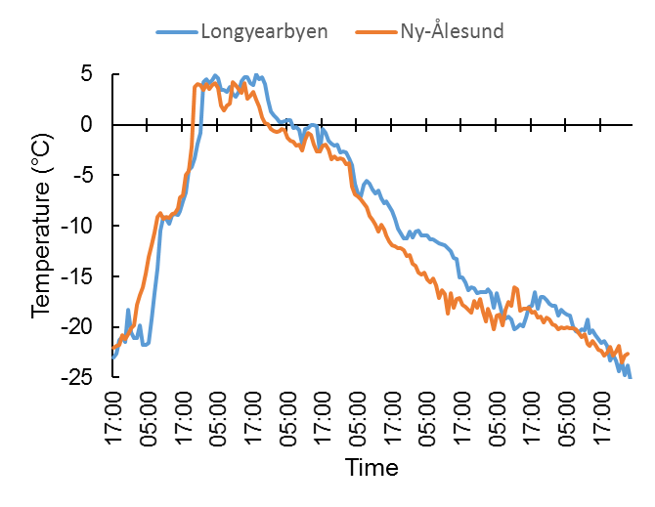
Fig. S5. Temperature development during an extreme freeze-thaw event at Spitsbergen in 2015 from 14 February 17:00 to 22 February 04:00.
Fig. S6. Types of damage to Vaccinium myrtillus detected in the field. Complete (a) and partial (b) leaf defoliation caused by larvae of Epirrita autmnata; note brown leaves that were not browsed completely, but were too damaged to sustain growth; (c) old (grey) and fresh (brown) frost drought-damaged shoots at a wind-exposed coastal site where snow is absent during long parts of winter; note that a few shoots survived; (d) frost drought damage to upper half of shoots, lower half survived due to partial snow protection during winter. Associated green plants are Cornus suecica and Avenella flexuosa (a), Agrostis capillaris (b and d), Empetrum nigrum (c and d), and V. vitis-idaea (c).

Fig. S7. Melting ice covering a mat of Dryas octopetala, Adventdalen, June 2015. The pale green dots are shoots of the moss Polytrichum juniperinum.

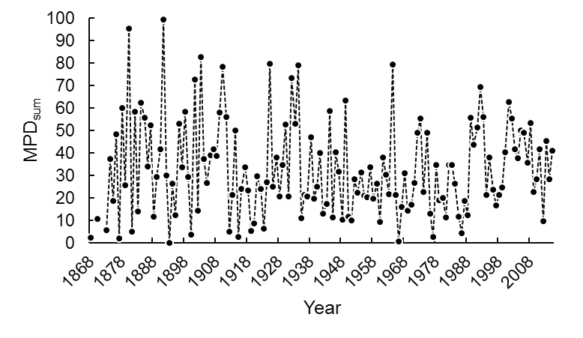
Fig. S8. Midwinter (December-February) values for the index precipitation sum for melt and precipitation days (MPD_{sum}) from Tromsø. Winters are denoted with the last year of the winter, e.g. “1868” represents the winter of 1867/68. Temperature records are lacking for some of the first years in the time series.

Table S1. Number of studied plots per district in boreal Norway.
District | Plot number
Flatanger | 142
Flakstad-Vesvågøy | 29
Vågan | 18
Vesterålen | 34
Troms | 9
Overall | 231

Table S2. Mean monthly snow depth (cm) at the weather stations Ny-Ålesund (a) and Svalbard Airport Longyearbyen (b) during the study period compared to previous periods. At Svalbard Airport, snow depth was measured from 1977 to 1993, and from 2009 onwards, but not from 1994 to 2008. At the Ny-Ålesund station, snow depth was measured in 1975, 1976 and 1979 (“1970s”), and from 2009 onwards. Cumulative snow depth has the unit cm-month referring to the sum of monthly means for the period from January to May.

- Ny-Ålesund | 1970s | 2009-2011 | 2012 | 2013 | 2014 | 2015
January | 29 | 24 | 13 | 10 | 47 | 8
February | 32 | 31 | 24 | 21 | 57 | 29
March | 43 | 46 | 25 | 26 | 95 | 34
April | 50 | 52 | 26 | 24 | 90 | 46
May | 31 | 43 | 20 | 22 | 90 | 42
Cumulative snow | 185 | 197 | 108 | 103 | 379 | 159

(b) Longyearbyen | 1977-1993 | 2009-2011 | 2012 | 2013 | 2014 | 2015
January | 13 | 12 | 5 | 18 | 7 | 5
February | 18 | 13 | 6 | 21 | 4 | 1
March | 22 | 16 | 6 | 19 | 9 | 4
April | 24 | 20 | 5 | 17 | 10 | 8
May | 12 | 7 | 6 | 9 | 5 | 3
Cumulative snow | 89 | 68 | 28 | 84 | 35 | 21

Table S3. Weather and snow data for the 2013/14 winter from selected lowland weather stations close to our study sites in mainland Norway. Municipality names with station names and altitude (m a.s.l.) in parentheses are given. Numbers refer to numbers in map in Fig. 2. (a) Precipitation sum; (b) temperature; (c) snow cover. Values are monthly means for snow cover and temperature. Values in parentheses are deviations from monthly normal values (1961-90) for precipitation and temperature and from monthly average snow cover for the period from 2000 to 2016. Deviations are expressed in percentage for snow depth and precipitation (100 = 2013/14 value identical to long-term value), and in degrees for temperature. NA = data not available. For some stations, data were lacking for a few days during the 2013/14 winter. Daily values for these days were estimated by using day-to-day variation in daily temperatures from nearby stations.

Table S3.
- Precipitation | Nov | Dec | Jan | Feb | Mar | Apr
1 Osen (Buholmråsa) | 157 (182) | 134 (149) | 7 (9) | 21 (33) | 85 (139) | 78 (139)
2 Bodø (Kjerringøy) | 172 (158) | 215 (179) | <1 (0) | 56 (71) | 119 (155) | 114 (178)
3 Hamarøy (Tømmerneset) | 238 (165) | 245 (139) | 1 (1) | 107 (85) | 235 (226) | 139 (172)
4 Moskenes (Reine) | 458 (148) | 383 (152) | 11 (4) | 131 (51) | 286 (125) | NA
5 Vestvågøy (Leknes) | 260 (184) | 173 (112) | 14 (10) | 98 (88) | 164 (167) | 155 (221)
6 Vågan (Kvitfossen) | 526 (185) | 345 (120) | 3 (1) | 177 (88) | 325 (145) | 374 (220)
7 Sortland (Sortland) | 250 (170) | 210 (147) | 4 (2) | 70 (59) | 250 (266) | 114 (137)
8 Øksnes (Alsvåg) | 254 (181) | 140 (99) | 2 (2) | 45 (39) | 169 (167) | 124 (142)
9 Andøy (Andøya) | 182 (167) | 110 (100) | <1 (1) | 47 (54) | 167 (211) | 105 (155)
10 Lenvik (Laukhella) | 127 (116) | 112 (101) | 5 (6) | 19 (21) | 177 (253) | 103 (171)
11 Tromsø (Langnes) | 149 (142) | 113 (108) | <1 (1) | 28 (32) | 151 (219) | 110 (180)
12 Karlsøy (Grunnfjord) | 120 (115) | 99 (90) | <1 (0) | 40 (45) | 115 (165) | 99 (164)

- Temperature | Nov | Dec | Jan | Feb | Mar | Apr
1 Osen (Buholmråsa) | NA | 4.7 (3.1) | NA | 4.4 (3.7) | 4.2 (2.3) | 5.6 (1.6)
13 Bodø (Helligvær) | 3.6 (1.1) | 3.1 (2.8) | -0.8 (0.0) | 3.2 (3.9) | 2.4 (1.9) | 4.0 (1.2)
14 Tysfjord (Drag) | 0.9 (NA) | 0.6 (NA) | -3.6 (NA) | 2.0 (NA) | 0.9 (NA) | 2.7 (NA)
15 Værøy (Værøy) | 4.0 (0.5) | 3.9 (2.4) | 1.1 (0.5) | 3.5 (3.0) | 3.0 (1.9) | 4 (1.5)
5 Vestvågøy (Leknes) | 2.0 (0.7) | 2.1 (2.8) | -1.5 (-0.1) | 2.2 (3.7) | 1.7 (2.5) | 3.2 (1.2)
16 Vågan (Svolvær) | 2.3 (0.6) | 2.0 (2.3) | -1.0 (0.1) | 2.4 (3.8) | 1.6 (2.2) | 3.0 (1.1)
7 Sortland (Sortland) | 1.2 (0.4) | 0.8 (2.2) | -2.6 (-0.3) | 1.5 (3.6) | 1.3 (2.3) | 2.8 (1.0)
8 Øksnes (Alsvåg) | 2.7 (NA) | 2.6 (NA) | -0.7 (NA) | 2.4 (NA) | 2.0 (NA) | 3.3 (NA)
9 Andøy (Andøya) | 1.2 (0.3) | 0.9 (2.1) | -2.5 (-0.4) | 1.2 (3.4) | 0.7 (2.1) | 2.5 (1.4)
17 Lenvik (Hekkingen) | 1.6 (0.6) | 1.3 (2.4) | -2.8 (-0.6) | 1.5 (3.6) | 1.0 (2.1) | 2.6 (1.0)
11 Tromsø (Langnes) | -0.2 (0.4) | -0.5 (2.2) | -5.9 (-2.1) | -0.1 (3.6) | -0.4 (1.9) | 1.3 (0.6)
18 Karlsøy (Torsvåg) | 1.9 (0.3) | 2.0 (2.3) | -0.5 (0.6) | 2.3 (3.5) | 0.9 (1.4) | 2.1 (0.7)

Table S3 continued
- Snow depth | Nov | Dec | Jan | Feb | Mar | Apr
19 Namsos (Otterøy) | 3.0 (114) | 4.0 (51) | 0 (0) | 0 (0) | 7 (43) | 0 (0)
2 Bodø (Kjerringøy) | 2.3 (110) | 7.3 (101) | 0 (0) | 0.1 (1) | 0.3 (4) | 0 (0)
3 Hamarøy (Tømmerneset) | 16.8 (259) | 15.1 (110) | 2.5 (11) | 0.3 (1) | 5.3 (16) | 3.7 (21)
4 Moskenes (Reine) | 2.5 (67) | 4.4 (35) | 0 (0) | 0 (0) | 1.8 (7) | 0 (0)
5 Vestvågøy (Leknes) | 3.5 (105) | 1.1 (12) | 0 (0) | 0 (0) | 3.7 (24) | 1.9 (34)
20 Vågan (Kongsmarka) | 13.5 (113) | 21.8 (111) | 8.2 (21) | 10.0 (16) | 12.2 (15) | 7.5 (11)
7 Sortland (Sortland) | NA | NA | 0.9 (NA) | 0.1 (NA) | 1.7 (NA) | 4.0 (NA)
8 Øksnes (Alsvåg) | 10.3 (194) | 7.3 (62) | 1.7 (8) | 0.3 (1) | 3.9 (16) | 3.5 (22)
10 Lenvik (Laukhella) | 16.9 (214) | 44.0 (308) | 39.1 (138) | 30.2 (66) | 10.5 (19) | 17.2 (37)
11 Tromsø (Langnes) | 2.9 (56) | 7.5 (88) | 0.8 (7) | 1.4 (7) | 4.4 (18) | 7.8 (71)
12 Karlsøy (Grunnfjord) | 8.2 (143) | 30.8 (231) | 23.0 (93) | 21.6 (68) | 13.4 (41) | 11.5 (46)

