Short-term response of testate amoebae to wildfire

Yangmin Qin^{1,2}*, Richard Payne^{3,4}, Yansheng Gu², Yuri Mazei^{4,5}, Yanxin Wang²

1. Department of Geography, School of Earth Science, China University of Geosciences, Wuhan 430074, China
2. State Key Laboratory of Biogeology and Environmental Geology, China University of Geosciences, Wuhan 430074, China
3. Environment, University of York, Heslington, York YO105DD, UK
4. Department of Zoology and Ecology, Penza State University, Krasnaya str. 40, 440026 Penza, Russia
5. M. V. Lomonosov Moscow State University, Leninskiegory 1, 119991, Moscow, Russia

*Corresponding author: E-mail : qinyangmin2005@163.com (Y. Qin)

Abstract

Many peatlands are exposed to intermittent burning but the implications of this burning for microbial communities have been little-studied. Here we consider the impacts of burning on the dominant protists of peatland ecosystems, the testate amoebae. To do this we used a ‘natural experiment’, a peatland exposed to wildfire where fire-fighting activity left a combination of unburned and heavily burned areas in close proximity. We assessed the change in testate amoebae three days after the end of the fire. We find that burning led to a large change in taxon composition, primarily noted by a shift from taxa with tests constructed of idiosomes to those constructed of xenosomes. The most likely explanation for this change is the direct destruction of mostly idiosome tests by extreme heat. Although we did not differentiate live individuals from empty tests it is probable that the fire led to a significant change in the testate amoeba community. This change may have interesting implications for the structure of microbial food webs, for biogenic silica cycling and for palaeoecological reconstruction in burned peatlands. This is clearly a topic which deserves more research attention.

Key words: testate amoebae, bioindicators, fire, idiosome, management

- Introduction
Natural fire is a complex process that plays an important role in terrestrial ecosystems as a driver of biodiversity (Williams et al., 2002; Andersen et al., 2005), soil carbon sequestration and stocks (Garnett et al., 2000; Turetsky et al., 2002), biogenic silica cycling (Unzué-Belmonte et al. 2016) and landscape heterogeneity (Turner et al., 1994). The impacts of fire on above-ground biodiversity are relatively well-understood (Gill, 1996), but impacts below ground have been much less studied (Ahlgren, 1974; Odion et al., 2004; Murphy et al., 2006). Palaeoecological records demonstrate that, despite high surface wetness, peatland ecosystems are exposed to wildfire with relative frequency (e.g. Kuhry, 1994) and in some regions peatlands are deliberately burned as a land management tool (Davies et al., 2008; Ward et al., 2007; Clifford and Booth, 2015).
A key group of soil protists in peatland ecosystems is the testate amoebae (TA) which constitute a large proportion of total microbial biomass and play an important functional role as microbial top predators (Gilbert et al., 1998; Wilkinson and Mitchell, 2010). There are reasons to suppose that fire might have important impacts on peatland TA community compositions but there is currently very little direct evidence (Turner and Swindles, 2012; Wanner, 2012).
It may be expected that burning would have an immediate negative effect on TA due to heat-induced mortality but long-term consequences may be more complex. In a New Zealand hill soil Stout (1961) found that the initial effect of wildfire was a partial sterilization of the soil but recovery in soil fauna was relatively rapid (>3 months) and top-soil protist diversity was actually increased by nutrient inputs. The impacts of burning are likely to be highly dependent on the heat and depth of burning which differ between managed, burning and wildfire (Davies et al., 2008; Ward et al., 2007; Clifford and Booth, 2015). In the context of managed burning showed that transient fire had little impact on soil TA abundance (Wanner and Xylander, 2003, Wanner, 2012). Soil micro fauna was found alive in the upper soil layers immediately after burning and the community remained relatively constant over post-fire periods up to 9-12 months. However, in a northern English moorland, Turner and Swindles (2012) showed considerable spatial variability which was partially explained by burning. Fire may also have indirect impacts on TA through impacts on hydrology, as shown by palaeoecological data (Marcisz et al., 2015).
Here we took advantage of an unusual fire event in a Chinese peatland to conduct a controlled study of the immediate impact of wildfire on TA assemblages. We hypothesized that the heat of burning would produce detectable impacts on TA assemblage through direct destruction of tests.

- Methods and materials

2.1 Sites, experiment design and sampling

The site for this study is a poor fen with a mean pH of 5.6, located near the middle reach of Nanwenghe River in northeastern China (Supplementary Figure 1). The vegetation in the fen is dominated by vascular plants including Carex sp., Sphagnum sp. and Phragmites australis, while Betula platyphylla dominates in forest located about 200 meters northwest from the fen.
It was extremely dry in northeast China from the end of spring to early summer 2012, which led to some intense wildfires. In June 2012 the site was subject to an intense fire which destroyed much of the surface vegetation. The fire was extinguished by a group from the Chinese army leaving the site divided between burned and unburned areas offering an ideal opportunity to study impacts on the soil biota. We sampled the site three days after the fire.
Our study consisted of two sub-components. In experiment 1 we considered the central area affected by the fire and extracted five samples in each of the burned and unburned areas (n=10). The boundary of burning reflects the point at which firefighters were able to control the fire, rather than any intrinsic difference in flammability. There is nothing to suggest any differences between unburned and burned areas prior to burning. In experiment 2, we considered the margin of the peatland where the wildfire left a mosaic of burned and unburned areas. Here we conducted paired sampling by selecting ten points each with a burned and an adjacent unburned spot (n=20).
In the field we collected about 50 g of the upper 2 cm of moss or peat which was sealed in plastic bags and refrigerated till analysis. A sub-sample of this sample (ca. 20 g) was used for testate amoeba analysis.

2.2 Laboratory analyses
Samples were prepared following a modified version of the method of Hendon and Charman (1997) involving i) disaggregation in boiling water; ii) sieving to remove coarse material using a 300 µm sieve; iii) centrifugation at 3,000 rpm for 5 mins; iv) adding 1-2 drops of Safranine (red color) for staining, followed by further centrifugation; and v) storage in water. The back-sieving step advocated by Hendon and Charman (1997) was omitted (Avel and Pensa, 2013; Payne, 2009; Mazei et al. 2015). Samples were analyzed microscopically at 400x magnification and tests identified following a range of standard literature (Charman and Wanner, 1997; Mitchell et al., 1999; Booth, 2001; Mazei and Tsyganov, 2006; Mitchell et al., 2008; Swindles et al., 2009; Lamentowicz et al., 2010; Markel et al., 2010). At least 100 tests per sample were enumerated, following Payne and Mitchell (2009).
Taxonomy partly follows the conservative approach of Charman et al. (2000) with the exception of a few rarer taxa not included in that guide, and the Cyclopyxis arcelloides type which was split into two morphotypes representing larger and smaller taxa with broadly ‘bowl-shaped’ tests (Meisterfeld, 2002; Mazei and Tsyganov, 2006). We attempted to differentiate empty tests from those with cytoplasm, however the samples from the burned locations were difficult to observe under the microscope due to abundant fine degraded organic matter which meant that we could not always be confident of the accuracy of this differentiation. We ultimately decided to group all tests for data analysis. The remaining sample not used for TA analysis was split in two parts; one half was weighed and dried to determine moisture content and the other half suspended in deionized water for pH measurements using a Hanna EC-214 pH meter.

2.3 Numerical analyses
In analyzing the data we first addressed whether burning affected the TA diversity of the samples. We considered two widely-used measures of diversity: the total species (taxon) richness and the Shannon diversity index (H), which incorporates a measure of evenness. In experiment 1 we tested for differences using the non-parametric Mann-Whitney U test. In experiment 2 we tested for differences using Wilcoxon signed-rank tests to account for the paired sampling structure. The two experiments were conducted in different areas of the peatland but results show little evidence for differences in TA assemblage (see below); therefore, as our sample size is comparatively small (total n=30), we also analyzed a combined dataset from both experiments using Mann-Whitney tests. We next considered the overall TA assemblage structure.
We first explored the overall structure of the data using a non-metric multi-dimensional scaling (NMDS) ordination based on Bray-Curtis dissimilarity (Beals, 1984; Bray and Curtis, 1957). We used redundancy analysis to test for differences between burned and unburned treatments while accounting for potentially co-varying factors (pH and moisture). Species data were Hellinger-transformed prior to analysis and significance tested using permutation tests (999 permutations). We tested for difference in assemblage based on each experiment individually and all experiments combined, with and without co-variates. As our experimental design does not include replication of treatment, our samples are arguably pseudo-replicates rather than true replicates; results should be interpreted in this light.

- Results
3.1 Testate amoebae diversity
Across all analyzed samples the most abundant taxa were Centropyxis cassis type, Cyclopyxis arcelloides type (large) and Euglypha strigosa type. Most taxa in this study are widely distributed in peatlands and organic soils around the world (Charman and Warner, 1997; Booth, 2001; Mitchell et al., 1999; Payne et al., 2008; Swindles et al., 2009; Lamentowicz et al., 2010; Markel et al., 2010; Lamarre et al., 2015). Both the species present and the community composition are broadly consistent with other studies from Chinese peatlands (Table 1) (Li et al., 2010; Qin et al., 2012; Song et al., 2014). However, a few taxa like Hyalosphenia papilio and Archerella (Amphitrema) ﬂavum, which are abundant in the present study and in other northern hemisphere peatlands, have been rarely reported in southern China (Qin et al., 2011, 2012). In addition, Hyalosphenia papilio and Argynnia dentistoma have been reported only recently from peatlands in China (Qin et al., 2013; Li et al., 2015).

3.2 Differences between burned and unburned areas
There were no significant differences in species richness with burning in either experiment individually or overall (Experiment 1: Mann-Whitney U=6.5, p=0.24, Experiment 2: Wilcoxon W=32, p=0.25, Overall: U=107, p=0.83) (Figure 1 a-c). Overall H was significantly lower in the burned points (Overall: Mann-Whitney U=48, p=0.008) (Figure 1 d). This difference was, however, relatively small with the H of burned points on average 0.43 lower. The same trend was evident in both experiments but the difference was not significant when analyzed separately (Experiment 1: Mann-Whitney U=3, p=0.06; Experiment 2: W=40, p=0.22, Figure 1 e-f). There was no significant difference in moisture content or pH between burned and unburned points in either experiment separately or both combined (Moisture overall: U=89, p=0.34; Moisture Experiment 1: U=10, p=0.68, Moisture Experiment 2: W=42, p=0.14, pH overall: U=76, p=0.13; pH experiment 1: U=7.5, p=0.34; pH experiment 2: W=36.5, p=0.36).
The NMDS plot highlights strong differences between the TA assemblages of the burned and unburned points (Figure 2). Burned samples have higher scores on axis one and cluster together, suggesting that fire has a homogenizing effect on assemblage. By contrast the NMDS plot does not highlight any obvious differences in TA assemblage between experiments 1 and 2. Redundancy analysis shows the difference in TA assemblage between burned and unburned points to be both distinct and highly significant (Table 2). Over a quarter of variance is explained and the difference is significant in all cases, including the comparatively small dataset from experiment 1. Compared to the effect sizes typically found in ecological studies of TA, this constitutes a major difference between the two sets of samples. The proportion of explained variance is only slightly lower when including co-variates, suggesting that the difference in TA community with burning is unlikely to be closely linked to a change in moisture or pH. Redundancy analysis shows no evidence for differences between the amoeba community of the two experimental areas (RDA p>0.05) when tested both alone, and when including pH, moisture and fire as co-variates. This result suggests that we are justified in conducting analysis on the combined dataset.
The dissimilarity in TA assemblage between the burned and unburned areas is due to a higher relative abundance of taxa with tests constructed of xenosomes in the burned plots and a higher relative abundance of taxa with tests constructed of idiosomes in the unburned plots (Table 1; Figure 3). The relative abundance of the most abundant taxon -Centropyxis cassis type- in the burned plots is more than two times higher compared to unburned plots. The closely-related Centropyxis platystoma is also more abundant in the burned plots, although absolute abundance is considerably less. The lower relative abundance of idiosome taxa in the burned plots is most obvious in the smaller taxa (Euglypha rotunda, Corythion dubium, Trinema lineare and Sphenoderia lenta) but is apparent for most taxa (Table 1). While the TA assemblage in the unburned plots is composed of similar proportions of idiosome and xenosome tests (Figure 3) burning shifts this balance heavily in the favour of xenosome taxa, which increase from 42 to 80% of all tests while idiosome tests decline from 52 to 17% (there is also a smaller decline in taxa with other test constructions).

- Discussion
Our data clearly show a difference in TA assemblage between burned and unburned plots, typified by a shift from idiosome to xenosome taxa with burning. As our data is based on relative abundance not absolute concentration, it is impossible to know with certainty whether the difference is due to increasing abundance of xenosome taxa, decreasing abundance of idiosome taxa or some combination of the two. However, in counting the samples we noted that the burned samples were more time-consuming to count suggesting lower concentration, so we believe that a loss of idiosome tests is the more likely explanation. Given the very short time period which had passed since burning we believe that community adaptation is extremely unlikely to explain such a large change in TA assemblage. We suggest that there are two plausible explanations for this result. The first is that burning has removed the upper layers of peat so that the ‘surface’ samples from the burned area actually represent sub-surface peat, which we would expect to contain fewer idiosome tests due to the well-established phenomenon of differential decomposition with depth (Payne, 2007; Swindles and Roe, 2007; Mitchell et al., 2008). The second alternative is that idiosome tests have been directly destroyed by fire. We are not aware of any studies which have directly addressed the resilience of idiosome and xenosome tests to heat, but it is well-established that xenosome tests are generally more robust to physical and chemical decomposition (Coûteaux, 1992; Payne, 2007; Swindles and Roe, 2007; Turner and Swindles, 2012; Wanner, 2012; Patterson et al., 2013), so it would be a reasonable supposition that this would also apply in the case of fire. While it is not possible to entirely discount either possibility we believe the second explanation is the more parsimonious as our field observations suggested that the depth of peat actually removed was likely to be very small due to the wet conditions at the surface of the peatland.
As we did not differentiate live individuals from empty tests we cannot conclusively determine the impact on the living community. The probable destruction of most idiosome tests suggests that these species were directly killed, whereas the xenosome species may or may not have survived. The balance of probability suggests that the post-burning TA community will have a higher abundance of xenosome species, at least in the short-term. This might have interesting implications for the functional role of TA as the idiosome species lost are primarily bacterivorous whereas the xenosome species have more diverse food sources, often including fungi (Gilbert et al., 2000). This suggests that the post-burning TA community may exert less top-down control on bacteria with potential consequences for bacterially-mediated ecosystem processes such as decomposition. It is also interesting to speculate on the impact of burning on the peatland silica cycle (Unzué-Belmonte etal. 2015). Biogenic silica is in limited supply in peatlands and is tightly cycled. Idiosome TA are believed to be an important silica pool (Wilkinson, 2008; Wilkinson et al., 2014; Puppe et al., 2014) and our results suggest that burning may liberate this silica. This may have potential impacts for the growth of silica-demanding groups such as diatoms and phytolith-forming plants (and thereby for primary production).
TA are widely-used indicator species in palaeoecology (Booth, 2001; Payne et al., 2008; Swindles et al., 2009; Lamentowicz et al., 2010; Li et al., 2015; Amesbury et al. 2016). Our findings imply that peat fires may lead to major changes in fossil assemblage. We conducted an experiment, applying an established transfer function from Chinese peatlands (Qin et al., 2013) to these samples (Supplementary Figure 2). Results showed a significant difference in predicted water table depth despite the lack of significant difference in measured moisture content, implying that transfer function predictions have been confounded by burning. Palaeoecological studies often assume that hydrology is the only driver of change in the stratigraphic profile but this assumption looks increasingly shaky (Payne et al., 2012; Payne et al., 2016).
Our results clearly imply that the impacts of burning on TA deserve further study to characterize TA assemblage change and understand the wider consequences of these changes.

- Conclusion
Peatlands are exposed to fire with relative frequency but the impacts of wildfire on the microbial top-predators are little known. Most previous studies have considered long-term change driven by inter-specific competition. Here we show that fire has immediate physical impacts through the destruction of idiosome tests. This destruction of tests most likely reflects widespread mortality of TA and may have knock-on impacts both through changes to the food-web structure and through release of nutrients. The possibility for abrupt changes to assemblage due to fire need to be considered in bioindicator studies based on TA in the present and the past.

Acknowledgement
This work was supported by 973 program (2011CB808800), the National Natural Science Foundation of China (No. 41330103, 41502167), and the 111 project (B08030). RJP and YuM were supported by the Russian Scientific Fund (grant 14-14-00891) and the Royal Society (grant IE150173).
Author contributions: YQ conceived and designed the study and conducted all data collection. RJP conducted the statistical analyses. RJP, YQ, YuM and SX wrote the first draft of the paper. All authors contributed to data interpretation and the final manuscript.

References

Ahlgren, I.F., 1974. The effect of fire on soil organisms. In: Kozlowski T. T., Ahlgren C. E. (Eds.) Fire and Ecosystems. Academic Press. pp. 47-72
Andersen, A.N., Cook, G.D., Corbett, L.K., Douglas, M.M., Eager, R.W., Russell-Smith, J., Setterfield, S.A., Williams, R.J., Woinarski, J.C.Z., 2005. Fire frequency and biodiversity conservation in Australian tropical savannas: implications from the Kapalga fire experiment. Austral Ecol. 30, 155-167.
Amesbury M.J., Swindles, G.T., Bobrov A., Charman D., Holden J., Lamentowicz M., Mallon G., Mazei Y., Mitchell E.A.D., Payen R., Roalnd T.P., Turner T.E., Warner B.G. 2016. Development of a new pan-European testate amoeba transfer function for reconstructing peatland palaeohydrology. Quaternary Sci. Rev, 152,132-151
Avel, E., Pensa, M., 2013. Preparation of testate amoebae sa mples affects water table depth reconstructions in peatland palaeoecological studies. Est. J. Earth Sci. 62, 113-119.
Beals, E.W., 1984. Bray-Curtis ordination: an effective strategy for analysis of multivariate ecological data. Advan. Ecol. Res. 14, 1-55.
Bray, J.R., Curtis, J.T., 1957. An ordination of the upland forest communities of southern Wisconsin. Ecol. Monogr. 27, 325-349.
Booth, R.K., 2001. Ecology of testate amoebae (protozoa) in two lake superior coastal wetlands: implications for palaeoecology and environmental monitoring. Wetlands 21, 564-576.
Charman, D.J., Warner, B. G., 1997. The ecology of testate amoebae (Protozoa: Rhizopoda) in oceanic peatlands in Newfoundland, Canada: Modelling hydrological relationships for palaeoenvironmental reconstruction. Ecoscience 4, 555-562.
Charman, D.J., Hendon, D., Woodland, W.A., 2000. The identification of testate amoebae (Protozoa: Rhizopoda) in peats: Quaternary Research Association.
Clifford, M.J., Booth, R.K., 2015. Late-Holocene drought and fire drove a widespread change in forest community composition in eastern North America. Holocene 25, 1102-1110.
Coûteaux, M. 1992). Decomposition of cells and empty shells of testate amoebae (Rhizopoda, Testacea) in an organic acid soil sterilized by propylene oxide fumigation, autoclaving, and γ-ray irradiation. Biol Fertil Soils. 12, 290-294.
Creevy, A. L., Fisher J., Puppe, D., Wilkinson D.M., 2016. Protist diversity on a nature reserve in NW England—With particular reference to their role in soil biogenic silicon pools. Pedobiologia, 59, 51–59.
Davies, M.G., Gray, A., Hamilton, A., Legg, C.J., 2008. The future of fire management in the British uplands. The Int. J. Biodiver. Sci. Manag. 4, 127-147.
Garnett, M.H., Ineson, P., Stevenson, A.C., 2000. Effects of burning and grazing on carbon sequestration in a Pennine blanket bog, UK. Holocene 10, 729-736.
Gill, A.M., 1996. How fires affect biodiversity. In: Biodiversity and Fire: the Effects and Effectiveness of Fire Management. pp. 47-55. Dept. Environment, Sports and Territories, Canberra.
Gilbert, D., Amblard, C., Bourdier, G., André-Jean, F., Mitchell, E.A.D., 2000. Le régime alimentaire des thécamoebiens (Protista, Sarcodina). L’année Biologique 39, 57-68.
Gilbert, D., Amblard, C., Bourdier, G., Francez, A.J., 1998. The microbial loop at the surface of a peatland: structure, function, and impact of nutrient input. Microbial ecol. 35, 83-93.
Hendon, D., Charman., D.J., 1997. The preparation of testate amoebae (Protozoa: Rhizopoda) samples from peat. Holocene 7, 199-205.
Kuhry, P., 1994. The Role of Fire in the Development of Sphagnum-Dominated Peatlands in Western Boreal Canada. J. Ecol. 82, 899-910.
Lamentowicz, M., Van der Knaap, P., Lamentowicz, Ł., Van Leeuwen, J.F.N., Mitchell, E.A.D., Goslar, T., Kamenik, C., 2010. A near-annual palaeohydrological study based on testate amoebae from an Alpine mire: surface wetness and the role of climate during theinstrumental period. J. Quat. Sci.25, 190-202.
Lamentowicz, M., Gałka, M., Lamentowicz, Ł., Obremska, M., Kühl, N., Lücke, A., Jassey, V.E.J., 2015. Climate change over the last 4000 years in a Baltic bog in northern Poland revealed by a trait-based approach, biotic proxies, and stable isotopes. Palaeogeogr. Paleoclimatol. Palaeocl. 418, 261–277.
Li, H.K., Wang, S.Z., Bu, Z.J., Zhao, H.Y., An, Z.S., Mitchell, E.A.D., Ma, Y.Y., 2010. The testate amoebae in Sphagnum peatlands in Changbai Mountains. Wetl. Sci. 8, 249-255.(in Chinese)
Li, H.K., Wang, S.Z., Zhao, H.Y., Wang M., 2015. A testate amoebae transfer function from Sphagnum-dominated peatlands in the Lesser Khingan Mountains, NE China. J. Paleolimnol. 54, 189-203.
Marcisz, K., Tinner, W., Colombaroli, D., Kołaczek, P., Słowiński, M., Fiałkiewicz-Kozieł, B., Łokas, E., Lamentowicz, M., 2015. Long-term hydrological dynamics and fire history over the last 2000 years in CE Europe reconstructed from a high-resolution peat archive. Quaternary Sci. Rev. 112, 138-152.
Markel, E., Booth, R.K., Qin, Y., 2010. Testate amoebae and 13C of Sphagnum as surface moisture proxies in Alaskan peatlands. Holocene 20, 463-475.
Mazei, Y., Tsyganov, A.N., 2006. Freshwater testate amoebae. KMK: Moscow.
Mazei, Y., Chernyshov v., Tsyganov, A., Payne, R. 2015. Testing the Effect of Refrigerated Storage on Testate Amoeba Samples. Microbil. Ecol. 70, 861-864.
Meisterfeld, R. 2002. Order Arcellinida Kent, 1880. In: Lee JJ, Leedale GF, Bradbury P (eds) The Illustrated Guide to the Protozoa, Society of Protozoologists, Lawrence, Kansas, USA, p. 827-860.
Mitchell, E.A.D., Payne, R.J., Lamentowicz, M., 2008. Potential implications of differential preservation of testate amoeba shells for paleoenvironmental reconstruction in peatlands. J. Paleolimnol. 40, 603-618.
Mitchell, E.A.D., Buttler, A.J., Warner, B.G., Gobat, J.M., 1999. Ecology of testate amoebae (Protozoa: Rhizopoda) in Sphagnum peatlands in the Jura mountains, Switzerland and France. Ecoscience 6, 565-576.
Murphy, J., Johnson, D., Miller, W., Walker, R., Carroll, E., Blank, R., 2006. Wildfire effects on soil nutrients and leaching in a Tahoe Basin watershed. J. Environ. Qual. 35, 479-489.
Odion, D. C., Frost, E. J. Stritholt, J. R., Jiang, H., Dellasala, D. D.,Moritz, M. A., 2004. Patterns of fire severity and forest conditions in the Western Klamath Mountains, California. Conserv. Biol. 18, 927-936.
Patterson, R.T., Lamoureux , E.T.R., Neville, L.A., Macumber , A. L. 2013. Arcellacea (Testate Lobose Amoebae) as pH Indicators in a Pyrite Mine-Acidified Lake, Northeastern Ontario, Canada. Microbil. Ecol. 65, 541–554
Payne, R., 2007. Laboratory experiments on testate amoebae preservation in pkeats: implications for palaeoecology and future studies. Acta Protozool. 46, 325-332.
Payne, R., 2009. The standard preparation method for testate amoebae leads to selective loss of the smallest taxa. Quaternary Newslett. 119, 16-20.
Payne, R.J., Mitchell, E.A.D., 2009 How many is enough? Determining optimal count totals for ecological and palaeoecological studies of testate amoebae. J. Paleolimnol. 42, 483-495.
Payne, R.J., Mitchell, E.A.D., Nguyen-Viet, H., Gilbert, D., 2012. Can pollution bias peatland paleoclimate reconstruction? Quaternary Res. 78, 170-173.
Payne, R., Charman, D.J., Matthews, S., Eastwood, W., 2008. Testate amoebae as palaeoclimate proxies in sürmene ağaçbaşi Yaylasi peatland (Northeast Turkey). Wetlands 28, 311-323.
Payne, R.J., Babeshko, K.V., van Bellen, S., Jeffrey, J., Blackford, J.J., Booth, R.K., Charman, D.J., Ellershaw, M.R., Gilbert, D., Hughes, P.M., Jassey, V.E.J., Lamentowicz, Ł., Lamentowicz, M., Malysheva, E.A., Mauquoy, D., Mazei, Y., Mitchell, E.A.D., Swindles, G.T., Tsyganov, A.N., Turner, T. E., Telford, R.J., 2016. Significance testing testate amoeba water table reconstructions. Quaternary Sci. Rev. 138, 131-135.
Puppe, D., Kaczorek, D., Wanner, M., Sommer, M., 2014. Dynamics and drivers of the protozoic Si pool along a 10-year chronosequence of initial ecosystem states. Ecol. Eng. 70, 477-482.
Qin, Y., Xie, S., Smith, H.G., Swindles, G.T., Gu, Y., 2011. Diversity, distribution and biogeography of testate amoebae in China: Implications for ecological studies in Asia. Eur. J. Protistol. 47, 1-9.
Qin, Y., Payne, R.J., Gu, Y., Huang, X., Wang, H., 2012. Ecology of testate amoebae in Dajiuhu peatland of Shennongjia Mountains, China, in relation to hydrology. Front. Earth Sci. 6, 57-65.
Qin, Y., Mitchell, E.A.D., Lamentowicz, M., Payne, R.J., Lara, E., Gu, Y., Huang, X.Y., Wang H.M., 2013. Ecology of testate amoebae in peatlands of central China and development of a transfer function for paleohydrological reconstruction. J. Paleolimnol. 50, 319-330.
Song, L., Li, H., Wang, K., Wu, D., 2014. Ecology of testate amoebae and their potential use as palaeohydrologic indicators from peatland in Sanjiang Plain, Northeast China. Front. Earth Sci. 8, 564-572.
Stout, J.D., 1961. Biological and chemical changes following shrub burning on a New Zealand hill soil. 4. Microbiological changes. New Zeal. J. Sci. 4, 740-752.
Swindles, G.T., Roe, H.M., 2007. Examining the dissolution characteristics of testate amoebae (Protozoa: Rhizopoda) in low pH conditions: implications for peatland palaeoclimate studies. Palaeogeogr. Paleoclimatol. Palaeocl. 252, 486-496.
Swindles, G.T., Charman, D.J., Roe, H.M., Sansum, P.A., 2009. Environmental controls on peatland testate amoebae (Protozoa: Rhizopoda) in the North of Ireland: Implications for Holocene palaeoclimate studies. J. Paleolimnol. 42, 123-140.
Turetsky, M., Wieder, K., Halsey, L., Vitt, D., 2002. Current disturbance and the diminishing peatland carbon sink. Geophys. Res. Lett. 29, 21-1-21-4.
Turner, M.G., Hargrove, W.W., Gardner, R.H., Romme, W.H., 1994. Effects of fire on landscape heterogeneity in Yellowstone National Park, Wyoming. J. Veg. Sci. 5, 731-742.
Turner, T.E., Swindles, G.T., 2012. Ecology of testate amoebae in moorland with a complex fire history: implications for ecosystem monitoring and sustainable land management. Protist 163, 844-855.
Unzué-Belmonte D., Struyf E., Clymans W., Tischer A. Potthast K., Bremer M., Meire P., Schaller J. 2015. Fire enhances solubility of biogenic silica. Sci. Total Environ. 572:1289-1296.
Wanner, M., 2012. Immediate effects of prescribed burning on terrestrial testate amoebae in a continental Calluna heathland. Ecol. Eng. 42, 101-106.
Wanner, M., Xylander, W.E., 2003. Transient fires useful for habitat-management do not affect soil microfauna (testate amoebae)—a study on an active military training area in eastern Germany. Ecol. Eng. 20, 113-119.
Ward, S.E., Bardgett, R.D., McNamara, N.P., Adamson, J.K., Ostle, N.J., 2007. Long-term consequences of grazing and burning on northern peatland carbon dynamics. Ecosystems 10, 1069-1083.
Williams, R.J., Griffiths, A.D., Allan, G.E., 2002. Fire regimes and biodiversity in the savannas of northern Australia. In: Bradstock, R.A., Williams, J.E., Gill, A.M., Flammable Australia: the fire regimes and biodiversity of a continent 2002 pp. 281-304.
Wilkinson, D.M., 2008. Testate amoebae and nutrient cycling: peering into the black box of soil ecology. Trend Ecol. Evolut. 23, 596-599.
Wilkinson, D.M., Mitchell, E.A., 2010. Testate amoebae and nutrient cycling with particular reference to soils. Geomicrobiol. J. 27.
Wilkinson, D.M., Creevy, A.L., Kalu, C.L., Schwartzman, D.W., 2014. Are heterotrophic and silica-rich eukaryotic microbes an important part of the lichen symbiosis? Mycology 6, 4-7.

Table 1. Testate amoeba assemblage of the plots showing mean relative abundances of major taxa (>1% total tests) for the entire site, and each experimental treatment.

Taxon | Entire site |  |  | Experiment 1 |  | Experiment 2 |  | All Control  Mean (%) | All  Burn  Mean (%)
 | Mean (%) | S.D. | N | Control Mean (%) | Burn Mean (%) | Control Mean (%) | Burn Mean (%)
Arcella catinus type | 1.50 | 2.10 | 18 | 0.39 | 3.23 | 1.11 | 1.59 | 0.87 | 2.14
Assulina muscorum | 1.78 | 2.58 | 19 | 1.64 | 1.79 | 3.28 | 0.35 | 2.73 | 0.83
Centropyxis cassis type | 37.45 | 18.45 | 30 | 16.30 | 57.39 | 24.81 | 50.68 | 21.98 | 52.92
Centropyxis platystoma | 1.64 | 1.95 | 18 | 0.76 | 1.62 | 0.80 | 2.95 | 0.79 | 2.50
Corythion dubium | 3.05 | 3.77 | 23 | 6.60 | 1.07 | 4.28 | 1.04 | 5.05 | 1.05
Cyclopyxis arcelloides type (small) | 11.83 | 8.21 | 29 | 11.08 | 13.65 | 9.30 | 13.83 | 9.89 | 13.77
Cyclopyxis arcelloides type (large) | 1.11 | 1.27 | 19 | 0.49 | 0.46 | 0.74 | 2.12 | 0.66 | 1.56
Euglypha rotunda type | 4.35 | 3.65 | 26 | 6.92 | 1.70 | 6.45 | 2.30 | 6.61 | 2.10
Euglypha strigosa type | 6.40 | 6.59 | 25 | 6.52 | 4.65 | 10.17 | 3.46 | 8.95 | 3.86
Euglypha tuberculata type | 3.79 | 3.55 | 25 | 4.16 | 2.00 | 5.61 | 2.69 | 5.13 | 2.46
Plagiopyxis callida | 4.27 | 6.28 | 26 | 11.72 | 4.72 | 1.59 | 2.99 | 4.97 | 3.57
Sphenoderia lenta | 3.43 | 6.26 | 17 | 7.96 | 0.63 | 5.52 | 0.47 | 6.33 | 0.52
Trigonopyxis arcula | 2.85 | 3.33 | 23 | 3.88 | 3.68 | 0.90 | 3.86 | 1.89 | 3.80
Trinema lineare | 8.67 | 8.64 | 27 | 14.43 | 1.24 | 15.06 | 3.11 | 14.85 | 2.49

Table 2. Results of redundancy analysis of Hellinger-transformed testate amoeba data.

Dataset | Explanatory variable | Co-variates | Explained variance (%) | P
Experiment 1 | Burning | - | 27.4 | 0.010
 | Burning | Moisture, pH | 25.8 | 0.015
Experiment 2 | Burning | - | 25.4 | 0.001
 | Burning | Moisture, pH | 20.3 | 0.001
All data | Burning | - | 21.9 | 0.001
 | Burning | Moisture, pH | 17.7 | 0.001

Figure captions
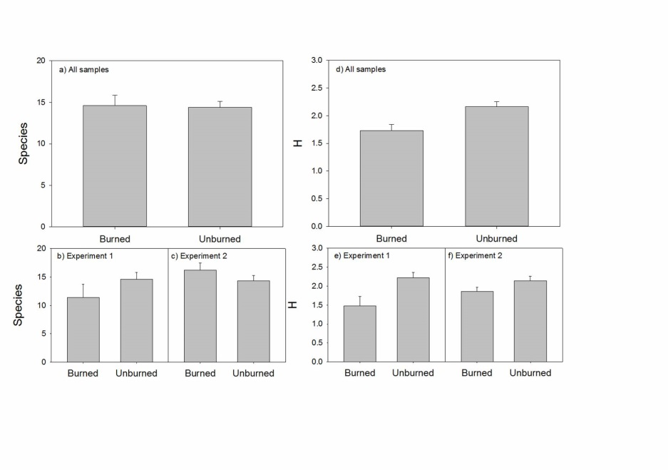
Figure 1. Species richness (plots a-c) and Shannon H (d-f) for experiment 1 (b and e), experiment 2 (c and f) and overall (a and d). Bars represent the standard error. Only the difference in H for all plots was significant (see text).

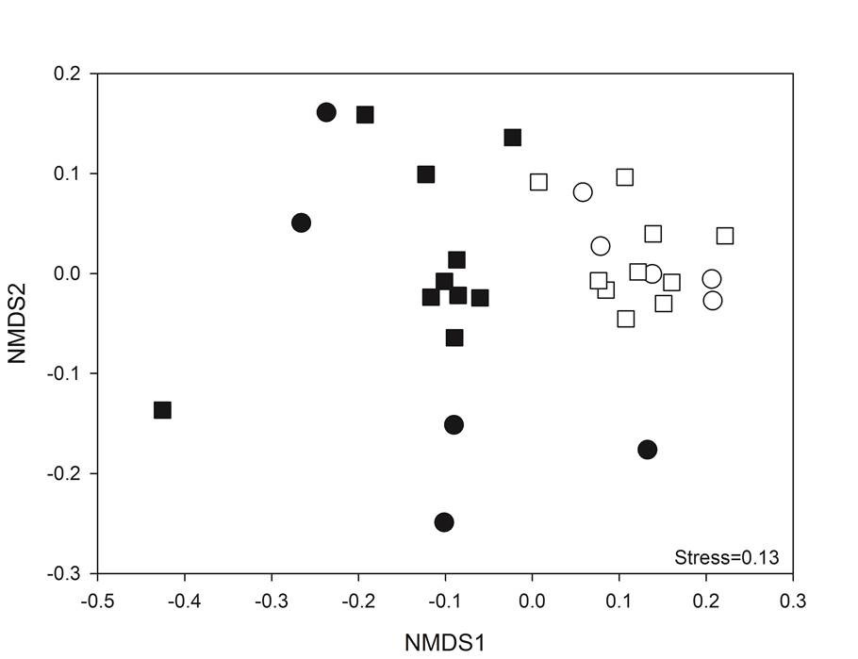
Figure 2. NMDS ordination plot of testate amoeba data from burned points (white) and unburned points (black) from experiment 1 (circle) and experiment 2 (square).

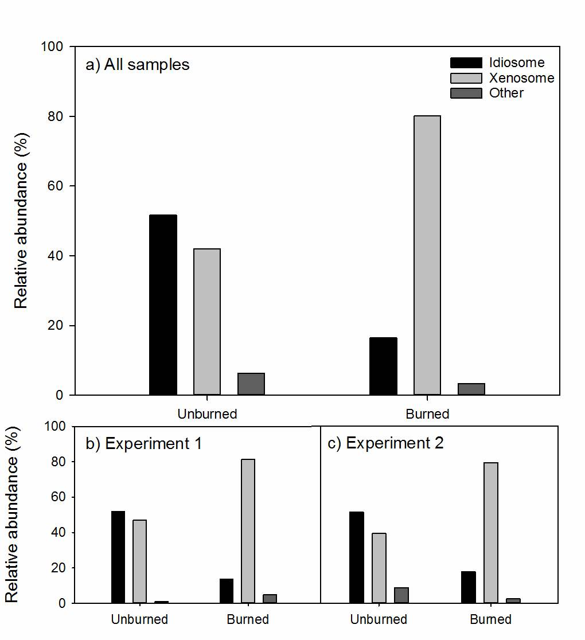
Figure 3. Relative abundance of taxa by test type in the burned and unburned plots of each experiment and overall.

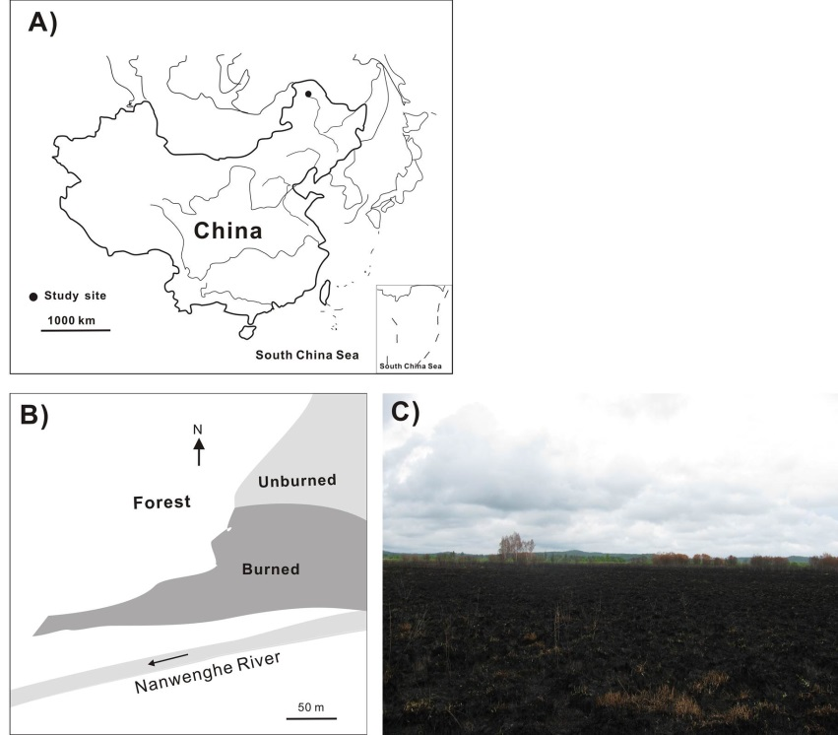
Supplementary Figure 1. Map showing the sampling site in Northeast China (A) and the areas of burned and unburned fen (B), and the landscape of burned site (C)

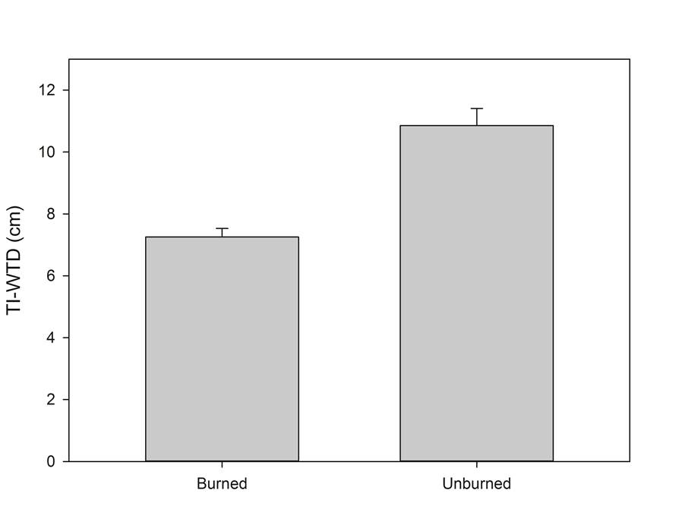

Supplementary Figure 2. Transfer function predictions of water table depth for samples from burned and unburned areas using the model of Qin et al., (2013). A mean of 83% of tests were included in the training set and sample specific errors averaged 5cm. The difference is statistically significant (Mann-Whitney U=14, P<0.001).

