Stone dead: uncovering Early Mesolithic mortuary rites, Hermitage, Ireland.

Authors: Aimée Little^{1*}, Annelou van Gijn², Tracy Collins³, Gabriel Cooney⁴, Ben Elliott⁵, Bernard Gilhooly⁴, Sophy Charlton⁶, Graeme Warren⁴

*Corresponding author

¹ BioArCh, Department of Archaeology, University of York, Environment Building, Wentworth Way, York, YO10 5DD, UK; Email: aimee.little@york.ac.uk
² Department of Archaeological Science, Faculty of Archaeology, Leiden University, PB 9514, 2300 RA Leiden, The Netherlands
³ Aegis Archaeology Limited, 32 Nicholas Street, King’s Island, Limerick V94 V6F7, Ireland
⁴School of Archaeology, University College Dublin, Belfield, Dublin 4, Ireland
⁵Department of Archaeology, University of York, Kings Manor, Exhibition Square, York YO1 7EP, UK
⁶ Department of Earth Sciences, Natural History Museum, Cromwell Road, London, SW7 5BD, UK

Abstract
In Europe, cremation as a burial practice is often associated with the Bronze Age, but examples of cremated human remains are in fact known from the Palaeolithic onwards. Unlike conventional inhumation, cremation destroys most of the evidence we can use to reconstruct the biography of the buried individual. Remarkably, in Ireland, cremation is used for the earliest recorded human burial and grave assemblage (7530-7320 BC) located on the banks of the River Shannon, at Hermitage, County Limerick. While we are unable to reconstruct in any great detail the biography of this individual, we have examined the biography of a polished stone adzehead interred with their remains. To our knowledge, this adze represents the earliest securely dated polished axe or adze in Europe. Microscopic analysis reveals that the adze was commissioned for burial, with a short duration of use indicating its employment in funerary rites. Before its deposition into the grave it was intentionally blunted, effectively ending its use-life: analogous to the death of the individual it accompanied. The microwear traces on this adze thus provide a rare insight into early Mesolithic hunter-gatherer belief systems surrounding death, whereby tools played an integral part in mortuary rites and were seen as fundamental pieces of equipment for a successful afterlife.

Keywords
Mesolithic, Ireland, burial, cremation, grave good, stone adze, microwear, biography

Introduction
Our research presents new material evidence for graveside mortuary rites performed by early Holocene hunter-gatherers living on an island at the western limits of Europe over 9,000 years ago. Discovered during excavations in 2001 (Collins 2009), the site of Hermitage, located on the banks of the River Shannon, County Limerick, Ireland, was quickly recognised by the Mesolithic research community as being of significance: cremations of this date are rare, and the burial feature itself was unusual. The adze, placed within the burial, is completely polished to a very high standard, and is also exceptional. Indeed, to our knowledge, it represents the earliest polished stone adze or axe from a securely dated archaeological context in Europe. However, it is not until recently, when microwear analysis of the adze was undertaken that the full significance of this finding was realised. Recorded microwear traces, alongside experimental research and technological analysis, suggest that this object was commissioned for the deceased and employed in their funerary rites. Most significantly, the adze itself was deliberately blunted: effectively ending its functional use life. We propose here that this symbolic act, clearly visible microscopically, was performed as a ritual expression of the death of the individual. Microwear traces, invisible to the naked eye, are often overlooked by archaeologists as a method of investigating mortuary rites. Thus, we argue that this method, when applied to grave assemblages, can provide valuable insights into the identity of the deceased and the rituals that took place at their graveside. It is said that death is for the living, not for the dead (Parker Pearson 2003)(Oestigaard & Goldhahn 2006); in which case, identifying specific funerary practices allows us intimate insights into how the dead were regarded by those who mourned them.

The colonisation and early settlement of Ireland
The island of Ireland was first visited by humans in the Late Glacial, with the first substantial evidence for settlement in the early Holocene. Ireland has been an island since c. 16,000 cal. BP (Edwards & Brooks 2008), long before there is any evidence for the post LGM human re-colonisation of Britain (Pettitt & White 2012) and colonisation of Ireland. Colonisation took place by boat. Our understanding of the very earliest colonisation of Ireland has been transformed by recent radiocarbon dating of brown bear (Ursus arctos) remains from caves in western Ireland (Dowd & Carden 2016). A butchered patella from the Alice and Gwendoline Cave, Co. Clare dates to c. 10,800-10,500 cal BC (UBA-20194, 10,798±71BP, OxA-29358, 10,850±50BP) almost at the start of the Younger Dryas. A cut-marked brown bear vertebrae from the Catacombs, Co. Clare dates to 9,080-8,400 cal BC (UBA-20195, 9414±57BP) and demonstrates the earliest human activity in Ireland in the Holocene. Little is known about the human context of these finds, which may have been little more than pioneering or exploratory visits (Dowd & Carden 2016).
The use of large huts at Mount Sandel, Northern Ireland at c.7700 BC (Bayliss & Woodman 2009) is the earliest substantial archaeological evidence for settlement. Ireland lacked many of the large mammals significant to Mesolithic subsistence elsewhere in northern Europe and settlement would have required changes to long established routines (Woodman 2015). This process appears to of been part of a broader suite of developments in the Mesolithic of Northern Europe at this time, with many aspects of the Mount Sandel lithic assemblage and settlement type closely paralleled in Northern Britain. The Irish Earlier Mesolithic lasts until c. 6800/6600 cal. BC (The Irish Earlier Mesolithic is not the same as the British Earlier Mesolithic but is directly comparable to the British Later Mesolithic), and although as many as 130 possible sites of this period are known (Woodman 2015, p.204), very few excavations have taken place of Earlier Mesolithic sites; thus, our models are dominated by evidence from a very small number of locations.Settlement was island-wide, with evidence of the use of interior lakes, for example Lough Boora (Ryan 1980), and coasts and estuaries as at Mount Sandel.
Evidence for funerary practice in the Irish Mesolithic as a whole is scant (Woodman 2015, p.315) with only two Earlier Mesolithic sites having evidence for the treatment of the dead: Hermitage (discussed here)and Killuragh Cave, both in Co. Limerick (Meiklejohn & Woodman 2012). At Killuragh Cave deposition of unburnt human bone took place at c. 7000-6500 cal BC, in the Later Mesolithic at c. 4600-4200 cal BC and in the Neolithic. Given the later use of the cave it is difficult to be certain about the practices that led to the deposition of bone in or near this cave, although Dowd (2015) believes it is more likely to relate to the excarnation of bodies, or deposition of body parts, rather than the placement of whole bodies.

Hermitage
At Hermitage, at a possible fording point, near Castleconnell in County Limerick, Ireland (Fig. 1), two and a probable third Mesolithic burial of individuals who had been cremated were excavated in advance of pipe-laying for a water scheme on the eastern bank of the River Shannon. The earliest burial, Pit A, which is the subject of this research, the cremated remains of an adult dates to 7530-7320 cal. BC, placing it very early in the Mesolithic period in Ireland (see Table 1). About 100m away was a second, larger pit (Pit B) containing the partial remains of an adult who, like the individual in Pit A, had also been cremated. Some of the cremated bone was then placed in the pit with heat-shattered stone and pieces of baked and burnt clay. The bones in Pit B were dated to 7090-7030 cal BC. In the case of both Pit A and Pit B, initial radiocarbon dates based on charcoal samples were later supported by direct dating (AMS on carbonate extraction) of the human remains. A third pit (Pit C), contained minute fragments of cremated bone, too small for positive species identification. A date from charcoal indicates that the bones were placed there around 6610-6370 cal BC. Field collected lithics of both Early and Late Mesolithic date suggest domestic settlement also took place here.
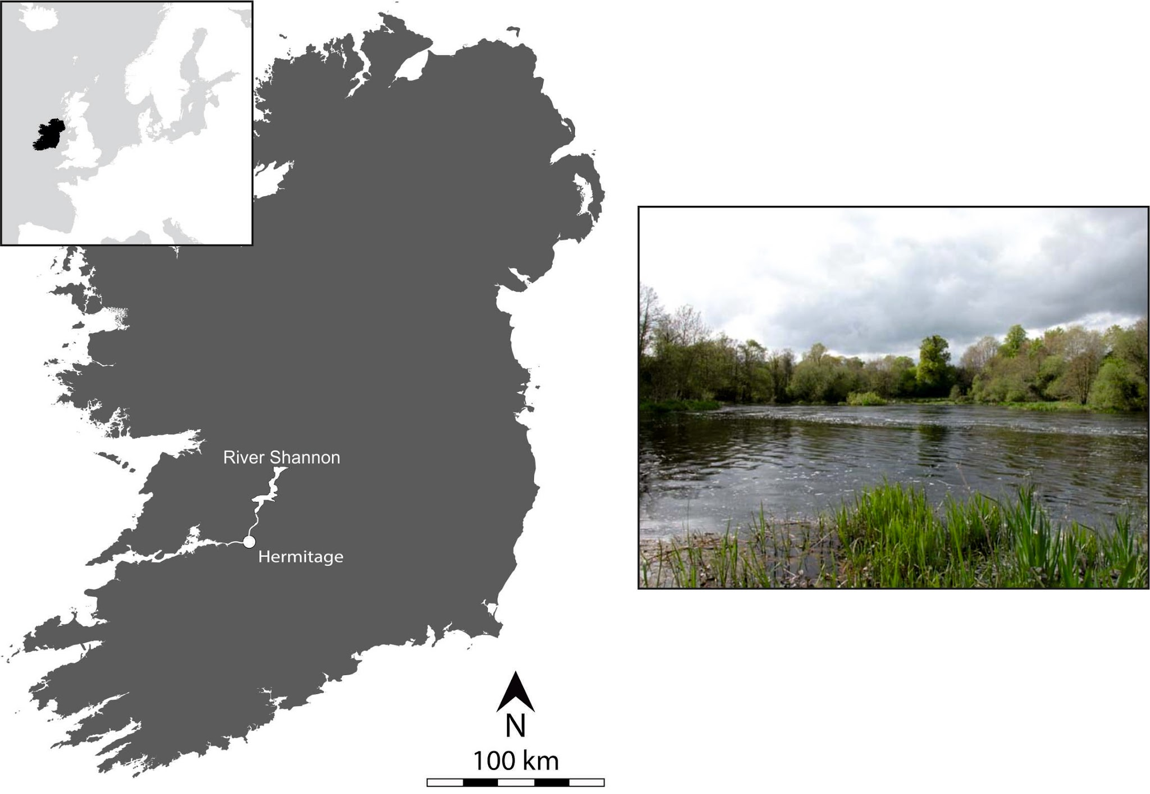

Figure 1. Map showing the location of the site at Hermitage and the view of the River Shannon from the location of the burials.

Feature | Material dated | Lab code | Date BP | Radiocarbon date (cal BC at 2σ)
Pit A fill | Charcoal (Pomoideae/Alder) | (beta 177370) | 8350 ± 60 | 7550-7290
Pit A cremation deposit | Human Cremated Bone, (Tibial Shaft) | (beta 214236) | 8350 ± 40 | 7530-7320
Pit B | Charcoal (Pomoideae) | (beta 177369) | 7890 ± 50 | 7030-6630
Pit B | Human Cremated Bone (Skull Vault) | (beta 214237) | 8070 ± 40 | 7090-7030
Pit C fill | Charcoal (Alder) | (beta 177377) | 7610 ± 40 | 6610-6370
Table 1. Summary of Mesolithic radiocarbon dates from Hermitage (after Collins 2009).

Burial pit
The Pit A burial was contained within a sub-circular pit, 60cm in diameter and 30cm in depth (Fig.2a-2c). The cremation was scattered in a crescent shape around what has been interpreted as a posthole for a wooden post which may have been erected to mark the place of burial: acting as a visible grave marker (Fig. 2a). The microliths were within the cremated deposit, the axe was placed in the pit resting against the post with the blade or cutting edge facing down into the pit and earth. Thus, the sequence into the pit was: post, then axe, then cremation with microliths. Initially the objects, which display heat alteration, were interpreted as accompanying the individual when the cremation took place (Collins & Coyne 2005). However, on re-analysis, the surface of the artefacts suggests that the degree of burning more closely resembles that which would occur if they were placed on or into hot cremains within the burial pit rather than the pyre itself.

Grave marker
The Pit A burial appears to have been deliberately marked and commemorated by the living with a timber post (Fig. 3a). It is possible the post was a carved efigie, though this is purely speculative. Nonetheless, a post-markerraises notions of Mesolithic memorialisation, whereby people mourned not just once at the graveside but possibly returned repeatedly through time. It is one of the few avowedly ceremonial structures that we can date to the Mesolithic in Ireland, and one of a rare number of examples from Europe.

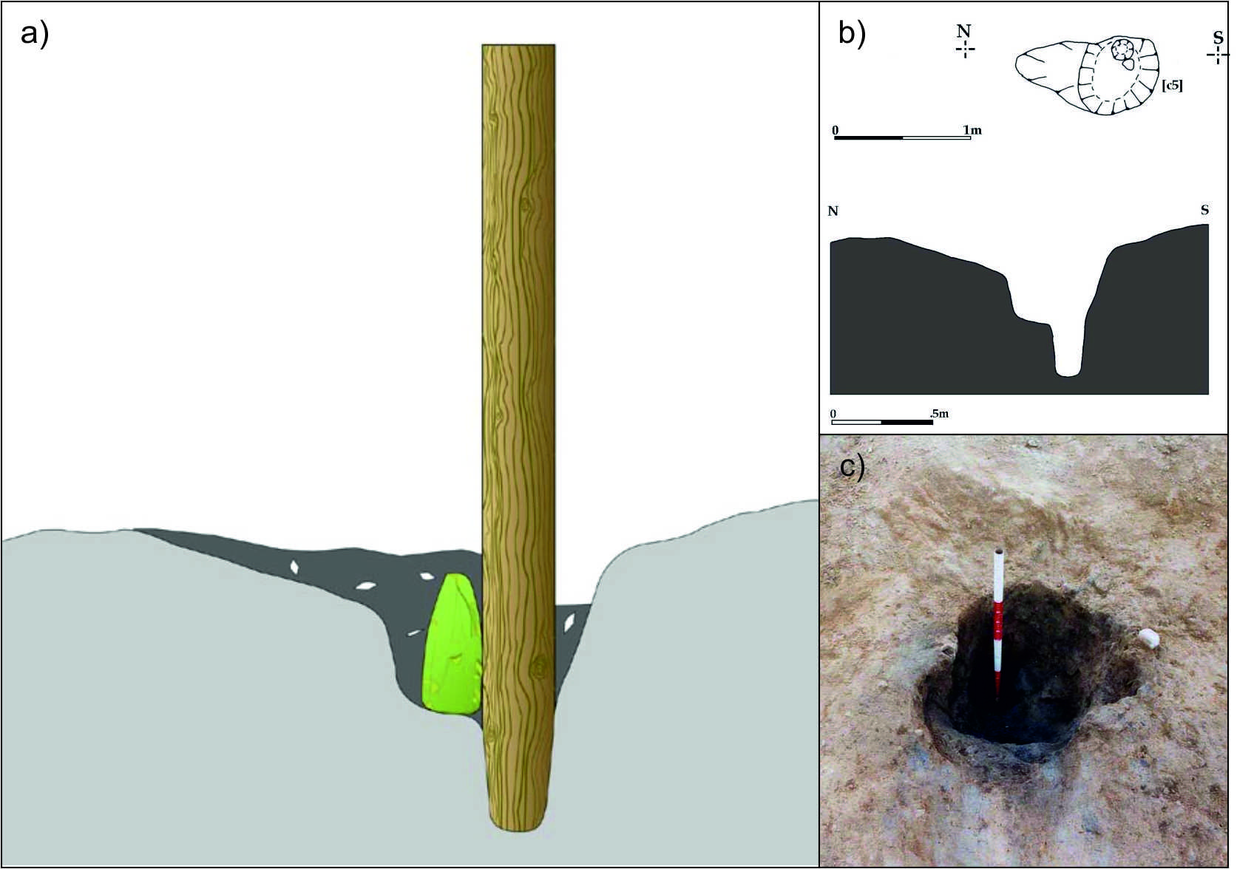

Figure 2a. Reconstruction of the Hermitage burial feature showing the axe placed blade-down into the pit, with the cremation deposit and wooden post grave marker; Figure 2b. Illustration of the Pit A burial feature in profile and plan view; Figure 2c. Post-excavation photo of the Pit A burial feature with postpipe feature in oblique plan view; (Credit: Tracy Collins, Aegis Archaeology Ltd).

The Hermitage Cremation
Pit A contained the cremated remains of an adult (Fig. 3). The osteologist, Linda Lynch, who examined the bones suggested the individual was probably a male. This was determined on the basis that a single fragment of the lateral margin of the right orbital rim resembled that of a male individual. However, the sexing of the individual is by no means conclusive, especially considering the fragmented state of the remains and the fact that no other sexually diagnostic features were identified - a point that Lynch has herself made previously (see Collins 2009).

The body was cremated and then virtually all the burnt bone, almost 2000 grams (the average predicted weight of a cremated adult male is c. 2300 grams (McKinley 1994), was collected and placed in the pit. Lynch, has remarked that the cremation was ‘well-executed’ (cited in Collins 2009, p.876) and thus expertly carried out, with temperatures of 645-1200° C required. Due to the high level of fragmentation of the cremated bone (nearly 40% of the fragments were less than 2-5mm), Lynch suggested that the bones may have been pounded post-cremation (Collins 2009). However, given the difficulties in determining intentional fragmentation of cremated remains (McKinley 1994) this interpretation, along with the sexing, comes with a caveat.

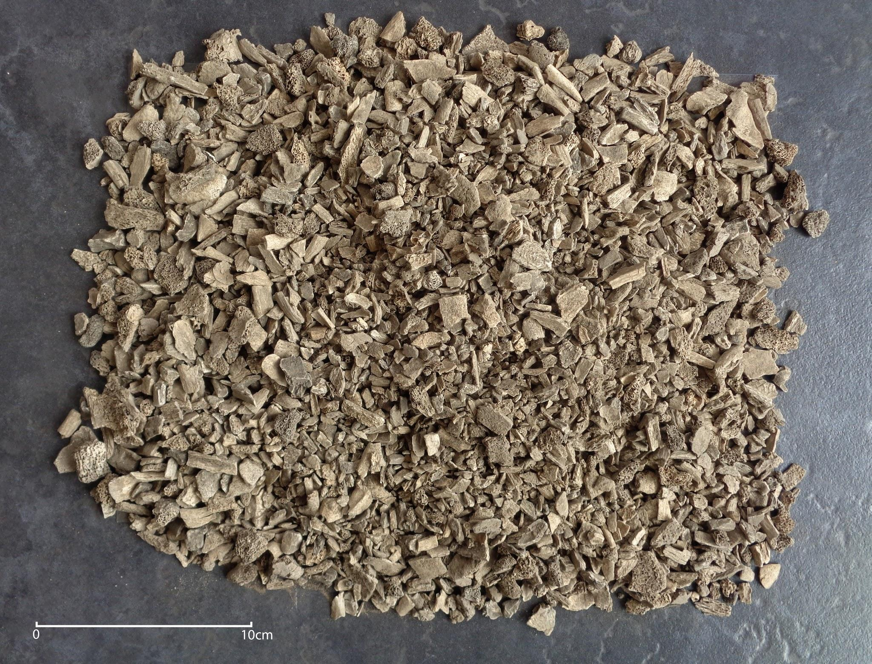Figure 3. Photograph of the cremation deposit from the Hermitage Pit A burial feature.

European context of the Hermitage cremation
Globally, cremation burials are known from the Pleistocene onwards, for example from the Natufian Culture contexts in the Levant, from Kebara Cave (Bar-Yosef & Sillen 1993) and at Lake Mungo, New South Wales in Australia (Bowler et al. 1970). Traditionally seen as a less common practice than inhumation within the Mesolithic period however, there is now a growing corpus of cremations known throughout Europe, at sites in Britain, Denmark, Greece, Sweden, Holland, Belgium, France, Poland and the Danube Gorges for example (see Table 2). Within these there exists significant variability in the types and contexts of cremation deposits, as well as differences in the number of individuals, and the presence/absence of grave goods (see Table 2). Despite this variability, Hermitage remains an unusual cremation - particularly given its early date, the presence of a polished stone axe within the pit, the degree of burning of the remains, and the post-hole.

Comparative examples of funerary practices to Hermitage are not currently known from Britain. However, given the scarcity of the cremation record for the British Mesolithic, with only one cremation currently recorded, this is unsurprising. The only British cremation burial of Mesolithic date (c.5600 cal. BC) was recently recovered in Langford, Essex, from a <1 metre-wide pit feature, and contained the incomplete remains of a single adult individual. The cremation deposit also contained large amounts of other burnt material and charcoal, prompting suggestions that it represented the partial remains of a pyre. No grave goods were present within the deposit (Gilmour & Loe 2015).

The closest parallel to Hermitage is the Danish Maglemosian site of Hammelev, in Southern Jutland (Eriksen & Andersen in press). Here a cremation burial pit contained one adult, probably female, dated to 8250 cal. BC. Sexing of the Hammelev individual is based on mandibular morphology and the gracile nature of the skeleton; however, it is acknowledged that the bones may have shrunk considerably during the cremation process. Like Hermitage, it was noted that the Hammelev individual had been very well cremated by intensive firing over 800°C, by someone who must have had expertise in the practice. In contrast to Hermitage, Hammelev represents only partial collection after the cremation and deposition of the human remains, mostly relating to the upper part of the skeleton (Eriksen & Andersen in press, p.3).

Alongside the single individual, the Hammelev burial pit contained a selection of flint tools, including an unpolished core axe, which were unburnt, a burnt bone pin, and burnt limb bones of a wild cat (Eriksen & Andersen in press). This variation in artefact burning is explained as the result of some objects being placed in the cremation pyre, while others were deposited directly into the pit. The core axe deposited with the individual at Hammelev provides comparable evidence for the deposition of axes with cremated remains. Unfortunately, the microwear analysis of this core axe was inconclusive due to the level of patination on the surface, thus limiting the amount of biographical information available.

The current realisation that cremation exists as a distinct mortuary practice within the European Mesolithic raises a number of questions and problems - most notably, why cremate some individuals but not others? Cremation itself is a difficult and time-consuming process: it can take 1-1.5 hours at a temperature of 700-1000°C to fully cremate a human body (Roberts 2009, p.52), and may require up to a tonne of dry timber in the pyre structure (Parker Pearson 2003, p.49). Whilst Mesolithic burials themselves appear to only represent certain individuals, rather than the whole population, cremation can simply be viewed as another variable within what were clearly complex mortuary practices. However, cremation can also be seen as reflecting some new form of belief or spiritualism set aside from inhumation – as a “heat-mediated transformation” of the body (Oestigaard 2000, p.44). Unfortunately, the process of cremation itself limits the ability to reconstruct human biographies and determine osteological information. The adze placed with the cremated remains at Hermitage provides the opportunity instead to reconstruct the object’s biography and its relationship with the individual.

Site | Date (¹⁴C age B.P.) | Context | Number of individuals | Grave goods? | References
Hammelev, Denmark | 8980 ± 80 (AAR-8195); 8800 ± 46 (AAR-8196); 8760 ± 60 (AAR-8197) | One cremation in pit feature | One adult (?)female | Range of flint tools, a bone pin, wild cat bones, some burnt, others unburnt | (Eriksen & Andersen in press); (Olsen et al. 2008)
Langford, Essex, England | 6680 ± 28 (GU35121); 6695 ± 31 (GU36754) | One cremation in sub-circular pit feature | One adult individual | None | (Gilmour & Loe 2015)
Vlasac, Serbia | Throughout 7th millennium BC | 56 contexts containing burnt human remains. Some secondary cremations. Some cremations placed in dwelling floors | Unknown | Carp tooth ornaments; broken & burnt projectile points | (Borić et al. 2014; Boric et al. 2009)
Franchthi Cave, Greece | c.9500-9000 (no direct dates on human remains) | Two cremations | One adult male, one adult female | None | (Cullen & Cook 1991; Cullen 1995)
Abris des Autours, Belgium | 9500 ± 75 (OxA-4917) | One cremation within large collective grave at cave site | One incomplete adult, indeterminate sex | Four non-retouched flint bladelets within whole collective grave | (Cauwe 2001, p.154)
Pomorsko 1, Poland | Atlantic period | One cremation within dwelling structure at settlement site | Multiple individuals. One child, other fragments unidentifiable (MNI unclear) |  | (Sulgostowska 2006)
Wieliszew VII, Poland | Atlantic period | One cremation in shallow pit feature | One adult (?)male |  | (Sulgostowska 2006)
Vedbæk (Gøngehusvej7 and Vedbæk Boldbaner), Denmark | 6720 ± 65 (K-6856; Gøngehusvej7 cremation N, date from accompanying charcoal) | Three cremations in pit features | Gøngehusvej 7: Cremation N - 5 individuals (2 adults, 3 non-adults); Cremation Æ - one adult (?)female. Vedbæk Boldbaner: one adult (?)female | Red ochre, worked flints, unworked amber, tooth pendants, animal bone | (Petersen & Meiklejohn 2003)
Heffingen-  Loschbour, Luxembourg | 7960 ± 40 (Beta-132067) | One cremation within small pit at rock-shelter | One mature adult (?)female | Perforated Bayania lactea shell (also burnt) | (Toussaint et al. 2009)
Le Petit Marais (La Chaussée-Tirancourt), France | ~8500 (associated hazelnut shell: 8460 ± 70 (Gif-9329); associated animal bone: 8360 ± 90 (GifA-95471)) | One cremation within pit feature | Three individuals, two adults and one child (c.3 years old) | Flint tools (narrow backed bladelets), ochre, perforated shells, animal bone (some burnt, others unburnt) | (Ducrocq & Ketterer 1995; Le Goff 2000; Meiklejohn et al. 2010)
La Vergne (La Grande Pièce), France | 9070 ± 70 (Ly-369/OxA-6699; date taken from associated inhumation, Pit 7) | Cremated remains scattered over inhumation | One adult | None | (Duday & Courtaud 1998; Meiklejohn et al. 2010)
Ruffey-sur-Seill (À Daupharde), France | 8735 ± 85 (Ly-238; date from accompanying hearth) | One cremation deposited next to hearth at open air site | One incomplete individual | Associated ochre ball and flint flake | (Valdeyron 2008; Meiklejohn et al. 2010)
Rueil-Malmaison ‘Les Closeaux’, France | 8870 ± 130 (OxA-7109/Lyon-612; date taken from associated inhumation) | Cremated remains spread over several square metres | Unknown |  | (Verjux 2000; Valentin et al. 2008)
Concevreux, France | 6440 ± 30 (GrA-37623) | One cremation within small pit, thought to originally be held within an organic container | Two individuals | Burnt lithics, tooth ornaments | (Ducrocq & Ketterer 1995; Le Goff 2000; Meiklejohn et al. 2010)
Oirschot V, Netherlands | 8320 ± 40 (GrA-13390) | One cremation within pit feature | One child, aged 10-13 years | Burnt worked flints | (Arts & Hoogland 1987); (Toussaint et al. 2009; Lanting et al. 2001)
Dalfsen, Netherlands | 7685 ± 130 (GrN-7283B; date from accompanying charcoal) | Cremated remains recovered from fill of domestic pits | MNI of one, ?adult female | None | (Smits & van der Plicht 2009); (Toussaint et al. 2009)
Collombey-Vionnaz, Switzerland |  | One cremation within rock-shelter |  |  | (Crotti 1993)
Buroer Feld, Coswig, Germany | 7920 ± 45 (OxA-13472) | One cremation |  | None | (Grünberg 2006)
Skateholm I, Sweden |  | Two cremations; one (grave 11) associated with 7 postholes, the other (grave 20) in a round, shallow feature | Grave 11 - one adult male; Gave 20 - one individual | Animal bone | (Larsson & Stutz 2014)
Skateholm II, Sweden |  | One cremation in stone-lined pit feature | One individual | One large burnt flint fragment | (Larsson & Stutz 2014)
Rochereil, France |  | One cremation in shallow depression, thought to be secondary cremation | (?)Two individuals, one aged 18-20 years, the other a young non-adult | None | (Gil-Drozd 2011)
Table 2. Summary highlighting the range of European Mesolithic cremation burials and associated grave goods.

Analysis of the Grave goods

In total, three objects were deposited in the Hermitage burial pit: a flint microlith, a microblade and a large polished shale adze (Fig. 3).
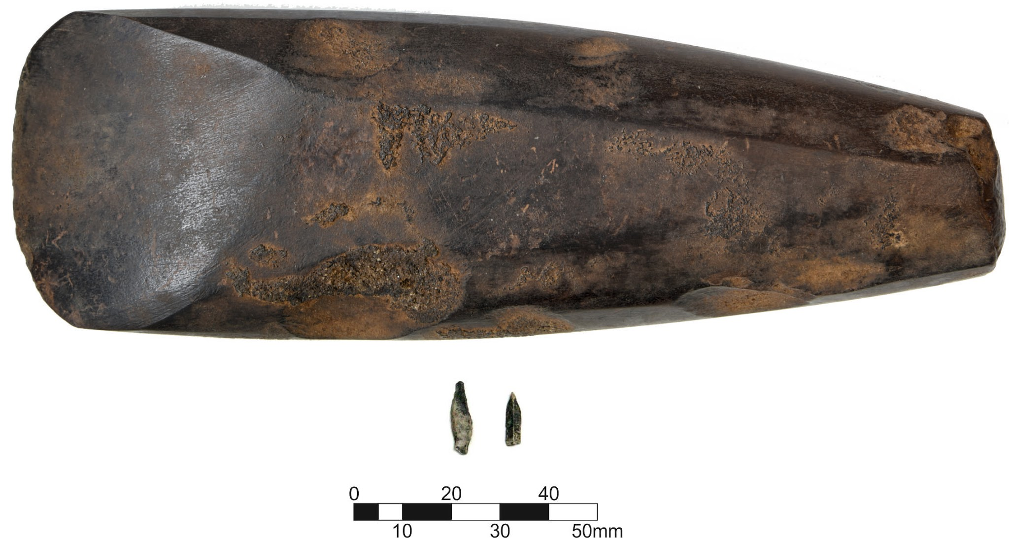
Figure 4. The Pit A grave assemblage: flint microlith and microblade and a large polished shale adze.

Flint tools
The micro scale of the microlith and microblade contrasts with the large form of the axe (see Fig. 3); it is tempting to see this composition as a play on scale, although we concede that this interpretation is highly subjective. Unfortunately, due to the level of heat alteration it was not possible to determine whether the two flint tools had been used. The flint microblade appears to have been broken - if this was intentional or not remains unclear. However, considering the treatment of the adze (discussed below) and the high frequency of broken objects found in hunter-gatherer graves from other parts of Europe (Zagorskis 2004; e.g. Larsson 1984; Mannermaa 2008), it is not beyond the realms of possibility that this blade was broken as part of the funeral rites.

The making of the Hermitage polished stone adze
The adze is made from shale. It is not possible to identify the exact source location of the shale used to make the Hermitage adze (See Cooney and Mandal, forthcoming, for further discussion). The geology in the surrounding area of its discovery is a mix of Old Red Sandstone, Carboniferous Limestone, Lower Carboniferous Shales and Lower Palaeozoic rocks (mainly Silurian) (Holland 2001; Boycott & Mullan 2003). Shales have been identified in the Shannon basin and adjoining areas (Sevastopulo 2009, p.275; Whittow 1974, p.174; Sleeman et al. 2004; Boycott & Mullan 2003). Namurian shales have been identified in South-West Clare, West Limerick, and North Kerry (Whittow 1974, p.199; Cooney & Mandal forthcoming; Sevastopulo 2009, p.275). It is possible the material could have been obtained from any of these sources. As shale is found in many locations around the island of Ireland (see Cooney & Mandal forthcoming for a list of locations), it is also conceivable, though less likely, that it came from further afield. Shale is a very widely used source for axehead production in both the Mesolithic and Neolithic periods in Ireland and it would appear that secondary sources, particularly water-rolled cobbles, were predominantly utilised (Cooney & Mandal forthcoming; Cooney et al. 1998, pp.85–86). The regularity and size of the Hermitage adze raises the possibility that in this case the raw material may have been deliberately procured from a primary source.
Based primarily on experimental research on Irish shale axe manufacture conducted by Gilhooly it has been possible to reconstruct the manufacturing process of the example from Hermitage.The conventional view on shale axe/adze manufacture is that the raw materials, the secondary sourced cobbles, are only flaked on one side (Cooney & Mandal forthcoming; Mandal et al. 2004). However, it is obvious that where necessary, both faces can be flaked to create/shape the blade. This is supported by the archaeological record where a number of roughouts, which have been knapped on both sides, have been identified. In some instances, only the blade was worked, while the rest of the cobble was left untouched, while in others, the body and butt were also shaped. Knapping was the most commonly used primary treatment for manufacturing shale axes/adzes; 89% are flaked in this manner (Cooney et al. 1998, p.85). It has been proposed that a hard hammer technique was the most likely form of knapping, although soft hammer, using sandstone hammerstones, was also possible but less likely.
After its primary treatment, the blade of the roughout was shaped/finished through grinding, and if desired, the body, sides and butt were also ground. Cooney & Mandel (forthcoming) have noted how the degree of grinding (and polishing) of a sample selection of 600 fine grained sedimentary axeheads can vary. Of the 467 complete axeheads analysed, 60% were ground and 14.8% polished all over, while those with just ground/polished blade, faces and sides (not the butt), were 69.7% and 33.5% respectively. The form the polishing took is not fully understood in an Irish context. It has been suggested that a relatively hard lithology, such as quartz sandstone, along with water and ash for lubrication, could have been used in Ireland (Cooney et al. 1998, p.13). Lewis et al. (2011) have suggested the use of leather, an abrasive, probably sand, and a lubricant, such as animal fat and water.
The Hermitage adze shows flake scarring along the sides, on both faces. This could be caused by environmental processes, as Cooney et al. (1998, pp.85–86) have noted the natural flaking of shale cobbles on coastal or lacustrine beaches. However, the apparent regular depth and systematic nature of the flake scarring, all along the sides of the adze, strongly suggests that most, if not all, are manufacture related. Even though there are no obvious signs of manufacture flaking on the blade, it is almost certain that it was shaped primarily through knapping. The depth/thickness of the piece (4.1cm) would have necessitated a significant amount of work to shape the blade, if just relying on grinding alone. The lack of flake scarring results from the high level of grinding on both faces of the blade area.
Recent experimental research (Gilhooly 2012) has shown that the knapping of the roughout would have taken ten to fifteen minutes. Although a matter of preference, it is common to knap/shape the blade end first, followed by the sides/body and finishing with the butt. Greater care would have been taken when shaping both the blade and butt, as they are the easiest to irreparably damage. Overlapping knapping scars visible at the junction of the butt with both sides, stress the desire to attain a specific butt shape. Similarly, the knapping scars seen along the length of both sides demonstrate that a particular overall morphology was required. The removals, along with the subsequent attempt to grind them down, created pronounced facets between the sides and the face. Once the desired shape was formed, the roughout was ground.
While a series of grinding stones, ranging from coarse to very fine, can be used to finish an axehead/adzehead, it was found that a medium grained stone could perform all the necessary grinding functions. Quartzite or Old Red Sandstone are particularly good choices for grinding stones. The use of these two lithologies is attested to in Irish prehistory, with Knowles (1893, p.158) highlighting quartzite use and Leon (2005, p.15), the use of red sandstone. The only other requirement is water as a lubricant. Neill (2014) has observed, with particular reference to Old Red Sandstone, how the use of water was very important to the efficiency of the grinding process. Similarly, Steensberg (1991, p.238) has noted the frequent use of water in Papua New Guinea when re-sharpening a stone adze with sandstone. An added abrasive is not recommended. While it can increase the rate of abrasion, it is also more likely to cause small chips or nicks in a blade (Gilhooly 2012).
The initial grinding would have focused on attaining the final shape of the adzehead, along with grinding out as many of the knapping scars as possible. As such, the piece would have been ground in a number of directions, usually with long strokes, applying greater downward force than used at the latter stages. This maximises the amount of material ground out. Compared to other lithologies, shale is relatively easy to grind. Experimental research carried out by Gilhooly on the manufacture of both shale and porcellanite axeheads/adzeheads established that, with regard to their grinding, on average, every thirty minutes 7.6 grams were removed from shale axes/adzes. In contrast, the average amount of porcellanite removed over the same period by grinding was 3.6 grams. Once the final morphology has been attained, fine grinding is undertaken.
The final grinding on the body and butt is undertaken before the blade, as it is more susceptible to damage. The knapping scars which remain after the initial grinding are either reduced in size or removed altogether, depending on their depth. As flake scarring is not regular in size, shape or depth, it is common to grind them in a number of directions to reduce their profile. As such, groupings of scratch marks can often be found around them, running in multiple directions. The scars on the sides of the adzehead are still quite prominent, even though they have been ground and polished to some degree (Fig. 4). Given time, all of these could have been removed. This raises the question if there were time constraints on the manufacture of the adze. If so, they do not seem to have applied to the blade, which shows no sign of flake scarring.
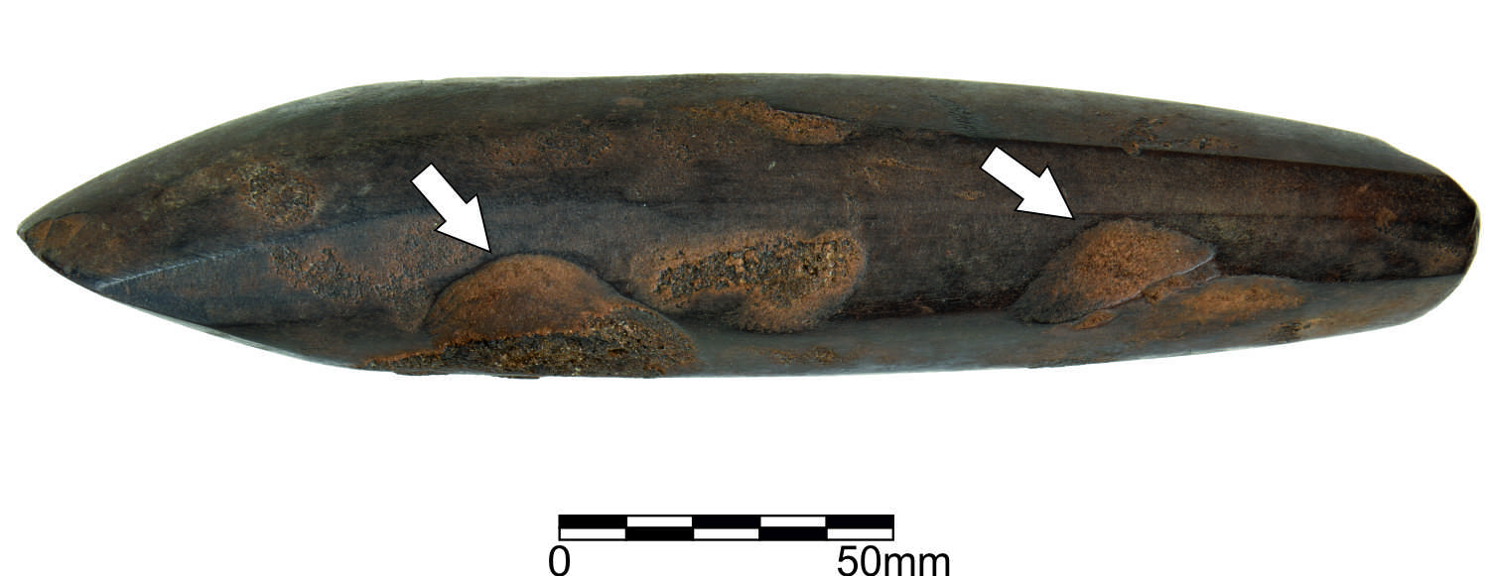
Figure 5. Prominent flake scars along side of adze, still visible despite grinding and polishing.
The blade is shaped by first standing the adzehead vertically and sweeping the blade edge across the grinding stone, to create the required curvature. Following that, the adzehead is held at an angle and ground with shorter strokes and less downward force. The angle is altered as required to form the finished blade edge. The blade must be convex in nature as this adds to its strength. Dickson (1981, pp.103–104), when discussing Australian stone hatchets, noted that the curvature/bevel of their blade end is the result of the standard grinding process and that if a hollow ground blade with concave bevels was created, it would be more likely to break. For the final sharpening of the blade edge, even lighter strokes are used. These will create a sharp smooth edge. However, it should be noted that the final appearance of the blade edge will depend on how fine grained the raw material is and on how thick it is. The grinding which focuses purely on the removal/reduction of flake scarring and the final shaping of the adzehead, would have taken approximately three to three and a half hours. The polishing, depending on the form it took, would have added another two hours. Therefore, in total, the adze would have taken roughly six hours to manufacture from start to finish (Table 3).
The Hermitage adze is one of a small number of outstanding examples found in Ireland, finished to a very high degree. Cooney and Mandal (forthcoming) have noted how in a sample analysis of 600 fine grained sedimentary axeheads, only 14.8% were ground and polished all over, while at 19.4 cm, it is well above the average length of 10-12 cm for a shale axe/adze (Cooney et al. 1998, pp.86–87). The grinding and polishing of almost the entire adzehead seems unnecessary, from a purely practical level. Once hafted, the vast majority of this would be unseen. In fact, it could be argued that the polishing could be detrimental to its use, as the binding could slip somewhat over the adze surface. The presence of the ground down knapping scars (see fig. 4) can be viewed in different ways. At a functional level, it would be necessary to grind the edges, as they could fray or cut the binding over time. However, they appear to have been ground more than necessary. As such, it likely that other factors, such as aesthetics or ritual concerns, were influencing their reduction. The fact they were not fully removed, but the adze was polished over most of its surface, suggests that time may have been a factor in its making.
Knapping: 10-15 minutes
Grinding: 3-3.5 hours
Polishing: 2 hours
Total: approx. 6 hours
Table 3. Estimation of time spent manufacturing the Hermitage axe based on experimental replication.

The chronological context of the Hermitage polished axe within Ireland and Europe
Conventionally, the appearance of polished stone axes and adzes is associated with the advent of agriculture in Europe. As such, polished stone tools have periodically been included within the “Neolithic package” (Cooney 2015): a suite of distinctive material cultures and practices believed to be indicative of an agriculturally based economy. However, the sporadic occurrence of polished axes within Mesolithic material culture repertoires has been noted across Europe, and presents some challenges for the concept of the “Neolithic Package”. In Ireland, the Mesolithic affinities of some ground and polished stone axes has been confirmed by the excavation of complete and fragments of polished stone axes from sealed and dated Mesolithic features at Mount Sandel (Woodman 1985), and the association of a single radiocarbon date with an assemblage of polished axes and diagnostically Mesolithic stone tools at Lough Boora (Woodman 1978; Costa et al. 2005). These dated finds form the minority or a much larger collection of stone axe finds from across Ireland (the vast majority of which lack stratigraphic security) and are believed to collectively span the Mesolithic, Neolithic and Bronze Age (Cooney et al. 1998). Within Mesolithic contexts, the typological distinction between axes and adzes is seldom (and inconsistently) drawn. The more common term “axe” will be used here to refer to both forms of tool.

Within the context of the Irish Mesolithic, the Hermitage adze represents some of the strongest evidence for the advent of this technological advancement in axe manufacture in the mid-late 8th millennium cal. BC. The security of the date, with two closely congruent radiocarbon dates from the same stratigraphically secure context as the artefact in question, is therefore more reliable than the single radiocarbon date of 7546-7188 cal. BC (UB 2200 8350±70) from Lough Boora (Costa et al. 2005). The dating of the polished axes from Mount Sandel is slightly more contested and complex, with the features from which the axes were recovered being included within a phase of “little pit” digging within the latest models of occupation at the site. This group of features has been modelled as being created at 7720–7595 cal. BC and infilled at 7630–7535 cal. BC using Bayesian statistics (Bayliss & Woodman 2009). However, it should be noted that this model rests upon the assumption that the pit from which the polished axes were recovered was dug at the same time as the other small pits from which radiocarbon dates have been obtained. There are no radiocarbon dates from the feature itself, and no stratigraphic evidence to suggest that this specific pit is directly contemporary with any of the directly dated pits. Whilst this does not undermine the utility of this particular model for establishing the broader chronology of occupation and activity at Mount Sandel, its suitability for establishing a robust date for the deposition of the polished axes at the site is limited. As such, the dating of the Hermitage adze stands out as both the most reliable, and earliest, for a polished stone axe in Ireland and serves as a theoretical advent point for axe polishing as a technological practice.

Beyond Ireland, ground, pecked and polished stone axes are sporadically distributed across Mesolithic Europe. Within Britain, the earliest pecked and ground stone axes, with areas of polish, are found in North Wales at the site of Nab Head II. Whilst the stratification of these finds is unclear, the earliest dates for occupation at the site fall at 7305-6701 cal. BC (OxA-1497, 8070±80BP) – providing a terminus post quem for these axes and an earliest possible date for the existence of groundstone technologies in Britain (David & Walker 2004).

There is evidence for the use of greenstone and diabase for the production of pecked and polished axes in Scandinavia from a relatively early date. The form of these early axes varies somewhat, with pecking generally used to initially shape the axe, and polish being localised along working edges. Although many of these finds have been sourced from surface scatters, dating of the early greenstone and diabase quarry sites of Hespriholmen and Stakaneset has helped to establish a terminus post quem for their appearance within the archaeological record. These coastal sites have been dated through the combination of radiocarbon dating and isostatic uplift models (Olsen & Alsaker 1984), which have been used to predict the earliest point at which these sources were accessible for quarrying. Although the precise dating of the commencement of quarrying is contested by several authors (Lindgren 1995; Bergsvik & Olsen 2003), most would agree that greenstone and diabase axes were being produced at the start of MM1, c.8000-7500 cal. BC (Bjerk 2008). Axes produced using diabase and greenstone are documented from contexts across Scandinavia. In particular, the trindøkse of the Maglemosian are particularly well documented and have been recovered from a mixture of surface finds and stratified, radiocarbon dated contexts within Denmark and Southern Sweden (Althin 1954; Henriksen et al. 1976). The dates currently available suggest that the production and use of these pecked and polished axes began in the first half of the 8th millennium cal. BC, roughly coinciding with the commencement of activities at the Hespriholmen and Stakaneset quarries (Sørensen & Casati 2010).

Within the context of Northwest Europe, the Hermitage adze stands out on two fronts – firstly, this represents an exceptionally well-dated, early example of a polished adze in Northwest Europe. Whilst many of the Mesolithic polished axes from the region lack stratigraphic security or refined radiocarbon chronologies, the Hermitage adze provides robust evidence for the production of polished stone adzes/axes in the mid-8th millennium cal. BC. The relatively narrow and congruent calibrated ranges of the two radiocarbon samples provide a well-defined chronological marker against which other evidence for early polished axe practices can be situated. Secondly, the extent to which the Hermitage adze has been polished is outstanding within the context of other broadly contemporary technologies. The total polish effect achieved on the Hermitage adze contrasts to the early Maglemose trindøkse from Denmark and Sweden, and coarse stone tools from Nab Head II. Whilst later axes in Southern Scandinavia achieve similar levels of polish (Carlsson 2007), the Hermitage adze is distinct from the other examples of well-dated, early, ground and pecked axes in this respect.

Microwear analysis of the Hermitage axe
Tools and other objects develop wear and tear as a result of use, handling or the various treatments they undergo. Experimental use of newly made tools have shown that the traces of wear vary in appearance depending on the contact material, the motion executed, and the length or intensity of use. This pertains to objects made of all types of materials, such as flint, hard stone, antler, bone, shell and coral (Adams 2014; Cuenca Solana et al. 2011; van Gijn & Little 2016; Maigrot 2003). Wear traces include edge removals (often referred to as “use retouch”), edge rounding, polish and striations. Residue from the contact material may be present as well (Fullagar 2006). Striations and edge removals give an indication of the hardness of the contact material and the direction of use, whereas the distribution, degree of linkage and topographical features of the polish allow us to interpret which contact material was involved. Commonly, microwear analysis is done by means of a stereomicroscope (magnif. 10-64x) to obtain an overview of the implement and a metallographic one (magnif. 50-500x) to study polish and striations in detail. It should be stressed that all inferences are based on analogy with experimentally obtained wear traces, so strictly speaking they constitute interpretations and not identifications of tool use and treatment (van Gijn 2014). For the study of the Hermitage adze, use was made of a Leica stereomicroscope and a Leica MD2700 metallographic microscope with a free arm, allowing the study of this large object.
Microwear analysis of the adze revealed very clear traces of manufacture. After having been shaped, the adze was ground with a coarse abrasive. The adze was subsequently ground with a finer abrasive, causing longitudinal scratches along the body of the adze (fig.6a). Finally the adze was polished, visible microscopically by the shallower striae oriented more randomly across its surface, which is congruent with the technological analysis discussed earlier.
It has been difficult to ascertain whether or not the adze was hafted. Convincing traces are lacking, partially due to heat alteration (fig. 6b) that are ubiquitous and obscure the possible hafting wear. The fact the adze displays traces of use on its working edge would suggest it was hafted as its large size would make it difficult to use without a haft. There are also small spots of bright, smooth polish on the sides of the adze, closely resembling those obtained experimentally from friction between the adze and a wooden haft during use (fig.6c). On the butt end of the adze, where friction with a wooden haft would have been considerable, similar smooth and bright spots of polish are visible (fig. 6d). Lastly, the presence of some bright polish, possibly from plant like material, on the sides of the adze (fig. 6e) may be due to wrapping of the adze and the haft with bindings, for example twisted roots (see fig.5). We believe that the haft was removed before being deposited into the hot embers due to the evenness of heat alteration visible across the surface.
The edge of the blade displays a small amount of highly elusive spots of smooth, bright polish, which resemble experimental woodworking traces (fig.6f). The polish extent is very limited; however, the development of woodworking traces on experimentally used adzes/axes is also limited (Van Gijn pers. observ.). Some tiny edge removals are present, supporting the interpretation that this adze was used, albeit for a relatively limited amount of time. The presence of possible hafting traces, especially on the butt end of the adze, is in support of this inference as such traces only develop as a result of the friction between haft and tool, hence only from use.
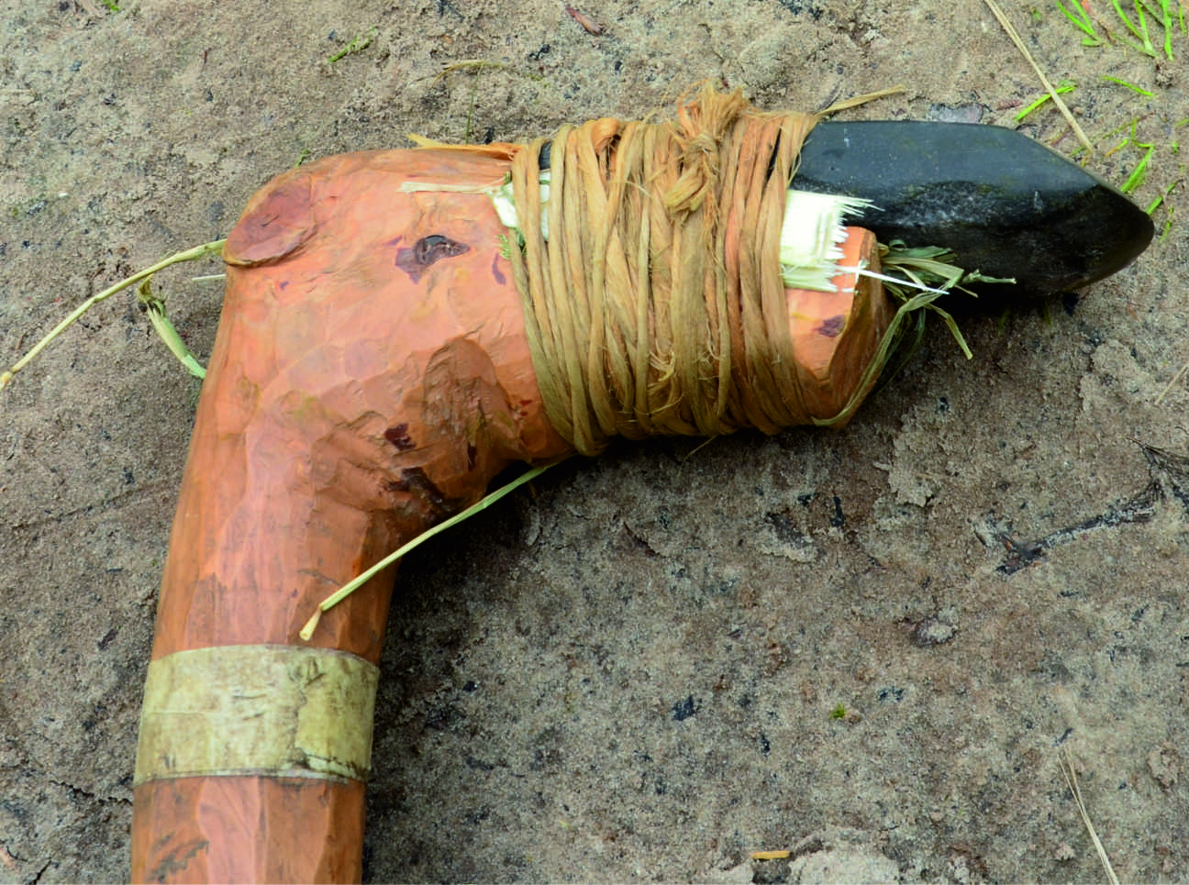
Figure 6. Replica adze hafted with twisted root bindings (© Horsterwold project, Laboratory for Artefact Studies, Leiden University).
After use, the edge was ground again, with a very hard stone, possibly flint (fig. 6g), causing extremely bright, almost metallic, linear streaks of spots of polish with a strong transverse directionality. The length of the polish streaks and their regularity indicates that it actually concerned grinding traces and that these traces were not the result of, for example, contact with ochre or some other mineral material. The striations within the polish vary in orientation from transverse to oblique to almost parallel to the edge. The polish and striations are limited to the edge of the implement. Although at first sight this could be interpreted as indicative of resharpening, a closer look reveals that the grinding was done in different directions, with the transverse orientation actually blunting the very edge (see Fig.6h which shows very clearly that the actual edge was rounded as a result of the grinding). The variable orientation of the grinding efforts resulted at some spots in a facet between two directions of grinding, further contributing to the blunting of the working edge (Fig. 6i). The working edge also appears to have been intentionally rounded (fig. 6h). There is therefore no question of resharpening. Instead, we suggest that the edge has been deliberately blunted by the repetitive grinding (Fig. 6ig). Although not visible to the naked eye, the effect would have been noticeable to anyone attempting to use this adze and the blunting can be felt by touch. Moreover, if the blunting would have taken place during the burial ceremony, as we suggest, then all concerned would have been knowledgeable of the act of decommissioning. This same treatment, seeming to rejuvenate but actually blunting the edge, has been observed before on axes from the Neolithic Funnelbeaker culture deposited with the dead in megaliths (van Gijn 2010; Wentink 2006; van Gijn & Raemaekers 2014, fig.2). As no multiperiod microwear study of adzes or axes from graves has been undertaken, we cannot be sure how temporally and geographically expansive this practice of decommissioning was.
Evidence of graveside destruction of offerings are recorded for modern hunter-gatherer groups (Woodburn 1982; see also discussion in Muniz 2004) and evidence suggestive of intentional damage of grave objects exists within a number of Mesolithic burials (e.g. Zagorskis 2004); yet, to our knowledge, no comparable example of intentional blunting of adzes/axes exists for the Mesolithic period.
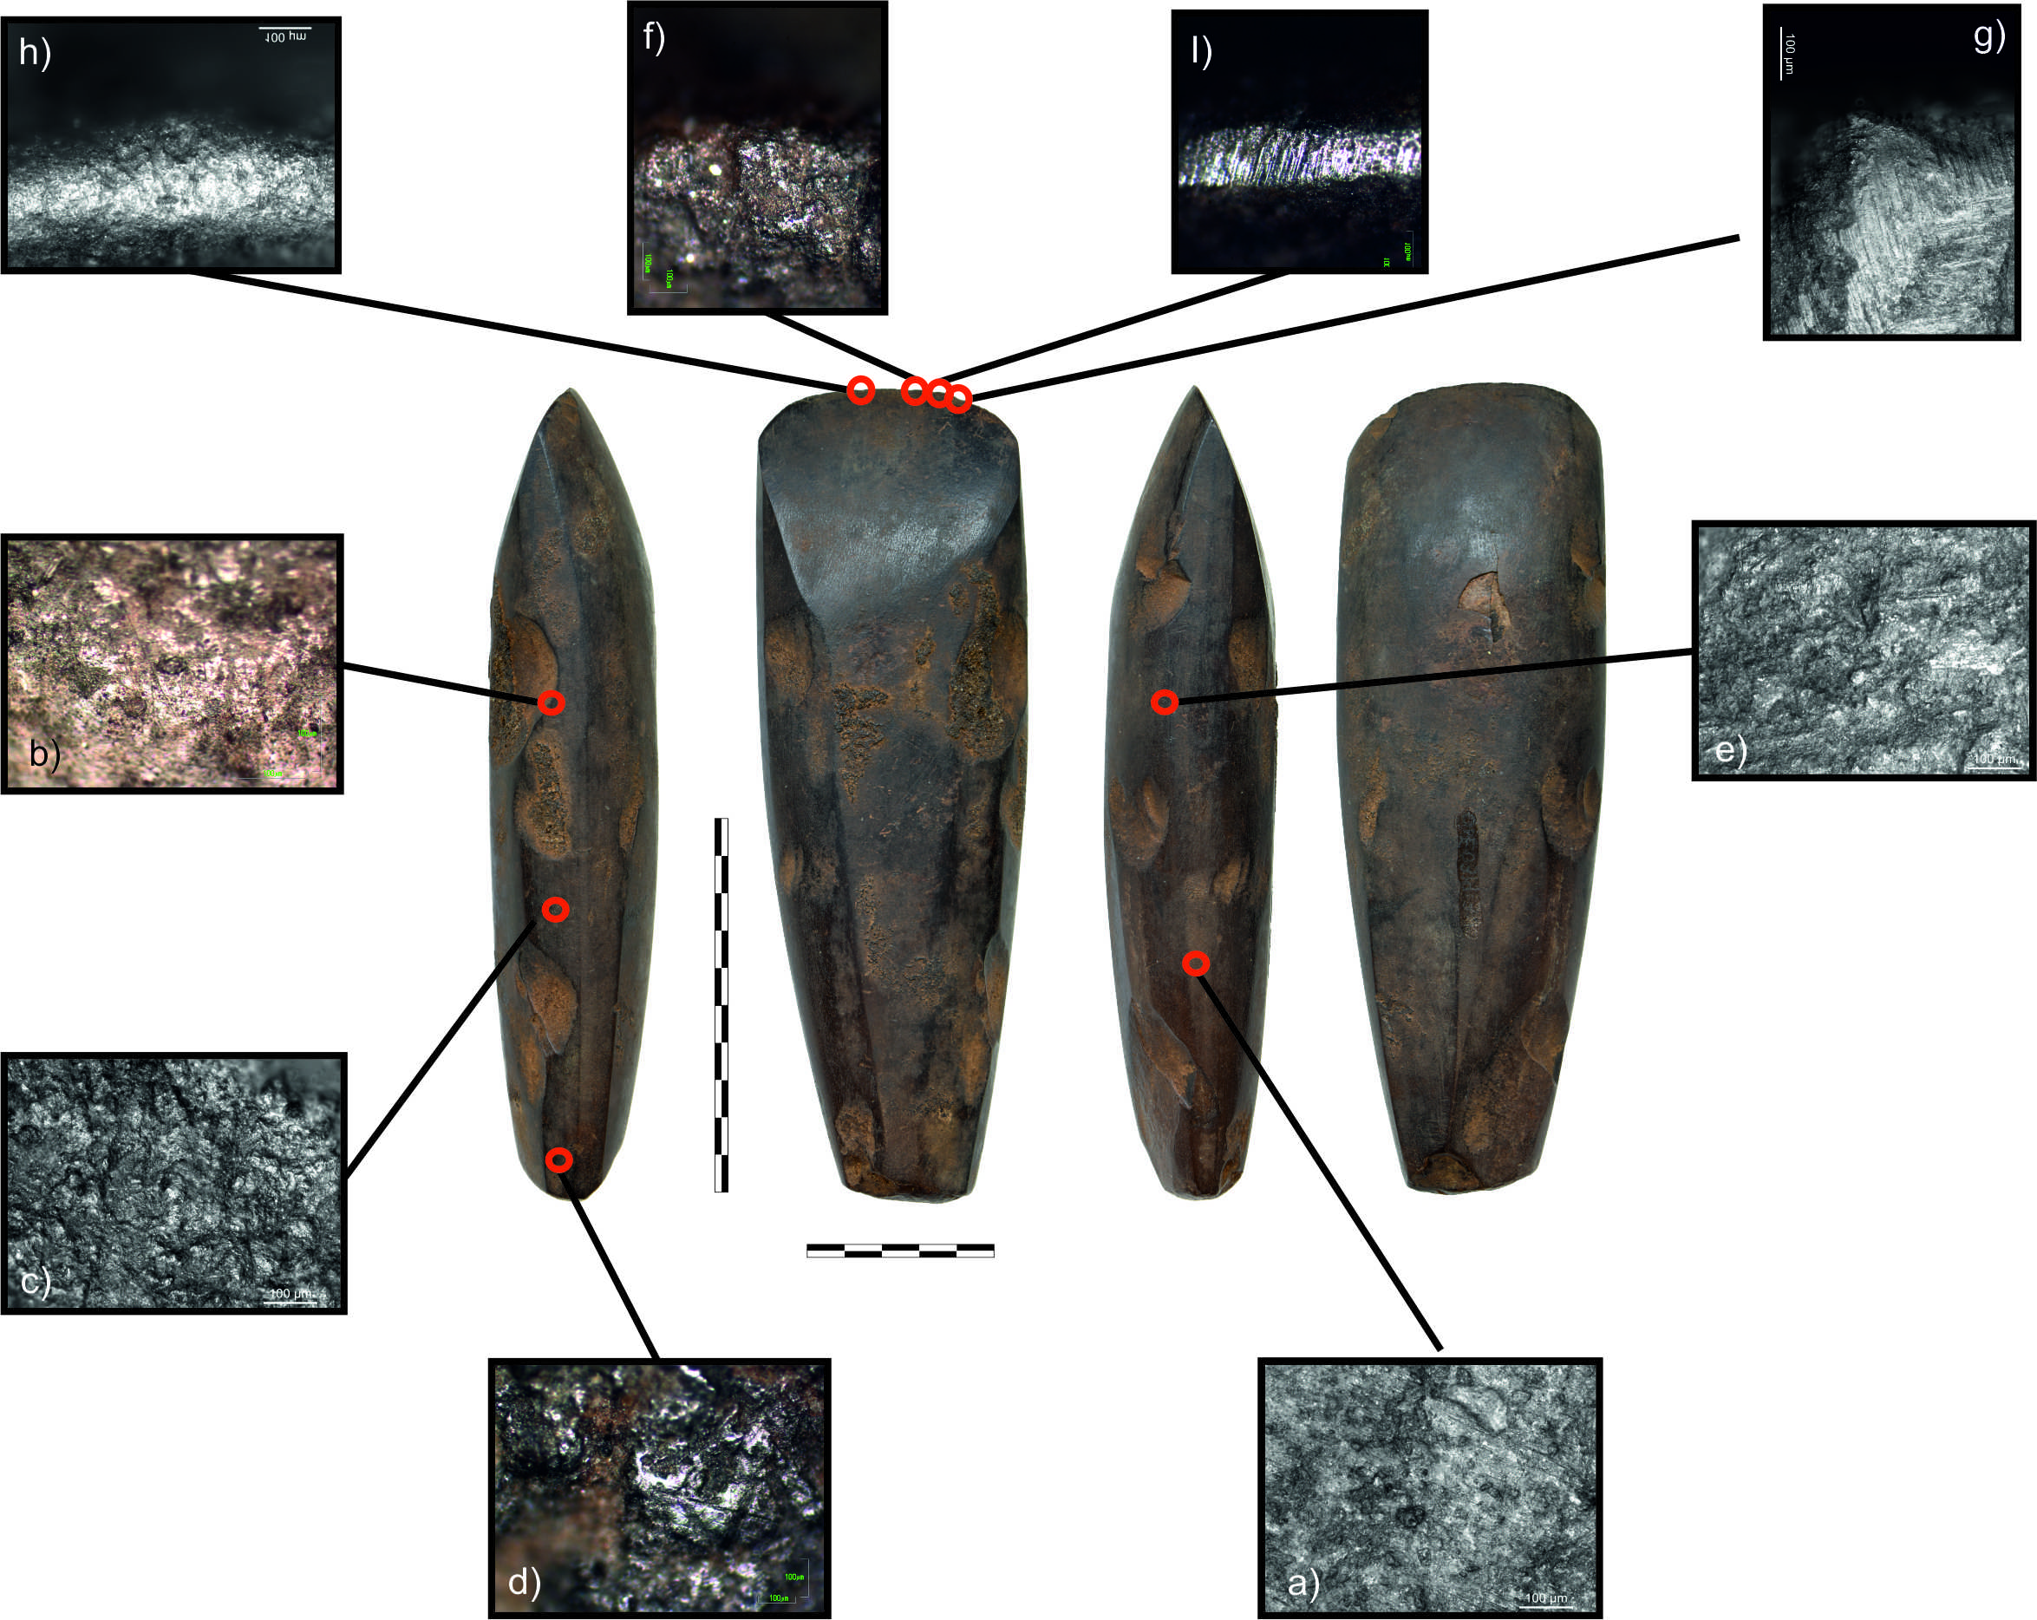
Figure 7 Microwear traces in relation to the adze morphology.

The biography of an Early Mesolithic grave good
Taking into consideration all the evidence from Hermitage presented above, we propose the following biography for the Hermitage shale adze: the shale was probably sourced locally, the adze was then made, perhaps even ‘commissioned’ either as the individual was dying or after (?) his death. In this regard it is interesting to note that technological and experimental analyses revealed some time went into the making of the adze, with care and attention placed on removing the knapping scars. However, these scars were not removed entirely. This incompleteness sits at odds with the other aspects of surface treatment which were completed to a high standard: suggesting that time pressures may have affected the amount of time allocated to the very final stages of its production. Although the cause of those time pressures will forever remain uncertain, the scheduling of the mortuary rites may have played a part in the apparent need for haste.

Because both hafting and heat alteration create bright spots it is not possible to say definitively that there is microwear evidence for hafting, but as woodworking polish is present along the working edge, the adze clearly must have been hafted. The adze was used to chop wood, but for a very limited duration of time. From the numerous experiments using replica axes for woodworking activities by researchers at the Laboratory for Artefact Studies at Leiden University and experiments at the Hosterwold Experimental Centre (van Gijn & Pomstra 2016) we know that woodworking traces on adzes/axes take a long time to develop, but even with that taken into consideration, the traces visible on this adze indicate a very short duration of use. It certainly was not well-used or curated, which is at odds with what would be expected for such a well-crafted object, unless it was abandoned, lost, or in this case, intended for ceremonial and/or ritual functions. We suggest that the wear traces on this adze may correspond to the length of time it would take to chop wood for the pyre and/or fell the tree to produce the grave marker. Thus it is possible that the adze played a part in the mortuary rites.

It can be argued that it is because of this active role in the funeral routines, the potential working of wood for the pyre and the gravemarker, that it was deemed necessary to kill the adze by intentional blunting of its working edge. This was achieved by using a hard stone such as flint, which was repeatedly ground across the working edge. These traces of blunting overlay previous woodworking traces, indicating that blunting was the last act prior to its deposition. The various material interactions within which the adze was enmeshed affected the adze and further caused the axe to have affect. The assembly of parts, the fragmented and well-cremated body, the post, the grave fill and goods, forming a syntax of graveside ritual through which the mourners made sense of their loss.

The death of the adze can be seen as an analogy to the end of life experienced by the person it accompanied into the ground: hence it provides a striking example of the intertwined lives of people and things (e.g. Joy 2009), and the dependency and entanglement of humans and things (Hodder 2011). But of course in most cosmological belief systems life does not end but change with death. We can go further to better understand these human actions, moving beyond the categorisation of material culture theory within the archaeological record, and to do so the rites practiced at this burial require contextualisation within the broader framework of hunter-gatherer studies. Ethnographic research on modern Northern European hunter-gatherer belief systems, in which the dead are regarded as having the power to return to the living, provides a framework for considering the measures taken to physically prevent the deceased returning to the world of the living. For example, the closure of paths leading to/from the cemetery and embedding a knife into the grave in order to stop the dead escaping (Jordan 2001). Archaeological examples, including stones being placed on the dead (Nilsson Stutz 2003) the wrapping of the corpse (Nilsson Stutz 2006), the frequency of occurrence of deliberately broken grave offerings (e.g. Zagorskis 2004; Mannermaa 2008; Larsson 1984),speak of similar preventive measures being enacted at the graveside during the Mesolithic. Within this context, the possibility of the recirculation of the Hermitage adze amongst the world of the living appears to have evoked as much fear as the return of the person it accompanied, requiring its decommissioning. In this context it is questionable, considering the close relationship of their treatment, whether adze and body were considered mutually exclusive entities at all, indicating the ‘inextricable enmeshment' (Olsen 2012, p.209) of people and things.

Discussion
The site of Hermitage is a striking addition to our understanding of Mesolithic Ireland for a number of reasons. Acknowledging the time and hence generation gap between the dates from the deposition of the cremated remains, people returned here to bury individuals on at least two occasions. Hence it could be argued on the one hand that the concept of a cemetery may have established at Hermitage from a very early stage; on the other hand there is a significant time gap between the episodes of burial activity. Interestingly, the mortuary rite utilised at Hermitage was cremation, contrasting with the evidence for inhumed bone from other sites in Ireland. Indeed, inhumation tends to dominate general discussion of Mesolithic burials and deposition of human bone at a European level, although the widespread use of cremation has been increasingly recognised over the last decade.

The adze itself holds chronological significance to our broader understanding of Early Holocene lithic technologies across Europe. It represents one of, if not the earliest dated example of a completely polished axe/adzehead within Europe. The fact it was found in a burial context - particularly a cremation - imbues the artefact with an increased social significance, which is arguably heightened by the microwear evidence suggesting that it was commissioned and decommissioned as part of the funerary rites. The Mesolithic in Northern Europe provides numerous examples of tools being gifted to the dead (Schulting 1996; Larsson 1988; Zagorskis 2004; e.g. Albrethsen & Brinch Petersen 1976; Gramsch & Schoknecht 2000). Most commonly, burial assemblages, with the addition of pendants, are made up of tools such as blades and knives. This can be read in various ways; these tools are multi-functional, which makes them ideal equipment for the unknown journey to afterlife. The bladelet and microlith deposited with the Hermitage adze can be read in much the same way - multifunctional, quickly manufactured, short-life tools. However, this higher rate of expediency contrasts to that associated with an adze; which, in this case, experimental research has shown would have taken focused effort and skill to make, and axes/adzes are typically regarded as curated objects.

Historically, Mesolithic research has tended to view grave goods as the possession of the deceased (Albrethsen & Brinch Petersen 1976; Brinch Petersen 2014); however, evidence is now emerging which shows that some tools found in graves played an active part in hunter-gatherer mortuary rites. For example, within the ochre-filled graves at Nederst, Denmark, microwear traces on four flint flakes displayed mineral traces congruent to that produced by scoring ochre to produce powder (Kannegaard in press). Thus, it appears, that some tools deposited with the deceased were employed in their graveside funerary rites. This evidence, the commissioning of the Hermitage axe, in addition to numerous occurrences of neonates (e.g. Brinch Petersen 2014; Brinch Petersen 1988) and even dogs with grave goods (Larsson 1984), suggests that we cannot assume that materials in a grave simply belonged to the deceased.

Returning to Hammelev, evidence indicates that the grave goods - a core axe, 16 blades and bladelets and a perforated bone or antler pin - had been treated differently. The bone pin accompanied the individual into the funeral pyre; the stone tools were simply placed in the grave. What guided the decision to cremate the bone pin and not the flint tools? Unfortunately, patination of the flint limited a detailed microwear study, but macro-analysis of the bone pin showed evidence of re-working after an earlier breakage, with ‘rounded edges of the surface fracture’ indicating use afterwards, the drilling of a new perforation, and the ‘shiny, polished surface [suggesting] it was already an old, well-worn piece of dry bone when committed to the funeral pyre’ (Eriksen & Andersen in press, p.4). The pin clearly had a rich and complex life history: it was a well-loved, personal belonging. Perhaps for this reason it was necessary for it to be cremated based on its “this life” connection to the individual, whilst the more expedient flint blades entered the grave un-burnt, fresh and ready for next life tasks.

The practice of creating material culture specifically for placement with burial echoes similar patterns of intentionally commissioning grave goods noted at Zvejnieki, Latvia, where technological differences between the production of animal tooth pendants found in burial and occupation contexts has been demonstrated (David 2006). The occupation contexts at the site feature animal teeth which have been notched for suspension via the sawing technique. In contrast, the tooth pendants recovered from contemporary graves have been perforated via drilling in order to be suspended - which strongly suggests that they were made for use as grave goods. This implies a similar pattern of material culture being commissioned specifically for use in a funerary context, and the associated levels of care and social interaction within mortuary practices (Stutz 2006) on the opposite sides of Europe during the Early Mesolithic.

At Hermitage, both the deceased and their grave good - the adze - share parallels in that they have contrasting aspects to their treatment. In both cases a high level of skill is required in achieving the final form of the cremation and the adze. The latter is extremely well crafted, finished with a high degree of attention. Similarly, the planning and skill required to create a funerary pyre capable of cremating human remains so efficiently suggests time and care were invested in making the cremation itself. Yet in both cases, despite the earlier effort invested in creating a specific form, destruction is a key objective of the process: expressed in the destruction of the body and the intentional blunting of the working edge of the adze. In equal measure, care was taken in the near complete recovery of the cremated skeletal remains, and by not destroying the integral form of the adze; the latter easily achieved by smashing into pieces. The need for “completeness” of both person and tool, combined with the varied level of destruction applied to both object and body provides evidence for a high degree of complexity in the planning and articulation of early Holocene mortuary rites.

In addition, the Hermitage Pit A cremation gives some unusual insights into the relationship between individuals and communities in Early Mesolithic Ireland. In reviewing the treatment of the body, the adze, and the presence of what has been interpreted as a gravemarker, it seems likely that this was a burial belonging to an individual of status. For which, it can be argued, retention of the all the fragments of their body, and the integral form of their adze, were critical to this individual’s successful transition to afterlife. The scale of time invested in the creation of the adze itself suggests the work of an individual, and could have been achieved within a day if so desired. The act of intentional blunting of the edge of the adze is similarly the act of one individual - an act so discrete that it calls into question the audience (if any) that witnessed it. However, the work required to gather fuel and assemble a funerary pyre is more indicative of a group of people working together in this particular element of the funerary rite. As such, it appears that the complexity of social interactions contained within the funerary rite encompassed space for both individual and communal acts of mourning.

The creation of a gravemarker highlights the temporal complexity of this particular funerary rite. The timing of the individual’s death, the commissioning of the adze, the management and collection of dry timber sources (within the context of a temperate Western Irish climate!), the excavation and filling of the pit, the revisitation implied through the erection of a grave marker, and the sporadic reuse of the site for further deposition of cremated remains, suggests that the death of this individual may have had a profound and long-lasting impact on the community which performed the cremation. These acts of commemoration may have begun whilst the person was still alive, if the adze was commissioned whist they were dying, or at least soon after their passing - as part of the preparations that were made during the funerary rites. Following the death itself, the actions involved in the funerary rite extended an awareness of this event into the social memory of this group long after the wooden grave marker had decayed away.

In sum, the analysis presented here illuminates a materially, temporally and socially complex funerary rite being practiced during the Irish Early Mesolithic, which contrasts significantly with the stereotypical single-event inhumations which have been previously thought to characterise the European Mesolithic. These unusual and profound insights into a hunter-gatherer community’s response to death are only possible through a multi-scalar approach to the archaeological material, with the interpretation of stratigraphic, radiometric and osteological data being dramatically affected by microscopic approaches to the material culture associated with this funerary context.

Conclusion
Given the very particular treatment of the body in Mesolithic burials (de-fleshing, dismemberment, disarticulation, rearticulation, wrapping, and various extended, crouched and flexed compositions within the grave) it should come as no surprise that objects were also given special and complex treatment as part of mortuary rituals, with certain objects belonging to particular members of a group requiring various scales of destruction (e.g. burning, intentional breakage, microscopically visible blunting of working edges) at the time of an individual’s death. Use traces on tools, only visible microscopically, and commonly overlooked in favour of ornaments, provide a methodological framework for investigating mortuary rites and religious belief systems for early Holocene hunter-gatherer societies. In the past, cremated remains have limited interpretations of an individual’s life history; here we have presented one alternative approach to that problem. By reconstructing the biography of the adze placed in the grave we have shown that it is possible to gain insights into the identity of the deceased, as well as reconstruct aspects of their mortuary rites. The evidence for commissioning, followed by decommissioning - the latter carried out in such a way to make the adze non functional in this life, but still retaining its form enabling its function in the next - brings new insights into Mesolithic belief systems.

Materials placed in Holocene hunter-gatherer graves have complicated biographies. A large scale regional project on Mesolithic grave tool assemblages is required in order to tease out patterns in the life histories of hunter-gatherer grave objects as it is clear that material travelled into graves by various routes. It is the varied nature of those journeys that we should be looking to understand.

Acknowledgements
The excavation was funded by the local authority, formerly Limerick County Council now Limerick City and County Council, the body who undertook the development works. Use-wear analysis of the adze was undertaken by the first two authors at the Laboratory for Artefact Studies, University Leiden, during a Marie Curie IEF Fellowship (2011-13) at the Laboratory for Artefact Studies, Leiden University, which was awarded to Aimée Little (TRAce project; Grant code no. 276516). We wish to extend thanks to the two anonymous reviewers whose feedback greatly improved this manuscript, Nik Hausmann for producing the map;Mark Edmonds for many a discussion on the social life of axes, and Chantal Conneller, Nicky Milner, Matthew Collins, and Oliver Craig who read and made constructive comments on various drafts of this manuscript (errors/omissions are our own).- Finally, we would like to dedicate this research to a fellow archaeologist, Dr Blaze O’Connor (1975-2009): a shining star in life and beyond.

Author biography for Aimée Little
Aimée Little is a Postdoctoral Research Associate on the ERC-funded POSTGLACIAL Project at the University of York. She has a BA in Anthropology and Maori Studies, a BFA in Etching and Maori and Polynesian Art from the University of Auckland. In 2010 she completed her PhD on the Irish Mesolithic at the University College Dublin. This was followed by a Marie Curie IEF Fellowship at the Laboratory for Artefact Studies, the Faculty of Archaeology, Leiden University. Aimée is a microwear and residue analysis specialist who works primarily on early Holocene hunter-gatherer material culture.

Bibliography
Adams, J.L., 2014. Ground stone use-wear analysis: a review of terminology and experimental methods. Journal of archaeological science, 48, pp.129–138.
Albrethsen, S.E. & Brinch Petersen, E., 1976. Excavation of a mesolithic cemetery at Vedbaek, Denmark. Acta Archaeologica, 47, pp.1–28.
Althin, C.A.G., 1954. The chronology of the stone age settlement of Scania, Sweden, R. Habelt.
Arts, N. & Hoogland, M., 1987. A Mesolithic settlement area with a human cremation grave at Oirschot V, municipality of Best, the Netherlands. Helinium, 27, pp.172–189.
Bar-Yosef, O. & Sillen, A., 1993. Implications of the new accelerator date of the charred skeletons from Kebara Cave (Mt. Carmel). Paléorient, pp.205–208.
Bayliss, A. & Woodman, P., 2009. A New Bayesian Chronology for Mesolithic Occupation at Mount Sandel, Northern Ireland. Proceedings of the Prehistoric Society, 75, pp.101–123.
Bergsvik, K.A. & Olsen, A.B., 2003. Traffic in stone adzes in Mesolithic western Norway. Mesolithic on the Move. Oxford: Oxbow Books, pp.395–404.
Bjerk, H., 2008. Norwegian Mesolithic Trends: A Review. In G. Bailey & P. Spikins, eds. Mesolithic Europe. Cambridge: Cambridge University Press, pp. 60–160.
Borić, D. et al., 2014. Late Mesolithic lifeways and deathways at Vlasac (Serbia). Journal of Field Archaeology, 39(1), pp.4–31.
Boric, D., Raičević, J. & Stefanović, S., 2009. Mesolithic cremations as elements of secondary mortuary rites at Vlasac (Serbia). Documenta Praehistorica, 36, pp.247–282.
Bowler, J.M. et al., 1970. Pleistocene Human Remains from Australia: A Living Site and Human Cremation from Lake Mungo, Western New South Wales. World Archaeology, 2(1), pp.39–60.
Boycott, T. & Mullan, G., 2003. Caves of County Clare & South Galway, University of Bristol Spelæological Society.
Brinch Petersen, E., 2014. Diversity of Mesolithic Vedbaek, oxford: ACTA ARCHAEOLOGICA.
Brinch Petersen, E., 1988. Ein mesolithisches Grab mit acht Personen von Stroby Egede, Seeland. Archäologisches Korrespondenzblatt, 18(2), pp.121–125.
Carlsson, T., 2007. Axe production and axe relations. In B. Hårdh, K. Jennbert, & D. Olausson, eds. ON THE ROAD STUDIES IN HONOUR OF LARS LARSSON. Acta Archaeologica Lundensia in 4o. Lund: Almqvist & Wiksell International, pp. 157–160.
Cauwe, N., 2001. Skeletons in Motion, Ancestors in Action: Early Mesolithic Collective Tombs in Southern Belgium. Cambridge Archaeological Journal, 11(02), pp.147–163.
Collins, T., 2009. Hermitage, Ireland: Life and death on the western edge of Europe. In Mesolithic horizons: Papers presented at the Seventh International Conference on the Mesolithic in Europe, Belfast. pp. 876–879.
Collins, T. & Coyne, F., 2005. Early Mesolithic Features at Hermitage, Castleconnell, Co. Limerick.
Cooney, G., 2015. Stone and flint axes in Neolithic Europe. In C. Fowler, J. Harding, & D. Hofmann, eds. The Oxford Handbook of Neolithic Europe. OUP Oxford, pp. 515–534.
Cooney, G. et al., 1998. The Irish Stone Axe Project, Wordwell.
Cooney, G. & Mandal, S. eds., forthcoming. The Irish Stone Axe Project Monograph II, Bray: Wordwell.
Costa, L.J., Sternke, F. & Woodman, P.C., 2005. Microlith to macrolith: the reasons behind the transformation of production in the Irish Mesolithic. Antiquity, 79, pp.19–33.
Crotti, P., 1993. L’Epipaléolithique et le Mésolithique en Suisse: les derniers chasseurs. La Suisse du Paléolithique à l’aube du Moyen-Age, 1, pp.203–240.
Cuenca Solana, D., Gutierrez Zugasti, I. & Conte, I.C., 2011. The use of mollusc shells as tools by coastal human groups: The contribution of ethnographical studies to research on Mesolithic and early Neolithic technologies in Northern Spain. Journal of anthropological research, 67(1), pp.77–102.
Cullen, T., 1995. Mesolithic mortuary ritual at Franchthi cave, Greece. ANTIQUITY-OXFORD-, 69, pp.270–270.
Cullen, T. & Cook, D.C., 1991. Mesolithic cremation at Franchthi cave, Greece: evidence and implications. American Journal of Archaeology, 95, p.305.
David, A. & Walker, E., 2004. Wales During the Mesolitihc Period. In A. Saville, ed. Mesolitihc Scotland and its neighbours: the early holocene prehistory of Scotland, its British and Irish context, and some Northern European perspectives. Edinburgh: Society of Antiquaries of Scotland, pp. 299–338.
David, E., 2006. Technical behaviours in the Mesolithic (9th-8th millennium cal. BC): The contribution of the bone industry from domestic and funerary contexts. Acta archaeologica Lundensia. Series in 8, (52), pp.235–252.
Dickson, F.P., 1981. Australian stone hatchets: a study in design and dynamics, Academic Pr.
Dowd, M., 2015. The Archaeology of Caves in Ireland, Oxbow Books.
Dowd, M. & Carden, R.F., 2016. First evidence of a Late Upper Palaeolithic human presence in Ireland. Quaternary science reviews, 139, pp.158–163.
Ducrocq, T. & Ketterer, I., 1995. Le gisement mésolithique du“ Petit Marais”, La Chaussée-Tirancourt (Somme). Bulletin de la Société préhistorique française, 92(2), pp.249–260.
Duday, H. & Courtaud, P., 1998. La nécropole mésolithique de La Vergne (Charente-Maritime). Sépultures d’occident et génèses des mégalithes, Paris, Errance, pp.25–34.
Edwards, R. & Brooks, A., 2008. The island of Ireland: Drowning the myth of an Irish land-bridge? The Irish naturalists’ journal, 29, pp.19–34.
Eriksen, B.V. & Andersen, H., in press. Hammelev. An Early Mesolithic cremation grave from Southern Jutland, Denmark. In J. M. Grünberg, ed. Rites, symbols and social organisation of early Postglacial communities. Saale: Halle: Landesmuseum füre Vorgeschichte Halle.
Fullagar, R., 2006. Residues and usewear. In J. Balme & A. Paterson, eds. Archaeology in Practice; A Student Guide to Archaeological Analyses. Oxford: Blackwell Publishing, pp. 207–233.
van Gijn, A.L. & Pomstra, D., 2016. Huize Hosterwold: the reconstruction of a Neolithic houseplan using Stone Age equipment. In L. M. Hurcombe & P. Cunningham, eds. The life cycle of structures in experimental archaeology: an object biography approach. Leiden: Sidestone Press.
van Gijn, A.L. & Raemaekers, D., 2014. Choosy about stone - the significance of the colour red the Dutch Funnel Beaker Culture. In Flint from Heligoland - the exploitation of a unique source of raw material on the North Sea Coast. Settlement and Coastal Research in the Southern North Sea Region 37. Rahden / Westfalen: Verlag Marie Leidorf GmbH, 195-202.
van Gijn, A., 2010. Flint in Focus: Lithic Biographies in the Neolithic and Bronze Age, Leiden: Sidestone Press.
van Gijn, A., 2014. Science and interpretation in microwear studies. Journal of archaeological science, 48, pp.166–169.
van Gijn, A. & Little, A., 2016. Tools, use-wear and experimentation: extracting plants from stone and bone. In K. Hardy & L. Kubiak-Martens, eds. Wild Harvest: Plants and people in the pre-agricultural and non-agricultural world. Studying Scientific Archaeology. Oxford: Oxbow, pp. 135–153.
Gil-Drozd, A., 2011. The Origins of Cremation in Europe. Analecta Archaeologica Ressoviensia, 5, pp.9–94.
Gilhooly, B., 2012. Neither Rough nor Tuff; an Experimental Approach to Understanding the Durability of Prehistoric Shale Axes. University College Dublin.
Gilmour, N. & Loe, L., 2015. A Mesolithic cremation-related deposit from Langford, Essex, England: a first for the British Mesolithic. Mesolithic Miscellany, 23(2), pp.55–57.
Gramsch, B. & Schoknecht, U., 2000. Groß Fredenwalde, Lkr. Uckermark-eine mittelsteinzeitliche Mehrfachbestattung in Norddeutschland. Veröffentlichungen zur brandenburgischen Landesarchäologie, 34, pp.9–38.
Grünberg, J.M., 2006. New AMS dates for Palaeolithic and Mesolithic camp sites and single finds in Saxony-Anhalt and Thuringia (Germany). Proceedings of the Prehistoric Society, 72, pp.95–112.
Henriksen, B.B., Aaris-Sørensen, K. & Sørensen, I., 1976. Sværdborg I: excavations 1943-44: a settlement of the Maglemose culture, Akademisk forlag.
Hodder, I., 2011. Human-thing entanglement: towards an integrated archaeological perspective. The journal of the Royal Anthropological Institute, 17(1), pp.154–177.
Holland, C.H. ed., 2001. Introduction. In The geology of Ireland. Edinburgh: Dunedin, pp. 1–6.
Jordan, P.D., 2001. Cultural Landscapes in Colonial Siberia: Khanty Settlements of the Sacred, the Living and the Dead. Landscapes, 2(2), pp.83–105.
Joy, J., 2009. Reinvigorating object biography: reproducing the drama of object lives. World archaeology, 41(4), pp.540–556.
Kannegaard, E., in press. Late Mesolithic ochre graves at Nederst, Denmark: Ochre rituals and customs of personal adornment. In Band 13. Tagungen Des Landesmuseums Fūr Vorgeschichte Halle.
Knowles, W.J., 1893. Irish Stone Axes and Chisels. Journal of the Royal Society of Antiquaries of Ireland. Royal Society of Antiquaries of Ireland, 3(2), pp.140–163.
Lanting, J.N., Aerts-Bijma, A.T. & van der Plicht, J., 2001. Dating of cremated bones. Radiocarbon, 43(2; PART A), pp.249–254.
Larsson, Å.M. & Stutz, L.N., 2014. Reconcilable Differences. Transformation by Fire: The Archaeology of Cremation in Cultural Context, p.47.
Larsson, L., 1984. The Skateholm project. A late Mesolithic settlement and cemetery complex at a Southern Swedish bey. Papers of the Archaeological Institute University of Lund, New Series Vol., pp.5–38.
Larsson, L., 1988. The Skateholm Project: Man and Environment, Almqvist & Wiksell International.
Le Goff, I., 2000. Une incinération mésolithique à la Chaussée-Tirancourt“ Le Petit Marais”(Somme). CROTTI P. (a cura di), Meso, 97, pp.115–118.
Leon, B.C., 2005. Mesolithic and Neolithic Activity on Dalkey Island—A Reassessment. The Journal of Irish Archaeology, 14, pp.1–21.
Lewis, R. et al., 2011. Abrasive and impact wear of stone used to manufacture axes in Neolithic Greece. Wear: an international journal on the science and technology of friction lubrication and wear, 271(9–10), pp.2549–2560.
Lindgren, C., 1995. Prehistoric quartz quarries and quarrying in Eastern Middle Sweden. Archaeologia Polona, 33, pp.89–97.
Maigrot, Y., 2003. Ivory, bone and antler tools production systems at Chalain 4 (Jura, France), late Neolithic site, 3rd millennium. In From Hooves to Horns, from Mollusc to Mammoth--Manufacture and Use of Bone Artefacts from Prehistoric Times to the Present. Proceedings of the 4th Meeting of the ICAZ WBRG at Tallinn. academia.edu, pp. 113–126.
Mandal, S. et al., 2004. Archaeological experiments in the production of stone axeheads. Lithics in Action, pp.116–123.
Mannermaa, K., 2008. Birds and burials at Ajvide (Gotland, Sweden) and Zvejnieki (Latvia) about 8000--3900BP. Journal of Anthropological Archaeology, 27(2), pp.201–225.
McKinley, J.I., 1994. Bone fragment size and weights of bone from modern British cremations and the implications for the interpretation of archaeological cremations. International Journal of Osteoarchaeology, 3(4), pp.283–287.
Meiklejohn, C., Bosset, G. & Valentin, F., 2010. Radiocarbon dating of Mesolithic human remains in France. Mesolithic Miscellany, 21(1), pp.10–56.
Meiklejohn, C. & Woodman, P., 2012. Radiocarbon dating of Mesolithic human remains in Ireland. Mesolithic Miscellany, 22(1), pp.22–41.
Muniz, M.P., 2004. Exploring Technological Organization and Burial Practices at the Paleoindian Gordon Creek Site (5LR99), Colorado. Plains anthropologist, 49(191), pp.253–279.
Neill, J., 2014. Stone Axe Manufacture: An Experimental Study. University College Dublin.
Nilsson Stutz, L., 2003. Embodied Rituals and Ritualized Bodies : Tracing Ritual Practices in Late Mesolithic Burials. Almqvist & Wiksell International. Available at: http://lup.lub.lu.se/record/21368 [Accessed August 22, 2016].
Oestigaard, T., 2000. Sacrifices of Raw, Cooked and Burnt Humans. Norwegian Archaeological Review, 33(1), pp.41–58.
Oestigaard, T. & Goldhahn, J., 2006. From the Dead to the Living: Death as Transactions and Re‐negotiations. Norwegian Archaeological Review, 39(1), pp.27–48.
Olsen, A.B. & Alsaker, S., 1984. Greenstone and diabase utilization in the stone age of western Norway: Technological and socio‐cultural aspects of axe and adze production and distribution. Norwegian Archaeological Review, 17(2), pp.71–103.
Olsen, B., 2012. Symmetrical archaeology. In I. Hodder, ed. Archaeological theory today. Cambridge: Polity Press, pp. 208–228.
Olsen, J. et al., 2008. Characterisation and blind testing of radiocarbon dating of cremated bone. Journal of archaeological science, 35(3), pp.791–800.
Parker Pearson, M., 2003. The Archaeology of Death and Burial, Sutton.
Petersen, E.B. & Meiklejohn, C., 2003. Three cremations and a funeral: Aspects of burial practice in Mesolithic Vedbaek, Left Coast Press Oxford.
Pettitt, P. & White, M., 2012. The British Palaeolithic: human societies at the edge of the Pleistocene world, Routledge.
Roberts, C.A., 2009. Human remains in archaeology: a handbook,
Schulting, R.J., 1996. Antlers, bone pins and flint blades: the Mesolithic cemeteries of Téviec and Hoëdic, Brittany. Antiquity, 70(268), pp.335–350.
Sevastopulo, G.D., 2009. Carboniferous: Mississippian (Serpukhovian) and Pennsylvanian. The Geology of Ireland: Edinburgh, Dunedin Academic Press Ltd.
Sleeman, A., McConnell & Gately, S., 2004. Understanding Earth processes, rocks and the geological history of Ireland, Dublin: Geological Survey of Ireland.
Smits, L. & van der Plicht, H., 2009. Mesolithic and Neolithic human remains in the Netherlands: physical anthropological and stable isotope investigations. Journal of Archaeology in the Low Countries, 1(1), pp.55–85.
Sørensen, L. & Casati, C., 2010. The Maglemose Culture in the Southern Baltic. University of Copenhagen.
Steensberg, A., 1991. Hafting of a stone axe-adze and its use in the fire-clearance husbandry of Papua New Guinea. Tools and Tillage (Denmark). Available at: http://agris.fao.org/agris-search/search.do?recordID=DK9221048.
Stutz, L.N., 2006. Unwrapping the dead: Searching for evidence of wrappings in the mortuary practices at Zvejnieki. Acta archaeologica Lundensia. Series in 8, (52), pp.217–233.
Sulgostowska, Z., 2006. Mesolithic mobility and contacts on areas of the Baltic Sea watershed, the Sudety, and Carpathian Mountains. Journal of Anthropological Archaeology, 25, pp.193–203.
Toussaint, M. et al., 2009. The Mesolithic site of Heffingen-Loschbour (Grand Duchy of Luxembourg). A yet undescribed human cremation possibly from the Rhine-Meuse-Schelde culture: anthropological, radiometric and archaeological implications. In P. H. Crombé et al., eds. Chronology and evolution within the Mesolithic of North-West Europe. Cambridge: Cambridge Scholars Publishing, pp. 239–260.
Valdeyron, N., 2008. The Mesolithic in France. In G. Bailey & P. Spikins, eds. Mesolithic Europe. Cambridge: Cambridge University Press, pp. 182–202.
Valentin, F. et al., 2008. Découvertes récentes d’inhumations et d’une incineration datées du mésolithique en Île-de-France. Revue Archéologique d’Ile-de-France (RAIF), 1, pp.21–42.
Verjux, C., 2000. The function of the Mesolithic sites in the Paris basin (France). New data. In Mesolithic on the move. Papers presented at the sixth international conference on the Mesolithic in Europe, Stockholm. pp. 262–268.
Wentink, K., 2006. Ceci n’est pas une hache. Neolithic depositions in the Northern Netherlands. Leiden: Leiden University.
Whittow, J.B., 1974. Geology and scenery in Ireland, Penguin.
Woodburn, J., 1982. Social dimensions of death in four African hunting and gathering societies. Death and the Regeneration of Life, pp.187–210.
Woodman, P., 2015. Ireland’s first settlers: time and the Mesolithic, Oxford: Oxbow Books.
Woodman, P.C., 1985. Excavations at Mount Sandel, 1973-77, County Londonderry, HM Stationery Office.
Woodman, P.C., 1978. The Mesolithic in Ireland: hunter-gatherers in an insular environment, British Archaeological Reports.
Zagorskis, F.A., 2004. Zvejnieki (Northern Latvia) stone age cemetery, British Archaeological Reports.

