Exchange bias induced at a Co2FeAl0.5Si0.5/Cr interface

C.N.T. Yu1. A.J. Vick1, N. Inami2, K. Ono2, W. Frost3 and A. Hirohata3

*1 Department of Physics, University of York, York, United Kingdom*

*2 Institution of Materials Structure Science, High Energy Acceleration Organization (KEK), Tsukuba, Japan*

*3 Department of Electronics, University of York, York, United Kingdom*

In order to engineer the strength of an exchange bias in a cubic Heusler alloy layer, crystalline strain has been induced at a ferromagnet/antiferromagnet interface by their lattice mismatch in addition to the conventional interfacial exchange coupling between them. Such interfaces have been formed in [Co2FeAl0.5Si0.5(CFAS)/Cr]3 structures grown by ultrahigh vacuum molecular beam epitaxy. The magnetic and structural properties have been characterised to investigate the exchange interactions at the CFAS/Cr interfaces. Due to the interfacial lattice mismatch of 1.4%, the maximum offset of 18 Oe in a magnetisation curve has been measured for the case of a CFAS (2 nm)/Cr (0.9 nm) interface at 193K. The half-metallic property of CFAS has been observed to remain unchanged, which agrees with the theoretical prediction by Culbert *et al.* [*J. Appl. Phys.* **103**, 07D707 (2008)]. Such a strain-induced exchange bias may provide insight of the interfacial interactions and may offer a wide flexibility in spintronic device design.

Exchange bias can be observed at an interface between ferromagnetic (FM) and antiferromagnetic (AF) materials under a field-cooled condition [1, 2, 3]. It is a result of interfacial magnetic coupling between FM and AF layers where the direction of magnetic anisotropy is shared by the setting. While the sample is cooled between the Néel temperature and Curie temperature with a presence of an applied magnetic field, the interfacial AF spins are coupled to the FM spins. During the FM magnetisation reversal, the AF layer spins do not follow the applied magnetic field, resulting in a horizontal shift in a magnetisation loop [4]. To increase the interfacial exchange bias, thin FM/AF layers with their crystalline matching are favourable. Thin layers can maximise the interfacial coupling and are more appropriate for device implementation [5]. The exchange bias has been used to form a magnetically pinned layer in devices such as magnetic sensors and read heads for hard disk drives.

There have been very few reports on exchange bias behaviour of Co-based Heusler alloys, which is a half-metallic ferromagnet [6] since there are several critical parameters to be controlled such as lattice mismatch, diffusion across the interface and impurities. The largest value of exchange bias at room temperature (RT) reported for Heusler alloy sample was 2520 Oe [7] with a Ni-based polycrystalline bulk [superparaagnetic Ni2Mn(Al,Si)] 250 Oe with a Co-based polycrystalline film (Co2FeAl0.5Si0.5/IrMn) [8]. These works are all based on the conventional exchange coupling induced at the FM/AF interfaces. However, according to Culbert *et al.* [9], a weak AF Cr ultrathin layer attached onto a Heusler alloy layer has been theoretically predicted not to affect its half-metallicity but to introduce the exchange coupling due to its interfacial strain. Cr is selected because it has a good epitaxial relationship with a conventional Heusler alloy, e.g., Co2FeAl0.5Si0.5 (CFAS). Epitaxial CFAS/Cr/CFAS tri-layers have then been grown by Furubayashi *et al.* [10], however they only show negligible exchange bias. This discrepancy between the theory and experiment may be caused because defects can be induced inevitably during the growth due to the lattice mismatch between the FM and AF layers (1.4%) [11, 12].

In this study, the uniaxial anisotropy is intentionally introduced in a Heusler alloy/Cr interface to enhance the exchange bias. The effect of crystalline strain on the exchange bias at the CFAS/Cr interface is investigated using repeated CFAS/Cr stacks by three times. Epitaxial growth and precise magnetic measurements with accurate in-place magnetic field control allow systematic study on the interfacial exchange bias and the induced lattice strain.

Samples with a stack structure of Cr (3)/Ag (30)/[CFAS (*t*CFAS)/Cr (*t*Cr)]3/Au (3) (nm), where CFAS is the FM layer and Cr is the AF layer, were grown on a single crystal MgO(001) substrate by ultrahigh vacuum (UHV) molecular beam epitaxy (MBE) at RT. The base pressure of the MBE system was 1.2x10-8 Pa and the pressure during the deposition was between 4.5x10-8 and 6.8x10-7 Pa. The deposition rate of these layers was controlled by adjusting the electron-beam current and was maintained to be at 0.01 nm/sec. The MgO substrate was pre-cleaned by ultra-sonication in acetone, isopropyl alcohol (IPA) and deionised water for 5 min. each, followed by pre-annealing at 600°C for 1 hour in the UHV chamber. The Cr/Ag seed layer was used to improve the crystallinity of CFAS as previously reported in similar films [13]. A series of samples were produced by varying the CFAS thickness to be 1 nm≤ *t*CFAS ≤ 4 nm and the Cr thickness to be 0.3 nm≤ *t*Cr ≤ 1.2 nm. These thicknesses were much smaller than the previous study on a similar system as reported in reference [10] and with more CFAS/Cr interfaces by repeating these layers by three times. No annealing was performed during and after the deposition to avoid inter-layer-diffusion of the Cr layer.

The crystalline structures of the samples were analysed by X-ray diffraction (XRD) at the Photon Factory (PF) in the High Energy Acceleration Organization (KEK). ADE Model 10 vibrating sample magnetometer (VSM) was used to study magnetic properties of the samples, which were cut into a circular shape to remove any shape anisotropy, measured at RT and 193K. Here, the Curie temperature of bulk Co2FeAl, which has similar magnetic properties with CFAS has been reported to be 1170K [14] and the Néel temperature of bulk Cr has been reported to be 311K [15], both of which are above the measurement temperatures in this study. The exchange bias was measured by following the York Protocol [3] with the setting temperature of 498K and the cooling field of 2 kOe. X-ray circular dichroism (XMCD) measurements were also performed at the PF in the KEK by applying a magnetic field of 120 kOe perpendicular to the film.

Reflection high-energy electron diffraction (RHEED) images for analysing surface structures were obtained during the MBE growth. Images were taken before and after the growth of each layer as respectively shown in Fig. 1. The RHEED pattern from the MgO substrate has relatively large spots, indicating that the surface of the substrate possess long-range roughness after annealing. Such roughness can be removed by depositing the Cr and Ag buffer layers as confirmed by the streak RHEED patterns. The pattern after the Ag deposition at RT clearly shows a formation of the face-centred cubic (fcc) (001) surface observed, confirming the epitaxial relationship of MgO(001)[110]//Ag(001)[110] with 3.1% lattice mismatch as reported previously [16]. The CFAS deposition is found to make the surface to be slightly rough as shown by the increase in the width of the streaks. This is due to initial island-like growth of the CFAS layer as similarly reported in Co2(Cr,Fe)Al films grown on GaAs(001) [17]. However, the epitaxial growth with the above crystalline orientation is maintained throughout the layer stack up to the Au capping layer.

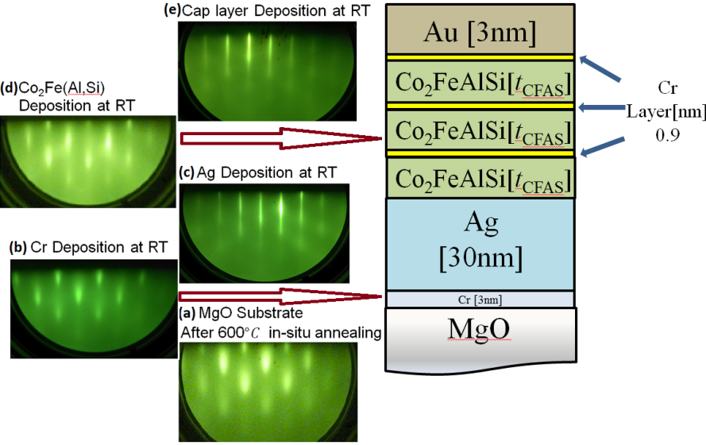

Figure 1. Schematic multilayered structure and the associated RHEED patterns taken (a) after annealing the MgO(001) substrate at 600°C for 1 h and after the deposition of (b) Cr, (c) Ag, (d) CFAS and (e) Au layers at RT.

Subsequently, XRD patterns were taken for one of the samples with *t*CFAS = 3 nm and *t*Cr = 0.9 nm as shown in Fig. 2. The pattern clearly shows strong spots from the MgO substrate, proving the single-crystallinity of the substrate. However, the Ag(111), (220) and (200) patterns form a weak ring, indicating that the Ag seed layer has some texture with minor crystalline misalignments in the plane. This may be induced by the long range roughness the MgO substrate initially has as observed in Fig. 1(a). Additionally rings are seen just outside of the Ag(220) ring in Fig. 2, which may represent Au(220) and CFAS(400). Here, Cr(200) may be overlapped with the Au peak, which suggests the lattice contraction of the Cr layer due to the presence of the CFAS neighbouring layer. The CFAS lattice constant is estimated to be 0.567 nm from Fig. 2, which is almost the same with the bulk value and our single-film value of 0.568 nm [18], while the Cr lattice constant is estimated to be 0.283 nm, which is 2% contraction as compared with the bulk value and our single-film value of 0.288 nm. These rings again confirm that the epitaxial growth of the [CFAS/Cr] samples with some in-plane misaligned textures.

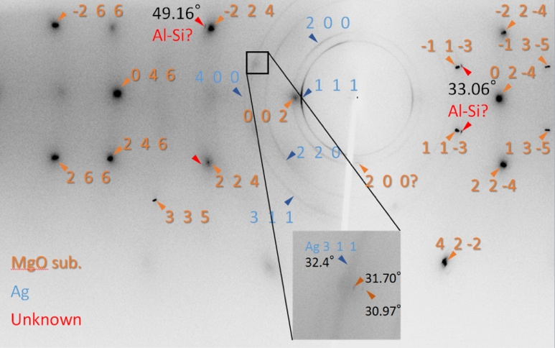

Figure 2. XRD pattern of the [*t*CFAS = 3 nm/*t*Cr = 0.9 nm] sample. The magnified image in the vicinity of 30 ~ 33° is also shown.

To engineer the exchange bias, the thickness of the Cr layer was first optimised to induce the maximum change onto the magnetisation curves of the [CFSA/Cr] samples. Figure 3(a) shows the magnetisation curves with *t*CFAS = 2 nm and 0.3 nm ≤ *t*Cr ≤ 1.2 nm measured at RT. The sample with *t*Cr = 0.9 nm shows a largest *H*c and squareness (0.98), therefore, *t*Cr = 0.9 nm is selected for further investigation. The thickness of the CFAS layer was then optimised by maintaining *t*Cr to be 0.9 nm, as shown in Fig. 3(b). By varying the thickness of both Cr and CFAS, *M*s and *H*c vary from 619 emu/cm3 (*t*CFAS = 1 nm and *t*Cr = 0.3 nm) to 1060 emu/cm3 (*t*CFAS = 2 nm and *t*Cr = 0.9 nm) and 10 Oe (*t*CFAS = 1 nm and *t*Cr = 0.3 nm) to 80 Oe (*t*CFAS = 2 nm and *t*Cr = 0.9 nm), respectively. *M*s corresponds to 128% of the theoretical value predicted by the generalised Slater-Pauling curve [8]. This may indicate that the magnetic dead layer can be 0.25nm thick at the CFAS/Cr interfaces, which is similar to the epitaxial Co2(Cr,Fe)Al/GaAs system as previously reported [17]. However, the bulk regions of the CFAS layers maintain their magnetic moments as predicted [9].

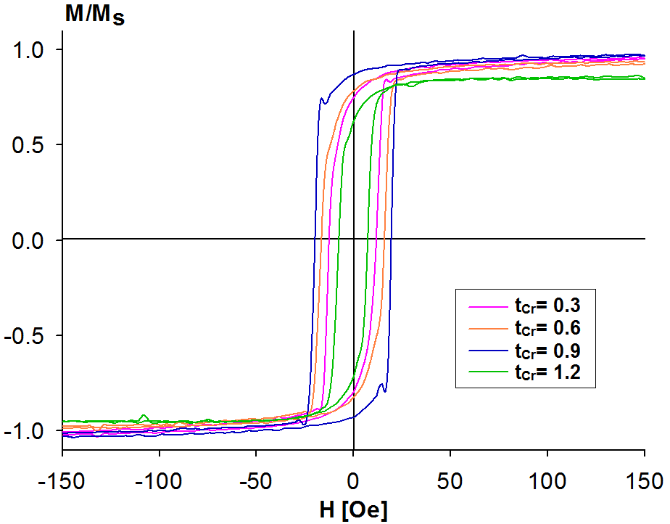 

(b)

(a)

Figure 3. Magnetisation curves of the (a) [*t*CFAS = 2 nm/*t*Cr] with 0.3 nm≤ *t*Cr ≤ 1.2 nm measured at RT and (b) [*t*CFAS/*t*Cr = 0.9] with 1 nm ≤ *t*CFAS ≤ 4 nm along the MgO [110] axis.

These samples with *t*Cr = 0.9 nm were also evaluated by rotating the in-plane fields at 193K. The largest value of squareness (*M*r/*M*s) is found to lie along 140° from the MgO [110] axis and the smallest *M*r/*M*s is 0.34 along 40° in *t*CFAS = 2 nm sample as shown in Fig. 4(d). CFAS has been reported to be cubic to exhibit fourfold magnetic anisotropy in their bulk regions [6] but the Co-based Heusler alloys are known to show uniaxial anisotropy in their thin film form [17]. From Fig. 4(a), it shows uniaxial anisotropy in the thinner region (*t*CFAS ≤ 4 nm) which is not consistent with the previous report and is also similar to an ultrathin Fe film strained by lattice mismatch [19]. For the *t*CFAS = 2 nm sample, the uniaxial anisotropy is found to be the maximum at almost 30° from the MgO[110] axis. The origin of the minor tilt is not clear at this stage but it may be induced by the interfacial strain. As the thickness of the Heusler alloy layer increases above 3 nm, *H*c is found to decrease, which is the result of emerging bulk-like properties of the Heusler-alloy layers. It should also be noted that the uniaxial anisotropy changes its orientation along the MgO[110] axis above *t*CFAS = 3 nm. This may indicate that the strong uniaxial anisotropy at ~ 30° induced by the Cr layer is interfacial sensitive and can be relaxed along the MgO[110] axis above five monolayers (~ 3 nm) of the CFAS deposition as previously reported. Figure 4(b) shows the corresponding remanence of the sample with *t*CFAS = 2 nm. This graph also shows 30° offset from the MgO[110] axis but in the opposite direction. This offset again vanishes by removing the Cr neighbouring layer, *i.e.*, single CFAS layer on MgO(001), as shown in Fig. 4(c). In the samples with *t*CFAS = 2 nm, there is a loop shift of 18 Oe as shown in Fig 4(d). This is five times larger than the previous reported value [9]. This proves that the exchange bias can be induced even by a weak AF layer by introducing additional interfacial strain in an epitaxial FM/AF structure.

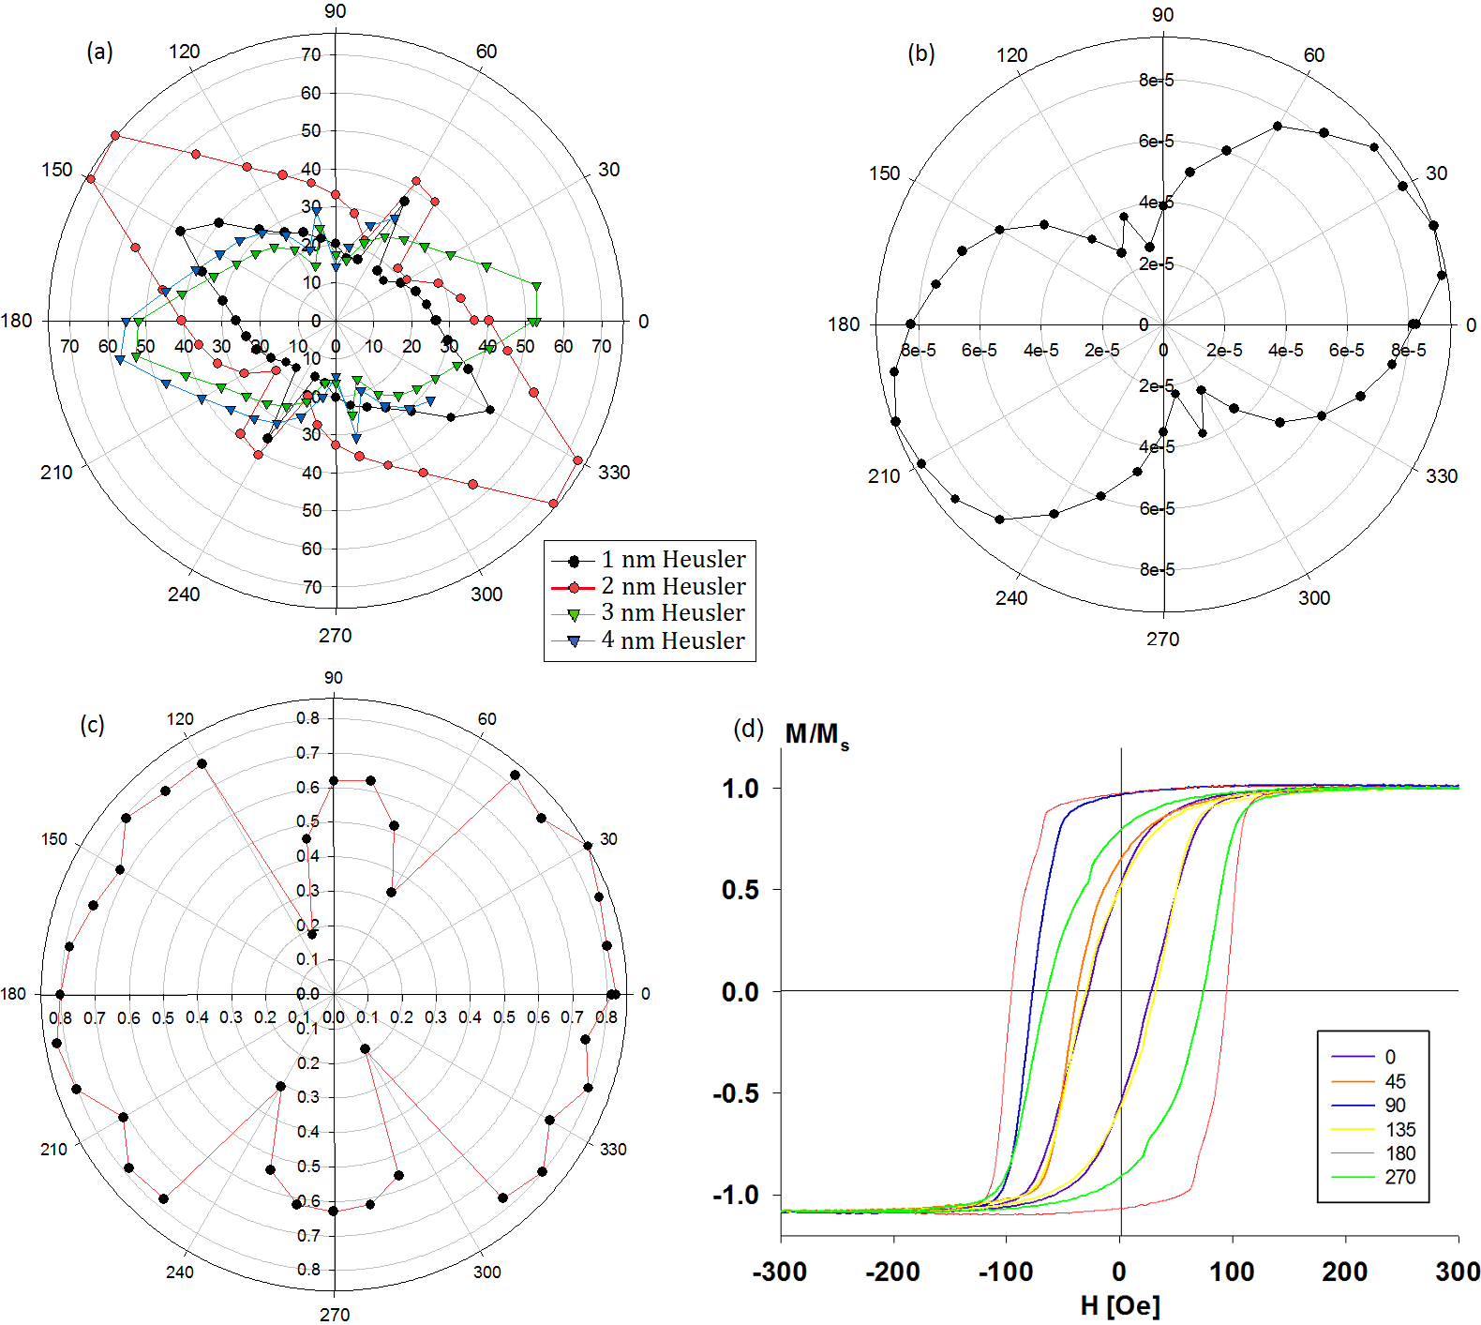

Figure 4. (a) Coercivity polar plot for the 4 sample with 1 nm ≤ *t*CFAS ≤ 4 nm with *t*Cr = 0.9 nm. The corresponding remanence polar plots is also shown for (b) the sample with *t*CFAS = 2 nm and (c) the 2 nm thick single CFAS film grown on the MgO substrate. (d) Representative magnetisation curves for the *t*CFAS = 2 nm sample.

In order to confirm the orbital and spin moments of the CFAS layer, XMCD measurements were also performed. As shown in Fig. 5(a), the circularly polarised X-ray was introduced at tilted angles of both 0° and 55° from the plane normal. The XMCD results show a spin moment (*m*spin) of (0.847 ~ 0.849) µB/atom and orbital moment (*m*orb) of (0.078 ~ 0.085) µB/atom for Co. These values are about 15% smaller as compared with the previously reported value in a similar Heusler alloy Co2FeAl [20]. This reduction may be caused by possible atomic disorder at the CFAS/Cr interfaces as discussed above. For Fe, *m*spin and *m*orb are measured to be (1.095 ~ 1.161) µB/atom and (0.154 ~ 0.1610) µB/atom, respectively. These values agree very well with the previous report [20]. These results further confirm indirectly that the sample maintains its half-metallicity as theoretically predicted [21], indicating the increase in the coercivity and exchange bias is due to the strain-induced coupling at the CFAS/Cr interfaces. Therefore, the exchange coupling between the Heusler alloy films and antiferromagnetic Cr films can be controlled by tuning the lattice matching without sacrificing their half-metallicity.

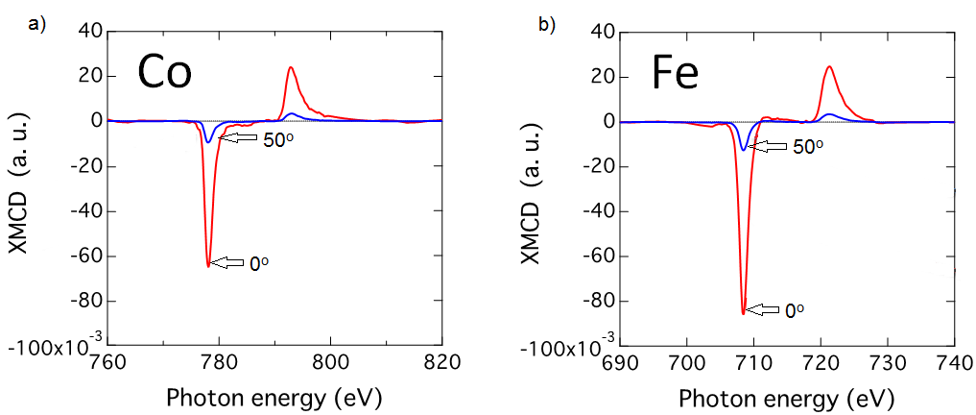

Figure 5. XMCD profiles for (a) Co and (b) Fe atoms in the sample with *t*CFAS=2 nm and *t*CFAS=0.9 nm. Red and blue lines represent the magnetic field applications at 0° and 55° from the plane normal, respectively.

In summary, we have measured a loop shift of 18 Oe at 193K in the [Co2FeAl0.5Si0.5(2 nm)/Cr (0.9 nm)]3 samples due to the lattice mismatch at the interface. This value is five times larger than the previously reported value [10]. The spin and orbital moments of the samples are found to be similar to those in the Co2FeAl single layer. These findings agree with the theoretical prediction [9]. For device applications a larger loop shift is required but such a strained system can offer an effective method to increase the exchange bias. Such a system may reveal insight of interfacial exchange coupling without sacrificing the half-metallicity of the Heusler alloys and may increase the design flexibility for spintronic devices.

**Acknowledgements**

We would like thank Mr Brent Wilkinson for his support for the sample fabrication. This work has been partially supported by EU FP-7 project (NMP3-SL-2013-604398) and UK EPSRC (EP/M02458X/1).

**References**

1. Meiklejohn, W., & Bean, C. (1956). *Phys. Rev.* **102**, 1413.
2. Nogués, J., & Schullerb, I. (1999). *J. Magn. Magn. Mater.* **192**, 203.
3. O'Grady, K., Fernandez-Outon, L. E., & Vallejo Fernandez, G. (2010). *J. Magn. Magn. Mater.* **322**, 883.
4. Meiklejohn, W. H. (1962) *J. Appl. Phys.* **33**, 1328.
5. Hirohata, A., Sagar, J., Lari, L., Fleet, L., & Lazarov, V. (2013).  *Appl. Phys. A.* **111**, 423.
6. [Felser](https://www.google.com.hk/search?hl=zh-TW&tbm=bks&tbm=bks&q=inauthor:%22Claudia+Felser%22&sa=X&ei=JEi5VIbQA4nuUKeXg9gL&ved=0CCEQ9AgwAA) C. & Hirohata A. (2015) *Heusler Alloy,* Berlin:Springer.
7. Singh, R., Ingale, B., Varga, L., Khovaylo, V., Taskaev, S., & Chatterjee, R. (2015).*J. Magn. Magn. Mater.* **394**, 143.
8. Hirohata, A., Izumida, K., Ishizawa, S., Sagar, J., & Nakayama, T. (2014). *J. Appl. Phys.* **115**, 17D725.
9. Culbert C. A. & Butler. W. H. (2008). *J. Appl. Phys.* **103**, 07D707.
10. Furubayashi, T., Kodama, K., Goripati, H., Takahashi, Y., Inomata, K., & Hono, K. (2009). *J. Appl. Phys.* **105**, 07C305.
11. Bass, M., [Van Stryland](https://scholar.google.com/citations?user=5XixMoAAAAAJ&hl=en&oi=sra) E, W., Williams D. R. & Wolfe W. L. (1995). *Handbook of Optics* **2**, 33-42, New York: McGraw-Hill.
12. Samsonov, G. (1968). *Handbook of the physicochemical properties of the elements* 114**,** New York: IFI/Plenum.
13. Sagar, J., Yu, C. N. T., Lari, L. & Hirohata, A. (2014) *J. Phys. D: Appl. Phys.* **47**, 265002.
14. Kobayashi, K., Umetsu, R. Y., Kainuma, R., Ishida, K., Oyamada, T., Fujita, A., & Fukamichi, K. (2004) *Appl. Phys. Lett.* **85**, 4684.
15. Arrott, A., Werner, S. A. & Kendrick, H. (1966) *Phys. Rev. Lett.* **14**, 1022.
16. Li, C., Wu, R., Freeman, A. & Fu, C. (1993). *Phys. Rev. B* **48**, 8317.
17. Hirohata, A., Kurebayashi, H., Okamura, S., Kikuchi, M., Masaki, T., Nozaki, T. & Inomata, K. (2005). *J. Appl. Phys.* ***97***, 103714.
18. Nakatani, T. M., Rajanikanth, A., Gercsi, Z., Takahashi, Y. K., Inomata, K. & Hono, K. (2007) *J. Appl. Phys.* **102**, 033916.
19. Wastlbauer, G., & Bland, J. A. C. (2005). *Adv. Phys.* **54**, 137.
20. Hirohata, A., Kurebayashi, H., Okamura, S., Masaki, T., Nozaki, T., Kikuchi, M., Tezuka, N., Inomata, K., Claydon, J. S. & Xu, Y. B. (2005). *J. Appl. Phys.* **97**, 10C308.
21. Hirohata, Kikuchi, M., Tezuka, N., Inomata, K., Claydon, J. S., Xu, Y. B. & van der Laan, G. *Curr. Opin. Solid Stat. Mater. Sci.* (2006) **10**, 93.