Supercritical CO₂ extraction as an effective pre-treatment step for wax extraction in a miscanthus biorefinery
Thomas M. Attardª, C. Rob McElroyª, Richard J. Gammonsª, John M. Slatteryª, Nontipa Supanchaiyamat^{b}, Claire Lessa Alvim Kamei^{c}, Oene Dolstra^{c}, Luisa M. Trindade^{c}, Neil C. Bruce^{d}, Simon. J. McQueen-Mason^{d}, Seishi Shimizuª and Andrew J. Hunt*ª
ª Department of Chemistry, University of York, Heslington, York, UK. YO10 5DD, email: andrew.hunt@york.ac.uk.
^{b} Materials Chemistry Research Centre, Department of Chemistry, Khon Kaen University, Khon Kaen, Thailand
^{c} Wageningen UR - Plant Breeding, Wageningen University and Research Centre, P.O. Box 386. 6700 AJ Wageningen. The Netherlands.
^{d} Department of Biology, University of York, Wentworth Way, York, YO10 5DD, UK
KEYWORDS
Miscanthus, supercritical, carbon dioxide, extraction, waxes, saccharification

The Authors would like to dedicate this paper to Professor James H. Clark in celebration of his 65th birthday. Thank you for inspiring a generation of scientists to go green.
ABSTRACT
The use of supercritical carbon dioxide (scCO₂) to extract valuable lipophilic compounds from miscanthus was investigated and subsequent enzymatic saccharification was carried out to determine the impact of scCO₂ extraction on downstream processing of miscanthus. Two miscanthus genotypes (Miscanthus x. giganteus and Miscanthus sinensis) were investigated and characterised. A diverse range of molecules were detected including long-chain hydrocarbons, fatty acids, n-policosanols, aldehydes, wax esters, sterols and steroid ketones. Quantification data indicates that there is a considerable difference among each species in the quantities of specific compounds. The waxes also exhibited significant differences in melting temperature, thus illustrating the opportunity for utilisation in various applications. In addition to the isolation of valuable chemical compounds, the scCO₂ pre-treatment also had a beneficial effect on the downstream processing of the biomass. The total sugars released after saccharification was found to increase by around 20% when coupled with scCO₂ extraction, as compared to untreated samples.
INTRODUCTION
The biorefinery concept is analogous to current petroleum refineries, dealing with the conversion of biomass into a number of added-value products such as chemicals, energy and materials.¹ However, the majority of first generation biorefineries utilise only single technologies and focus mainly on feedstocks that are in competition with food and feed.¹⁻² Recently the uses of wastes, agricultural residues and energy crops have become an important aspect of green chemistry that can be exploited in biorefinery applications.³⁻⁸ Miscanthus, a perennial grass, has been extensively grown for energy production. It is a C₄ photosynthetic plant and therefore demonstrates high photosynthetic activity, high rates of CO₂-fixation, high radiation and utilises water efficiently, thus leading to high rates of growth and productivity.⁹⁻¹² Research has demonstrated the potential for incorporating miscanthus within a biorefinery framework, whereby chemicals, fuels and materials can be produced, when using this biomass as a feedstock.¹³⁻¹⁶ Miscanthus side-streams, including waxes, can be exploited for a range of applications.
Over a century ago paraffin, a by-product residue from the petroleum refining industry, was introduced as an abundant and low cost alternative to natural waxes. It has since been the dominant source of wax.¹⁷ A decline in petroleum wax supply coupled with their ever-increasing costs and the switch to ‘greener’ alternative products by consumers has led to new opportunities for renewable natural waxes.¹⁸
Traditional organic solvents such as hexane, toluene, dichloromethane (DCM) and chloroform have been used to extract waxes from biomass, but the use of these is becoming restricted due to a number of human health (toxicological) and environmental issues.¹⁹ ScCO₂ has shown to be a suitable alternative green solvent for extracting natural products from biomass.²⁰⁻²¹ CO₂ is a renewable solvent, has low levels of toxicity and is non-flammable. Furthermore, it is cheap and easily recycled.²² The scCO₂ extraction of waxes from C₃ plants has been well reported.^{19, 23-26} However, there is very limited work concerning supercritical extraction of waxes from C₄ plants.²⁷⁻²⁸ In addition, only limited work has been conducted with respect to the extraction of molecules from Miscanthus x. giganteus and the extraction solvent utilised in the study was DCM.²⁹ To the best of the authors’ knowledge there is no work investigating scCO₂ extraction of waxes from miscanthus.
This study highlights the advantages of incorporating scCO₂ extraction of waxes as an initial step in a miscanthus biorefinery. The scCO₂ extraction of waxes was conducted on the leaves and stems of two miscanthus species; Miscanthus sinensis and Miscanthus x. giganteus. The lipophilic constituents of the waxes were identified and quantified in order to identify potential applications for this unutilised resource, which is frequently considered to be an agricultural waste. In addition, saccharification was carried out on the scCO₂ extracted miscanthus and compared to untreated and ethanol-washed miscanthus in order to investigate potential additional benefits of scCO₂ extraction on the biomass. This allowed for the assessment of any beneficial effect on the amount of sugars released during saccharification after using scCO₂ to extract waxes. It was thought that the extraction of waxes in this way opens the biomass structure and facilitates enzymatic hydrolysis of the polysaccharide components.
MATERIALS AND METHODS
Materials and Sample preparation
Samples of leaves and stems from two miscanthus species (Miscanthus x. giganteus genotype HO118 and Miscanthus sinensis genotype H0121) were collected from the WUR-PB collection of miscanthus. Collection of the shoots occurred on the 5th November 2010 from a field nursery set up at Wagenin University in 2003. The shoots were taken from numerous fully-grown multi-tillered plants. The leaves and stems were separated and subsequently dried at 70 ºC using a forced-air oven until constant weight was achieved. A Glen Creston Ltd. cutting mill with a 1 mm grate was used to mill the miscanthus biomass. The MG stem and leaf dry matter content was 39.2% and 35.2% respectively while those for the MS stem and leaf were 40.2% and 38.9% respectively.
Supercritical Fluid Extraction (SFE)
Supercritical Fluid Extraction of miscanthus samples was conducted according to the method as previously reported in the literature.³⁰ The optimal conditions (pressure and temperature) were selected following an optimisation study (factorial experimental design) whereby different extractions were carried out at varying pressures (80, 240, 325, 350 and 400 bar) and temperatures (40, 50 and 60 ºC). The optimal conditions were found to be 350 bar and 50 ºC at 40 g min⁻¹ CO₂. DCM was utilised in this study to ensure that all the lipids were removed from the separator in order to get an accurate % yield. However, the use of non-green solvents is not required for collection of extracts on an industrial scale. A method for the recovery of waxes on a lab-scale that does not require the use of DCM will be presented in future work by the authors.
Preparation, pre-treatment and saccharification of Miscanthus x. giganteus samples
Preparation, pre-treatment and saccharification of Miscanthus x. giganteus samples were conducted according to the method previously reported in the literature.³¹

Wax analysis methods
Derivatization and HT-GC (and HT-GC-MS) procedures for wax analysis were conducted according to a previously published methodology. ²⁸ DSC analysis was conducted according to a previously published method.²⁷ The standard deviation (errors) in the quantification data have been calculated based on three replicates.
RESULTS AND DISCUSSION
Supercritical extraction of waxes from M. x. giganteus and M. sinensis
A 2x2 factorial experimental design was conducted on the leaves of MG to identify the optimal conditions (pressure and temperature) leading to the highest % yield of wax from miscanthus biomass (see supplementary information). Various different temperatures and pressures were investigated and it was found that the optimal conditions were 350 bar and 50 ºC. The leaves and stems of two miscanthus species were investigated; M. x. giganteus (MG) and M. sinensis (MS). The % extraction yield of wax from the stems and leaves of MS and MG (by scCO₂ extraction) may be viewed in Figure 1.

Figure 1. % crude yields of waxes extracted from MS and MG stems and leaves. (MS – miscanthus sinensis, MG – miscanthus giganteus).
Figure 1 highlights large wax contents in the leaves of both MG and MS, when compared to the stems. This is not surprising as the leaf surface area to volume ratio is much higher, meaning that the risk of water loss via transpiration and mechanical damage is similarly much greater than the stems. Therefore, higher wax content is found in the leaves to minimise these risks.
ScCO₂ extractions of MG leaf exhibited the highest wax yields (1.96 ±0.03%), while leaves of MS were found to be 1.59 ±0.1%. The opposite was observed in the stems, whereby the largest quantities of wax were obtained from the MS stems (0.46 ±0.04%) when compared to the MG stems (0.38 ±0.03%). Soxhlet extractions were also undertaken using heptane. Although the % crude yields were higher (% yields of: MS stem 0.69%, MS leaves 3.03%, MG stem 0.52% and MG leaves 3.35%), the % composition of compounds identified was lower due to the large number of unwanted co-extractives obtained using heptane (due to the lower selectivity of conventional organic solvents).
Table 1. Quantification data of the lipophilic compounds found in the waxes from MS and MG (in μg/g⁻¹ of biomass). MS – miscanthus sinensis MG – miscanthus giganteus.

Compounds | MS ScCO₂ |  | MG ScCO₂
 | Stems | Leaves | Stems | Leaves
Pentanoic acid (C₅H₁₀O₂) | 0.8 ±0.3 | 2.3 ±0.3 | 0.4 | 3.2 ±0.7
Hexanoic acid (C₆H₁₂O₂) | 5.1 ±0.3 | 5.1 ±0.3 | 7.6 | 12.8 ±1.8
Heptanoic acid (C₇H₁₄O₂) | 0.9 ±0.2 | 1 ±0.3 | 1.2 ±0.1 | 2 ±0.8
Octanoic acid (C₈H₁₆O₂) | 2.6 ±0.8 | 7 ±0.7 | 2.4 ±0.1 | 8.3 ±1.1
Nonanoic acid (C₉H₁₈O₂) | 2.8 ±0.4 | 4.3 ±1.1 | 4.2 ±0.1 | 10.4 ±1.1
Decanoic acid (C₁₀H₂₀O₂) | 2.4 ±0.9 | 18.5 ±1.7 | 1.7 | 15.9 ±2.1
Dodecanoic acid (C₁₂H₂₄O₂) | 9.2 ±0.6 | 128.1 ±12.3 | 5.1 ±0.2 | 124.4 ±13.8
Tetradecanoic acid (C₁₄H₂₈O₂) | 7.4 ±0.5 | 74.9 ±4.7 | 5.2 | 86.4 ±7.5
Pentadecanoic acid (C₁₅H₃₀O₂) | 5.9 ±1.2 | 7.5 ±0.9 | 8.5 ±0.2 | 16.9 ±2.1
Hexadecanoic acid (C₁₆H₃₂O₂) | 165.5 ±5.7 | 307.5 ±35.7 | 169 ±1.6 | 464.6 ±47.6
Heptadecanoic acid (C₁₇H₃₄O₂) | 4.2 ±0.3 | 15.5 ±7.9 | 8.7 ±0.1 | 13.4 ±0.4
Octadecanoic acid (C₁₈H₃₆O₂) | 18.6 ±1.2 | 94.3 ±13.1 | 15.4 ±0.1 | 88.5 ±7.6
Nonanoic acid (C₁₉H₃₈O₂) | 3.3 ±1.1 | 18 ±2.4 | 2.4 | 19.1 ±3.4
Eicosanoic acid (C₂₀H₄₀O₂) | 11 ±1 | 99.9 ±16.3 | 12.8 ±0.5 | 85.3 ±6.4
Heneicosanoic acid (C₂₁H₄₂O₂) | 3.7 ±0.4 | 8.1 ±0.7 | 7.1 ±0.1 | 10.6 ±2.1
Docosanoic acid (C₂₂H₄₄O₂) | 9.1 ±3.3 | 39.1 ±1.8 | 16.8 ±0.1 | 44.3 ±7.4
Tricosanoic acid (C₂₃H₄₆O₂) | 7.1 ±2 | 25.8 ±2.3 | 20.8 ±0.2 | 35.5 ±6.4
Tetracosanoic acid (C₂₄H₄₈O₂) | 7.4 ±2.7 | 35.3 ±5.8 | 29.5 ±0.4 | 60.7± 12.6
Pentacosanoic acid (C₂₅H₅₀O₂) | 2.7 ±0.5 | 13.9 ±1.8 | 16.8 ±0.1 | 24.4 ±2.6
Hexacosanoic acid (C₂₆H₅₂O₂) | 17.8 ±0.7 | 10.4 ±2.5 | 2.9 ±0.1 | 69.4 ±27.2
Octacosanoic acid (C₂₈H₅₆O₂) | TR | TR | TR | TR
Tricontanoic acid (C₃₀H₆₀O₂) | TR | TR | TR | TR
Dotriacontanoic acid (C₃₂H₆₄O₂) | TR | TR | TR | TR
Total saturated fatty acids | 287.5 ±24.1 | 916.5 ±112.6 | 338.5 ±4 | 1196.1 ±154.7
9-hexadecenoic acid (C₁₆H₃₀O₂) | 1.6 ±0.3 | - | 0.9 | 15.1 ±2.2
9-octadecenoic acid (C₁₈H₃₄O₂) | 6.6 | 4.6 ±2.2 | 1.1 ±0.1 | 8.7 ±1.4
9,12-Octadecadienoic acid (C₁₈H₃₂O₂) | 64.9 ±0.1 | 213.6 ±17.4 | 1.8 ±0.1 | 48.2 ±1.8
9,12,15-Octadecatrienoic acid (C₁₈H₃₀O₂) | 90.1 | 87 ±10.1 | 1.7 ±0.1 | 27.1 ±4.9
Total unsaturated fatty acids | 160.7 ±0.1 | 305.2 ±29.7 | 4.6 ±0.3 | 99.1 ±8.1
Heptanedioic acid (C₇H₁₂O₄) | - | - | 1.2 ±0.1 | -
Octanedioic acid (C₈H₁₄O₄) | 0.9 ±0.2 | - | 0.9 ±0.1 | 3 ±0.2
Nonanedioic acid (C₉H₁₆O₄) | 10.2 ±4 | 5.1 ±1.7 | 21.5 ±0.5 | 26 ±7.7
Decanedioic acid (C₁₀H₁₈O₄) | 1 ±0.3 | - | 1.5 | -
Total saturated difatty acids | 12.1 ±4.5 | 5.1 ±1.7 | 25.1 ±0.7 | 29 ±7.9
Docosanol (C₂₂H₄₆O) | 1.7 ±0.1 | 12 ±2.6 | 0.9 | 6.5 ±2.5
Tetracosanol (C₂₄H₅₀O) | 1.4 ±0.1 | 9.1 ±3.7 | 2.3 ±0.2 | 13.6 ±3.7
Hexacosanol (C₂₆H₅₄O) | 6.3 ±0.4 | 16.2 ±0.1 | 12.7 ±0.1 | 31.5 ±7.4
Octacosanol (C₂₈H₅₈O) | 26.4 ±2.4 | 54.2 ±1.6 | 210.2 ±1.4 | 227.7 ±9.6
Triacontanol (C₃₀H₆₂O) | 84.3 ±0.8 | 138.5 ±23.6 | 36.6 ±0.8 | 157.8 ±20.5
Dotriacontanol (C₃₂H₆₆O) | 17.1 ±0.9 | 319.4 ±45.6 | 29.3 ±0.4 | 356 ±119.3
Total saturated fatty alcohols | 137.2 ±4.7 | 549.4 ±77.2 | 292 ±2.9 | 793.1 ±163
Tetracosanal (C₂₄H₄₈O) | - | 14.3 ±3.4 | 1.8 ±0.1 | 7.2 ±1.2
Hexacosanal (C₂₆H₅₂O) | 11.6 ±0.8 | 24.7 ±1 | 18.2 ±0.3 | 50.8 ±12.5
Octacosanal (C₂₈H₅₆O) | 49.2 ±8.1 | 121.2 ±12.3 | 206.7 ±0.1 | 498.3 ±55.6
Triacontanal (C₃₀H₆₀O) | 64 ±3.4 | 124.9 ±61 | 35.4 ±1.3 | 311.7 ±71.5
Total saturated fatty aldehydes | 124.8 ±12.3 | 285.1 ±77.7 | 262.1 ±1.8 | 868 ±140.8
Pentacosane (C₂₅H₅₂) | 4.9 ±0.4 | 25.8 ±4.5 | 13.6 ±0.2 | 34.4 ±1.1
Heptacosane (C₂₇H₅₆) | 11.2 ±0.1 | 82 ±5.1 | 15.8 ±0.2 | 175.7 ±10.1
Octacosane (C₂₈H₅₈) | - | 14.2 ±2.4 | 2.9 ±0.2 | 20 ±2.4
Nonacosane (C₂₉H₆₀) | 16.7 ±0.9 | 120.7 ±5.9 | 8.1 ±0.1 | 215.9 ±16.9
Hentriacontane (C₃₁H₆₄) | 17.9 ±2.2 | 158.4 ±0.7 | 21.9 ±0.7 | 169.8 ±6.7
Triatriacontane (C₃₃H₆₈) | 6.1 ±1.3 | 63.1 ±1.4 | 7.7 ±0.7 | 63.8 ±11.7
Total hydrocarbons | 56.8 ±4.9 | 464.2 ±20 | 70 ±2.1 | 679.6 ±48.9
Campesterol (C₂₈H₄₈O) | 73.5 ±1.2 | 117.9 ±19.1 | 25.7 ±0.5 | 165.3 ±15
Stigmasterol (C₂₉H₄₈O) | 78.3 ±2.3 | 73.4 ±20.7 | 45 ±0.4 | 135.6 ±12.6
β-Sitosterol (C₂₉H₅₀O) | 140.2 ±5 | 387.7 ±45.7 | 57.8 ±0.6 | 311.3 ±21.5
Total sterols | 292 ±8.5 | 579 ±85.5 | 128.5 ±1.5 | 612.2 ±49.1
Stigma-4-en-3-one (C₂₉H₄₈O) | 37.3 ±2.8 | 85.7 ±2.9 | 21.6 ±0.6 | 55 ±12.2
Stigmastan-3,6-dione (C₂₉H₄₈O₂) | 24 ±3.3 | 67.4 ±20.4 | 22.6 ±0.9 | 81.1 ±27.6
Total steroid ketones | 61.3 ±6.1 | 153.1 ±23.3 | 44.2 ±1.5 | 136.1 ±39.8
Wax ester 38 (C₃₈H₇₈O₂) | 3 ±0.2 | 64.6 ±20.4 | 1.4 | 4.5 ±0.3
Wax ester 40 (C₄₀H₈₂O₂) | 9.8 ±0.9 | 36.3 ±7.3 | 5.2 | 11.8 ±2.8
Wax ester 41 (C₄₁H₈₄O₂) | 0.9 ±1.5 | - | 0.6 ±0.2 | 4.5 ±1.1
Wax ester 42 (C₄₂H₈₆O₂) | 31 ±2.3 | 23 ±5.3 | 24.4 ±0.2 | 24.2 ±1.2
Wax ester 43 (C₄₃H₈₈O₂) | 6.9 ±0.6 | 14.9 ±4.3 | 10.7 | 16.6 ±5.8
Wax ester 44 (C₄₄H₉₀O₂) | 83.8 ±11.2 | 28.7 ±1.6 | 143.1 ±0.3 | 72.2 ±2.6
Wax ester 45 (C₄₅H₉₂O₂) | 8.4 ±1.2 | 14.3 ±0.3 | 9.4 ±0.1 | 14.5 ±0.4
Wax ester 46 (C₄₆H₉₄O₂) | 36.4 ±7.1 | 60.8 ±9.4 | 28 ±0.1 | 50.5 ±7.3
Wax ester 47 (C₄₇H₉₆O₂) | 5.7 ±1 | 12.9 ±0.9 | 4.1 | 12.6 ±2.1
Wax ester 48 (C₄₈H₉₈O₂) | 37.8 ±9.2 | 110.7 ±1 | 27.7 | 76.1 ±6.4
Wax ester 49 (C₄₉H₁₀₀O₂) | 5 ±1.5 | 11.9 ±1.5 | 3.8 | 10.4 ±1.5
Wax ester 50 (C₅₀H₁₀₂O₂) | 19.8 ±6.2 | 65.3 ±9 | 12.5 | 34.7 ±4.4
Wax ester 51 (C₅₁H₁₀₄O₂) | 3.9 ±1.6 | 8.6 ±2.8 | 4.1 | 7.8 ±2.1
Wax ester 52 (C₅₂H₁₀₆O₂) | 13.7 ±5.2 | 46 ±25.4 | 9.6 ±0.1 | 31 ±9.1
Wax ester 53 (C₅₃H₁₀₈O₂) | TR | 3.6 ±6.2 | 2.5 | TR
Wax ester 54 (C₅₄H₁₁₀O₂) | 7.4 ±3.1 | 24.1 ±13.1 | 7.9 | 16.7 ±11
Wax ester 55 (C₅₅H₁₁₂O₂) | TR | TR | - | TR
Wax ester 56 (C₅₆H₁₁₄O₂) | 11.5 ±1.1 | 31.4 ±10.4 | 11.5 ±1.7 | 19.6 ±8.5
Wax ester 58 (C₅₈H₁₁₈O₂) | TR | 17 ±1.4 | TR | 19.8 ±4.2
Wax ester 60 (C₆₀H₁₂₂O₂) | - | TR | - | TR
Total wax esters | 285 ±53.9 | 574.1 ±120.3 | 306.5 ±2.7 | 427.5 ±75.7
2-Pentadecanone-6,10,14-trimethyl (C₁₈H₃₆O) | 49 ±18.3 | 264.2 ±124.7 | 19.3 ±0.9 | 597.6 ±60.1
Phytol (C₂₀H₄₀O) | 2.2 ±1.4 | 359.5 ±15.2 | 3.3 | 26.5 ±4.9
Total ‘other’ compounds | 75.2 ±19.7 | 623.7 ±139.9 | 21.3 ±0.9 | 624.1 ±65

The identification and quantification of the various families of compounds constituting the waxes was conducted via GC and GC-MS (Figure S1). Table 1 illustrates the various lipophilic molecules present in the leaf and stem extracts of the two species. A large, diverse range of molecules were detected (varying in both structure and molecular weight); including long-chain hydrocarbons, fatty acids (saturated and unsaturated), n-policosanols, aldehydes, wax esters, sterols and steroid ketones. Although there is a similarity in the types of molecules found in each extract (as shown by GC-MS), quantification data indicates that there is a considerable difference in the quantities of specific compounds among each species.
Numerous odd-chained hydrocarbons (C₂₅ – C₃₁) were detected in all waxes from MS and MG. Octacosane (C₂₈) was also identified in minute amounts. For all waxes, the predominant hydrocarbons were found to be nonacosane (C₂₉) and hentriacontane (C₃₁). n-Alkanes could be used in insecticides as they are known to act as semiochemicals in plant-insect interactions.³² In a previous study in which DCM was used to extract waxes from the bark and core of MG, the sole hydrocarbon detected was heptacosane indicating that scCO₂ can extract a greater variety of n-alkanes.
A large range of saturated fatty acids was detected in each extract having chain lengths of C₅ – C₃₂. Even-chain length fatty acids were dominant. However, odd-chain fatty acids were identified albeit in significantly smaller quantities. In both the stem and leaf extracts, MG had the highest amount of saturated fatty acids. The most abundant fatty acid in all extracts was found to be palmitic acid (hexadecanoic acid), while stearic acid (octadecanoic acid), myristic acid (tetradecanoic acid) and lauric acid (dodecanoic acid) were also found in considerable amounts. Interestingly, unusually high quantities of lauric acid were found in the leaf extracts of both MS and MG (second highest amount in the leaf extracts following palmitic acid). Saturated fatty acids are utilised in a wide array of applications including soaps, detergents, lubricating grease and polishes.³³ Previous work on the bark and core of MG has shown saturated fatty acids with chain lengths of C₆ – C₃₀, using DCM as the extraction solvent.²⁹ These results are in good agreement with those obtained in in this current investigation.
All waxes contained small amounts of dicarboxylic acids; however these differed in type and quantity. Azelaic acid (nonanedioic acid) was the predominant compound which is a component of plant systemic immunity. Although dicarboxylic acids are quite polar molecules, it has been demonstrated that there is an increase in solubility of these compounds in CO₂ once a cross-over pressure has been reached. The pharmaceutical properties of azelaic acid have been well documented, being used effectively in the treatment of comedonal and inflammatory acne.³⁴ Azelaic acid is the only saturated dicarboxylic acid from miscanthus previously reported in the literature.^{29, 35} Figure 2 indicates the distribution of unsaturated fatty acids in the stem and leaf waxes of MS and MG. Two chain lengths were detected; C₁₆ (C_{16:1}) and C₁₈ unsaturated fatty acids (C_{18:1}, C_{18:2} and C_{18:3}). It is interesting to note that there are significantly higher amounts of unsaturated fatty acids in the stem and leaf extracts of MS when compared to MG. In the leaf extracts of both species, linoleic acid (C_{18:2}) was the major unsaturated fatty acid detected while in the stem of MS linolenic acid (C_{18:3}) predominated.

Figure 2. Unsaturated fatty acid content in all scCO₂ mediated extracts from the various miscanthus samples. (MS – miscanthus sinensis, MG – miscanthus giganteus).
It has been well documented that linoleic acid and linolenic acid have a hypocholesterolemic effect.³⁶⁻³⁸ Work has shown that diets rich in varied compositions of unsaturated fatty acids lowers the levels of serum cholesterol.³⁹ Diets that are rich in α-linolenic acid have also been found to be effective in cardioprotection.⁴⁰ Previous work has shown the presence of C_{16:1}, C_{18:1} and C_{18:2} in the extracts from the bark and core of MG but no C_{18:3} was identified.²⁹
The stem and leaf waxes of both MG and MS had long-chain fatty alcohols (even-chain length) ranging from C₂₂ – C₃₂. Figure 3 shows the three predominant fatty alcohols in the stem and leaf waxes; 1-octacosanol (C₂₈), 1-triacontanol (C₃₀) and 1-dotriacontanol (C₃₂)

Figure 3. Predominant policosanols in MS and MG (scCO₂ extraction). (MS – miscanthus sinensis, MG – miscanthus giganteus).
Interestingly, there is a substantial quantity of 1-octacosanol in the stem wax of MG when compared to all other extracts. In fact, the stem wax of MG was the only extract in which 1-octacosanol was the major fatty alcohol. In the leaf extracts of both species, the major alcohol was 1-dotriacontanol while the predominant alcohol in the stem extract of MS was found to be 1-triacontanol. In contrast to the leaves, 1-dotriacontanol was found in the lowest amounts in the stems of both species. The nutraceutical benefits of n-policosanols have been well established with particular relevance to cardiovascular health.⁴¹ The application of policosanol therapy has been found to have a beneficial effect in the treatment of conditions such as arteriosclerosis, intermittent claudication and hypercholesterolemia.⁴¹⁻⁴³ In previously published work on extracts from the bark and core of MG, the predominant alcohol detected was 1-octacosanol (25 mg kg⁻¹ of dry plant in the core, 81 mg kg⁻¹ of dry plant in the bark) which is comparable to the stem wax composition of MG. Four other alcohols were detected albeit in minimal quantities.²⁹ Therefore, this demonstrates the dominance of different chain lengths in varying parts of the plant.
Long-chain fatty aldehydes were also present in the extracts, with chain-lengths varying from C₂₄ – C₃₀. The MG extracts had considerably higher amounts of aldehydes (69 ±0.48 mg g⁻¹ of stem wax, 44 ±7.2 mg g⁻¹ of leaf wax) than the MS extracts (29.8 ±2.7 mg/g⁻¹ of stem wax, 18 ±4.9 mg/g⁻¹ of leaf wax). Octacosanal (C₂₈) was the major aldehyde identified in the extracts (stem and leaf) of MG while triacontanal was the most abundant aldehyde in the MS extracts. Long-chain aldehydes are utilised extensively in the food industry as food flavouring agents.⁴⁴
The cyclic compounds detected in the miscanthus wax samples were phytosterols and steroid ketones. The major sterol identified in the extracts was β-sitosterol, with two other sterols (stigmasterol and campesterol) also present. A larger abundance of sterols were found in the stem extracts from both species (64 ±1.9 mg g⁻¹ of MS stem wax MS, 34 ±0.4 mg g⁻¹ of MG stem wax) than in the leaves (36 ±5.4 mg g⁻¹ of MS leaf wax, 31 ±2.5 mg g⁻¹ of MG leaf wax). Stigma-4-en-3-one and stigmastan-3,6-dione were the steroid ketones found in the waxes, with the former predominating. Consumption of phytosterol-enriched diets leads to a significant decrease in common cancers namely colon, breast, lung and prostate cancers.⁴⁵⁻⁴⁹ Phytosterols have also been shown to reduce the levels of plasma LDL-cholesterol.⁵⁰ The phytosterol results are comparable to those obtained by DCM extraction, highlighting that β-sitosterol was the dominant sterol in the bark and core of MG.²⁹

Figure 4. Wax ester composition of MS and MG stems and leaves as extracted by scCO_{2.} (MS – miscanthus sinensis, MG – miscanthus giganteus).
A high abundance of wax esters (with chain lengths of up to C₅₈ detected for the stem samples, C₆₀ for the leaf samples) were present in the MS and MG waxes, as shown in Figure 4. The stem extracts (for both MS and MG) had larger amounts of wax esters (55 ±10 mg g⁻¹ of MS wax, 71 ±0.6 mg g⁻¹ of MG wax) than the leaf extracts (32 ±6 mg g⁻¹ of MS wax, 18 ±3 mg g⁻¹ of MG wax). Interestingly, C₄₄ wax ester was the most abundant wax ester for both the MS and MG stem extracts. In the MG stem extract this comprised approximately 53% of the total wax ester composition (37.7 ±0.07 mg g⁻¹ of MG stem wax). C₄₈ wax ester was found to be the major wax ester in both of the leaf extracts. Significant value is given to wax esters due to their use in a vast array of industrial applications, some of which include hard wax polishes, plasticisers, lubriacants and coatings.⁵¹ No wax esters were indicated in previous studies.²⁹
A number of additional lipophilic molecules were identified in the wax samples including phytol and 2-pentadecanone-6,10,14-trimethyl. In the case of the latter, higher quantities were found in the leaf waxes for both species when compared to the stems. Considerably higher amounts of phytol were found in the MS extracts (both leaves and stems) when compared to the MG extracts. Phytol is widely utilised in the fine fragrance industry as well as in other numerous applications, in the home and personal care market⁵²
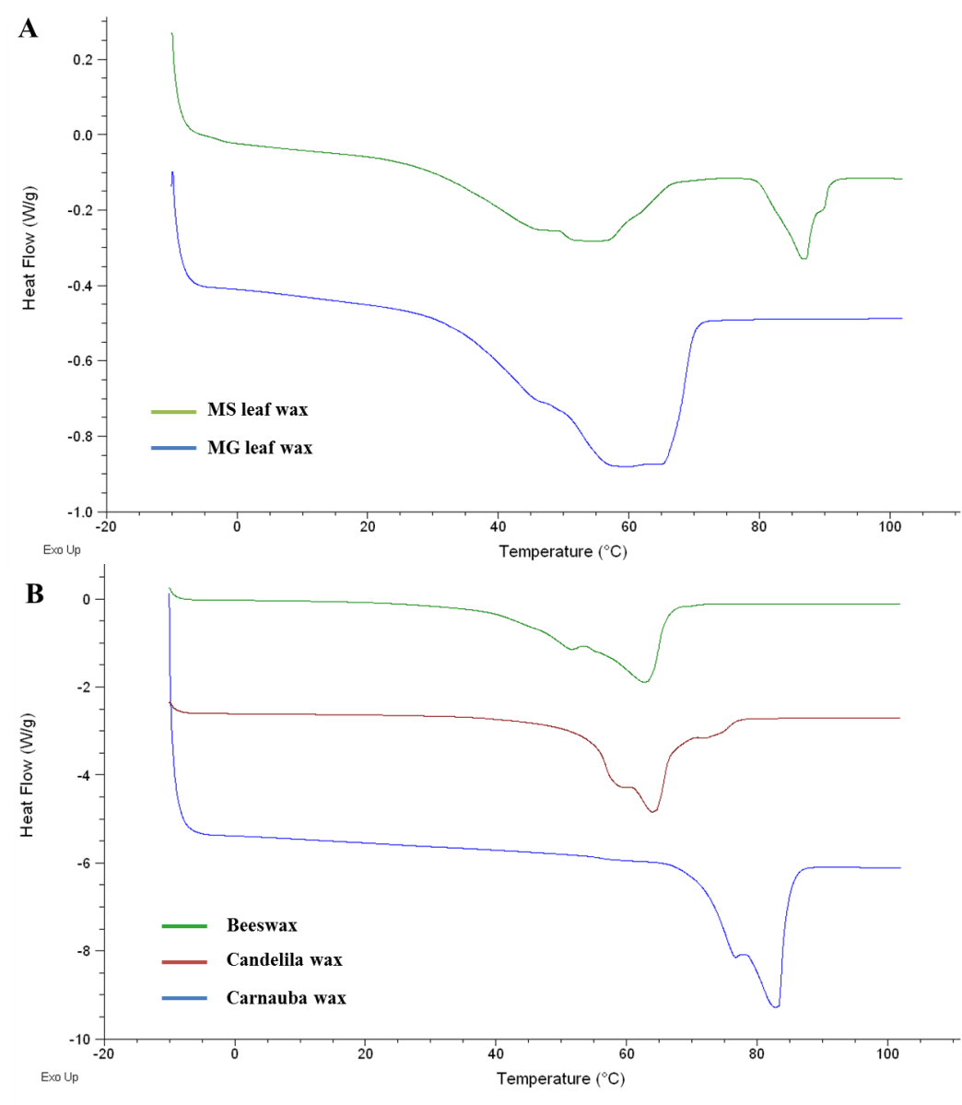
Figure 5. DSC thermograms of: A) MS and MG leaf wax B) Beeswax, candelila wax and carnauba wax. (MS – miscanthus sinensis, MG – miscanthus giganteus).
Figure 5A and 5B compare the DSC thermograms of the MS and MG waxes (extracted with scCO₂) with waxes that are commercially available (beeswax, candelila wax and carnauba wax). Results indicate considerable differences between the DSC thermograms of each extract (MS and MG waxes) as well as with the commercially available waxes. The DSC thermogram of the MG stem extract was similar to that of the leaf extract with endothermic mimina at 68 ºC and 66 ºC respectively. These melting profiles are very similar to that of the candelila wax (64 ºC). Interestingly, a contrast was observed between the MS extracts and the MG extracts in that there were two distinct melting regions in the former (whereas only one was observed in the MG extracts). In the first melting region, endothermic minima were observed at 60 ºC and 67 ºC for the stem and leaf waxes respectively while in the second melting point region a sharper peak was observed with a melting maximum at 87 ºC for both the leaf and the stem waxes. In this study, the DSC traces obtained for the commercial waxes are similar to previously recorded data in literature.²⁴ Since the melting profiles of the lipophilic extracts are different, this indicates that they could be used in different applications. The MS wax extracts from the stems and leaves have high-melting point waxy constituents (having higher melting profiles than carnauba wax (83ºC)) which could enable them to be utilised in applications requiring this characteristic such as polishes for instruments and automobiles. However, future work involves looking at the fractionation and purification of these high-melting waxy constituents for applications testing. The waxes from the MG stem and leaves have melting profiles that make them useful for applications including food, pharmaceuticals and cosmetics.
In order to determine whether scCO₂ extraction was an effective pre-treatment step in a biorefinery, it was important to see what effect the supercritical extraction has on the biomass. Saccharification was conducted on the MG leaves following scCO₂ extraction (scCO₂-treated) and compared to samples of untreated MG leaves (untreated) and the alcohol-insoluble residue (AIR-treated) of these MG leaves.
Saccharification of M. x. giganteus

Figure 6. Total sugars released from MG after NaOH pre-treatment and saccharification for the untreated, AIR-treated and ScCO₂-treated samples compared to a control where no NaOH pre-treatment had taken place. (MG – miscanthus giganteus).
Each biomass sample was subsequently subjected to 0.1 M NaOH treatment before enzymatic hydrolysis to increase the ease with which sugars were released. A control sample (control) of untreated MG leaves, which were not modified with NaOH, was also subjected to saccharification to assess the effectiveness of the NaOH treatment step. The results indicate that extraction of waxy components using scCO₂ improved the saccharification efficiency of the biomass (Figure 6). 220 nmols of sugars mg⁻¹ of material were produced for the scCO₂ pre-treated sample compared to 180 nmols of sugars mg⁻¹ of the untreated example (the AIR-treated sample produces essentially the same result as the untreated sample, within error). Thus, scCO₂ extraction lead to an increase in sugar release of approximately 20% compared to the non-treated and AIR samples. These results suggest that in addition to the benefit of extracting valuable waxes, scCO₂ also has a positive effect on the downstream processing of the biomass compared to untreated samples.
Previous work has already demonstrated the advantages of utilising scCO₂ as a pre-treatment step for lignocellulosic biomass, improving sugar release.⁵³⁻⁵⁴ However, the role of scCO₂ in this research was to provide a cheap and nontoxic method for pressurising the system, which was then rapidly released to explosively open up the biomass or as part of a static two solvent system to increase hydrolysis yields. Carrying out dynamic extraction not only helps to increase free sugar content for fermentation but also gives rise to a wide range of high value extractives. This demonstrates the applicability of scCO₂ extraction as an important initial step in a miscanthus biorefinery.
Scanning Electron Microscopy (SEM) of miscanthus biomass following hydrolysis
SEM analysis of the biomass before and after extraction was conducted. SEM micrographs of the samples indicates that the overall structure of the materials is similar before and after supercritical extraction (figure 7 A and E). However, on further examination at X5000 magnification significant textural differences can be observed post extraction (figure 7 B, D and F), with supercritical treated surfaces being noticeably rougher. As such the supercritical extracted materials were the only samples where the xylem and phloem are clearly exposed (Supporting information Figure S2).
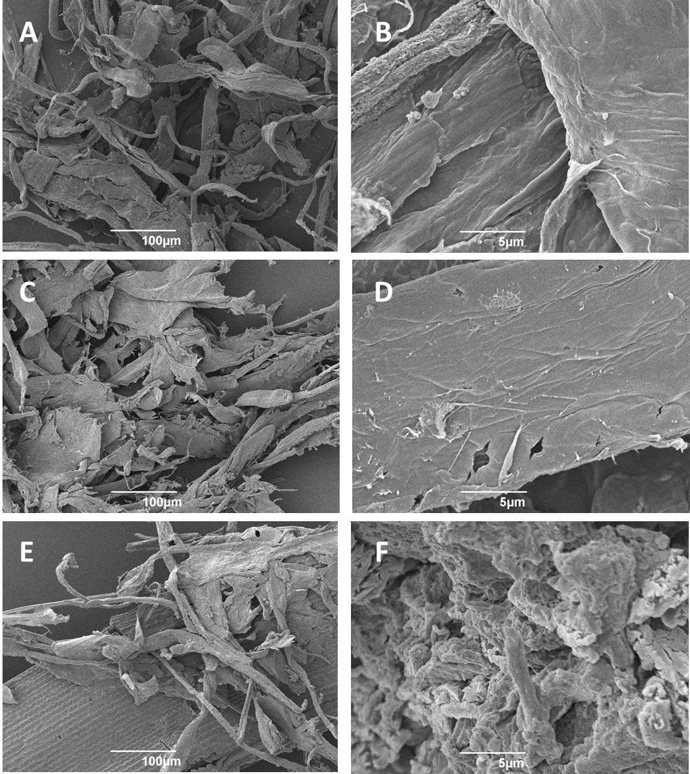
Figure 7. SEM micrographs of A) Untreated MG (X250 magnification), B) Untreated MG (X5000 magnification), C) Ethanol extracted MG (X250 magnification), D) Ethanol extracted MG (X5000 magnification), E) Supercritical extracted MG (X250 magnification), F) Supercritical extracted MG (X5000 magnification). (MG – miscanthus giganteus).
Economic study of scCO₂ extraction of waxes from M. x. giganteus
In order to assess the viability of the extraction process, it is important to carry out an economic assessment based on the scCO₂ extraction of waxes from miscanthus. This study was performed using a model by Turton et al, developed to estimate the cost of manufacture (COM) of chemicals.⁵⁵ This model has been used previously to adequately estimate scCO₂ extraction costs of essential oils, resin and fatty acids, as well as for waxes from other biomass.⁵⁶⁻⁵⁹ The COM was calculated using five main costs: the fixed capital investment (FCI), operational labour costs (C_{OL}), raw material costs (C_{RM}), utility costs (C_{UT}) and waste treatment costs (C_{WT}) (eq. 1).
COM = 0.280FCI + 2.73C_{OL} + 1.23(C_{RM} + C_{WT} + C_{UT}) (1)
The COM for the extraction of waxes from miscanthus is based on a small commercial scCO₂ plant normally used to extract spices, essential oils, natural pigments and nutraceuticals.⁵⁶⁻⁵⁹ The annual capacity of a facility this size is ca. 2000 tonnes year⁻¹. The pressure and temperature of the extraction were taken to be 350 bar and 50 ºC. The flow rate was taken to be 40 g min⁻¹. A kinetic study (Figure S5 – supplementary information) was carried out in order to identify the ideal extraction time using the flow rate selected. It was found that 40 minutes gave rise to 83% of the total wax extracted and was found to be optimal from an economic perspective. Therefore, in the economic study, the extraction time was taken to be 40 minutes and not four hours (as in the lab-scale study). The results from the kinetic study are very similar to other studies in which the same flow rate was incorporated.⁵⁸ Furthermore, CO₂ is recycled on an industrial scale, meaning that limited CO₂ is lost in the process. The supporting information contains a fully detailed breakdown of all the calculations and costs associated with the extraction process. Four types of calculations were estimated: (i) Cost of extracting from milled miscanthus straw (ii) cost of extracting from pelletised miscanthus straw (iii) cost of extracting from pelletised miscanthus leaves (iv) cost of extracting from pelletised miscanthus leaves followed by combustion of the miscanthus for electricity generation.
The COM for the scCO₂ extraction from milled miscanthus straw was estimated to be around €160 kg⁻¹ of miscanthus straw wax. However, modifying some parameters can lead to improvements in the COM. In this study, the COM was based on milled miscanthus. In industry, pelletised biomass is normally utilised leading to a threefold increase in biomass loading. A calculation using pelletised miscanthus straw was therefore carried out. Although the C_{RM} and C_{UT} costs increase when pelletised miscanthus straw is utilised, the total COM is reduced to approximately €96 kg⁻¹ of miscanthus straw wax. From the results shown above it was found that there is a higher wax content in the miscanthus leaves when compared to the stem. The third calculation looked at the COM for scCO₂ extraction of waxes from the leaves of miscanthus and it was found that the COM reduced significantly to ca. €24 kg⁻¹ of miscanthus leaf wax (due to the wax yield being almost 3 times as much.)
Finally, as scCO₂ extraction is a non-destructive technique, it can be viewed as an initial step in a biorefinery process, with the resultant biomass available for further valorisation. Any additional steps employed would thus lower the COM of the wax produced. One example of a downstream process following extraction is electricity generation. Herein, cost estimations for the scCO₂ extraction of waxes from pelletised leaves and subsequent combustion for electricity generation was conducted. It was found that the COM further reduces to €6 per kg of miscanthus wax.
CONCLUSIONS
This work demonstrated the successful extraction of surfaces waxes from the stems and leaves of miscanthus sinensis and miscanthus giganteus using scCO₂. Extractions of MG leaf exhibited the highest wax yields (1.96 ±0.03%), while the opposite was observed in the stems, whereby the largest quantities of wax were obtained from the MS stems (0.46 ±0.04%). A diverse range of molecules were detected including long-chain hydrocarbons, fatty acids (saturated and unsaturated), n-policosanols, aldehydes, wax esters, sterols and steroid ketones. These molecules may find use in a number of different applications including cosmetics, nutraceuticals, home and personal care products. Although there is a similarity in the types of molecules found in each extract, quantification data indicates that there is a considerable difference among each species in the quantities of specific compounds, as well as families of compounds. Furthermore, a positive effect was observed when using scCO₂ extraction prior to the downstream processing of the miscanthus, thus illustrating its usefulness as a pre-treatment technique prior to saccharification. Enhanced plant digestibility was observed with the scCO₂-treated material (ca. 20% increase in sugars released compared to non-treated MG leaves) which may be related to structural changes to the biomass particles, as evident at high magnification in SEM studies.
ASSOCIATED CONTENT
Supporting Information.
Word document explaining the model for the economic analysis. (file type: Word document (.docx)
AUTHOR INFORMATION
Corresponding Author
Andrew J. Hunt. Department of Chemistry, University of York, Heslington, York, UK. YO10 5DD, Email: andrew.hunt@york.ac.uk. Tel. +44 (0)1904 324456
Author Contributions
The manuscript was written through contributions of all authors. All authors have given approval to the final version of the manuscript. ‡These authors contributed equally. (match statement to author names with a symbol)
ACKNOWLEDGMENTS
We gratefully acknowledge funding through the European Commission's Directorate-General for Research within the 7th Framework Program (FP7/2007–2013) under the grant agreement no. 251132 (SUNLIBB).
ABBREVIATIONS
ScCO₂, supercritical carbon dioxide; MG, miscanthus x. giganteus; MS, miscanthus sinensis; GC, gas chromatography; GC-MS, gas-chromatography mass spectrometry; DSC, differential scanning calorimetry; COM, cost of manufacture; FCI, fixed capital investment; C_{OL}, labour costs; C_{RM}, cost of raw materials; C_{WT}, waste treatment costs; C_{UT}, utility costs.
REFERENCES
1. Budarin, V. L.; Shuttleworth, P. S.; Dodson, J. R.; Hunt, A. J.; Lanigan, B.; Marriott, R.; Milkowski, K. J.; Wilson, A. J.; Breeden, S. W.; Fan, J.; Sin, E. H. K.; Clark, J. H., Use of green chemical technologies in an integrated biorefinery. Energy & Environmental Science 2011, 4 (2), 471-479.
2. Clark, J. H.; Budarin, V.; Deswarte, F. E. I.; Hardy, J. J. E.; Kerton, F. M.; Hunt, A. J.; Luque, R.; Macquarrie, D. J.; Milkowski, K.; Rodriguez, A.; Samuel, O.; Tavener, S. J.; White, R. J.; Wilson, A. J., Green chemistry and the biorefinery: a partnership for a sustainable future. Green Chemistry 2006, 8 (10), 853-860.
3. Attard, T. M.; Watterson, B.; Budarin, V. L.; Clark, J. H.; Hunt, A. J., Microwave assisted extraction as an important technology for valorising orange waste. New Journal of Chemistry 2014, 38 (6), 2278-2283.
4. Dodson, J. R.; Hunt, A. J.; Budarin, V. L.; Matharu, A. S.; Clark, J. H., The chemical value of wheat straw combustion residues. RSC Advances 2011, 1 (3), 523-530.
5. Dodson, J. R.; Cooper, E. C.; Hunt, A. J.; Matharu, A.; Cole, J.; Minihan, A.; Clark, J. H.; Macquarrie, D. J., Alkali silicates and structured mesoporous silicas from biomass power station wastes: the emergence of bio-MCMs. Green Chemistry 2013, 15 (5), 1203-1210.
6. Jiang, T.; Budarin, V. L.; Shuttleworth, P. S.; Ellis, G.; Parlett, C. M. A.; Wilson, K.; Macquarrie, D. J.; Hunt, A. J., Green preparation of tuneable carbon-silica composite materials from wastes. Journal of Materials Chemistry A 2015, 3 (27), 14148-14156.
7. Hunt, A. J.; Budarin, V. L.; Breeden, S. W.; Matharu, A. S.; Clark, J. H., Expanding the potential for waste polyvinyl-alcohol. Green Chemistry 2009, 11 (9), 1332-1336.
8. Clark, J. H.; Pfaltzgraff, L. A.; Budarin, V. L.; Hunt, A. J.; Gronnow, M.; Matharu, A. S.; Macquarrie, D. J.; Sherwood, J. R., From waste to wealth using green chemistry. Pure and Applied Chemistry 2013, 85 (8), 1625-1631.
9. Greef J, M.; Deuter, M., Syntaxonomy of Miscanthus × giganteus GREEF et DEU. Angewandte Botanik 1993, 67 (3-4), 87-90.
10. Zub, H. W.; Brancourt-Hulmel, M., Agronomic and physiological performances of different species of Miscanthus, a major energy crop. A review. Agronomy for Sustainable Development 2010, 30 (2), 201-214.
11. Beale, C. V.; Long, S. P., Can perennial C4 grasses attain high efficiencies of radiant energy conversion in cool climates? Plant, Cell & Environment 1995, 18 (6), 641-650.
12. Clifton-Brown, J. C.; Lewandowski, I., Water Use Efficiency and Biomass Partitioning of Three Different Miscanthus Genotypes with Limited and Unlimited Water Supply. Annals of Botany 2000, 86 (1), 191-200.
13. Michel, R.; Mischler, N.; Azambre, B.; Finqueneisel, G.; Machnikowski, J.; Rutkowski, P.; Zimny, T.; Weber, J. V., Miscanthus × Giganteus straw and pellets as sustainable fuels and raw material for activated carbon. Environ Chem Lett 2006, 4 (4), 185-189.
14. Mansouri, N.-E. E.; Salvadó, J., Structural characterization of technical lignins for the production of adhesives: Application to lignosulfonate, kraft, soda-anthraquinone, organosolv and ethanol process lignins. Industrial Crops and Products 2006, 24 (1), 8-16.
15. Vega, A.; Bao, M.; Lamas, J., Application of factorial design to the modelling of organosolv delignification of Miscanthus sinensis (elephant grass) with phenol and dilute acid solutions. Bioresource Technology 1997, 61 (1), 1-7.
16. Fernando, S.; Adhikari, S.; Chandrapal, C.; Murali, N., Biorefineries: Current Status, Challenges, and Future Direction. Energy & Fuels 2006, 20 (4), 1727-1737.
17. Lemke, D. W.; Thiede, M. C. Wax compositions and methods of preparing wax compositions. 0024281, 2010.
18. Kline Global wax industry 2010: Market analysis and opportunities; Kline & Company Inc.: 2011.
19. Deswarte, F. E. I.; Clark, J. H.; Hardy, J. J. E.; Rose, P. M., The fractionation of valuable wax products from wheat straw using CO2. Green Chemistry 2006, 8 (1), 39-42.
20. Hunt, A. J.; Sin, E. H. K.; Marriott, R.; Clark, J. H., Generation, Capture, and Utilization of Industrial Carbon Dioxide. ChemSusChem 2010, 3 (3), 306-322.
21. Arshadi, M.; Hunt, A. J.; Clark, J. H., Supercritical fluid extraction (SFE) as an effective tool in reducing auto-oxidation of dried pine sawdust for power generation. RSC Advances 2012, 2 (5), 1806.
22. Subramaniam, B.; Rajewski, R. A.; Snavely, K., Pharmaceutical processing with supercritical carbon dioxide. Journal of Pharmaceutical Sciences 1997, 86 (8), 885-890.
23. Sin, E. H. K.; Marriott, R.; Hunt, A. J.; Clark, J. H., Identification, quantification and Chrastil modelling of wheat straw wax extraction using supercritical carbon dioxide. Comptes Rendus Chimie 2014, 17 (3), 293-300.
24. Athukorala, Y.; Mazza, G., Supercritical carbon dioxide and hexane extraction of wax from triticale straw: Content, composition and thermal properties. Industrial Crops and Products 2010, 31 (3), 550-556.
25. Choi, Y.; Kim, J.; Noh, M.; Park, E.; Yoo, K.-P., Extraction of epicuticular wax and nonacosan-10-OL from Ephedra herb utilizing supercritical carbon dioxide. Korean Journal of Chemical Engineering 1996, 13 (2), 216-219.
26. Athukorala, Y.; Mazza, G.; Oomah, B. D., Extraction, purification and characterization of wax from flax (Linum usitatissimum) straw. European Journal of Lipid Science and Technology 2009, 111 (7), 705-714.
27. Attard, T. M.; McElroy, C. R.; Rezende, C. A.; Polikarpov, I.; Clark, J. H.; Hunt, A. J., Sugarcane waste as a valuable source of lipophilic molecules. Industrial Crops and Products 2015, 76 (0), 95-103.
28. Attard, T. M.; Theeuwes, E.; Gomez, L. D.; Johansson, E.; Dimitriou, I.; Wright, P. C.; Clark, J. H.; McQueen-Mason, S. J.; Hunt, A. J., Supercritical extraction as an effective first-step in a maize stover biorefinery. RSC Advances 2015, 5 (54), 43831-43838.
29. Villaverde, J. J.; Domingues, R. M. A.; Freire, C. S. R.; Silvestre, A. J. D.; Neto, C. P.; Ligero, P.; Vega, A., Miscanthus x giganteus Extractives: A Source of Valuable Phenolic Compounds and Sterols. Journal of Agricultural and Food Chemistry 2009, 57 (9), 3626-3631.
30. Attard, T. M. Supercritical CO2 extraction of waxes as part of a holistic biorefinery. University of York, York, March 2015.
31. Gammons, R. J. Optimising the Pre-treatment Effects of Protic Ionic Liquids on Lignocellulosic Materials. University of York, York, September 2014.
32. Schiestl, F. P.; Ayasse, M.; Paulus, H. F.; Löfstedt, C.; Hansson, B. S.; Ibarra, F.; Francke, W., Orchid pollination by sexual swindle. Nature 1999, 399 (6735), 421-421.
33. Hill, K., Fats and oils as oleochemical raw materials. Pure and applied chemistry 2000, 72 (7), 1255-1264.
34. Fitton, A.; Goa, K., Azelaic Acid. Drugs 1991, 41 (5), 780-798.
35. Villaverde, J. J.; De Vega, A.; Ligero, P.; Freire, C. S. R.; Neto, C. P.; Silvestre, A. J. D., Miscanthus x giganteus Bark Organosolv Fractionation: Fate of Lipophilic Components and Formation of Valuable Phenolic Byproducts. Journal of Agricultural and Food Chemistry 2010, 58 (14), 8279-8285.
36. Shepherd, J.; Packard, C. J.; Patsch, J. R.; Gotto Jr, A. M.; Taunton, O. D., Effects of dietary polyunsaturated and saturated fat on the properties of high density lipoproteins and the metabolism of apolipoprotein AI. Journal of Clinical Investigation 1978, 61 (6), 1582.
37. Ahrens Jun, E.; Insull Jun, W.; Blomstrand, R.; Hirsch, J.; Tsaltas, T.; Peterson, M., THE INFLUENCE OF DIETARY FATS ON SERUM-LIPID LEVELS IN MAN. The Lancet 1957, 269 (6976), 943-953.
38. Horrobin, D. F.; Huang, Y. S., The role of linoleic acid and its metabolites in the lowering of plasma cholesterol and the prevention of cardiovascular disease. International Journal of Cardiology 1987, 17 (3), 241-255.
39. Chan, J. K.; Bruce, V. M.; McDonald, B. E., Dietary alpha-linolenic acid is as effective as oleic acid and linoleic acid in lowering blood cholesterol in normolipidemic men. The American journal of clinical nutrition 1991, 53 (5), 1230-1234.
40. de Lorgeril, M.; Renaud, S.; Salen, P.; Monjaud, I.; Mamelle, N.; Martin, J. L.; Guidollet, J.; Touboul, P.; Delaye, J., Mediterranean alpha-linolenic acid-rich diet in secondary prevention of coronary heart disease. The Lancet 1994, 343 (8911), 1454-1459.
41. Marinangeli, C. P. F.; Jones, P. J. H.; Kassis, A. N.; Eskin, M. N. A., Policosanols as Nutraceuticals: Fact or Fiction. Critical Reviews in Food Science and Nutrition 2010, 50 (3), 259-267.
42. Arruzazabala, M. L.; Carbajal, D.; Mas, R.; Garcia, M.; Fraga, V., Effects of policosanol on platelet aggregation in rats. Thrombosis Research 1993, 69 (3), 321-327.
43. Arruzazabala, M. L.; Valdés, S.; Más, R.; Carbajal, D.; Fernández, L., COMPARATIVE STUDY OF POLICOSANOL, ASPIRIN AND THE COMBINATION THERAPY POLICOSANOL-ASPIRIN ON PLATELET AGGREGATION IN HEALTHY VOLUNTEERS. Pharmacological Research 1997, 36 (4), 293-297.
44. Mottram, D. S., Flavour formation in meat and meat products: a review. Food Chemistry 1998, 62 (4), 415-424.
45. De Stefani, E.; Boffetta, P.; Ronco, A. L.; Brennan, P.; Deneo-Pellegrini, H.; Carzoglio, J. C.; Mendilaharsu, M., Plant Sterols and Risk of Stomach Cancer: A Case-Control Study in Uruguay. Nutrition and Cancer 2000, 37 (2), 140-144.
46. Shimizu, H.; Ross, R.; Bernstein, L.; Yatani, R.; Henderson, B.; Mack, T., Cancers of the prostate and breast among Japanese and white immigrants in Los Angeles County. British Journal of Cancer 1991, 63 (6), 963-966.
47. Mendilaharsu, M.; De Stefani, E.; Deneo-Pellegrini, H.; Carzoglio, J.; Ronco, A., Phytosterols and risk of lung cancer: A case-control study in Uruguay. Lung Cancer 1998, 21 (1), 37-45.
48. Ronco, A.; De Stefani, E.; Boffetta, P.; Deneo-Pellegrini, H.; Mendilaharsu, M.; Leborgne, F., Vegetables, Fruits, and Related Nutrients and Risk of Breast Cancer: A Case-Control Study in Uruguay. Nutrition and Cancer 1999, 35 (2), 111-119.
49. McCann, S. E.; Freudenheim, J. L.; Marshall, J. R.; Graham, S., Risk of Human Ovarian Cancer Is Related to Dietary Intake of Selected Nutrients, Phytochemicals and Food Groups. The Journal of Nutrition 2003, 133 (6), 1937-1942.
50. Moghadasian, M. H.; Frohlich, J. J., Effects of dietary phytosterols on cholesterol metabolism and atherosclerosis: clinical and experimental evidence. The American Journal of Medicine 1999, 107 (6), 588-594.
51. Gunawan, E. R.; Basri, M.; Rahman, M. B. A.; Salleh, A. B.; Rahman, R. N. Z. A., Study on response surface methodology (RSM) of lipase-catalyzed synthesis of palm-based wax ester. Enzyme and Microbial Technology 2005, 37 (7), 739-744.
52. McGinty, D.; Letizia, C. S.; Api, A. M., Fragrance material review on phytol. Food and Chemical Toxicology 2010, 48, Supplement 3 (0), S59-S63.
53. Zheng, Y.; Lin, H.-M.; Wen, J.; Cao, N.; Yu, X.; Tsao, G., Supercritical carbon dioxide explosion as a pretreatment for cellulose hydrolysis. Biotechnol Lett 1995, 17 (8), 845-850.
54. Kim, K. H.; Hong, J., Supercritical CO2 pretreatment of lignocellulose enhances enzymatic cellulose hydrolysis. Bioresource Technology 2001, 77 (2), 139-144.
55. Turton, R.; Bailie, R. C.; Whiting, W. B.; Shaeiwitz, J. A., Analysis, Synthesis and Design of Chemical Processes. Prentice Hall: New Jersey, 2013.
56. Rosa, P. T. V.; Meireles, M. A. A., Rapid estimation of the manufacturing cost of extracts obtained by supercritical fluid extraction. Journal of Food Engineering 2005, 67 (1–2), 235-240.
57. Pereira, C. G.; Meireles, M. A. A., Economic analysis of rosemary, fennel and anise essential oils obtained by supercritical fluid extraction. Flavour and Fragrance Journal 2007, 22 (5), 407-413.
58. Attard, T.; McElroy, C.; Hunt, A., Economic Assessment of Supercritical CO2 Extraction of Waxes as Part of a Maize Stover Biorefinery. International Journal of Molecular Sciences 2015, 16 (8), 17546.
59. Attard, T. M.; Arshadi, M.; Nilsson, C.; Budarin, V. L.; Valencia-Reyes, E.; Clark, J. H.; Hunt, A. J., Impact of supercritical extraction on solid fuel wood pellet properties and off-gassing during storage. Green Chemistry 2016.

For table of context only
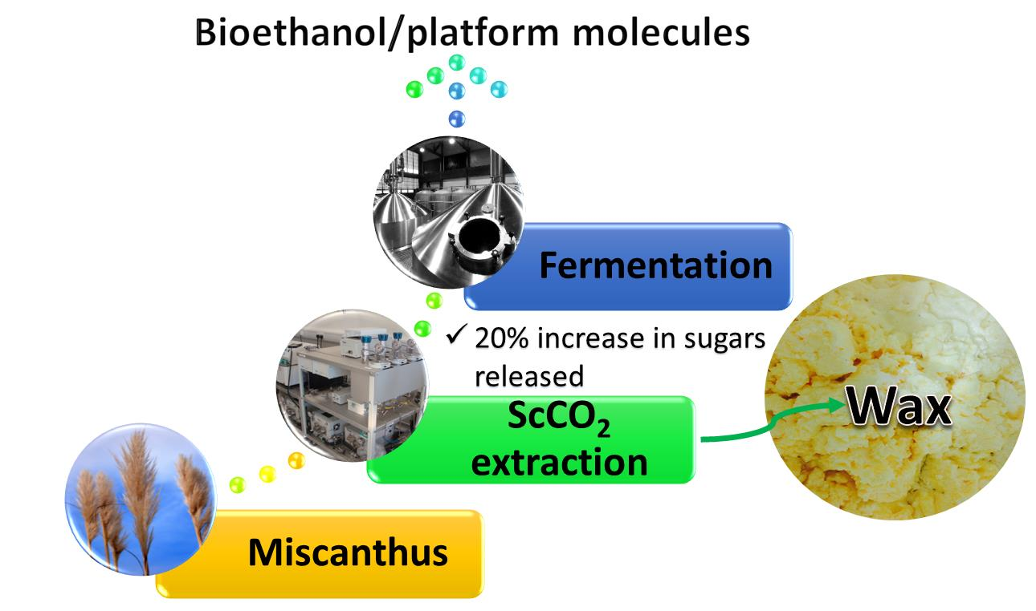
Supercritical CO2 extraction as an effective pre-treatment step for wax extraction in a miscanthus biorefinery, Thomas M. Attard, C. Rob McElroy, Richard J. Gammons, John M. Slattery, Nontipa Supanchaiyamat, Claire Lessa Alvim Kamei, Oene Dolstra, Luisa M. Trindade, Neil C. Bruce, Simon. J. McQueen-Mason, Seishi Shimizu and Andrew J. Hunt

This work demonstrates supercritical CO2 extraction of waxes as an effective pre-treatment in a holistic miscanthus biorefinery.

