Supplementary information
SI Figure 1: The Mesolithic site of Star Carr. (A) The approximate location of the site within the United Kingdom; (B) an example of the iconic carved red deer antler headdresses excavated at the site (Image from the British Museum, reproduced under a creative commons license); a comparison between the depth of trench 2 during initial excavations in 1948 (C) compared to more recent excavations within the same trench (D), illustrating the extent to which the peat has shrunk. Images reproduced with permission from Scarborough Archaeological and Historical Society and ‘Postglacial’ project, University of York.
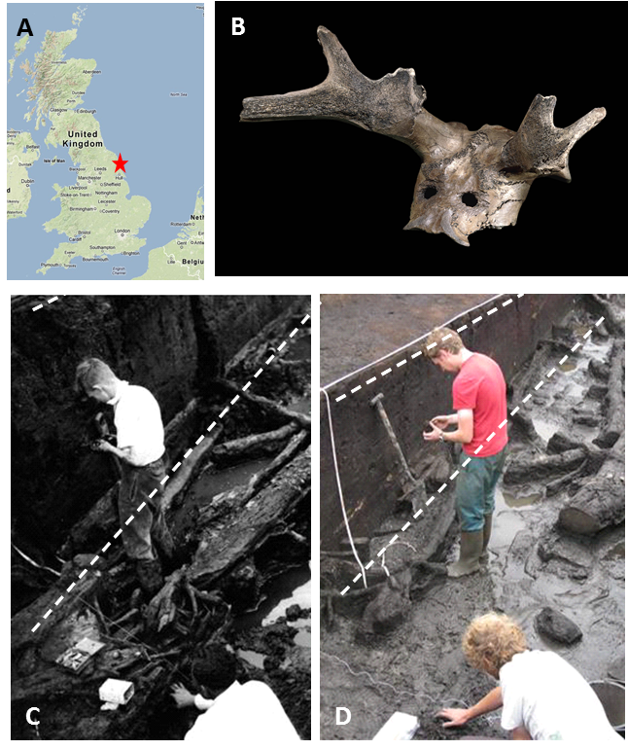

SI Figure 2: pH values measured from the excavated surface of Trench SC34 in 2013. Samples were taken in association with organic finds and are therefore not uniformly spaced. However, extremely localised variation in pH can be observed across the surface of the trench. SC34 represents the extent of excavations in 2013, and intersects trenches excavated in the original excavations (Cutting 2) and in the 1980’s (VP85). Previous trenches are outlined in red.
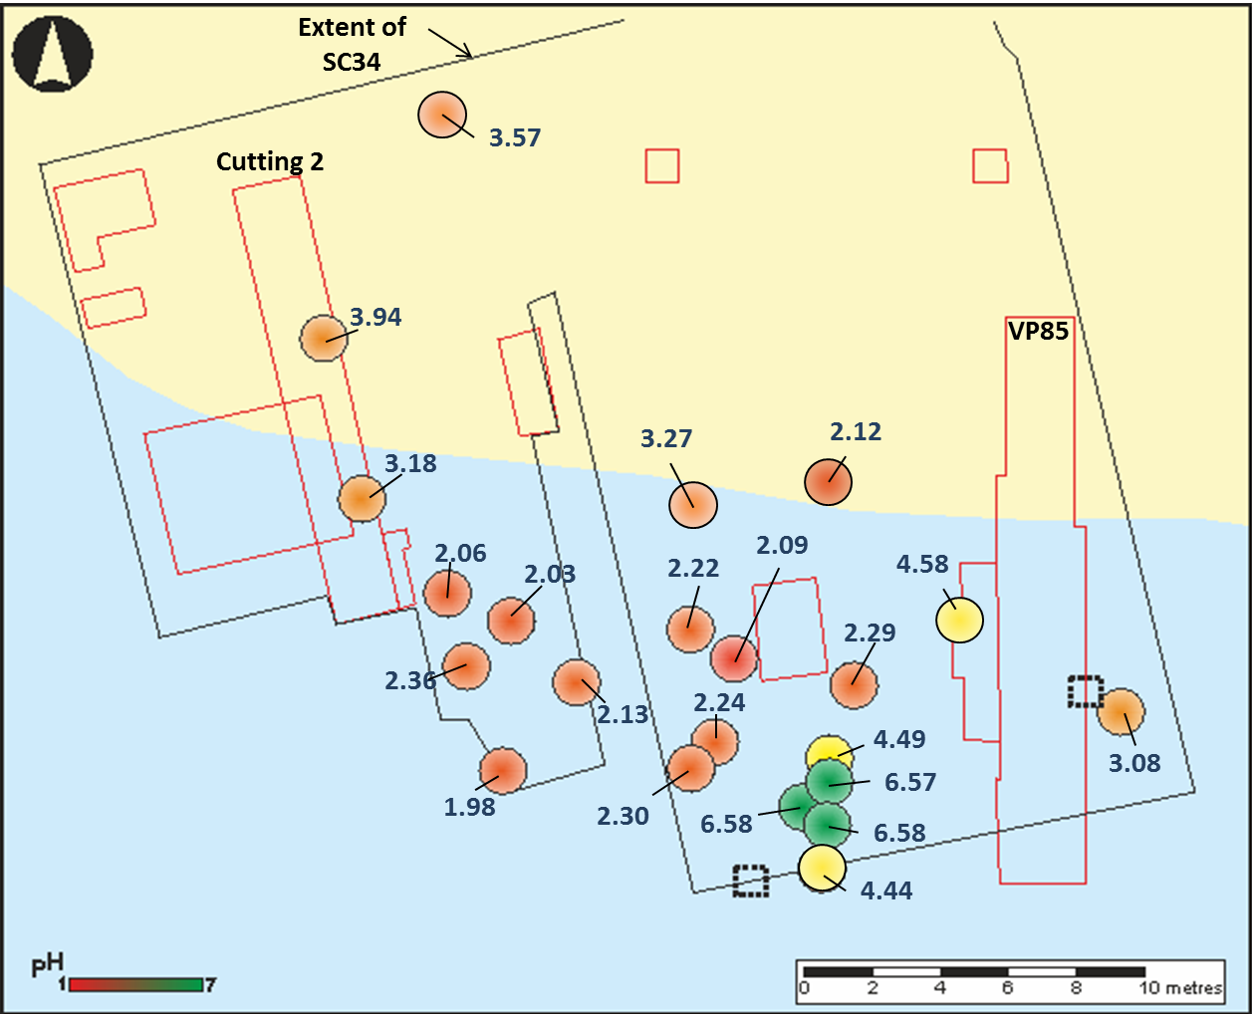

SI Figure 3: Extensive deterioration seen in bone buried in microcosm C (Star Carr) after 12 months burial. bone material prior to burial (top row) compared to the equivalent material after 12 months burial in peat from Star Carr (middle row) and compost (bottom row). The equivalent material buried in sand (microcosm A) also displayed little or no visual alteration.

SI Figure 4: Total amino acid concentration (left) and Asx racemisation (right) for bone material excavated from microcosm zones A3, B3 and C3 (all waterlogged) compared to the starting material. A reduction in concentration in C3 samples is likely to be an artefact of the mass increase. Slight elevation of Asx racemisation in archaeological bones (Tanner Row ad Star Carr) indicates collagen damage, and racemisation is elevated to a greater extent in C3 than A3 and B3, suggesting that greater collagen damage has occurred in Star Carr sediments. Differences in modern bone tend to be lie within the margin of error
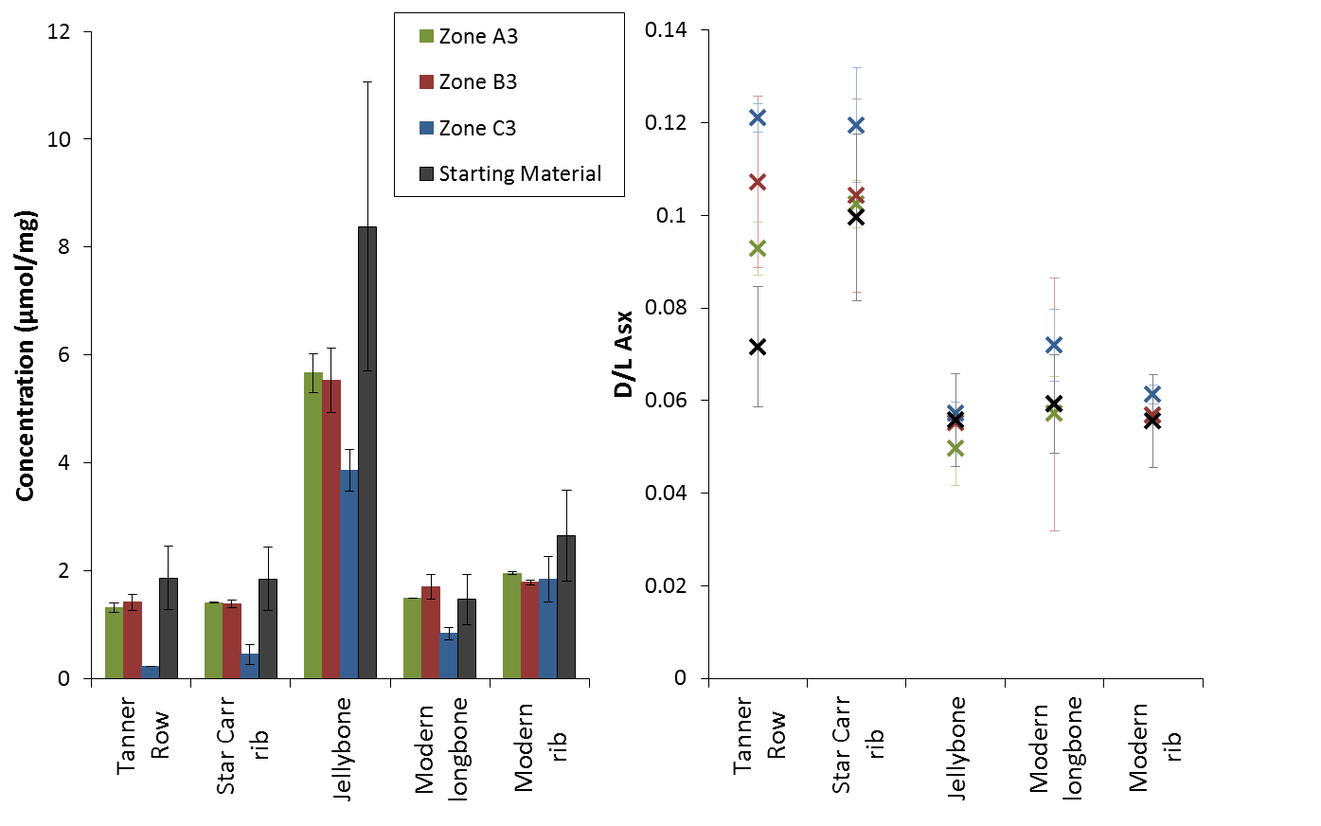

SI Figure 5: py-GC chromatograms for experimental and archaeological wood samples: In zone C1, loss of cellulose and lignin are indicated by a reduction in the intensity of the cellulose degradation products (1-10 minutes) and the later eluting lignin degradation products, whilst defunctionalised lignin (phenol) has increased in abundance. In comparison, the same sample from B1 displays a chromatogram similar to fresh wood. The archaeological sample analysed shortly after excavation in 2013 appears to have both lignin and cellulose remaining, although a high intensity phenol peak suggests defunctionalisation of lignin has occurred.

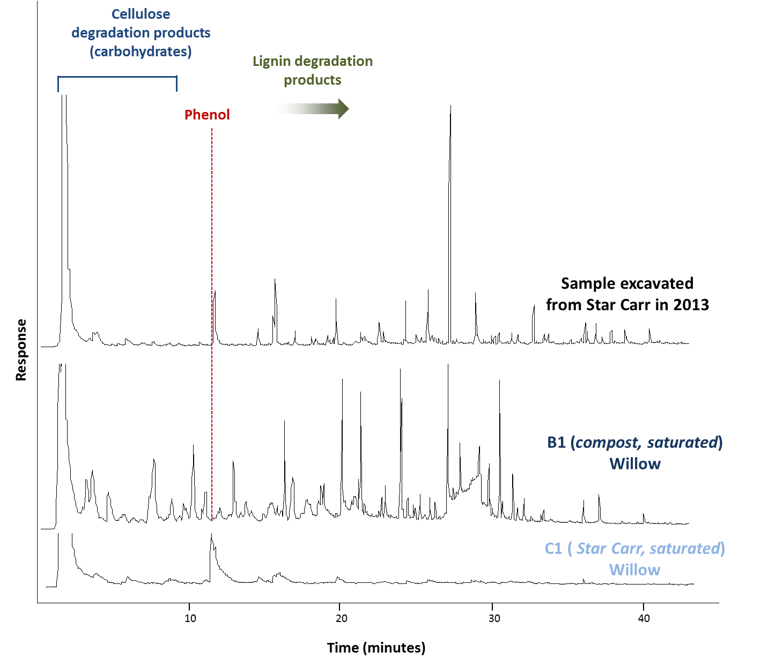

SI Table 1: Description of each of the ‘zones’ set up in the microcosms experiment and summary of the material contained within each. Geochemical data presented is as measured at the end of the 12 month burial period
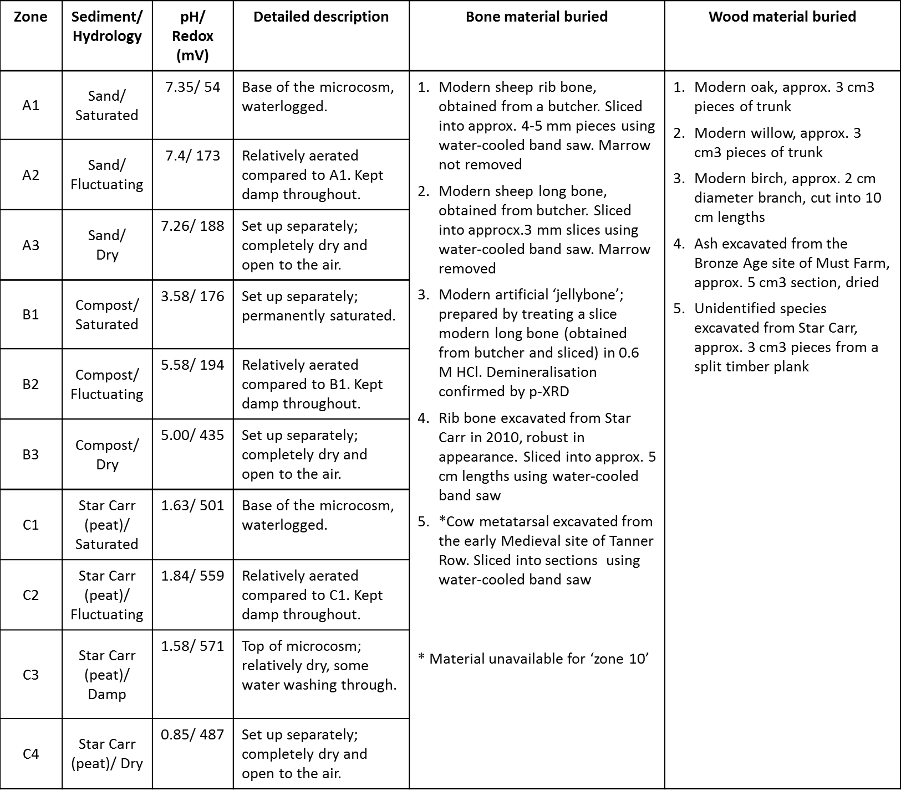

SI Table 2: Mass loss for all recovered bone samples as a percentage of the starting mass. Negative values therefore indicate a mass gain, values of zero indicate a negligible change, and a 100 % mass loss indicates that the bone was not recovered (Note that Tanner Row bone was not buried in zone C4)
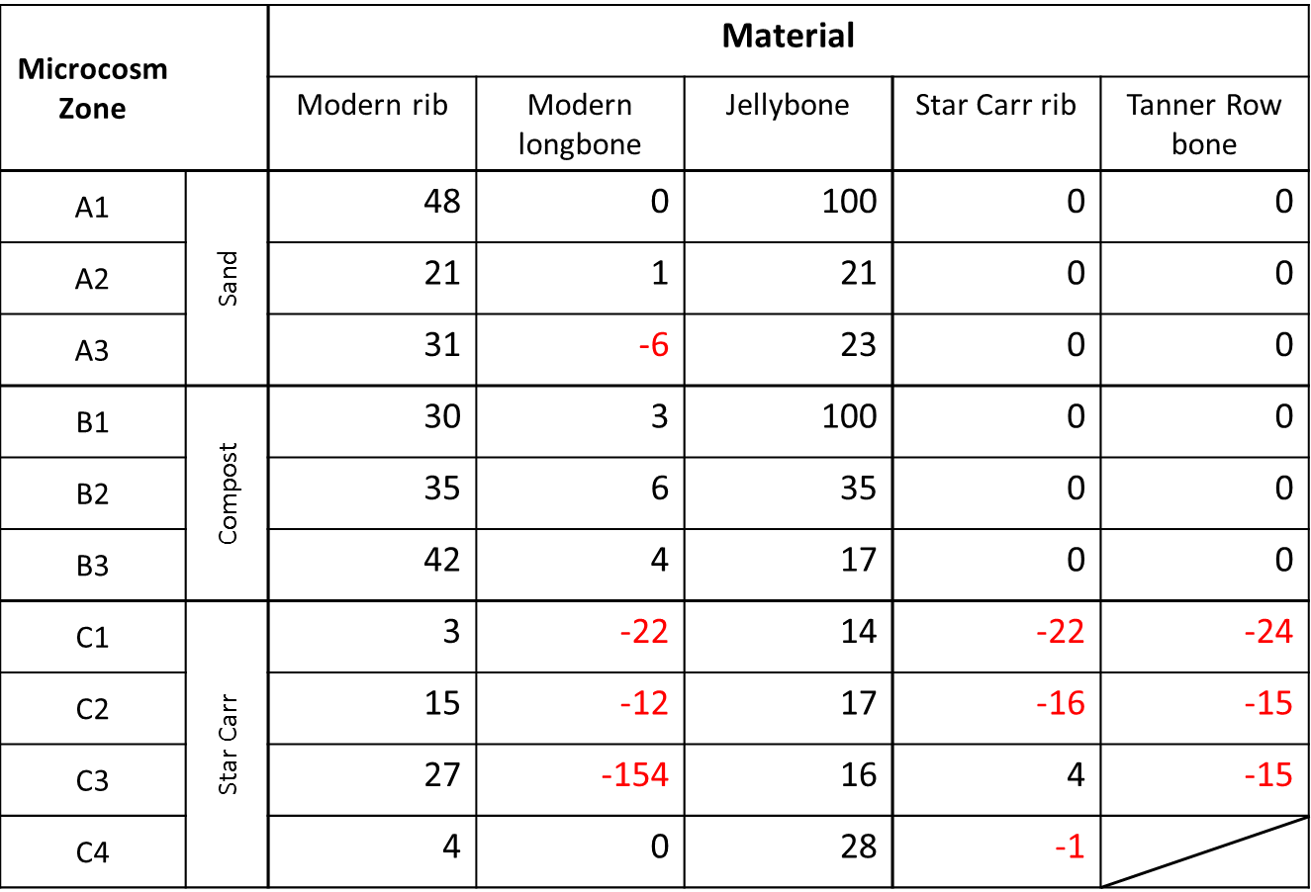

SI Table 3: Mass loss for all recovered wood samples as a percentage of the starting mass. Negative values therefore indicate a mass gain.
