Liquid-crystalline ionic liquids as ordered reaction media for the Diels-Alder reaction
Duncan W. Bruce,*^{[a]} Yanan Gao,^{[b]} José Nuno Canongia Lopes,*^{[c,d]} Karina Shimizu^{[c]} and John M. Slattery*^{[a]}
[a] Dr John M. Slattery, Prof. Duncan W. Bruce
Department of Chemistry
University of York
Heslington, York, YO10 5DD, UK
E-mail: john.slattery@york.ac.uk, duncan.bruce@york.ac.uk
[b] Prof. Yanan Gao
Dalian Institute of Chemical Physics
Chinese Academy of Sciences
457 Zhongshan Road, Dalian 116023, P. R. China
[c] Prof. José Nuno Canongia Lopes, Dr Karina Shimizu
Centro de Química Estrutural
Instituto Superior Técnico
Universidade de Lisboa
Av. Rovisco Pais, 1049-001 Lisboa, Portugal.
E-mail: jnlopes@ist.utl.pt
[d] Prof. José Nuno Canongia Lopes
Instituto de Tecnologia Química e Biológica
Universidade Nova de Lisboa
Av. República, 2780-157 Oeiras, Portugal
Supporting information for this article is given via a link at the end of the document.

Abstract: Liquid-crystalline ionic liquids (LCILs) are ordered materials that have untapped potential to be used as reaction media for synthetic chemistry. This paper investigates the potential for the ordered structures of LCILs to influence the stereochemical outcome of the Diels-Alder reaction between cyclopentadiene and methyl acrylate. The ratio of endo- to exo-product from this reaction was monitored for a range of ionic liquids (ILs) and LCILs. Comparison of the endo:exo ratios in these reactions as a function of cation, anion and liquid crystallinity of the reaction media, allowed for the effects of liquid crystallinity to be distinguished from anion effects or cation alkyl chain length effects. These data strongly suggest that the proportion of exo-product increases as the reaction media is changed from an isotropic IL to a LCIL. A detailed molecular dynamics (MD) study suggests that this effect is related to different hydrogen bonding interactions between the reaction media and the exo- and endo-transition states in solvents with layered, smectic ordering compared to those which are isotropic.
Introduction
Solvents play a crucial role in most chemical reactions, from the small scale of the laboratory to large-scale, industrial applications. The properties of a solvent (e.g. dielectric constant, boiling point, vapour pressure) can have a profound influence on reactions taking place within it, for example, by affecting the solubility of reagents or products, promoting desired reaction pathways by preferential stabilisation of certain transition states, or simply by allowing control over the reaction temperature. Solvents can also have a significant impact on the sustainability of a chemical process, and there is a great deal of current interest in alternative solvent systems that may allow for greener processes. As such, choice of solvent is an important part of the optimisation of many reactions.
In recent years, ionic liquids (ILs) have emerged as a novel class of solvent with properties that are often rather different to conventional reaction media (e.g. their ability to dissolve solutes with a range of different polarities, negligible vapour pressures, and high chemical and thermal stability). Significant efforts have been made to understand the role that ILs can play as tuneable, neoteric solvents for organic synthesis, catalysis, the synthesis of nanomaterials and many more.^{[1]} However, most conventional solvents and ILs have one property in common, that they are isotropic fluids, i.e. they exhibit no long-range ordering in their liquid state. There exists significant untapped potential in reaction media that are anisotropic fluids, which are structured and exhibit long-range ordering that is resistant to perturbation. The order inherent in these phases could place steric or electronic constraints on reactants, transition states or products so provide a directing influence on a chemical reaction and thus increasing the chemist or engineer’s toolkit for controlling reaction outcomes. Liquid crystals (LCs) are anisotropic fluids that form a wide range of phase types with different structures and as such have significant potential to be used as ordered reaction media, which may allow control over the rate and/or stereochemical outcome of reactions taking place within them.
Thermotropic LCs were investigated for their potential to influence the outcome of chemical reactions in a range of systems in the 1980s.^{[2]} Many interesting results were obtained, but two main issues are likely to have held back developments in this area. Firstly, neutral thermotropic LCs are not particularly versatile solvents, tending to dissolve only those substrates with relatively similar polarity, functional groups and structure to the LC phase itself. Secondly, and perhaps more importantly, the addition of solutes to LC phases tends to destabilise them, leading to loss of their ordered structures. ILs that display liquid-crystalline mesophases, liquid-crystalline ILs (LCILs), have the potential to overcome both of these problems. The ability of ILs to solubilise a range of substrates of differing polarities is well known and so LCILs are likely to be much more versatile solvents than neutral LCs. The ability to influence reaction chemistry occurring within the LCIL by chemical modification of the anion or cation also gives significant potential to 'tune' the properties of a LCIL to suit a reaction of interest. In addition to their favourable solvent properties compared to neutral LCs, LCILs often form mesophases that are stable over a wide temperature range (over 200 ºC in some cases).^{[3]} This means that LCILs are significantly more tolerant to the addition of non-LC compounds and any depression of the clearing point that occurs on adding solutes will still leave a very large LC range within which to work. As such, LCILs represent extremely attractive targets as LC solvents.
While there have been many reports of ILs being used as reaction media, there are few reports of the use of LCILs as reaction media. Lee et al., used the LCIL 1-dodecylimidazolium chloride ([C₁₂mim]Cl.H₂O_{n}), formed as its hydrated salt by protonation of 1-dodecylimidazole with aqueous HCl, as a reaction media for the Diels-Alder (DA) reaction between cyclopentadiene and diethylmaleate.^{[4]} The stereochemical outcome of this reaction (i.e. the ratio of endo- to exo-product ) was significantly different to that found when EtOH was used as a solvent (0.85 vs. 7.3, respectively) and it was proposed that this may indicate a liquid-crystalline effect on the stereochemistry of the reaction. However, later studies by Welton and Dyson, which investigated the endo:exo ratio for the DA reaction between cyclopentadiene and methyl acrylate in a range of ILs,^{[5]} found that there is a significant difference in endo:exo ratio between different ILs and between ILs and some conventional solvents. These observations have been attributed to hydrogen bonding between the solvents and the carbonyl oxygen of the dienophile, which favours the endo transition state to varying degrees depending on hydrogen bonding ability.^{[5a]} Hence, because only two solvent systems were considered in the study by Lee et al., it is not clear whether their observations are evidence of a liquid-crystal effect on this reaction or simply a consequence of changing between the very different solvent systems of EtOH and the LCIL. In addition, the potential for HCl and/or significant H₂O impurities in the LCIL used by Lee et al. may complicate the analysis of these data.
A recent study by Do and Schmitzer showed that LCILs with layered smectic T (SmT) phases can promote an intramolecular over an intermolecular DA reaction, when compared to a conventional isotropic IL ([C₄mim][Tf₂N]).^{[6]} This is suggested to occur because the substrate conformation that leads to intramolecular reactivity is favoured in the LCIL and because substrate molecules are well dispersed so that bimolecular reactivity is disfavoured. While potentially compelling, this study only compared reactivity in one LCIL with one conventional IL, whose chemical structures are somewhat different and so there is still some potential for the chemical differences between the salts to play a role in the observed results, in addition to changes in ordering.
In order to shed more light on the possibility for ordered LCIL solvents to influence the outcome of a chemical reaction, we have re-investigated the DA reaction between cyclopentadiene and methyl acrylate in a range of ILs and LCILs. In particular, combinations of these solvents were chosen in order to allow the best possibility of distinguishing between anion effects, alkyl chain length effects and true liquid-crystalline effects on the stereochemical outcome of this reaction. This reaction was chosen because benchmark data from the Welton^{[5a]} and Dyson^{[5d]} groups were available for some of the ILs used, which allowed us to gain confidence in the results, by comparison with previous established reactions.
Results and Discussion
The DA reaction between cyclopentadiene and methyl acrylate proceeds via a highly ordered transition state, which can have either an endo or exo geometry, leading to two different stereochemical outcomes (figure 1). It was anticipated that such ordered transition states would interact in different ways with the ordered structure provided by a LCIL solvent, leading to differences in the stereochemical outcome of the reaction compared to isotropic reaction media.
Figure 1. The endo and exo transition-state structures and their products for the DA reaction between cyclopentadiene and methyl acrylate.
DA reactions such as this have been studied in detail in conventional solvents and the endo:exo product ratio is known to be sensitive to the solvent used.^{[7]} However, there tends to be a preference for the endo product in many of these reactions (the so-called 'endo rule'). The origin of this effect has been the subject of much debate and factors such as secondary orbital interactions and unfavourable steric interactions between oxygen atoms on the dienophile and the methylene protons on cyclopentadiene in the exo transition state are likely to play a role.^{[8]} A number of studies have explored DA reactions involving cyclopentadiene in ILs.^{[5, 9]} As with conventional solvents, there is a general preference for the endo product when ILs are used as reaction media, but the observed endo:exo ratios are strongly dependent on the nature of the IL used (see table 1 for examples). Welton et al. have suggested that hydrogen bonding between the acidic C-2 proton of imidazolium-based ILs and the carbonyl oxygen of methyl acrylate particularly stabilises the endo transition state in these solvents.^{[5a]}
Figure 2. The IL and LCILs, and their abbreviated names, used in this study.

Table 1. Phase transition temperatures and endo:exo ratios for the DA reaction between cyclopentadiene and methyl acrylate observed here and in selected related studies. For LCIL materials POM measurements were used to check that the LCIL + substrate mixtures displayed the desired LC mesophase at 25 ºC.
Entry | IL/LCIL | Transition] | Temp. (ºC) | endo:exo (literature) |  | endo:exo (this work) ^{[c]}
1 | [C₄mim][PF₆] |  |  | 4.8 ^{[a]}, 3.8 ^{[b]} |  | 4.7
2 | [C₄mim][BF₄] |  |  | 4.6 ^{[a]}, 3.5 ^{[b]} |  | 4.4
3 | [C₄mim][Tf₂N] |  |  | 4.3 ^{[a]}, 4.2 ^{[b]} |  | 4.2
4 | [C₈mim][Tf₂N] |  |  | 3.9 ^{[b]} |  | 4.0
5 | [C₈mim][Br] |  |  |  |  | 4.0
6 | [C₈mim][BF₄] |  |  |  |  | 4.0
7 | [C₁₂mim][Tf₂N] |  |  |  |  | 3.8
8 | [C₈mim][PF₆] |  |  |  |  | 3.8
9 | [fan-c8-im][Tf₂N] ^{[d]} | Cr–I | 9.0 |  |  | 3.8
10 | [gemini-848][Tf₂N] ^{[d]} | Cr–I | 42.5 |  |  | 3.7
11 | [fan-c8-im][PF₆] ^{[e]} | Cr–Col_{h} | -38.0 |  |  | 3.6
 |  | Col_{h}–I | 73.0
12 | [C₁₂mim][Br] ^{[f]} | Cr–SmA | 45.8 |  |  | 3.5
 |  | SmA–I | 126.0
13 | [fan-c8-im][BF₄] ^{[d]} | g–Col_{h} | -35.1 |  |  | 3.4
 |  | Col_{h}–I | 132.7
14 | [C₁₂mim][BF₄] ^{[g]} | Cr–SmA | 7.4 |  |  | 3.3
 |  | SmA–I | 37.0
15 | [gemini-848][BF₄] ^{[d]} | Cr–Col_{h} | 34.4 |  |  | 3.3
 |  | Col_{h}–I | 237.5
16 | Methanol |  |  | 6.7 ^{[h]}
17 | Ethanol |  |  | 5.2 ^{[h]}
18 | Acetone |  |  | 4.2 ^{[h]}
19 | Diethylether |  |  | 2.9 ^{[h]}
^{[a]} From ref. ^{[5a]}: 72 hours at 25 °C; ^{[b]} From ref ^{[5d]}: 24 hours at room temp; ^{[c]} This work: one week at 25 °C; ^{[d]} Phase change data (on 1st cooling) from ref. ^{[[3b]]}; ^{e} Phase change data (on 1st cooling) from ref. ^{[3e]}; ^{[f]} Phase change data from ref. ^{[10]}; ^{[g]} Phase change data (on 1st cooling) from ref. ^{[11]}; ^{[h]} From ref. ^{[7a]}.

The ILs and LCILs for this study were chosen to investigate the effects of different anions, increasing alkyl chain length, LC effects and the effects of different LC mesophase structures on the endo:exo ratio. Figure 2 shows the structures and abbreviated names used for each of the ILs and LCILs used. The LC phases observed and their temperature ranges for the LCILs are shown in table 1 (entries 11-15).
We used a similar experimental procedure to that described by Welton et al. and Dyson et al., to study the DA reaction between cyclopentadiene and methyl acrylate in IL and LCIL solvents (see ESI for details).^{[5a, 5d]} It was hoped that by using comparable reaction conditions and repeating some of the measurements made previously, we could validate our methodology and ensure that the endo:exo product ratios were not being biased by potential impurities present in the ILs. All ILs and LCILs in this study were synthesised and dried to minimise potential impurities such as halide salts and water (see ESI for details). A comparison of the endo:exo ratios between this study and those of Welton and Dyson (Table 1, entries 1-4) showed that for ILs based on the bis(trifluoromethylsulfonyl)imide ([Tf₂N]⁻) anion there is a very good agreement between the three studies, with a maximum deviation of 0.1 in the endo:exo ratios. However, while there is good agreement between the present study and that of Welton for [C₄mim][BF₄] and [C₄mim][PF₆], the data from Dyson’s study find lower endo:exo ratios for these two ILs. This has previously been discussed in terms of the concentration-dependence of the endo:exo ratio in these reactions and the different concentrations used in the two studies.^{[5d]} In any case, the good agreement between the present study and Welton’s data, which were collected using similar conditions, gave us confidence in both the ILs and the methodology used for the DA reaction.
Figure 3. Chart showing the endo:exo ratios in each IL for the DA reaction studied here. Error bars are set at +/- 0.05, as the median deviation seen between the endo:exo ratio in this study and previous studies was 0.1. The insert shows selected endo:exo ratios for four ILs, which allow anion and LC effects to be disentangled.
Figure 3 shows a plot of the endo:exo ratios seen in this study for each of the ILs and LCILs used as reaction media. In general, it was seen that increasing the volume fraction of alkyl chains compared to polar groups (defined as the imidazolium ring, including the α-carbons of the alkyl groups at the ring, and the anion) in the ILs resulted in a decrease in the endo:exo ratio. For example, increasing the alkyl chain length on [C_{n}mim][Tf₂N] salts from C₄, to C₈, to C₁₂ gave endo:exo ratios of 4.2, 4.0 and 3.8, respectively. Increasing the number of alkyl chains on a cation, albeit in a system with a slightly different chemical structure, from [C₈mim][Tf₂N] to [fan-C8-IM][Tf₂N] also decreases the endo:exo ratio from 4.0 to 3.8. These are small effects, but we believe that they are significant based on the close agreement (endo:exo ratio within 0.1) between this study and previous work for [Tf₂N]-based ILs, where one might expect the data to be most scattered because the ILs used were synthesised completely independently and DA reactions were performed in different laboratories. The fact that the endo:exo ratio decreases as the volume fraction of the IL occupied by non-polar alkyl chains increases is consistent with observations in conventional solvents, where this ratio decreases with decreasing solvent polarity. Entries 16-19 in table 1 show how the endo:exo ratio for this reaction decreases markedly from methanol (ε = 6.7) to diethylether (ε = 2.9). Molecular dynamics (MD) studies (vide infra) suggest that the DA products (and one can assume from this also the starting materials) spend the majority of their time in the non-polar alkyl chain region of an IL such as [C₁₂mim][Tf₂N]. As such, it makes sense that the endo:exo ratio will move towards that seen in non-polar solvents as the IL volume is increasingly filled by non-polar domains. However, the MD simulations also suggest that while the reactants/products may be predominantly located in the alkyl chain regions they do make contact with the polar domains from time to time, which allows for crucial interactions (such as imidazolium C-H…O hydrogen bonding), which can influence the reaction, to take place.
Changing the anion also affects the endo:exo ratio in this DA reaction. In ILs containing the [C₄mim]⁺ cation, moving from [Tf₂N]⁻ to [BF₄]⁻ to [PF₆]⁻ increases the endo:exo ratio from 4.2 to 4.4 to 4.7 respectively. In previous studies, this has been discussed in terms of competition between the anion and the DA substrate/TS for hydrogen bonding to the relatively acidic imidazolium C-2 proton, which seems to favour formation of the endo product.^{[5a]}
An understanding of alkyl chain and anion effects on the endo:exo ratio allows for the possibility of LC effects on the stereochemical outcome of this DA reaction to be explored, and crucially to be distinguished from competing effects due to changing the chemical structure of the IL/LCIL. In general, the LCIL solvents (entries 11-15 in table 1) show lower endo:exo ratios compared to the isotropic ILs. One reason for this is that these systems have larger volume fractions of non-polar alkyl chains compared to many of the ILs, i.e. there is an alkyl chain effect. However, the data also give a strong indication that the anisotropic ordering of the LCILs has an impact on the observed endo:exo ratio.
Examining in detail entries 2, 3, 7 and 14 in table 1 (also highlighted as an insert in figure 3), which show the stereochemical outcome of the reaction for [C₄mim][BF₄], [C₄mim][Tf₂N], [C₁₂mim][Tf₂N] and [C₁₂mim][BF₄], allows alkyl chain, anion and LC effects to be disentangled. Moving from [C₄mim][Tf₂N] to [C₄mim][BF₄] leads to a higher endo:exo ratio (4.2 to 4.4), thus the anion effect from [BF₄]⁻ to [Tf₂N]⁻ increases the amount of endo product that is formed. Making the same anion substitution for the [C₁₂mim]⁺ cation, from [C₁₂mim][Tf₂N] (which is an isotropic liquid) to [C₁₂mim][BF₄] (which is a LCIL that
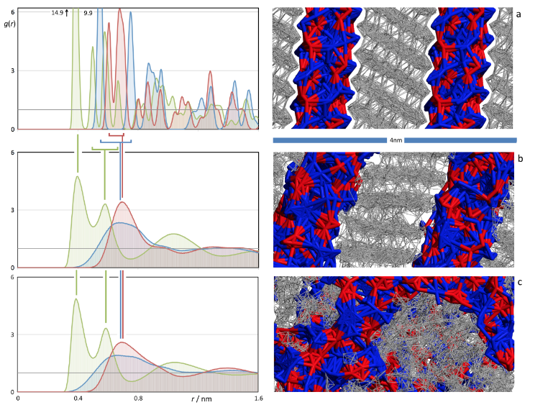
Figure 4. (left panels) Radial distribution functions, RDFs, between interaction-centre pairs representative of the charged parts of the [C₁₂mim](BF₄] ions. Green lines = cation(imidazolium ring C2 atom)-anion(boron atom) RDFs; red = anion-anion RDFs; blue = cation-cation RDFs. (right panels) simulation snapshots of the corresponding IL phases. (a) [C₁₂mim](BF₄] crystal; (b) [C₁₂mim](BF₄] SmA liquid crystal; (c) [C₁₂mim](BF₄] isotropic liquid.

displays a layered smectic A (SmA) phase at 25 °C) would be expected to result in the same type of anion effect, i.e. that the amount of endo product would increase relative to the exo product. In fact, moving from [C₁₂mim][Tf₂N] to [C₁₂mim][BF₄] leads to the opposite effect and a marked decrease in the endo:exo ratio, from 3.8 to 3.3, is seen. The anion effect is therefore not driving this change in the stereochemical outcome of the reaction. While there is a small increase in the volume fraction of the liquid that is taken up by the alkyl chains on moving between these salts, the magnitude of the observed change in endo:exo ratio is much larger than would be consistent with a simple alkyl chain effect. As such, it seems there is a strong suggestion that in these systems the anisotropic ordering of the LCIL [C₁₂mim][BF₄] is having an impact on the stereochemical outcome of this reaction, increasing the proportion of exo product that is formed. This would be consistent with the sterically less demanding nature of the exo transition state being slightly better accommodated by the ordered fluid that is the LCIL. In order to test this assumption, detailed MD studies were conducted and are now described.

Molecular dynamics studies

In order to gain a deeper insight into the experimental observations and to provide a molecular basis upon which to understand the LC effects described above, a detailed MD study of selected IL, LCILs and solutions containing the endo or exo product in these materials was undertaken. The reaction products were used as proxies for the transition states (TS) in the DA reaction, as their structures are quite similar to the TSs, but being ground state species they are significantly simpler to parameterise appropriately for the MD simulations.

1. Ionic liquids as crystalline, liquid crystal (LC) and isotropic-liquid media.

Figure 4 shows three MD simulation snapshots of 1-dodecyl-3-methylimidazolium tetrafluoroborate, [C₁₂mim][BF₄], as a crystalline phase, as a liquid crystal, and as an isotropic liquid (panels a-c, respectively). Each panel is supplemented by a set of three radial distribution functions between selected atoms belonging to the charged parts of the cation (the carbon between the two nitrogen atoms in the imidazolium ring) and the anion (the boron atom). The three possible combinations (cation–anion, cation–cation and anion–anion) are depicted as green, blue and red lines, respectively.
The simulations in the crystalline phase of [C₁₂mim][BF₄] were started from initial configurations based on crystallographic information for [C₁₂mim][PF₆] deposited at the CCDC (ref: HIWNOQ).^{[12]} Both crystals exhibit layered structures, where the anions and the polar moiety of the cations (red and blue, respectively) form different tiers separated by non-polar strata composed of the dodecyl chains. The distance between the polar planes in [C₁₂mim][PF₆] is 1.63 nm (minimal distance between boron atoms belonging to two polar planes mediated by the
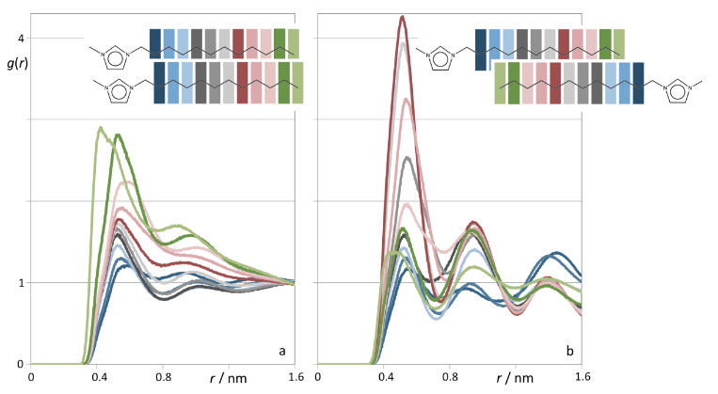
Figure 5. Radial distribution functions, RDFs, between interaction-centres in the alkyl side chains of the imidazolium rings in [C₁₂mim][BF₄]. The colour coding refers to pairs of carbon atoms occupying the same position in the dodecyl chain (e.g. a C7-C7 RDF is depicted in red). (a) [C12mim][BF₄] isotropic liquid.; (b) [C12mim][BF₄] SmA liquid crystal. The change in height of the first RDF peak along the two series — monotonous in (a), with a maximum in (b) — reflect the parallel (head-to-head) or interdigitated arrangements of the alkyl side chains in the two cases, as depicted by the two inserts.
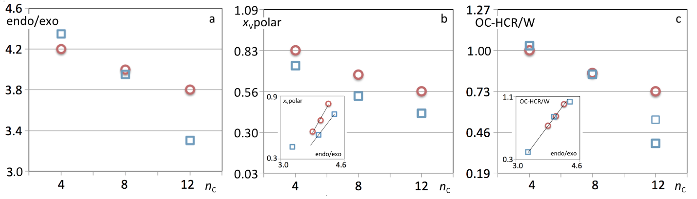
Figure 6. (a) Experimental endo/exo ratio of DA products in six different ionic liquids as a function of the alkyl side chain length, n_{C}, in the IL cation. The heights of the symbols correspond to the estimated uncertainty of the experimental data (ca 0.05). (b) Volume fraction occupied by the polar network of the ILs, x_{v}polar, as a function of n_{C}. The inset correlates directly x_{v}polar with the experimental endo/exo ratio. (c) The number of contacts, OC-HCR/W, between the carbonyl oxygen atom of the endo or exo compound (OC) and one of the aromatic hydrogen atoms of the imidazolium ring (HCR, HCW₁ or HCW₂). The inset correlates directly OC-HCR/W with the experimental endo/exo ratio. The red circles indicate bis(triflamide)-based ILs ([C₄mim][Tf₂N], [C₈mim][Tf₂N] and [C₁₂mim][Tf₂N]); the blue squares represent tetrafluoroborate-based ILs ([C₄mim][BF₄], [C₈mim][BF₄] and [C₁₂mim][BF₄]). The thinner blue square in (c) corresponds to [C₁₂mim][BF₄] simulated as an isotropic liquid phase.

non-polar strata) whereas in [C₁₂mim][BF₄] the distance obtained after equilibration of the MD runs is 1.75 nm. The larger distance observed between the polar planes in the [BF₄]– salt, despite the fact that both systems contain C₁₂ chains, can be rationalised in terms of the smaller area occupied by the [BF₄]– ions in the polar planes and the smaller tilt of the dodecyl chains relative to the polar planes (31° in [C₁₂mim][BF₄] against 34° in [C₁₂mim][PF₆]) that is necessary to accommodate this (see ESI for an illustration of this). The multitude of peaks in the corresponding g(r) functions (figure 4, panel d) reflect the ordering of the ions within each plane. The liquid-crystalline phase of [C₁₂mim][BF₄] was obtained by partially melting the corresponding crystalline phase using a series of temperature-annealing runs. The snapshots show a smectic phase where the layered structure of the crystal remains. Order is still maintained in the direction normal to the planes/strata but disrupted in the two in-plane directions. This can be seen by the 'fusing' of the peaks in the corresponding g(r) functions. Nevertheless it must be stressed that the same degree of charge ordering is maintained within each polar plane as attested by the out-of-phase character of the three functions depicted. The distance between polar planes increases to a value of 1.90 nm (and the tilt from the normal decreases to 18°). Some ordering is also maintained within the non-polar strata: dodecyl chains originating from two different polar layers adopt interdigitated configurations relative to each other, c.f. Figure 5.
Finally, some simulations were performed in the isotropic liquid region of [C₁₂mim][BF₄]. These were obtained starting from expanded and random configurations containing both ions. Here, the layered structure is lost but the segregation of the system into polar and non-polar domains is retained. On one hand, charge ordering within the polar domains is very similar to that observed for the liquid crystal phase (c.f. middle-left and bottom-left panels of figure 4). On the other hand, X-ray diffraction studies predict (by extrapolation) that in this case the non-polar domains should have characteristic thicknesses of 3.10 nm.^{[13]} This very large increase in the bulk of the non-polar domains can be understood if one recognises that the non-polar domains are no longer constrained to strata (they can also form more globular structures) and that whereas the chains are interdigitated in the crystal or liquid-crystalline structure, the dodecyl chains can adopt head-to-head and/or side-by-side configurations in the isotropic liquid, e.g. Figure 5.

2. Endo/Exo molecules in the IL media

The different characteristics of the ILs can now be used to rationalise their behaviour as reaction media, namely their effect on the ratio of endo/exo products obtained in the DA reaction between cyclopentadiene and methyl acrylate. Figure 6a shows the endo-to-exo ratio as a function of the alkyl side chain obtained in six different IL media that were also modelled using MD simulations. One of the ionic liquids under discussion, [C₁₂mim][BF₄], can exhibit a SmA phase.
The endo-to-exo ratio always decreases with increasing alkyl chain length in the ILs. It is a known fact that the polarity of the reaction media strongly influences the endo-to-exo ratio of a DA reaction:^{[7]} strongly dipolar media favour the endo product (e.g. in methanol the endo-to-exo ratio of 6.7, table 1), whereas more apolar solvents reduce such tendency (e.g. in toluene or in ethers, the endo-to-exo ratio is around 3). Although there is still some controversy regarding the origin of such solvent effects — theories range from hindrance and deformation of the transition state to stabilisation of π-orbitals involved in the cycloaddition reaction^{[7-8]} — one can certainly transpose these facts to the media under discussion.
Given the fact that ILs are segregated at a nanoscopic level (a polar network permeated by non-polar domains), the most obvious way to rationalise this behaviour is to calculate the volume fraction occupied by the polar network for each type of ionic liquid. Figure 6b shows the polar volume fractions, x_{V}, as a function of the alkyl side chains for the six ILs under discussion. The x_{V}(polar) results were estimated taking into account the volume of each ion and non-polar moiety, calculated via a group contribution scheme based on the additive volumetric behaviour of ionic liquids.^{[14]} The results show that the volume fraction occupied by the polar network decreases with the increasing length of the alkyl side chains in a way similar to the trends
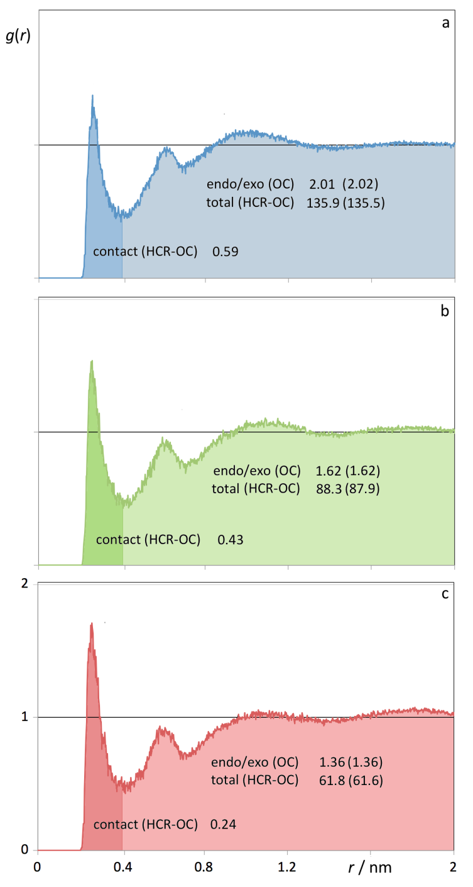
Figure 7. Radial distribution functions, RDFs, between interaction centres in the endo or exo DA products (oxygen atom, OC, of the carbonyl group) and in the IL cation imidazolium ring (aromatic hydrogen atom, HCR, connected to the C2 (= CR) carbon atom). (a) [C₄mim][Tf₂N];(b) [C₈mim][Tf₂N]; (c) [C₁₂mim][Tf₂N]. The light shaded areas beneath the RDFs correspond to integrations up to cut-off radii of 2 nm, yielding the number of DA products found within the cut-off sphere and the total number of possible DA products-IL cation pairs. The dark shaded areas correspond to contact in DA compound-IL cation pairs.
observed for the endo-to-exo ratios. In other words, as the alkyl chains of the ionic liquid grow longer, the DA reactants find themselves more often than not in a more non-polar alkane-like environment, which decreases the endo-to-exo ratio. In other words, the ionic liquids are amphiphilic solvents where the amount of each part (polar and non-polar regions) can be inferred by the corresponding polar volume fraction. Nevertheless, when one compares the two IL series based on the bistriflamide and tetrafluoroborate anions, respectively, one can notice that the steeper endo-enrichment trend observed for the latter series relative to the former one is not totally reflected by the corresponding polar volume fraction shifts. Moreover, the
Table 2. Summary of experimental, correlation, and Molecular Dynamics simulation data calculated for the seven (IL plus DA products) under discussion. The experimental results (EXP) refer to endo-to-exo ratios of DA products; the correlation (CORR) results refer to estimations of the volume fraction of the system occupied by the polar network of the ionic liquid; the MD results tally the number of contacts between the DA products and the charged part of the IL cations per DA product found in the simulation box.
IL/media | n_{C} | endo/exo | x_{V}polar | ΣOC-HCR/W | OC-HCR | OC-HCW₁ | OC-HCW₂
 |  | EXP | CORR | MD | MD | MD | MD
[C₄mim][BF₄] / ISO | 4 | 4.35 | 0.73 | 1.03 | 0.30 | 0.35 | 0.38
[C₈mim][BF₄] / ISO | 8 | 3.95 | 0.53 | 0.84 | 0.25 | 0.29 | 0.30
[C₁₂mim][BF₄] / ISO | 12 | NA ^{[a]} | 0.42 | 0.54 | 0.20 | 0.17 | 0.17
[C₁₂mim][BF₄] / LC | 12 | 3.30 | 0.42 | 0.40 | 0.20 | 0.17 | 0.03
[C₄mim][Tf₂N] / ISO | 4 | 4.20 | 0.83 | 1.00 | 0.30 | 0.35 | 0.35
[C₈mim][Tf₂N] / ISO | 8 | 4.00 | 0.67 | 0.85 | 0.27 | 0.27 | 0.30
[C₁₂ mim][Tf₂N] / ISO | 12 | 3.80 | 0.56 | 0.73 | 0.22 | 0.27 | 0.24
[a] DA reaction not attempted in the isotropic phase of [C₁₂mim][BF₄], by heating above the clearing point, due to the volatility of the cyclopentadiene (b.p. = 41 ºC).

liquid-crystalline nature of the [C₁₂mim][BF₄] system is not a factor in a simple calculation of polar volume fraction.
In order to analyse in more detail the types of interaction present in the different systems, it was decided to compute the number of interactions between the endo and exo products and the polar network of the ionic liquid. In this case the endo and exo products are acting as proxies for the two DA reactants arranged in the corresponding transition states. We performed several MD runs with either the endo or the exo compounds. In most cases we did not observe any difference in the results within statistical uncertainty. Thus, unless otherwise stated explicitly, the following discussion will be based on results that are the data average from both types (endo/exo) of run.
Figure 7 shows the pair radial distribution functions between the oxygen atom (OC) in the carbonyl group of the endo/exo product and the most acidic aromatic hydrogen atom (HCR) of the imidazolium cation (hydrogen in the 2-position – see Table 2 inset) in [C_{n}mim][Tf₂N] (n = 4, 8, 12) solutions. We have chosen these two interaction centres as the most representative of the possible specific interactions taking place between the DA products (or reactants in the transition state) and the polar parts of the ionic liquid. RDFs between interaction centres in the anions and in the exo/endo compounds show no specific interactions.
Integration of the RDFs up to a cut-off distance of 2 nm allowed us to calculate the number of endo/exo compounds (OCs) and IL cations (HCRs) within the cut-off radius and the total number of possible (HCR-OC) pairs. These numbers (depicted in figures 7a-c) were combined with the values (also depicted between parentheses in figures 7a-c) obtained from the total number of species within the simulation box and the volume ratio between the cubic boxes and the cut-off spheres. The conformity of the numbers reflect the fact that at the cut-off distance of 2 nm, the anisotropy of the IL has been averaged-out relative to the centre of the cut-off sphere. This allowed us to estimate with some confidence the number of contact (HCR-OC) pairs via integration under the first RDF peaks (up to a distance of ca 0.4 nm).
The number of HCR-OC contact pairs decreases as the alkyl side chain along the [C_{n}mim][Tf₂N] increases. If the number of HCR-OC contacts per endo/exo compound present in the box are calculated (c.f. 6th column in Table 2), the values also decrease along the series, confirming the ‘dilution’ of the charged part along the IL series, the more ‘non-polar’ environment felt by the endo/exo products and, consequently, their tendency to yield smaller endo-to-exo product ratios. This is apparent if data for [C_{n}mim][Tf₂N] in figures 6a-c are compared: the endo-to-exo ratio versus alkyl side chain length (Fig. 6a) is reflected both in the trends found for the volume fraction occupied by the polar network (Fig. 6b) and for the total number of contacts between the OC oxygen of the endo/exo products and the aromatic hydrogen atoms of the imidazolium rings (Fig. 6c). It must be stressed that Figure 7 shows only the contact pairs involving the HCR hydrogen atom of the imidazolium ring, but similar RDF integrations were performed using the other two aromatic hydrogen atoms (HCW) present in the ring. Table 2 includes the partial (columns 6-8) and total (column 5) number of contacts for each type of OC-HCR/W contact per number of exo/endo molecules present in the cut-off sphere (inset to Table 2 gives a key).
Similar RDF integration procedures were performed for the [C_{n}mim][BF₄] series. In this case we have modelled the [C₄mim][BF₄], [C₈mim][BF₄] and [C₁₂mim][BF₄] systems not only as isotropic fluid media but also, in the case of [C₁₂mim][BF₄], as a SmA phase.
The RDF integration results (also included in table 2 show that the number of OC-HCR/W contacts decreases faster in the [BF₄]-based IL series than in the [Tf₂N]-based one —a trend that is not fully captured in the polar volume fraction analysis (cf. Figure 6b), probably because the specificity of the interactions between ions within the polar network is not taken into account. A more pronounced segregation between polar and apolar domains in the isotropic [C₁₂mim][BF₄] relative to all other isotropic Ils (where the volume fraction occupied by the non-polar domains is smaller and the tendency to form LC structures is supressed) can explain the relatively low values for the contacts between the DA product and the charged parts of the IL. These facts can also be appreciated via the correlations between the two types of analysis and the observed endo-to-exo ratios, cf. insets in Figures 6b and 6c.
Table 2 and Fig. 6c also show that there is a difference between the results obtained for the endo/exo compounds included in [C₁₂mim][BF₄] modelled as an isotropic liquid or as a SmA liquid crystal. The experimental endo-to-exo ratios correlate very well with the contact numbers obtained in the (real) [C₁₂mim][BF₄] liquid crystal phase, but deviate from those obtained in the (hypothetical) [C₁₂mim][BF₄] isotropic liquid, cf. Fig. 6c. In fact it is quite easy to unveil the reason behind the lower number of OC-HCR/W contacts (and lower observed endo-to-exo ratios) in the SmA phase: the layered nature of the polar network of the smectic ionic liquid crystal (cf. Fig 4b) means that one of the HCW hydrogen atoms of the imidazolium ring (labelled in our simulations as HCW₂) is embedded within the polar layer. Since the DA reactants spend very little time within the polar network (they are located preferentially within the alkyl chain regions of the LCIL) they are therefore not able to interact with HCW₂. This fact is endorsed by the MD simulation results, which show that the decrease in the number of OC-HCR/W contacts from the [C₁₂mim][BF₄] liquid to the [C₁₂mim][BF₄] liquid crystal is due to the large decrease in the number of OC-HCW₂ contacts (c.f. final column of Table 2). In other words, the observed endo-to-exo ratio is even lower than expected in the LC-based systems because one potential C-H hydrogen bond donor site is hidden from the Diels-Alder reactants because of the layered ordering of the SmA phase. This effect is not seen in the isotropic liquids, for while they display nanoscale segregation of the polar and non-polar parts of their constituent ions, the cationic head groups are orientated randomly in the polar domains and so all parts of the cation are accessible to solutes residing in the non-polar regions. Thus, there is an LCIL effect in this system (at least for [C₁₂mim][BF₄]) where the order in the system causes the LC phase to appear less polar than the isotropic phase. This results in an increased proportion of exo product, as expected from the shift in apparent polarity.
The MD simulation runs have also unveiled other interesting structural issues. Thus, during the course of the simulation runs we have witnessed several (unexpected) events where one of the endo or exo compounds would leave the non-polar strata where it usually resides for periods of some nanoseconds, partially disrupt a polar layer, get embedded in it for some tenths of nanoseconds (in the mid-region of the double-plane polar layer), and eventually migrate to a neighbouring (or return to the original) non-polar stratum (Fig. 8). During the whole process the polar network contained in the polar planes was always able to accommodate the (bulky) DA compound without any disruption of the layered structure of the smectic ionic liquid (a movie of this process is given in the ESI). Such permeability and resilience of the polar layers is another proof of the flexibility and adaptability of the strong electrostatic interactions that exist among the IL ions.
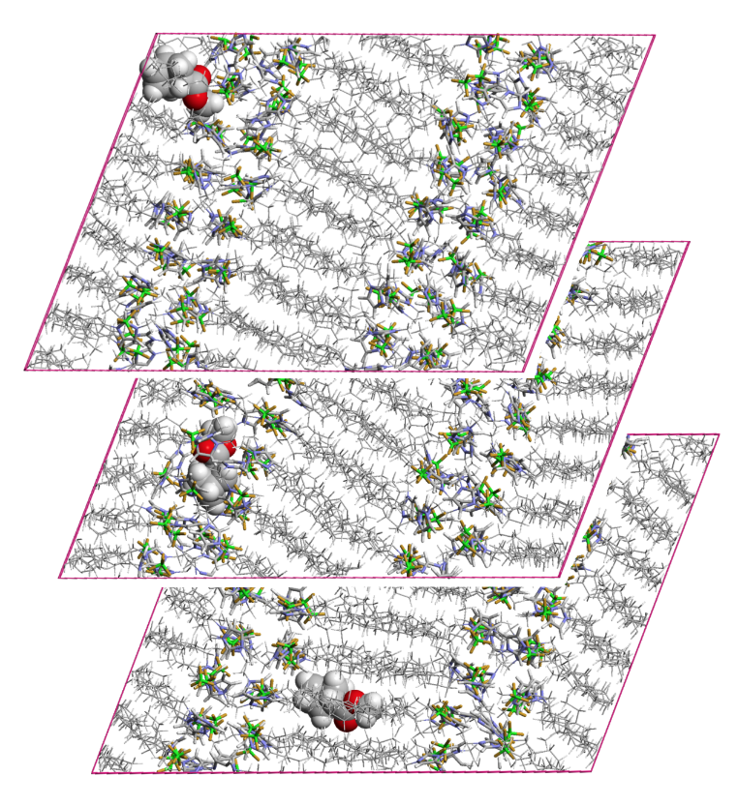
Figure 8. Three simulation snapshots showing the DA products in the SmA liquid crystal phase of [C₁₂mim][BF₄]. (bottom) DA product in a non-polar, alkane-like layer; (middle) DA product embedded in a polar layer; (top) DA product exiting to another non-polar layer. The three snapshots occurred during the same simulation run and were registered a few ns apart.
Although the simulations were performed with very few solute molecules (1-6 endo/exo compounds in systems with a few hundred ion pairs) and the corresponding statistics are poor for the estimation of cross interactions —the main conclusions concerning the endo-to-exo ratio drawn from the previous analyses of results from the MD runs with endo and exo results combined — the runs in the smectic [C₁₂mim][BF₄] system seemed to suggest some sort of differentiation between the two types of molecules. It can be seen from fig 9a that the exo product appears to form a more significant interaction with HCR than the endo form. One can speculate that the more structured nature of the SmA LCIL promotes better interactions between the polar layer and the more exposed carbonyl group of the exo product. If this is so (and assuming again that the DA product can be used as a proxy for the reactants arranged in the corresponding transition state) the exo product would also react more efficiently and the outcome would also contribute to the observed lower endo-to-exo ratio in liquid-crystalline ILs.
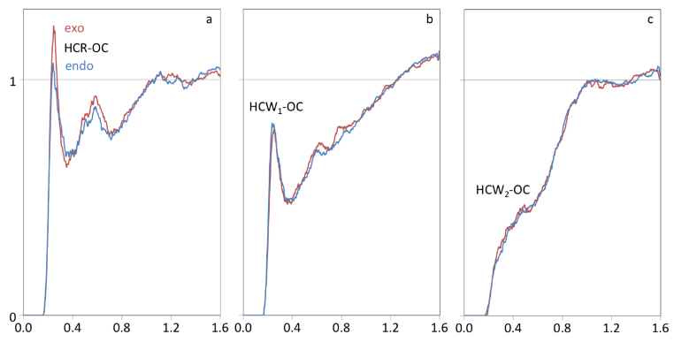
Figure 9. Radial distribution functions, RDFs, between interaction centres in the endo or exo DA products (oxygen atom, OC, of the carbonyl group) and in the IL cation imidazolium ring (aromatic hydrogen atoms, (a) HCR, (b) HCW₁ and (c) HCW₂) in the [C₁₂mim][BF₄] smectic liquid crystal phase system. Red lines: exo DA product system; blue lines: endo DA product system.
Conclusions
As outlined briefly in the introduction, one of the attractions of using liquid crystals as reaction solvents is the inherent order that characterises the mesophase, which it is postulated can affect some combination of rate of reaction and regio-/stereo-chemical outcome. This can be exemplified by the work of Leigh and co-workers who showed, for example, how the trans/cis isomerisation of 1,2-di-(4-cyanophenyl)-1,2-diphenylethylene was slowed in LC solvents compared to isotropic solvents^{[15]} or how the regiochemistry of the Diels-Alder addition of N-biphenylmaleimide to cholesta-5,7-dien-3β-yl acetate was influenced by carrying out the reaction in the LC mesophase.^{[16]} Curiously, however, in studying the Diels-Alder reaction between 2,5-dimethyl-3,4-diphenylcyclopentadienone and a variety of dienophiles, no effect of LC solvent was observed, which was tentatively attributed both to lack of discrimination in solvating the two transition states and also the high tendency for the diene to destabilise the LC phase of the solvents used.^{[17]} Therefore, the nature of the effect being observed is not necessarily a generalised phenomenon.
One of the reasons for choosing to investigate LCILs as solvents is the fact that the wide LC range means that it is unlikely that solutes will effect too strong a destabilisation of the LC phase and so it was envisaged that specific effects of this nature would not come into play. As such, it was reasonable, as a first assumption, that the LC effect observed in the present system arose from a combination of solvent order and anisotropy. However, the results from the atomistic simulations painted a subtly different picture.
MD simulations of the SmA phase of [C₁₂mim][BF₄] suggest that the layered structure of this LCIL restricts the accessibility of C-H hydrogen bond donor groups on the IL cation to both DA products (as proxies for the exo and endo transition states) when compared to the isotropic phase. This reduces hydrogen bonding interactions between the solutes and the IL, and thus lowers the effective polarity of the solvent, which correlates well with the reduction in endo/exo ratio seen experimentally. This effect is not seen in simulations of the isotropic phase of [C₁₂mim][BF₄] or other isotropic ILs, where all C-H bonds on the imidazolium cation are accessible to solutes. In addition, there are hints in the results of the MD simulations (fig. 9) that there is preferential hydrogen bonding to the exo-product (as proxy for the exo-transition state) in the polar region of the segregated bilayer of the SmA phase of the LC-Ils, which is both the more polar region (which would favour the exo- product) and also the region where the order of the phase is greatest (much less motional/conformational freedom owing to the electrostatic interactions locating the imidazolium cations.
Therefore, the LC effect in this system, which here favours the exo product, is attributed to a combination of two factors: A change in apparent solvent polarity, due to the ordering present in the SmA mesophase, and better shape complementarity between the exo transition state and the LCIL, which leads to preferential hydrogen bonding. Both of these effects support each other to promote the formation of more exo product. Such a result is exciting because the detailed mechanism for the observed effect was not predicted a priori, which shows the benefit of a combined experimental and computational approach, and also because it shows that specific intermolecular interactions can be used in conjunction with the LC solvent to exert influence on the product distribution. As such, this opens up more exciting design possibilities for exploitation in other solvent/solute combinations.
Experimental Section
Experimental details are given in the ESI.
Acknowledgements
We thank the University of York, the Royal Society (BP Amoco fellowship for Y. G. and International Exchanges Grants). In Portugal financial support was provided by the Fundação para a Ciência e Tecnologia (FCT) through projects FCT-ANR/CTMNAN/0135/2012, PTDC/CTM- NAN/121274/2010 and UID/QUI/00100/2013. KS acknowledges the postdoctoral grant SFRH/BPD/94291/2013.
Keywords: Ionic liquids • Liquid crystals • Diels Alder reaction • Molecular dynamics simulations • Ordered solvents
[1] a) P. Wasserscheid, T. Welton, Ionic Liquids in synthesis, 2nd edn ed., Wiley-VCH, Weinheim, 2008; b) T. Welton, Chem. Rev. 1999, 99, 2071-2083; c) V. I. Parvulescu, C. Hardacre, Chem. Rev. 2007, 107, 2615-2665; d) J. P. Hallett, T. Welton, Chem. Rev. 2011, 111, 3508-3576; e) M. Antonietti, D. B. Kuang, B. Smarsly, Z. Yong, Angew. Chem., Int. Ed. 2004, 43, 4988-4992; f) J. D. Scholten, B. C. Leal, J. Dupont, Acs Catal 2012, 2, 184-200; g) R. A. Sheldon, R. M. Lau, M. J. Sorgedrager, F. van Rantwijk, K. R. Seddon, Green Chem. 2002, 4, 147-151; h) R. Hayes, G. G. Warr, R. Atkin, Chem. Rev. 2015, 115, 6357-6426.
[2] R. G. Weiss, Tetrahedron 1988, 44, 3413-3475.
[3] a) D. W. Bruce, S. Estdale, D. Guillon, B. Heinrich, Liq. Cryst. 1995, 19, 301-305; b) Y. A. Gao, J. M. Slattery, D. W. Bruce, New J. Chem. 2011, 35, 2910-2918; c) K. Binnemans, Chem. Rev. 2005, 105, 4148-4204; d) M. Yoshio, T. Mukai, H. Ohno, T. Kato, J. Am. Chem. Soc. 2004, 126, 994-995; e) M. Yoshio, T. Ichikawa, H. Shimura, T. Kagata, A. Hamasaki, T. Mukai, H. Ohno, T. Kato, Bull. Chem. Soc. Jpn. 2007, 80, 1836-1841; f) K. V. Axenov, S. Laschat, Materials 2011, 4, 206-259.
[4] C. K. Lee, H. W. Huang, I. J. B. Lin, Chem. Commun. 2000, 1911-1912.
[5] a) A. Aggarwal, N. L. Lancaster, A. R. Sethi, T. Welton, Green Chem. 2002, 4, 517-520; b) R. Bini, C. Chiappe, V. L. Mestre, C. S. Pomelli, T. Welton, Org. Biomol. Chem. 2008, 6, 2522-2529; c) R. Bini, C. Chiappe, V. L. Mestre, C. S. Pomelli, T. Welton, Theor. Chem. Acc. 2009, 123, 347-352; d) A. Vidis, C. A. Ohlin, G. Laurenczy, E. Kusters, G. Sedelmeier, P. J. Dyson, Adv. Synth. Catal. 2005, 347, 266-274.
[6] T. D. Do, A. R. Schmitzer, RSC Adv. 2015, 5, 635-639.
[7] a) J. A. Berson, W. A. Mueller, Z. Hamlet, J. Am. Chem. Soc. 1962, 84, 297-&; b) M. F. Ruizlopez, X. Assfeld, J. I. Garcia, J. A. Mayoral, L. Salvatella, J. Am. Chem. Soc. 1993, 115, 8780-8787; c) C. Cativiela, J. I. Garcia, J. A. Mayoral, L. Salvatella, J. Chem. Soc., Perkin Trans. 2 1994, 847-851; d) C. Cativiela, J. I. Garcia, J. A. Mayoral, L. Salvatella, Chem. Soc. Rev. 1996, 25, 209-&; e) T. R. Furlani, J. L. Gao, J. Org. Chem. 1996, 61, 5492-5497; f) J. I. Garcia, J. A. Mayoral, L. Salvatella, Tetrahedron 1997, 53, 6057-6064.
[8] I. Fernandez, F. M. Bickelhaupt, J. Comput. Chem. 2014, 35, 371-376.
[9] a) D. A. Jaeger, C. E. Tucker, Tetrahedron Lett. 1989, 30, 1785-1788; b) M. J. Earle, P. B. McCormac, K. R. Seddon, Green Chem. 1999, 1, 23-25; c) T. Fischer, A. Sethi, T. Welton, J. Woolf, Tetrahedron Lett. 1999, 40, 793-796; d) C. W. Lee, Tetrahedron Lett. 1999, 40, 2461-2464; e) A. P. Abbott, G. Capper, D. L. Davies, R. H. Rasheed, V. Tambyrajah, Green Chem. 2002, 4, 24-26; f) I. Meracz, T. Oh, Tetrahedron Lett. 2003, 44, 6465-6468; g) A. Kumar, S. S. Pawar, J. Org. Chem. 2004, 69, 1419-1420; h) E. Janus, I. Goc-Maciejewska, M. Lozynski, J. Pernak, Tetrahedron Lett. 2006, 47, 4079-4083; i) S. Tiwari, A. Kumar, Angew. Chem., Int. Ed. 2006, 45, 4824-4825; j) O. Acevedo, W. L. Jorgensen, J. D. Evanseck, J. Chem. Theory Comput. 2007, 3, 132-138; k) A. Vidis, G. Laurenczy, E. Kusters, G. Sedelmeier, P. J. Dyson, J. Phys. Org. Chem. 2007, 20, 109-114; l) A. R. Harifi-Mood, A. Habibi-Yangjeh, M. R. Gholami, J. Phys. Org. Chem. 2008, 21, 783-788; m) E. Janus, W. Stefaniak, Catal. Lett. 2008, 124, 105-110; n) A. Vidis, E. Kuesters, G. Sedeimeier, P. J. Dyson, J. Phys. Org. Chem. 2008, 21, 264-270; o) O. Acevedo, J. Mol. Graphics Modell. 2009, 28, 95-101; p) S. Hayaki, K. Kido, D. Yokogawa, H. Sato, S. Sakaki, J. Phys. Chem. B 2009, 113, 8227-8230; q) N. D. Khupse, A. Kumar, J. Phys. Chem. A 2011, 115, 10211-10217; r) W. Stefaniak, E. Janus, E. Milchert, Catal. Lett. 2011, 141, 742-747; s) A. Kumar, S. S. Pawar, Sci. China. Chem. 2012, 55, 1633-1637; t) K. Nobuoka, S. Kitaoka, A. Yanagisako, Y. Maki, T. Harran, Y. Ishikawa, RSC Adv. 2013, 3, 19632-19638.
[10] T. Inoue, B. Dong, L. Q. Zheng, J. Colloid Interface Sci. 2007, 307, 578-581.
[11] J. D. Holbrey, K. R. Seddon, J. Chem. Soc., Dalton Trans. 1999, 2133-2139.
[12] C. M. Gordon, J. D. Holbrey, A. R. Kennedy, K. R. Seddon, J. Mater. Chem. 1998, 8, 2627-2636.
[13] a) A. Triolo, O. Russina, B. Fazio, R. Triolo, E. Di Cola, Chem. Phys. Lett. 2008, 457, 362-365; b) A. Triolo, O. Russina, H. J. Bleif, E. Di Cola, J. Phys. Chem. B 2007, 111, 4641-4644.
[14] a) I. Krossing, J. M. Slattery, C. Daguenet, P. J. Dyson, A. Oleinikova, H. Weingartner, J. Am. Chem. Soc. 2006, 128, 13427-13434; b) I. Krossing, J. M. Slattery, C. Daguenet, P. J. Dyson, A. Oleinikova, H. Weingartner, J. Am. Chem. Soc. 2007, 129, 11296-11296; c) J. M. Slattery, C. Daguenet, P. J. Dyson, T. J. S. Schubert, I. Krossing, Angew. Chem. Int. Ed. 2007, 46, 5384-5388; d) U. P. R. M. Preiss, J. M. Slattery, I. Krossing, Ind. Eng. Chem. Res. 2009, 48, 2290-2296.
[15] W. J. Leigh, D. T. Frendo, P. J. Klawunn, Can. J. Chem. 1985, 63, 2131-2138.
[16] W. J. Leigh, D. S. Mitchell, J. Am. Chem. Soc. 1992, 114, 5005-5010.
[17] W. J. Leigh, Can. J. Chem. 1985, 63, 2736-2741.

Entry for the Table of Contents

FULL PAPER
Liquid-crystalline ionic liquids are used as reaction media and their ordered structures are shown to influence the stereochemical outcome of a Diels-Alder reaction. |  | Duncan W. Bruce,* Yanan Gao, José Nuno Canongia Lopes,* Karina Shimizu and John M. Slattery*  [a] Dr John M. Slattery, Prof. Duncan W. Bruce  Department of Chemistry  University of York  Heslington, York, YO10 5DD, UK  E-mail: john.slattery@york.ac.uk, duncan.bruce@york.ac.uk  [b] Prof. Yanan Gao  Dalian Institute of Chemical Physics  Chinese Academy of Sciences  457 Zhongshan Road, Dalian 116023, P. R. China  [c] Prof. José Nuno Canongia Lopes, Dr Karina Shimizu  Centro de Química Estrutural  Instituto Superior Técnico  Universidade de Lisboa  Av. Rovisco Pais, 1049-001 Lisboa, Portugal.  E-mail: jnlopes@ist.utl.pt  [d] Prof. José Nuno Canongia Lopes  Instituto de Tecnologia Química e Biológica  Universidade Nova de Lisboa  Av. República, 2780-157 Oeiras, Portugal  Supporting information for this article is given via a link at the end of the document.  Page No. – Page No.  Liquid-crystalline ionic liquids as ordered reaction media for the Diels-Alder reaction

