Supplementary File 1. Full MEDLINE Search strategy

1 (pregnancy adj4 diabetes).ti,ab. (4082)
2 (gestational adj4 diabetes).ti,ab. (8108)
3 exp DIABETES, GESTATIONAL/ (7439)
4 gdm.ti,ab. (3272)
5 (glucose adj4 (pregnan* or gestation* or natal or maternal)).ti,ab. (3469)
6 1 or 2 or 3 or 4 or 5 (15075)
7 macrosomia.ti,ab. (2314)
8 exp FETAL MACROSOMIA/ (1826)
9 7 or 8 (3157)
10 exp BIRTH INJURIES/ (4937)
11 ((perinatal or labor or labour or birth) adj4 trauma).ti,ab. (1355)
12 ((perinatal or labor or labour or birth) adj4 injur*).ti,ab. (2542)
13 ((perinatal or labor or labour or birth) adj4 complication*1).ti,ab. (4372)
14 exp OBSTETRIC LABOR COMPLICATIONS/ (53369)
15 *DYSTOCIA/ (1902)
16 (shoulder adj4 dystocia).ti,ab. (1021)
17 (fracture*1 adj4 clavicle*1).ti,ab. (1218)
18 (fracture*1 adj4 humerus).ti,ab. (3451)
19 (fracture*1 adj4 shoulder*1).ti,ab. (753)
20 (fracture*1 adj4 arm*1).ti,ab. (454)
21 "erb* palsy".ti,ab. (185)
22 neuropath*.ti,ab. (97784)
23 exp BRACHIAL PLEXUS NEUROPATHIES/ (2817)
24 10 or 11 or 12 or 13 or 14 or 15 or 16 or 17 or 18 or 19 or 20 or 21 or 22 or 23 (168258)
25 (preeclampsia or pre-eclampsia).ti,ab. (20669)
26 exp PRE-ECLAMPSIA/ (24509)
27 25 or 26 (31679)
28 (heart adj4 (disorder*1 or disease*1)).ti,ab. (142562)
29 (cardiovascular adj4 (disorder*1 or disease*1)).ti,ab. (119950)
30 (cardiac adj4 (disorder*1 or disease*1)).ti,ab. (26958)
31 exp CARDIOVASCULAR DISEASES/ (1944605)
32 exp HEART DISEASES/ (922916)
33 28 or 29 or 30 or 31 or 32 (2024083)
34 exp HYPOGLYCEMIA/ (22500)
35 hypoglyc*.ti,ab. (42033)
36 34 or 35 (48692)
37 exp DIABETES MELLITUS, TYPE 2/ (90640)
38 (("type 2" or "' type AND two" or "type II") adj4 diabet*).ti,ab. (87156)
39 37 or 38 (121847)
40 exp OBESITY/ (152662)
41 (obesity or obese or bmi or "body mass" or overweight).ti,ab. (311123)
42 40 or 41 (343012)
43 9 or 24 or 27 or 33 or 36 or 39 or 42 (2561831)
44 (offspring or son*1 or daughter*1 or child or children or pediatric*1 or paediatric*1).ti,ab. (1177569)
45 exp CHILD OF IMPAIRED PARENTS/ (4392)
46 exp CHILD/ (1595153)
47 (maternal or mother*2).ti,ab. (288181)
48 exp MOTHERS/ (27857)
49 44 or 45 or 46 or 47 or 48 (2246955)
50 43 and 49 (274768)
51 6 and 50 (4840)
52 51 not (animals/ not humans/) (4622)

Supplementary File 2. Statistical methods

To model the associations between outcomes and glucose levels a log-linear relationship between risk and outcome was assumed; that is, the log odds of the outcome was assumed to vary linearly with glucose level. This association was modelled separately for each outcome and glucose test. Formally the models had the form:

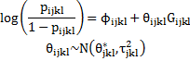

where i indicates study, j glucose test (eg. fasting 75g OGTT), k the outcome of interest (eg. macrosomia) and l the glucose category. Then p_{ijkl} is the probability of having the outcome in the relevant glucose category, G_{ijkl} is the typical glucose level in that category. Hence φi_{jkl} is the baseline log odds of the outcome in study I, which are assumed to be independent across stuidies. Also, θ_{i ijkl} is the association between glucose and outcome, in terms of the log odds of outcome per 1 mmol/L increase in glucose, assumed to have a random effect across studies to allow for heterogeneity in the trend. The model was fitted in R using the lme4 package for mixed effect regression modelling.

For outcomes reported in only one study the same logistic regression model was used without the meta-analysis across studies or the random effects. That is:

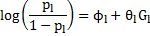

To test the assumption of linearity a term in glucose squared was added to each model:

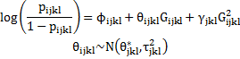

With the glucose squared terms γ modelled as fixed effects. Any deviation from linearity would be indicated by finding a statistically significant γ term.
Supplementary Table 1. Results of the risk of bias assessment
Study | Year of publication | Prospective  or retrospective | Representative population | Loss to follow up | Consistent glucose measurement | Consistent outcome measurement | ‘Blinding’ |  | Selective reporting | Adjusted results presented
 |  |  |  |  |  |  | of glucose measurements | of outcomes
Atlantic DIP | N/A | P | Low | Low | Low | Low | High | High | Low | Low
Aris | 2014 | P | Low | Low | Low | Low | Unclear | Unclear | Low | Low
BiB | N/A | P | Low | Low | Low | Low | High | High | Low | Low
Carr | 2011 | R | Low/moderate | Low | Low | Low | High | High | Low | Low
Chadna | 2006 | R | Unclear | Low | Unclear | Unclear | High | High | Unclear | High
Cheng | 2007 | R | Low | Low | Low | Unclear | High | High | Unclear | Low
Figueroa | 2013 | Secondary analysis of RCT data | Low (but subset of trial) | Low | Low | Low | Unclear | Unclear | Low | Low
HAPO | 2008 | P | Low | Low | Low | Low | Low | Low | Low | Low
HAPO | 2010 | P | Low | Low | Low | Low | Low | Low | Low | Low
Hillier | 2008 | Unclear | Low | Low | Low | Unclear | Unclear | Unclear | Unclear | Low
Jensen | 2001 | R | High (higher risk group) | Low | Low | Low | High | High | Low | High
Kerenyi | 2009 | Unclear | Low | Low | Low | Low | Unclear | Unclear | Unclear | Low
Landon | 2011 | Secondary analyses of RCT data | Low (subset of trial) | Low | Low | Low | Unclear | Low | Low | Low
Lao | 2003 | R | Low (Chinese) | Low | Low | Low | High | High | Low | High
Little | 1990 | P | Low | Low | Low | Unclear | Unclear | Unclear | Unclear | High
Lurie | 1998 | P | Low | Low | Low | Low | Unclear | Low | Low | High
Metzger | 2010 | P | Low | Low | Low | Low | Low | Low | Low | Low
Moses | 1995 | P | Low | Unclear | Low | Low | Unclear | Unclear | Low | High
Ong | 2008 | R | Low | Low | Low | Unclear | High | High | Unclear | High
Pettitt | 1980 | P | High (Pima Indian) | Low | Low | Low | Unclear | Unclear | Unclear | High
Riskin-Mashia | 2009 | R | Low | Low | Low | Low | High | High | Low | Limited adjustment
Savona-Ventura | 2010 | R | Low | Low | Low | Unclear | High | High | Unclear | High
Scholl | 2001 | P | Low | Low | Low | Low | Unclear | Unclear | Low | Low
Sermer | 1995 | P | Low | Low | Low | Low | Low | Low | Low | High
Tallarigo | 1986 | Unclear | Low | Low | Low | Low | Unclear | Unclear | Low | High
Witter | 1988 | R | Low, but young age group | Low | Low | Low | High | High | Low | High
Yee | 2011 | R | Low | Low | Low | Low | High | High | Low | Low
R=retrospective, P=prospective,
Supplementary Table 2. Analysis testing for linearity of association between glucose levels and outcomes
Outcome | Number of studies | Log odds ratio of glucose squared |  | 95% CI | P-value
Fasting 75g OGTT
C-section | 6 |  | -0.115 | (-0.25 - 0.02) | 0.1
Induction | 3 |  | -0.197 | (-0.52 - 0.13) | 0.23
Instrumental birth | 3 |  | 0.107 | (-0.21 - 0.42) | 0.5
LGA | 7 |  | -0.02 | (-0.16 - 0.12) | 0.77
Macrosomia | 6 |  | -0.18 | (-0.39 - 0.03) | 0.09
Neonatal hypoglycemia | 2 |  | 0.29 | (0.05 - 0.53) | 0.02
PIH/Pre-eclampsia | 3 |  | 0.461 | (0.03 - 0.9) | 0.04
Pre-eclampsia | 4 |  | -0.005 | (-0.28 - 0.27) | 0.97
Preterm birth | 3 |  | 0.577 | (0.09 - 1.07) | 0.02
Shoulder dystocia | 4 |  | -0.142 | (-1.06 - 0.78) | 0.76
50g OGCT
C-section | 7 |  | -0.029 | (-0.07 - 0.01) | 0.18
Instrumental birth | 2 |  | -0.008 | (-0.08 - 0.07) | 0.84
LGA | 4 |  | -0.044 | (-0.1 - 0.01) | 0.11
Macrosomia | 7 |  | -0.004 | (-0.02 - 0.02) | 0.69
Neonatal hypoglycemia | 3 |  | 0.047 | (-0.18 - 0.27) | 0.68
Pre-eclampsia | 6 |  | -0.082 | (-0.15 - -0.02) | 0.01
Preterm birth | 2 |  | 0.021 | (-0.05 - 0.09) | 0.55
Shoulder dystocia | 2 |  | -0.113 | (-0.25 - 0.03) | 0.12
2 hour 75g OGTT
C-section | 9 |  | -0.016 | (-0.03 – 0.00) | 0.06
Induction | 3 |  | 0.006 | (-0.04 - 0.05) | 0.81
Instrumental birth | 4 |  | -0.01 | (-0.05 - 0.03) | 0.65
LGA | 11 |  | 0.004 | (-0.01 - 0.02) | 0.67
Macrosomia | 7 |  | 0.006 | (-0.03 - 0.05) | 0.77
Neonatal hypoglycemia | 3 |  | 0.002 | (-0.02 - 0.03) | 0.91
PIH/Pre-eclampsia | 3 |  | 0.02 | (-0.07 - 0.11) | 0.67
Pre-eclampsia | 4 |  | -0.026 | (-0.05 – 0.00) | 0.05
Preterm birth | 6 |  | 0.009 | (-0.05 - 0.07) | 0.78
Shoulder dystocia | 5 |  | -0.067 | (-0.19 - 0.06) | 0.29

Supplementary Figure 1. Odd ratios for outcomes at one and two-hour and combined for the 75g and 100g post-load OGTT
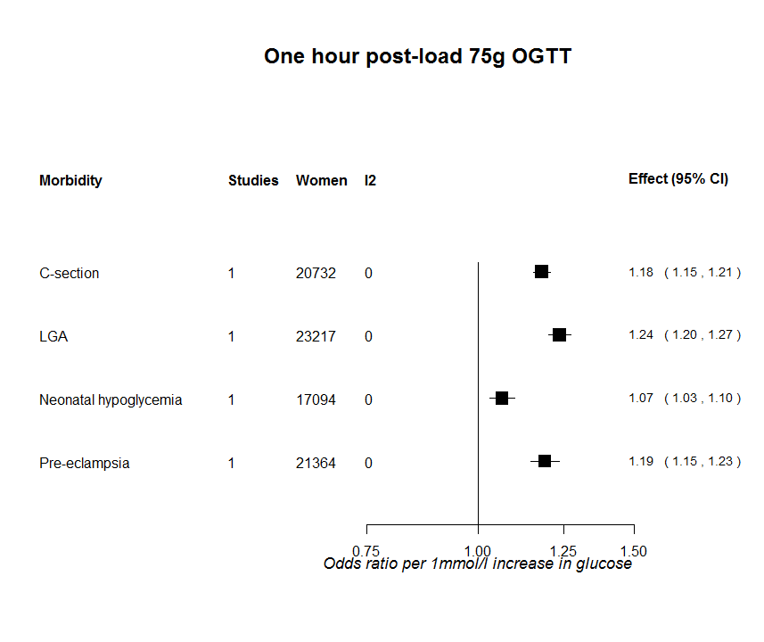
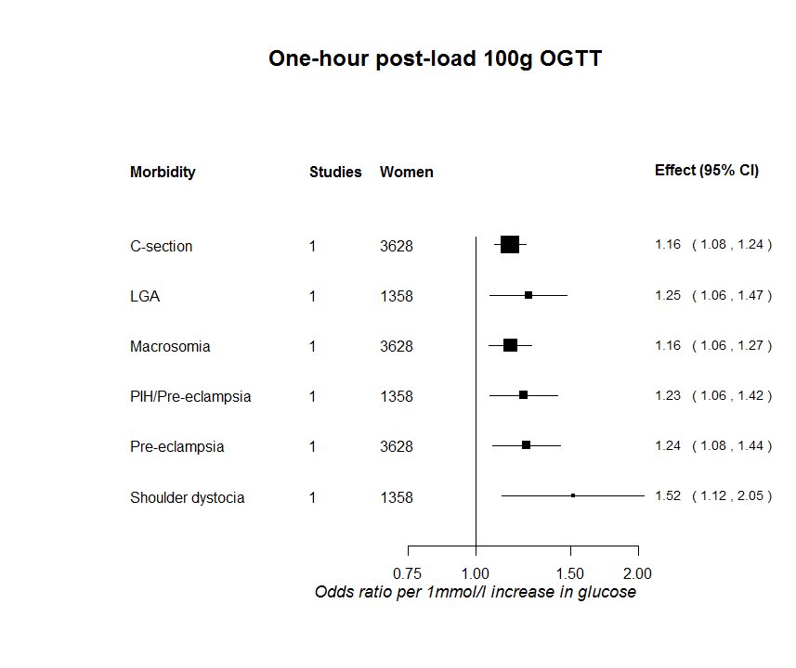
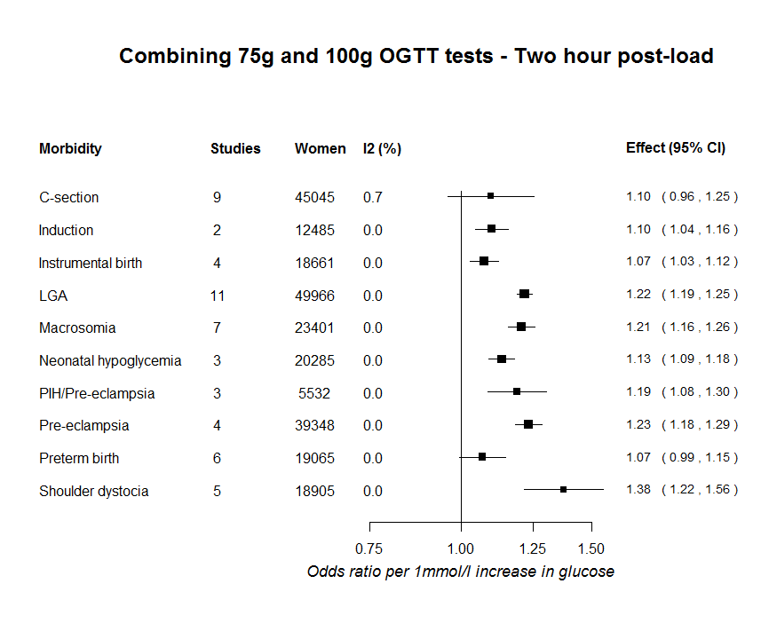

Supplementary Figure 2. Associations for fasting, one-hour post-load 50g OGCT and two-hour post-load 75g OGTT and Caesarean section
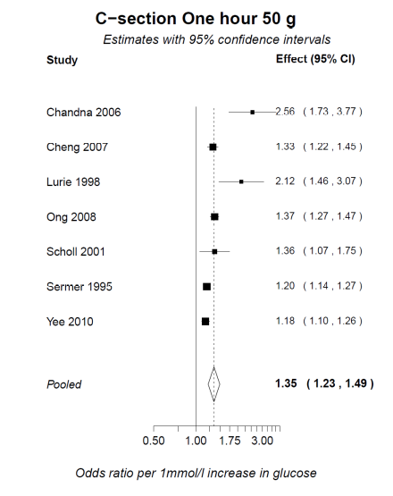
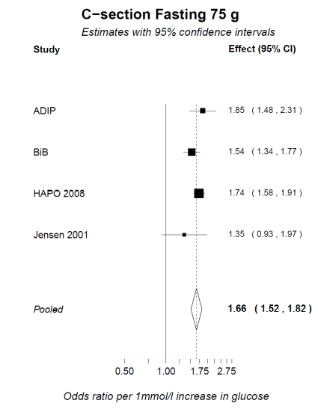
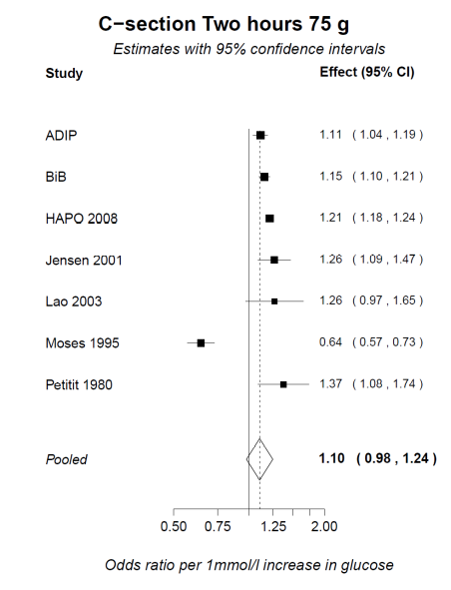

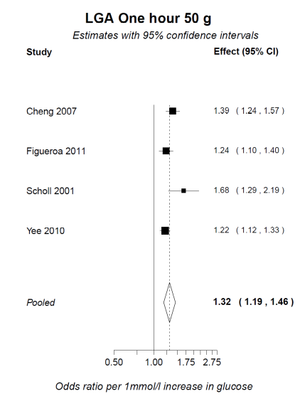
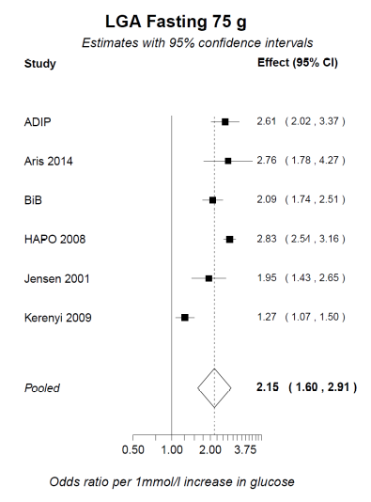
Supplementary Figure 3. Associations for fasting, one-hour post-load 50g OGCT and two-hour post-load 75g OGTT and Large for gestational age
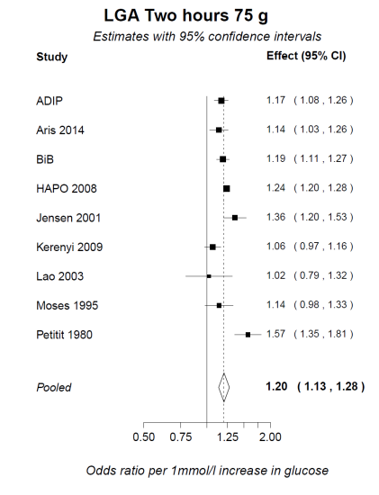

Supplementary Figure 4. Associations for fasting, one-hour post-load 50g OGCT and two-hour post-load 75g OGTT and macrosomia
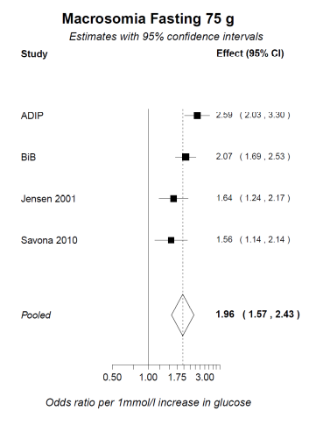

Supplementary Figure 5. Associations for fasting, one-hour post-load 50g OGCT and two-hour post-load 75g OGTT and induction of labour
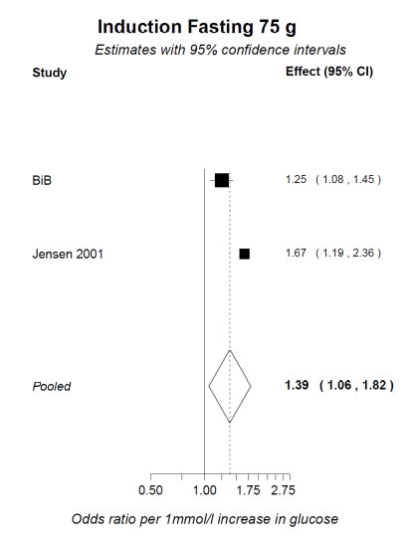
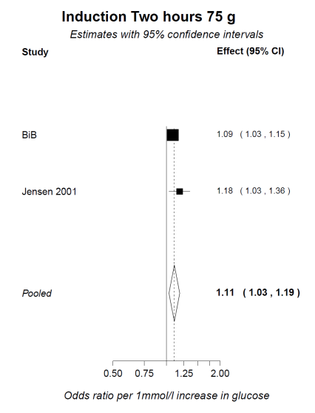

Supplementary Figure 6. Associations for fasting, one-hour post-load 50g OGCT and two-hour post-load 75g OGTT and instrumental birth
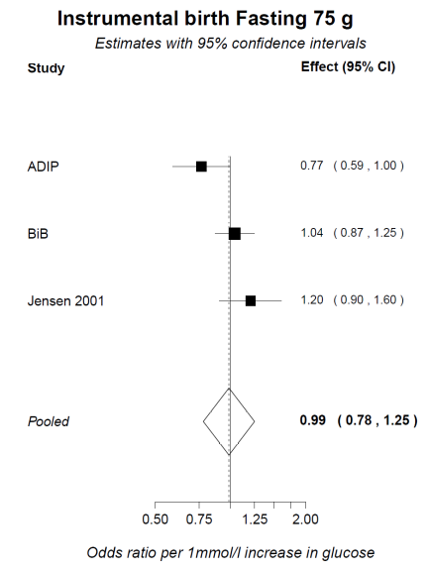
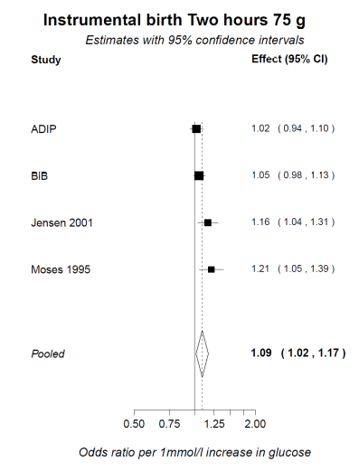

Supplementary Figure 7. Associations for fasting, one-hour post-load 50g OGCT and two-hour post-load 75g OGTT and macrosomia

Supplementary Figure 8. Associations for fasting, one-hour post-load 50g OGCT and two-hour post-load 75g OGTT and pre-eclampsia
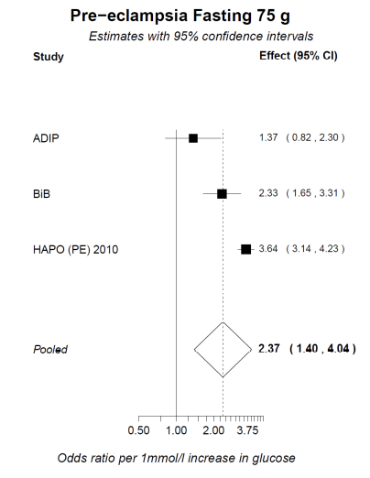
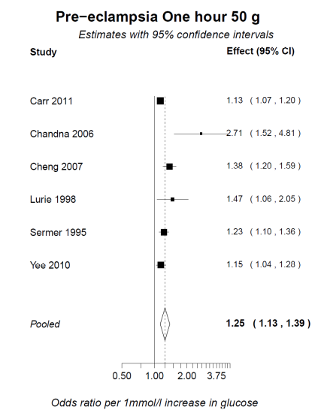
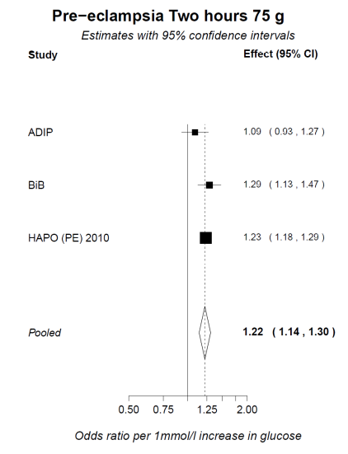

Supplementary Figure 9. Associations for fasting, one-hour post-load 50g OGCT and two-hour post-load 75g OGTT and preterm birth
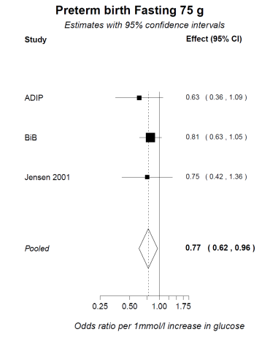
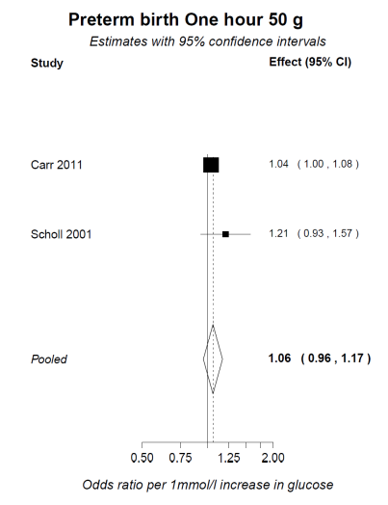
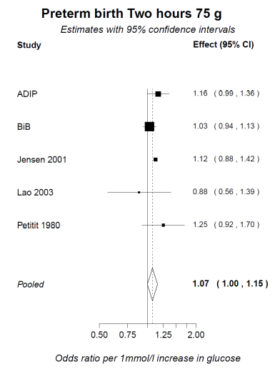

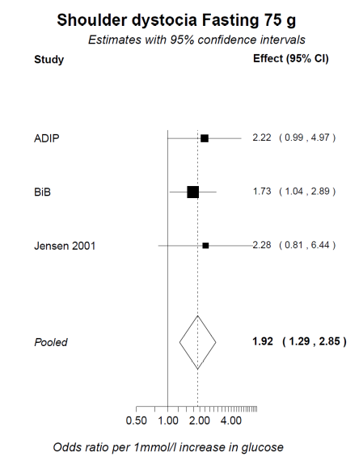
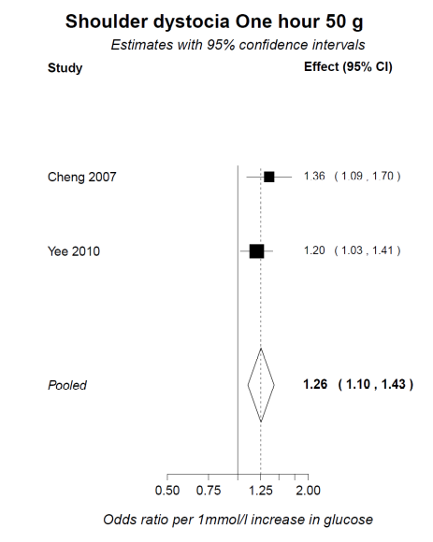
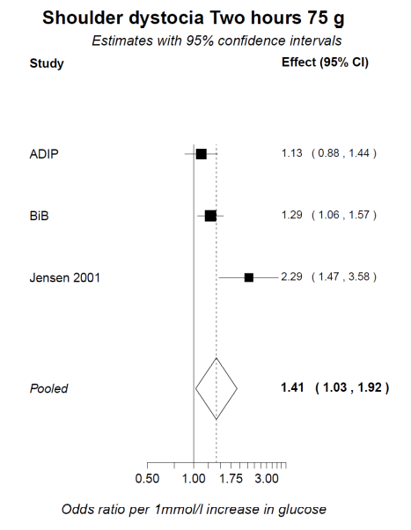
Supplementary Figure 10. Associations for fasting, one-hour post-load 50g OGCT and two-hour post-load 75g OGTT and shoulder dystocia

Supplementary Figure 11. Odd ratios for outcomes at fasting 75g and 100g OGTT combined and grouped by whether blinded or unblinded/unclear
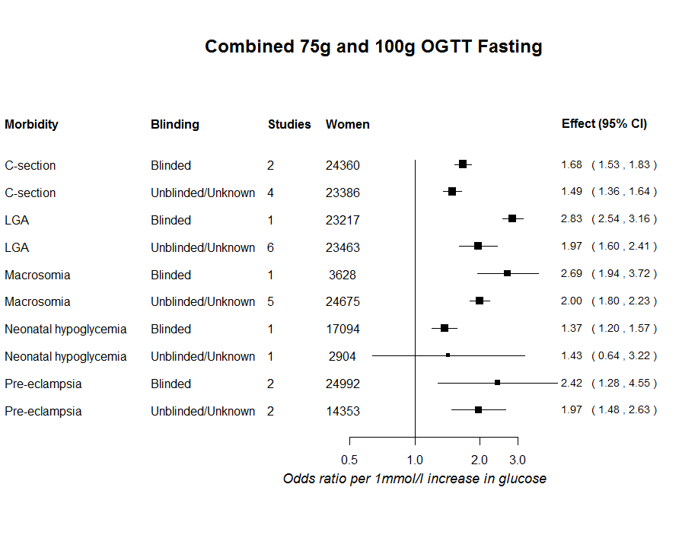

Supplementary Figure 12. Odd ratios for outcomes at two-hour post-load 75g and 100g OGTT combined and grouped by whether blinded or unblinded/unclear

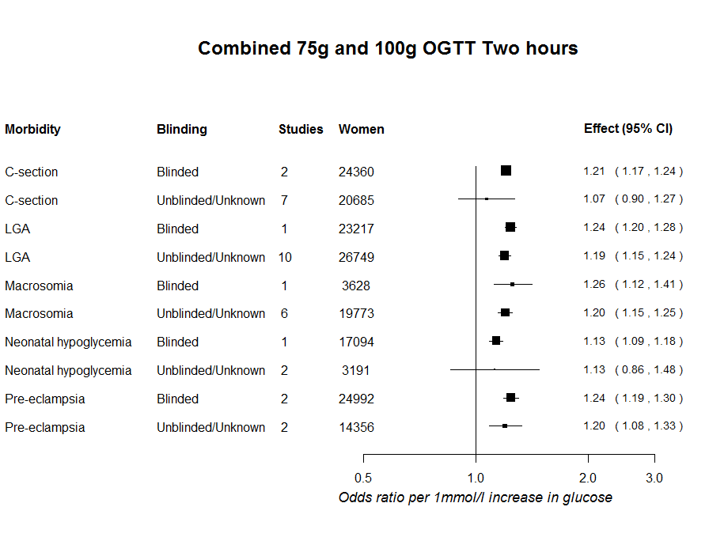

Supplementary Figure 13. Odd ratios for outcomes at fasting 75g and 100g OGTT combined and grouped by region
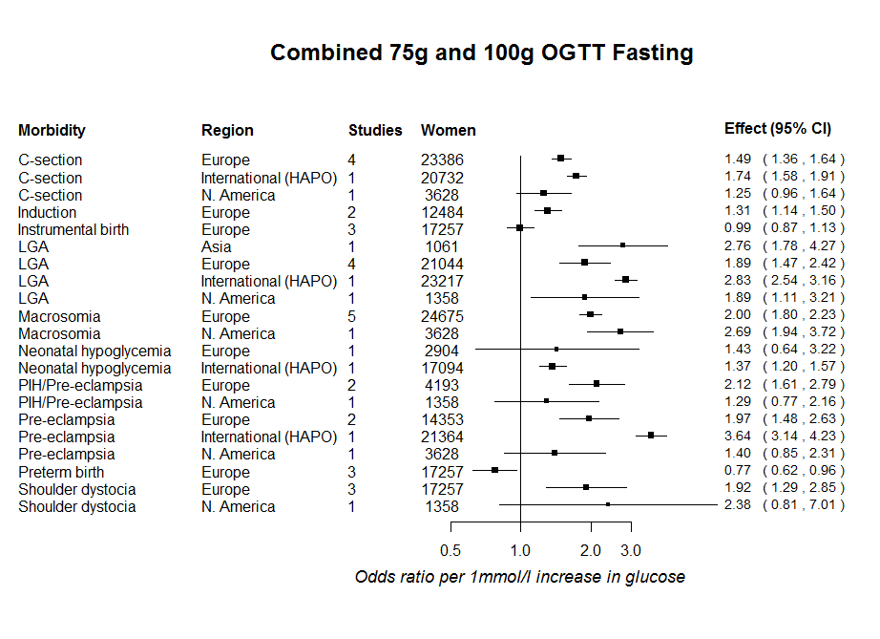
N. America (North America= Canada and USA),¹ Multinational,²⁻⁴ Asia (Singapore, China), Europe (Denmark, Hungry, Malta UK),⁷⁻¹¹ Australia¹²

Supplementary Figure 14. Odd ratios for outcomes at two-hour post-load 75g OGTT grouped by region
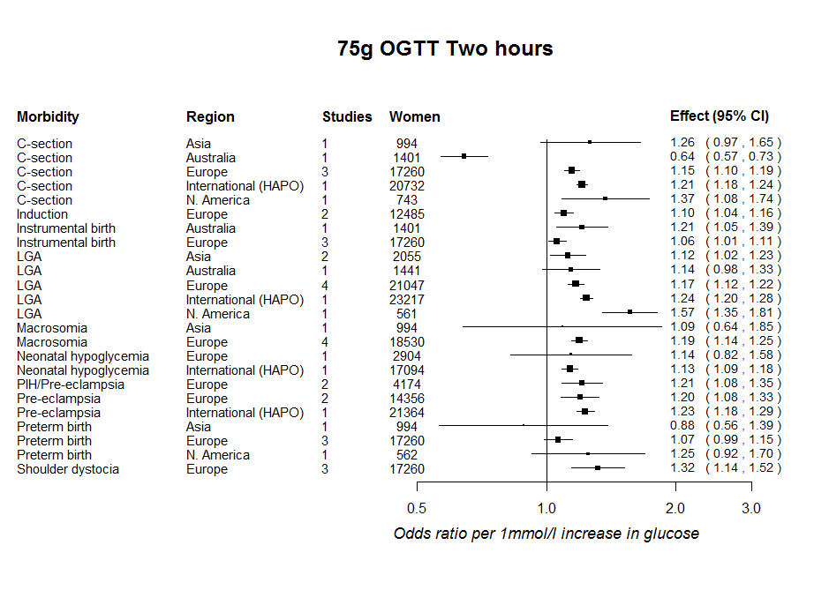

N. America (North America= Canada and USA),¹ Multinational,²⁻⁴ Asia (Singapore, China), Europe (Denmark, Hungry, Malta UK),⁷⁻¹¹ Australia¹²

References
1. Pettitt DJ, Knowler WC, Baird HR, Bennett PH. Gestational diabetes: infant and maternal complications of pregnancy in relation to third-trimester glucose tolerance in the Pima Indians. Diabetes Care. 1980; 3(3): 458-64.
2. HAPO Hyperglycemia and Adverse Pregnancy Outcomes. N Engl J Med. 2008; 358: 1991-2002.
3. HAPO Study Cooperative Research Group. Hyperglycemia and adverse pregnancy outcome (HAPO) study: preeclampsia. Am J Obstet Gynecol. 2010; 202(3): e1-e7.
4. Metzger BE, Persson B, Lowe LP, Dyer AR, Cruickshank JK, Deerochanawong C, et al. Hyperglycemia and Adverse Pregnancy Outcome Study: Neonatal Glycemia. Pediatrics. 2010; 126(6): e1545-e52.
5. Aris IM, Soh SE, Tint MT, Liang S, Chinnadurai A, Saw SM, et al. Effect of Maternal Glycemia on Neonatal Adiposity in a Multiethnic Asian Birth Cohort. J Clin Endocrinol Metab. 2014; 99(1): 240–7.
6. Lao TT, Ho LF. Does maternal glucose intolerance affect the length of gestation in singleton pregnancies? J Soc Gynecol Invest. 2003; 10(6): 366-71.
7. Jensen DM, Damm P, Sorensen B, Molsted-Pedersen L, Westergaard JG, Klebe J, et al. Clinical impact of mild carbohydrate intolerance in pregnancy: a study of 2904 nondiabetic Danish women with risk factors for gestational diabetes mellitus. Am J Obstet Gynecol. 2001; 185(2): 413-9.
8. Kerényi Z, Tamás G, Kivimäki M, Péterfalvi A, Madarász E, Bosnyák Z, et al. Maternal Glycemia and Risk of Large-for-Gestational-Age Babies in a Population-Based Screening. Diabetes Care. 2009; 32(12): 2200-5.
9. Savona-Ventura C, Craus J, Vella K, Grima S. Lowest threshold values for the 75g oral glucose tolerance test in pregnancy. Malta Med J. 2010; 22(1): 18-20.
10. Wright J. Born in Bradford cohort. Personal communication. 2014.
11. Dunne F. Atlantic Diabetes in Pregnancy cohort. Personal communication. 2014.
12. Moses RGF, Calvert DP. Pregnancy Outcomes in Women Without Gestational Diabetes Mellitus Related to the Maternal Glucose Level: Is there a continuum of risk? Diabetes Care. 1995; 18(12): 1527-33.

