Mind-wandering:
The scientific navigation of the stream of consciousness

Jonathan Smallwood¹ & Jonathan W. Schooler²

¹Department of Psychology, The University of York, UK
²Department of Psychological and Brain Sciences, University of California, Santa Barbara, USA.

Address for correspondence. Jonthan Smalllwood, Department of Psychology, The University of York, Hesslington, York.
Email: jonny.smallwood@york.ac.uk
- Introduction
- Terminology, measurement and conceptual
  - Terminology
  - Measurement
  - Conceptual Issues
    - Lack of direct experimental control]
    - The covert nature of the mind-wandering state
    - The influence of measurement on the mind-wandering state
- Phenomenology
  - The content of self-generated-thought
  - Relation to awareness
- The component process view
  - How higher order cognition becomes disengaged from external processing
    - Perceptual coupling and decoupling
  - How people self-generate task unrelated mental content
    - Episodic Thought
    - Emotion
  - How decoupling and self-generation are co-ordinated and/ or regulated
    - Executive control
    - Meta-cognition
  - Open questions facing the component process view
- Cost and benefits of the mind-wandering state
  - Mind-wandering and ongoing performance
  - The benefits of a wandering mind
    - Creativity
    - Meaning
    - Mental Breaks
    - Parallels to night dreaming
- Mind-wandering in daily life
- Techniques for minimising the disruptive effects of mind-wandering
  - Mindfulness training
  - Meta-awareness
  - Task engagement
- Concluding remarks
Abstract

Conscious experience is fluid; it rarely remains on one topic for an extended period without deviation. An illustration of its dynamic nature can be found in the experience of mind-wandering in which attention switches from a current task to unrelated thoughts and feelings. Studies exploring the phenomenology of mind-wandering highlight the importance of its content and relation to meta-cognition in determining its functional outcomes. Examination of the information processing demands of the state demonstrates it depends on perceptual decoupling to escape the constraints of the moment, its content depends on affective processes and episodic thought and executive control is important in its regulation. Mind-wandering also has a complex balance of costs and benefits: its association with absent-minded error underline that the experience has a cost, while its association with creativity and patient decision-making indicates the state has benefits as well.

Keywords: mind-wandering; self-generated-thought; perceptual decoupling; meta awareness; mental time travel; default mode network.

1. Introduction
Experience is not always tethered to the here and now; instead it ebbs and flows between mental contents from both intrinsic and extrinsic sources. Although there is a long tradition of research on how attention shifts between external sources (Desimone & Duncan 1995, Posner & Petersen 1990, Treisman & Gelade 1980), science has only recently taken aim at understanding how the mind shifts between external events and internal thoughts and feelings unrelated to the goings on around it. Following the seminal work of Jerome Singer, Eric Klinger and John Antrobus on daydreaming in the late 60’s and early 70’s (Antrobus et al 1967, Antrobus & Singer 1964, Antrobus et al 1970, Klinger 1966, Klinger 1973) a handful of researchers explored the psychological processes underpinning the mind’s capacity to stray from external events and to generate thoughts with no referent in the environment (Giambra 1989, Giambra 1993, Giambra 1995, Teasdale et al 1995). However, only in the last decade has widespread scientific attention been given to the topic of mind-wandering (Smallwood & Schooler, 2006).

A confluence of factors have contributed to the suitability of mind-wandering as a focus of research (Callard et al 2013, Forster 2013, Gilbert et al 2007, Gruberger et al 2011, Kane & McVay 2012, Killeen 2013, Marchetti et al 2012, Schooler et al 2011, Smallwood 2013a, Smallwood & Schooler 2006). Unquestionably this question has been the beneficiary of a change in the scientific zeitgeist regarding the appropriateness of the study of consciousness. The field of psychology was slow to shed the scepticism towards internal experience that it inherited from the Behaviorist era (Callard et al 2012, Cohen & Schooler 1997). However, as scientific consideration of consciousness became more accepted so too did the investigation of mind-wandering. Closely allied with this shift were methodological advances in the study of consciousness. As will be discussed, the stream of consciousness is being increasingly illuminated by the strategy of triangulating between self-report, behavioural, and neurocognitive measures (Schooler & Schreiber 2004, Varela & Thompson 2003).

Research on mind-wandering has also undoubtedly been advanced by research in cognitive neuroscience, and in particular technological advances such as the development of functional magnetic resonance imaging (fMRI, (Ogawa et al 1990). The spatial resolution offered by fMRI has meant that it has swiftly become a primary tool for investigating the inner workings of the mind, a technique that is at its most advantageous when focused on private experiences such as mind-wandering. Moreover, in the early years of this century a network of brain regions focused on the medial surface of the cortex and known as the default mode network was discovered (Greicius et al 2003, Raichle et al 2001). This network is engaged when participants engage in the sort of thinking that occur during mind-wandering, such as thoughts about the future, of themselves, or, of other people (Andrews‐Hanna et al 2014) and was swiftly linked to the mind-wandering state (Mason et al 2007, McKiernan et al 2006, McKiernan et al 2003). The discovery of this network and its experiential correlates provided a viable starting point from which to understand the brain basis of mind-wandering.

Finally, it has become apparent that neurocognitive processes that are not constrained by external input are ubiquitous aspects of the human condition. Unconstrained neural processing, such as that which occurs during the resting-state, are common to all known brain networks, raising important questions on how to interpret task-free activity (Buckner & Vincent 2007, Smith et al 2009). Moreover, studies indicate that people spend somewhere between 25 and 50% of their waking hours engaged in thoughts unrelated to the here and now (Kane et al 2007, Killingsworth & Gilbert 2010). Unconstrained mental processes are the norm rather than the exception for our species, and mind-wandering provides a clear paradigm in which to understand them.

Happily the gap is closing between the regularity with which people mind-wander and the frequency with which scientists study it. The last decade has witnessed an explosion of developments in understanding how, when, and why the mind wanders. This review will describe the methods that have been established to understand mind-wandering, examine its phenomenology and the neurocognitive processes that it entails, and will consider the costs and benefits that this experience can bring. Before considering these issues in detail, the conceptual and empirical challenges that understanding the wandering mind entails will be considered.

2. Terminology, measurement and conceptual issues
Terminology
When the mind wanders, attention drifts from its current train of thought (often an external task) to mental content generated by the individual rather than the environment. Often the thoughts that occurs during mind-wandering experiences is described as task unrelated (Giambra 1995) or stimulus independent thoughts (Antrobus et al 1967, Antrobus et al 1970), terms which capture the independence of the experiences from perception and on-going actions. Other terms like autobiographical thought or mind pops (Kvavilashvili & Mandler 2004), capture the generative process that provides the content of the experience itself. One term that captures both the generative aspects of these experiences as well as their independence from perception is self-generated-thought (Smallwood 2013a, Smallwood 2013b). The conceptual basis of self-generated-thought, and is distinction from both task-unrelated-thought and external distraction is described in Box One and Figure One.

Measurement
Investigations of mind-wandering use the technique of experience sampling (ES, (Kahneman et al 2004) Box Two) to capture moments when consciousness is occupied by intrinsic topics and others when it is attending to external input. Although researchers are often interested in investigating the wandering that leads our thoughts to stray from the moment, the experimental measurement usually corresponds to the content of conscious experience at the time the ES probe is given. Although it is safe to assume that dynamic changes must have led to the current mental state, the ES approach does not enable researchers to watch in real time as conscious states evolve from one mental state to the next. This is one reason why an important avenue in research on mind-wandering is the pursuit of indirect measures of the experience.

Conceptual issues

It is standard to understand the basis of cognitive functions through the experimental manipulation of the process in question. Usually an imperative stimulus is presented to a participant and their response (behavioural, neural or psychological) is recorded. By varying the nature of the stimulus or the task that the participant performs and observing any changes that occur, inferences can be drawn on the nature of the underlying mental processes (Donders 1969). Mind-wandering episodes depend to a large extent on processes that are spontaneous rather than those induced directly by the experimenter (Smallwood 2013a), and these changes have few directly observable consequences. The experimental investigation of mind-wandering, therefore, poses a number of specific challenges that must be overcome in order for it to be measured and assessed in a scientific manner.

One challenge arises because researchers lack the ability to directly cause the mind to wander. Instead the spontaneous occurrence of mind-wandering means that causal path that links the experience to on-going processes and outcomes is opaque. For example, evidence has demonstrated that poor executive control led to greater mind-wandering during demanding tasks (McVay & Kane 2009, McVay & Kane 2011). However, studies have shown that mind-wandering in the context of executive control tasks has a negative influence on performance (Mrazek et al 2012a). It is thus unclear whether low executive control causes greater mind-wandering, or greater mind-wandering during span tasks causes lower estimations of control.

The covert nature of mind-wandering creates a second challenge to its investigation. Unlike perceptual guided thought which can be assessed directly through its contributions to action, self-generated experiences are fundamentally internal with few external manifestations. Current understanding of the mind-wandering state depends on the experimenter’s capacity to sample experience in an effective and non-biased manner. Box Two describes the different ES approaches that can be used to study mind-wandering.

A third challenge arises because mind-wandering is a conscious experience and so can only be verified through self-report. A reliance on introspection, however, means that studies of mind-wandering need to be corroborated by external measures to ensure that the results are not simply a consequence of the limitations of self-report (Schooler & Schreiber, 2004) or the concern that they may indirectly change the quality of the experience (Smallwood & Schooler 2006).

There are, therefore, at least three conceptual issues that arise in the investigation of mind-wandering: i) the lack of direct experimental control, ii) the covert nature of self-generated-thoughts, and iii) the validity and reactive nature of introspective evidence. Over the last decade advances in the field of mind-wandering have facilitated progress on these issues and Figure One provides a schematic account of how these different techniques might be employed in a laboratory study.

Lack of direct experimental control. Although the mind-wandering state cannot be induced as precisely as can external task performance, techniques exist that can influence its occurrence. For example, studies have shown that mind-wandering is closely linked to unhappiness (Smallwood et al 2007b) and by exploiting this link research has documented that mood inductions prior to an experimental session can increase the occurrence of the mind-wandering (Smallwood et al 2009a, Smallwood & O'Connor 2011) as can the experimental induction of stress (Engert under revision, Vinski & Watter 2013) (see sub panel in Figure One). Other work has found that states of craving or intoxication through alcohol, increase mind-wandering (Sayette et al 2012, Sayette et al 2010). Finally studies have documented that engaging in meditative practice can help to reduce the minds tendency to wander (Morrison et al 2013, Mrazek et al 2013a).

It is also possible to manipulate mind-wandering by varying the demands of an on-going task. A greater dependence on controlled processing (Mason et al 2007, Teasdale et al 1995) and elevated perceptual input (Forster & Lavie 2009, Levinson et al 2012), faster stimulus demands and greater financial rewards reduce mind-wandering (Antrobus et al 1966). One common approach is to vary between a choice reaction time task and a working memory task (Smallwood et al 2009b). This paradigm holds perceptual input constant and manipulates the extent to which participants have to encode the stimulus, leads to less task-unrelated-thoughts in the working memory task (see sub panel Figure One).

Thus, although the mind-wandering state cannot be directly manipulated, by altering a person’s psychological state, or varying the complexity of an on-going task it is possible to gain experimental control over the experience. These manipulations are critical in understanding the nature of the mind-wandering state because they provide boundary conditions that inform our understanding of the functions of the state.

The covert nature of the mind-wandering state. To measure mind-wandering researchers employ ES to document when and under what conditions the experience occurred. These approaches are invaluable in illuminating the content of the experiences themselves, however, because they are subjective they are also difficult to verify objectively. One solution is to combine it subjective and objective indices of cognitive function (Schooler & Schreiber 2004) and identify the variance common to both.

Studies have found that greater behavioural variability is characteristic of the mind-wandering state (Carriere et al 2008, Cheyne et al 2006, Cheyne et al 2011, McVay & Kane 2009), including physical posture (Carriere et al 2013, Seli et al 2013a). Mind-wandering is also lined to divergent eye movements (Foulsham et al 2013, Reichle et al 2010), greater pupil dilation (Franklin et al 2013a, Smallwood et al 2012, Smallwood et al 2011b), more frequent eye blinks (Smilek et al 2010), changes in the electroencephalogram (EEG) (Barron et al 2011, Kam et al 2011, Smallwood et al 2008a) and fMRI (Allen et al 2013, Christoff et al 2009, Stawarczyk et al 2011a). At the neural level multi-voxel pattern analysis has been able to predict subjective reports of the content of thought at rest based on task based examples of the same types of thought (Tusche under revision). These verify the subjective measures and allow different cognitive and neural accounts of the mind-wandering experience to be tested. They also raise the possibility that indirect markers for mind-wandering could ultimately be used to detect the occurrence of mind-wandering without interrupting the participants.

The influence of measurement on the mind-wandering state. Although ES is an invaluable tool in the study of mind-wandering, it also carries the risk that introspection changes the nature of the state that is being assessed. Online ES alerts the participant to the key dependent measure of the experiment and by periodically disrupting the on-going task disrupts the natural dynamics of both task performance and of the experience itself. Finally, because introspection has the potential to change the psychological meaning of an event, ES could also actually alter the quality of the experience itself.

One solution is to acquire self-report data after participants have completed an experimental session. Although this measure necessarily depends on memory, it allows the collection of data without artificial disruptions and is useful because by preserving the integrity of time course data, it allows temporal properties in objective measures to be related to ES data. Retrospective indicators of self-generated-thought have been related to the dynamical changes that occur in the time-series data derived from pupilometry (Smallwood et al 2012), the EEG (Barron et al 2011), and the BOLD signal at rest (Gorgolewski under review).

3. Phenomenology
Research over the last fifteen years has made progress on understanding the phenomenological aspects of mind-wandering. Studies have explored the form and content of the self-generated-thoughts that occur during mind-wandering, revealing that it is often an eclectic mixture of thoughts regarding the future and memories from the past, usually with personal relevance. Research has also focused on the relationship between mind-wandering and meta-awareness; i.e. individuals explicit awareness of the current contents of thought. This work has shown that often individuals fail to notice that their minds have wandered, and a lack of meta-awareness is often associated with more pronounced indicators of the state.

The content of self-generated-thought
Introspective evidence suggests that the different forms that the mind-wandering experience can take are limited primarily by the scope of an individual’s imagination. Despite the eclectic mixture of mental contents that occupy our minds when they wander, research exploring its content has demonstrated a number of general principles upon which this complexity can be understood.

Inspired by work on mental time travel (Tulving 2002), research has shown that mind-wandering about the past and future has distinct psychological correlates. Studies have documented a bias towards thinking about the future in both the laboratory and in daily life, and across a range of different countries including China (Song & Wang 2012), Japan (Iijima & Tanno 2012), the US (Baird et al 2011, Smallwood et al 2011b), the UK (Smallwood et al 2009b), Germany (Ruby 2014), and Belgium (Stawarczyk et al 2011a). This prospective bias may be moderated by task demands because participants tend to decrease the amount of future thinking as task demands increase (e.g. Smallwood et al., 2009). The left hand panel of Figure Three illustrates two examples of the prospective bias as it is seen in the laboratory.

Past related thought also has a distinct psychological profile. Studies suggest that although unhappiness is a correlate of mind-wandering in general (Killingsworth & Gilbert 2010, Smallwood et al 2004, Smallwood et al 2007b) and in particular episodes focused on the past. A retrospective bias to mind-wandering is present during low mood in the laboratory (Ruby 2013, Smallwood & O'Connor 2011, Stawarczyk et al 2013) and in daily life (Poerio et al 2013).

Other work has identified a range of phenomenological features that characterize mind-wandering. For example, self-generated experiences with perseverative features tend to be associated with psychopathological states such as anxiety and depression (Ottaviani & Couyoumdjian 2013, Ottaviani et al 2013) and interesting mind-wandering experiences are a concomitant of positive mood (Franklin et al 2013b). Finally, studies have examined the different form of thoughts including imagery and words, the specificity of the experience and their personal relevance (Delamillieure et al 2010, Gorgolewski under review).

A more principled approach to dealing with the wide variety of experiences that occur during mind-wandering is to explore the patterns of co-variance that are present within ES data. To achieve this aim, multiple dimensions of ES data are collected at the same time and is decomposed using statistical techniques such as principal components analysis (PCA), to reveal its latent structure. Ruby and colleagues applied PCA to ES data to confirm that past and future related self-generated-thoughts are unique statistical categories of thought (Ruby 2014, Ruby 2013). These statistically derived components were predictive of independent measures such as on-going performance and individual differences in psychological function. The right-hand panel of Figure Three illustrates the structure of thoughts identified by PCA across two independent data sets.

Hierarchical clustering has also been used to provide information on the dimensional structure of thought. This technique has shown that valence, specificity and self-relevance account for substantial variance in the content of mind-wandering episodes (Andrews-Hanna et al 2013). These dimensions explained significant variance in independent measures such as rumination and mindfulness.

Altogether research suggests that the content of self-generated-thoughts that arise during mind-wandering has a rich structure reflecting variables such as its temporal focus, affective state, interest. Moreover, the form and content of the self-generated experiences that occur during mind-wandering can influence the associated functional outcomes of the state. This is known as the content regulation hypothesis (Andrews‐Hanna et al 2014, Smallwood & Andrews-Hanna 2013) (see Box Five).

Relation to awareness
One important feature of mind-wandering is when we recognize that the current content of thought is discrepant from the ostensible task that the individual is (or was) performing (Schooler 2002). This aspect of the experience can be compelling, for example when we notice our mind has wandered while reading, or watching television (Schooler et al 2004). On at least certain occasions, therefore, mind-wandering reflects a failure to maintain continuous awareness on the links between the contents of conscious thought and our current goals.

There are two approaches that have been used to investigate meta-awareness of mind-wandering. One asks participants to indicate whether they had been aware that their minds had drifted and has shown that the consequences of mind-wandering are more pronounced when the episode was described as lacking awareness. Unaware mind-wandering episodes are associated with greater behavioural cost, such as especially rapid and careless task performance (Smallwood et al 2008b, Smallwood et al 2007a). One study measured mind-wandering while participants read a detective novel (Smallwood et al 2008c). Analysis indicated that participants who mind wandered without awareness (termed zoning out) at critical periods in the task were less likely to solve the crime than those who mind-wandered but were aware of this fact (termed tuning out, see Figure Four, left panel). Neuroimaging studies have shown that neural systems that play a role in self-generated experiences are more engaged during mind-wandering episodes of which the participant lacks awareness (Christoff et al 2009). Finally, unaware mind-wandering has also been associated with higher levels of depression (Deng et al 2012), increases following stereo-type threat (Mrazek et al 2011), greater disruption of everyday tasks (McVay et al 2009), and increases the risk of accidents while driving a car (Cowley 2013).

A second approach examines how effectively participants can notice that their mind has wandered. Participants are asked to indicate with a manual response when they notice that their minds have wandered from the task being performed. These self-caught mind-wandering episodes constitute a hypothetical metric of mind-wandering that reached meta-awareness. By comparing self-caught mind-wandering with mind-wandering episodes caught by probes, it is possible to draw inferences about the role of meta-awareness in various situations (Schooler et al, 2011). For example, whereas probe caught mind-wandering is predictive of reading comprehension, self-caught episodes are often less so (Schooler et al 2004).

Studies have shown that manipulations that reduce meta-awareness increase the probability of mind-wandering and decrease the probability of it being noticed. For example, Sayette et al (2009) found that while alcohol intoxication doubled the likelihood of probe caught mind-wandering episodes, participants were still numerically less likely to self-catch mind-wandering episodes when intoxicated relative to when sober (see Figure Four, right hand panel). Inducing cigarette craving produced similar disparate effects on self and probe caught mind-wandering rates (Sayette et al 2010). Self-caught episodes also have a unique relationship to the eye-movements that occur during reading (Reichle et al 2010). Finally, an investigation of people’s capacity to notice thought intrusions regarding a prior romantic partner who they were trying not to think about, revealed that people were routinely caught thinking about the partner before they noticed it themselves. Moreover, the desire to still be with a partner was associated with an increased likelihood of thinking about the partner (as revealed by more frequent probe caught episodes) and a decreased probability of spontaneously noticing such thoughts (as revealed by less frequent self-caught episodes) (Baird et al 2013).

Overall, studies have revealed 1) that participants’ often fail to notice that their minds have wandered 2) that various factors can have distinct effects on the likelihood of mind-wandering versus noticing that one is mind-wandering 3) that aware versus unaware mental diversions can have distinct characteristics with respect to both their impact and content. Although these findings are consistent with the hypothesis that meta-awareness may play a functional role in modulating the impact of mind-wandering additional research is needed to ascertain the role meta-awareness has in controlling the mind-wandering state (see Box Three).

4. The component processes view

One problem that arises when attempting to understand the thoughts that occur during mind-wandering is that the rich diversity of potential experiences has to be accounted for by a smaller subset of underlying processes. This section considers evidence from psychology and neuroscience with the aim of describing the different underlying processes that in combination produce the complex varieties of experiences, not only those that occur during mind-wandering, but also those that make up other aspect of daily life. This is known as the component-process view of mental states (Smallwood 2013a, Smallwood 2013b) and assumes that different types of thoughts and feelings arise through the flexible combination of a smaller and finite number of underlying processes.

The self-generated-thoughts that occur during mind-wandering demonstrate that complex higher order cognition can arise despite being unrelated to the events in the external environment, or any task being performed. There at least three important aspects of this phenomenon, therefore, that a component process account would need to explain: 1) how higher cognition can become disengaged from external processing; 2) how people self-generate task unrelated mental content; and 3) how this disengagement and self-generation are co-ordinated and / or regulated by the individual.

Recent neurocognitive studies have shed light on all three issues. First, studies have demonstrated that the amplitude of responses evoked by external events are reduced during periods of mind-wandering. This provides basic support for the principle of perceptual decoupling that suggests during periods of self-generated-thought attention is disengaged from perception. Second, studies suggest that emotional and episodic processes are involved in the self-generation of mental content during mind wandering. Third, studies have found evidence that executive control processes are important in the co-ordination of the mind-wandering state itself. Evidence for each of these component processes forms the focus of this section of the review.

How higher cognition becomes disengaged from external processing:

Perceptual coupling and decoupling. When attention is directed to an external goal it can facilitate action by increasing the processing of relevant sensory input (Posner & Petersen 1990). By contrast, when the mind wanders to self-generated information it becomes disengaged from events in the external world. This attentional shift is known as perceptual decoupling and is hypothesised to have two consequences. First, it corresponds to a re-organization of cognition to focus on intrinsic rather than extrinsic inputs. Second, it is associated with reduced attention to the external input. Perceptual decoupling is therefore one reason why transient self-generated states can persist and hence lead to errors on demanding external tasks (Kam & Handy 2013, Smallwood 2013a) (see Section on Costs and Benefits). Figure Five highlights several key results demonstrating the decoupling of attention from perception during mind-wandering.

Evidence for perceptual decoupling comes from studies that examine the temporal relationship between self-generated-thought and the cortical processing of external information. One way that the cortical processing of external information can be characterized is by quantifying the evoked response that occurs because of a stimulus such as the amplitude of event related potentials (ERPs) that are derived from the EEG. An ERP known as the P3 occurs approximately 300 milliseconds after task relevant events are processed and indexes task related attention (Polich 1986). At the trait level studies have shown that the P3 is reduced for individuals who experienced high levels of task unrelated thinking during a task (Barron et al 2011). The P3 is also smaller during states of task-unrelated-thought (Kam et al 2013, Macdonald et al 2011, Smallwood et al 2008a). A reduction in the amplitude of the ERP is not limited to the P3, it also occurs for components that indicate sensory processing of auditory, visual and tactile domains, suggesting that changes in early perceptual processes occur during mind-wandering (Kam et al 2011, Kam et al 2013). The left hand panel of Figure Five illustrates reductions in the P3 component from two representative studies. It is important to note that the studies yielded similar results, yet differed on the method of experience sampling they employed, illustrating that the reduced P3 during high incidence periods of mind-wandering is observed across different measures of the experience.

How people self-generate task unrelated mental content:

Episodic thought. Self-reports of the content of mind-wandering episodes suggest that they are frequently focused on events that occur at distinct time periods either in the past or future (see section on Phenomenology). This mental time travel is thought to depend on episodic memory processes to generate the mental content (Tulving, 2002). This raises the possibility that the self-generated mental content associated with mind-wandering is partly the product of the episodic memory system.

Neuroimaging provides basic support for this episodic memory hypothesis. A large-scale network focused on the medial pre-frontal cortex (mPFC) and the posterior cingulate cortex (pCC), and known as the default mode network (DMN) and is identified by its co-ordinated activity at rest (Greicius et al 2003). A number of parallels between the literature on the DMN and mind-wandering suggest that both have similar properties. Just as the mind-wandering state is conceived of as a process that is in opposition to external perception, at rest the core elements of the DMN are anti-correlated with brain regions engaged by external sensory processes, such as regions of the occipital cortex (Vincent et al 2006). Furthermore, the degree of the anti-correlation between these regions and the mPFC is enhanced for participants who mind wander more during reading (Smallwood et al 2013a).

More specifically, the DMN has been shown to be involved in the kind of thoughts that people experience during mind-wandering. When tasked with imagining another place or time (Addis et al 2012), or to think about themselves (Kelley et al 2002, Macrae et al 2004, Mitchell et al 2006), regions in the DMN increases their activity. The left panel of Figure Six presents the results of a meta-analysis using the automated meta-analysis tool Neurosynth (Yarkoni et al 2011) to identify the keywords that were most associated with different subsystems of the DMN (Andrews‐Hanna et al 2014). It can be seen that the terms semantic and episodic are both prominent and that others (such as self, social, past and future) correspond to the contents of thoughts that commonly occur during the mind-wandering state (see section on Phenomenology). More direct evidence of the involvement of the DMN in mind-wandering comes from studies that examine its neural correlates. Studies using ES have documented that the DMN exhibits elevated activity during periods of task unrelated self-generated-thought (Allen et al 2013, Christoff et al 2009, Mason et al 2007, Stawarczyk et al 2011b). Figure Six (right hand panel) presents evidence for activity in the DMN during periods of self-generated-thought as indexed using online ES.

Emotion. Studies have shown that dysphoria is associated with greater mind-wandering (Smallwood et al 2005, Smallwood et al 2007b) and a large scale experience sampling study found that when people mind wander their mood is generally low (Killingsworth & Gilbert 2010). More recent work has documented that this relationship is mediated by the content of the mind-wandering experience, with higher levels of unhappiness associated with the past (Poerio et al 2013, Ruby 2013, Smallwood & O'Connor 2011, Stawarczyk et al 2013). Studies have also found that the consequence of self-generated-thought on subsequent affect depends on its temporal content, future thinking tends to reduce subsequent negative mood (Ruby 2013) and reduces cortisol levels following social stress (Engert under revision). Together these results suggest that affect processes are an important influence on the self-generated though that occurs during mind-wandering.

How disengagement and self-generation are co-ordinated and/or regulated:

Executive control. Individuals with good cognitive control limit their task-unrelated-thoughts when external task demands are high (Kane & McVay 2012). Negative correlations between off task thought and executive control abilities have been observed during complex span tasks, sustained attention tasks and during reading (McVay & Kane 2009, McVay & Kane 2011, Mrazek et al 2012a, Unsworth & McMillan 2013). By contrast, individuals with good cognitive control tend to produce more off-task thoughts when the environment is non-demanding (Levinson et al 2012) and this effect has also been observed outside of the laboratory (Kane et al 2007). Together these data suggest that expertise in attentional control manifests as variations in the allocation of attention to internal and external sources depending on the demands of the environment. This is known as the context regulation hypothesis (see Box Five).

Meta-cognition. In addition to executive control, meta-cognitive processes may also contribute to the regulation of mind-wandering (Fox & Christoff 2014). Allen and colleagues showed that participants who tended to vary in their attention between on task and off task states (as indexed by variability) tended to do show better meta-cognitive awareness of task performance (Allen et al 2013). Likewise, resting state functional magnetic resonance imaging has shown that the DMN is important in meta cognition for information from memory (Baird 2013). Finally, Mrazek and colleagues have shown that improving awareness of mind-wandering via meditation reduced the occurrence of the experience (Mrazek et al 2013b).

Open questions
One important question is what process controls the motivation for mind-wandering. Eric Klinger and colleagues demonstrated that a critical reason for mind-wandering is because people are committed to goals that extend beyond the here and now, referred to as current concerns (Klinger 1967, Klinger 1973, Klinger 1984, Klinger 2013). This view hypothesises that conscious thought is attracted to the most salient information and explains why our mind frequently turns inward under conditions when the external environment is relatively uninteresting. Consistent with this hypothesis studies have shown that financial motivation to perform the task reduces mind-wandering (Mrazek et al 2012a).

5. Costs and benefits of the mind-wandering state
Although the necessity of external attention to guide behaviour is self-evident, the value of mind-wandering is less clear. Indeed, more than a decade of research has revealed the broad range of situations under which the tendency to mind-wander has a negative influence on task performance. By contrast, studies suggest that the tendency to mind wander is common across different cultures, and the relatively high frequency of the experience suggests that it is a normal, rather than pathological aspect of the human condition. This section considers the evidence of costs and benefits of mind-wandering with a view to emphasising that the context in which the experience occurs and the content of the experience itself can determine the functional consequences of this state (see Box Five). It will then consider the potential benefits that the mind-wandering state allows.

Mind-wandering and ongoing performance

Mind-wandering has been linked to poor outcomes in a wide range of tasks, such as those common in education (Szpunar et al 2013b, Unsworth et al 2012). For example, mind-wandering impairs comprehension during reading (Dixon & Bortolussi 2013, Feng et al 2013, Franklin et al 2011, Jackson & Balota 2012, McVay & Kane 2011, Schooler et al 2004, Smallwood et al 2013a, Smallwood et al 2008c, Unsworth & McMillan 2013) and during a lecture (Farley et al 2013, Szpunar et al 2013a).

Although, mind-wandering tends to be generally associated with poor performance it is generally less disruptive in tasks in which monitoring and encoding immediate input is less important (Ruby 2014), or when performance is automated (Teasdale et al 1995). These contextual variations in the relationship between mind-wandering and ongoing performance highlight that the costs of the experience can be better understood by taking into account the context in which it occurs. This is known as the context-regulation hypothesis and is discussed in Box Five (Andrews‐Hanna et al 2014, Smallwood & Andrews-Hanna 2013).

One implication of the context regulation hypothesis is that cognitive functioning may be maximized if mind-wandering is limited to non-demanding circumstances, rather than avoided entirely. Support for this view comes from a variety of sources, including studies that examine the relationship between mind-wandering and control and those investigating its relationship to the capacity to delay gratification. When tasks make consistent demands on external attention, individuals with good executive control tend to limit the occurrence of task unrelated self-generated-thought (McVay & Kane 2009, McVay & Kane 2011, Mrazek et al 2012a, Unsworth & McMillan 2013). By contrast, when tasks make fewer demands, executive control tends to maximise the occurrence of task-unrelated-thought both inside (Levinson et al 2012, Rummel & Boywitt 2014) and outside of the laboratory (Kane et al 2007). This facilitation is especially true of mind-wandering episodes in which the content is related to the future (Baird et al 2011). Consistent with the context regulation hypothesis, future thinking is not associated with higher working memory when external task demands are especially strong. Altogether these results suggest that effective executive control can suppress task unrelated self-generated-thought when external demands are high, but when demands are low they will take advantage of their excess resources and indulge in mind-wandering.

A particularly troubling aspect of mind-wandering is its relation to poor performance on demanding tasks that require general intellectual functioning. Mrazek et al found that mind-wandering was associated with disrupted performance on a range of tasks involving executive control (Mrazek et al 2012a). Critically, it was demonstrated that an individuals’ tendency to mind-wander while taking working memory and intelligence tests was predictive of their prior SAT performance. Structural equation modelling based on these measures derived two latent variables: one corresponding to mind-wandering during the working memory and intelligence measures and the other to general aptitude on these measures as well as the SAT. Strikingly, at the latent-variable level, mind-wandering predicted 49% of the variance in general aptitude. Consistent with the context-regulation hypothesis the ability to avoid mind-wandering while engaging in a demanding task is a primary component of general intellectual ability, at least as measured by aptitude tests.

Further support for the context regulation hypothesis comes from studies that explore how mind-wandering is related to an individual’s capacity to delay gratification: The ability to disregard smaller immediate rewards in favour of greater rewards in the future (Mischel & Gilligan 1964). Superior delayed gratification is known to be predictive of positive attributes such as greater intelligence (Shamosh & Gray 2008). Studies have shown that individuals who make patient temporal economic decisions tend to report more self-generated-thought primarily when external demands are low (Bernhardt in press, Smallwood et al 2013b). The linkage between delay gratification and the capacity to regulate the occurrence of mind-wandering may reflect a capacity to titrate experiential demands in a strategic fashion in line with external conditions. Work exploring the link between ADHD, a disorder characterised by impulsivity, and mind-wandering suggests that ADHD prone individuals fail to accurately trade-off the value of their thoughts with respect to the demands of the external task (Franklin & Schooler. Under Review).

The benefits of a wandering mind

As well as understanding how the costs of mind-wandering emerge, researchers have begun to investigate and speculate about its potential benefits (for recent reviews see (Mooneyham & Schooler 2013, Smallwood & Andrews-Hanna 2013).

Prospection Mind-wandering is often focused on the future which would facilitate the benefits that prospection can bring to daily life (Baumeister & Masicampo 2010, Baumeister et al 2011). The benefit of future planning during mind-wandering may depend on the processes of mental contrasting (Oettingen & Schwörer 2013), whereby individuals consider both the potential obstacles to their goal and the benefits that will be accrued if those obstacles are overcome.

Creativity A second beneficial outcome from mind-wandering is the capacity to generate novel, creative thoughts. There is a fundamental similarity between the creative experience and the self-generated-thoughts that arise during mind-wandering: Both are illustrative of experiences people generate that are discrepant from the current or dominant psychological interpretations of the task environment. Consistent with this broad similarity (Baird et al 2012) found a relationship between people’s tendency to mind-wander and their performance on the unusual uses test, a measure of divergent thinking (Guilford et al 1959). Moreover circumstances conducive to mind-wandering (i.e. engaging in a non-demanding task) resulted in a greater incubation benefit relative to those that required either continual external attention, or periods of idle rest (Baird et al 2012). In a related study, Ruby and colleagues found a positive relationship between mind-wandering and the tendency to generate solution steps in a social problem solving task (Ruby 2014). Thus, a second outcome of mind-wandering could be the self-generation of pathways to problem solution, perhaps because both depend on a capacity to generate mental contents that are divergent from current reality (see section on Mind-wandering in everyday life for further discussion).

Meaning Another potential value of mind-wandering may be enabling people to place their experience in a meaningful context. Finding meaning in one’s personal experiences can foster well-being (Janoff-Bulman) and enhance health outcomes (Taylor et al 2000). Research indicates that engaging in mental time travel, particularly thinking about specific remembered or anticipated events can enhance people’s self-reported meaning in life (Waytz, Hershfield &Tamir, in press). Given that mind-wandering routinely entails thinking about past or future events, it may provide an important context for integrating experienced and anticipated events into a meaningful life narrative.

Mental breaks. Mind-wandering may also be useful by providing mental breaks from monotonous activities that may help to relieve boredom. For example, Baird, Smallwood, & Schooler (2010) found that the reduction in mood associated with engaging in a boring task was attenuated for those individuals who regularly engaged in mind-wandering. Similarly, Ruby and colleagues (2013) showed that self-generated-thought focused on the future could help remediate an unpleasant mood. The mental breaks associated with mind-wandering may also enable dishabituation. Specifically, engaging in mind-wandering may provide breaks that serve the equivalent of spaced learning in memory paradigms or that attenuate the inhibition that builds up in semantic satiation.

Parallels to night dreaming. Ultimately it is plausible that mind-wandering will be found to serve a functional role that rivals that of dreaming. Indeed there are parallels between mind-wandering and dreaming (Fox et al 2013): Both require that attention is decoupled from perceptual input and are accompanied by self-generated-thought (e.g. dreams), both involve dampened executive and meta-cognitive processing, and both have been linked to benefits in creative incubation (Cai et al 2009). Moreover, a substantial proportion of both dreams (Armitage et al 1995) and mind-wandering episodes (Killingsworth & Gilbert 2010, Ruby 2013) focus on negative content. Quite plausibly in both cases this negative content may be useful by encouraging the simulation of, and thereby preparedness for, potential threats (Revonsuo 2000). In fact in the case of mind-wandering given that the thoughts that occur during mind-wandering are explicitly directed to the future, this hypothesis may be more pertinent to daily than night time self-generated-thought.

6. Mind-wandering in daily life
One of the most significant aspects of mind-wandering is its relevance to everyday experience. Many everyday activities may be vulnerable to the effects of mind-wandering. The experience is costly in educational contexts because it can profoundly undermine reading comprehension (Schooler et al 2004), attending to lectures (Szpunar et al 2013a), and even test taking (Mrazek et al 2012a). Driving is also especially vulnerable to mind-wandering. Mind-wandering increases drivers’ velocities and response times to sudden events, while reducing the amount of headway distance that they maintain (Yanko & Spalek 2013). Epidemiological investigations of victims of car accidents provide further evidence of the likely contribution that mind-wandering may have in driving accidents(Galera et al 2012). Galera and colleagues queried accident victims in emergency rooms regarding their circumstances immediately before the crash. Although a variety of factors discriminated the responsible from the non-responsible driver (including alcohol consumption, external distraction, negative affect, psychotropic drug use, and sleep deprivation) being deeply absorbed in mind-wandering was the single best predictor of accident responsibility.

Even specialists are susceptible to mind-wandering. Aviation is one domain in which mind-wandering appears to be pervasive. (Casner & Schooler 2013) used ES with professional pilots in a full-motion 747-400 flight simulator certified for airline training and testing. In support of the context regulation hypothesis, pilots’ were especially likely to report mind-wandering when engaging in flight segments that were going smoothly relative to segments in which they were having some difficulty. A follow up study revealed that when taking the role of co-pilot, mind-wandering was nearly as twice as often as when they were in the role of the pilot. Moreover, co-pilots no longer evidenced the capacity to reign in mind-wandering when performance was challenged. Together these findings suggest that even highly trained experts can mind-wander in their domain of expertise, and while they may often manage to limit mind-wandering to times that are minimally disruptive, at least sometimes they fail to do this. An important area for future research is to explore the many other domains in which mind-wandering may impair performance.

Most of the research on everyday mind-wandering focuses on the many situations in which mind-wandering has detrimental consequences. Nevertheless, one recent study, suggests an important real world context in which mind-wandering may be helpful. Gable, Hopper, Mrazek, & Schooler (under review), examined the situations surrounding the generation of creative ideas by professional writers and physicists. Every evening for two weeks, participants responded to a questionnaire that asked them to indicate if they had any creative ideas that day, and, if so, to indicate the situation and the estimated quality of the idea. Nearly 1/3 of participants creative ideas occurred when they were engaged in a non-work related activity and/or thinking about something unrelated to the topic. Moreover, although creative ideas that occurred during mind-wandering were not rated overall as more creative, they were more likely to be characterized as involving an “aha” experience, and contributing to overcoming an impasse. These preliminary findings bear out many anecdotal reports that important creative ideas occur while mind-wandering.

7. Techniques for minimizing the disrupting effects of mind-wandering
The many situations in which mind-wandering can be disruptive naturally raise the question of what strategies can be brought to bear in order to minimize its negative consequences.
Mindfulness training
Practices that encourage individuals to be mindful of the present are currently the most empirically validated technique for minimizing the disruptive effects of mind-wandering. For example, (Mrazek et al 2013a) compared the impact of a 2 week mindfulness training program to an active control (nutrition training). They found that mindfulness training significantly reduced mind-wandering on both reading and working memory measures which partially mediated concomitant improvements on both tasks. Mindfulness programs have reduced mind-wandering and enhanced people’s performance on several other tasks including vigilance task (Jha et al 2010). Even a simple 10 minute mindful breathing exercise can reduce absent-minded errors on a simple vigilance task (Mrazek et al 2012b).
Meta-awareness
Several lines of research are consistent with the hypothesis that regularly “checking in” on the contents of one’s mind may help to curtail episodes of mind-wandering. Franklin et al found that the association between ADHD symptoms and mind-wandering related disruptions in everyday life, was partially mediated by the degree to which individuals routinely noticed their mind-wandering (Franklin & Schooler. Under Review). Finally, the beneficial effects of mindfulness training may in part stem from the fact that this practice encourages people to routinely take notice of the contents of their thoughts (see above). Although more research is clearly needed, encouraging people to regularly take stock of whether or not they are mind-wandering may help curtailing its disruptive effects.
Task Engagement
Unquestionably one of the most effective ways to avoid mind-wandering is to participate in activities that encourage individuals to feel engaged in the task. For example, Szpunar et al (2013) found that interpolating periodic memory tests into on line lecture material markedly reduced mind-wandering which in turn led to improved retention of the lecture material. Other techniques that have increased individuals engagement with the material, and thereby reduced mind-wandering include: offering motivational incentives (Antrobus et al 1967, Antrobus et al 1970), increasing the intrinsic interest (Grodsky & Giambra 1990, Unsworth & McMillan 2013) and engaging in elaborative processing (Moss et al 2013).

8. Concluding remarks
A careful consideration of the evidence discussed in this review raises the question of how to understand the role and functions that mind-wandering plays in our lives. Email, smart-phones, Facebook and other vehicles for social networking allow us to interact with individuals who are a great geographical distance from us. This illustrates the emphasis that we place on social interaction, even if they do not take place in the here and now. Given that self-generated-thoughts are often of a social nature (Ruby 2014, Ruby 2013) our species habit of mind-wandering likely illustrates a more basic example of the same phenomenon: Even when deprived from our technology, we are still inclined to escape from the constraints of the moment to consider other times, places and people.

The frequency with which our minds wander, thus, illustrates our desire for freedom from immediacy – a general property of cognitive systems that reflects activity that is unrelated to current environmental input (Shadlen & Kiani 2011). Intrinsic processes that are the hallmark of freedom from immediacy are a property of the brain (Smith et al., 2009), and are considered influential in volitional choice and action (Haggard 2008, Schurger et al 2012). The costs and benefits that arise from mind-wandering can be understood as reflecting how we manage our desire for freedom from immediacy (Smallwood 2013b). Regulating mind-wandering to positive non-ruminative thoughts may bring happiness and limiting the time during lectures or meetings we devote to mentally planning a vacation may improve vocational outcomes. Because freedom from immediacy is an adaptive feature of cognition, its association with mind-wandering provides an important perspective on how to conceive of the value of the experience. Just as smart phones are valuable to society, yet can cause automobile accidents (Nemme & White 2010), the rich imaginative mental life that mind-wandering affords is valuable when used correctly, but counter-productive when it is not.

Acknowledgments. Thanks to Masaki Hagino for providing the artwork, to Florence Ruby, Mahiko Konishi and Helga Smallwood for their help in the preparation of this manuscript, and to Micah Allen, Jessica Andrews-Hanna, Arnaud D’Argembeau and David Stawarczyk for providing their data. Both authors are supported by Grant R305A110277 from the US Office of Education.

References
Addis DR, Knapp K, Roberts RP, Schacter DL. 2012. Routes to the past: Neural substrates of direct and generative autobiographical memory retrieval. NeuroImage 59: 2908-22
Allen M, Smallwood J, Christensen J, Gramm D, Rasmussen B, et al. 2013. The balanced mind: the variability of task-unrelated thoughts predicts error monitoring. Front Hum Neurosci 7: 743
Andrews-Hanna JR, Kaiser RH, Turner AE, Reineberg AE, Godinez D, et al. 2013. A penny for your thoughts: dimensions of self-generated thought content and relationships with individual differences in emotional wellbeing.
Andrews‐Hanna JR, Smallwood J, Spreng RN. 2014. The default network and self‐generated thought: component processes, dynamic control, and clinical relevance. Ann N Y Acad Sci
Antrobus JS, Coleman R, Singer JL. 1967. Signal-detection performance by subjects differing in predisposition to daydreaming. Journal of consulting psychology 31: 487-91
Antrobus JS, Singer JL. 1964. Eye Movements Accompanying Daydreaming, Visual Imagery, and Thought Suppression. J Abnorm Psychol 69: 244-52
Antrobus JS, Singer JL, Goldstein S, Fortgang M. 1970. Mindwandering and cognitive structure. Trans N Y Acad Sci 32: 242-52
Antrobus JS, Singer JL, Greenber.S. 1966. Studies in Stream of Consciousness - Experimental Enhancement and Suppression of Spontaneous Cognitive Processes. Percept Motor Skill 23: 399-&
Armitage R, Rochlen A, Fitch T, Trivedi M, Rush AJ. 1995. Dream recall and major depression: A preliminary report. Dreaming 5: 189
Baird B, Smallwood J, Fishman DJ, Mrazek MD, Schooler JW. 2013. Unnoticed intrusions: Dissociations of meta-consciousness in thought suppression. Conscious Cogn 22: 1003-12
Baird B, Smallwood J, Mrazek MD, Kam JW, Franklin MS, Schooler JW. 2012. Inspired by distraction: mind wandering facilitates creative incubation. Psychol Sci 23: 1117-22
Baird B, Smallwood J, Schooler JW. 2011. Back to the future: Autobiographical planning and the functionality of mind-wandering. Conscious Cogn
Baird B, Smallwood, J., Gorgolewski, K. & Margulies, D.S. 2013. Medial and lateral networks in anterior prefrontal coretx support meta cognitive ability for memory and perception. Journal of Neuroscience
Barron E, Riby LM, Greer J, Smallwood J. 2011. Absorbed in thought: the effect of mind wandering on the processing of relevant and irrelevant events. Psychol Sci 22: 596-601
Baumeister RF, Masicampo EJ. 2010. Conscious thought is for facilitating social and cultural interactions: how mental simulations serve the animal-culture interface. Psychol Rev 117: 945-71
Baumeister RF, Masicampo EJ, Vohs KD. 2011. Do conscious thoughts cause behavior? Annu Rev Psychol 62: 331-61
Bernhardt B, Smallwood, J. et al. in press. Neuroimage.
Buckner RL, Vincent JL. 2007. Unrest at rest: default activity and spontaneous network correlations. NeuroImage 37: 1091-96
Cai DJ, Mednick SA, Harrison EM, Kanady JC, Mednick SC. 2009. REM, not incubation, improves creativity by priming associative networks. Proceedings of the National Academy of Sciences 106: 10130-34
Callard F, Smallwood J, Golchert J, Margulies DS. 2013. The era of the wandering mind? Twenty-first century research on self-generated mental activity. Front Psychol 4
Callard F, Smallwood J, Margulies DS. 2012. Default Positions: How Neuroscience's Historical Legacy has Hampered Investigation of the Resting Mind. Frontiers in psychology 3: 321
Carriere JS, Cheyne JA, Smilek D. 2008. Everyday attention lapses and memory failures: the affective consequences of mindlessness. Conscious Cogn 17: 835-47
Carriere JS, Seli P, Smilek D. 2013. Wandering in both mind and body: individual differences in mind wandering and inattention predict fidgeting. Can J Exp Psychol 67: 19-31
Casner SM, Schooler JW. 2013. Thoughts in Flight Automation Use and Pilots’ Task-Related and Task-Unrelated Thought. Human Factors: The Journal of the Human Factors and Ergonomics Society
Cheyne JA, Carriere JS, Smilek D. 2006. Absent-mindedness: Lapses of conscious awareness and everyday cognitive failures. Conscious Cogn 15: 578-92
Cheyne JA, Carriere JS, Solman GJ, Smilek D. 2011. Challenge and error: critical events and attention-related errors. Cognition 121: 437-46
Christoff K, Gordon AM, Smallwood J, Smith R, Schooler JW. 2009. Experience sampling during fMRI reveals default network and executive system contributions to mind wandering. Proc Natl Acad Sci U S A 106: 8719-24
Cohen JD, Schooler JW. 1997. Scientific approaches to consciousness. Psychology Press.
Cowley JA. Proceedings of the Human Factors and Ergonomics Society Annual Meeting2013, 57: 1214-18. SAGE Publications.
Delamillieure P, Doucet G, Mazoyer B, Turbelin MR, Delcroix N, et al. 2010. The resting state questionnaire: An introspective questionnaire for evaluation of inner experience during the conscious resting state. Brain research bulletin 81: 565-73
Deng Y-Q, Li S, Tang Y-Y. 2012. The Relationship Between Wandering Mind, Depression and Mindfulness. Mindfulness: 1-5
Desimone R, Duncan J. 1995. Neural mechanisms of selective visual attention. Annu Rev Neurosci 18: 193-222
Dixon P, Bortolussi M. 2013. Construction, Integration, and Mind Wandering in Reading. Can J Exp Psychol 67: 1-10
Donders FC. 1969. On the speed of mental processes. Acta Psychol (Amst) 30: 412-31
Engert V, Smallwood, J. & Singer, T. under revision. Mind your thoughts when stressed. Biol Psychol
Epel ES, Puterman E, Lin J, Blackburn E, Lazaro A, Mendes WB. 2013. Wandering minds and aging cells. Clinical psychological science 1: 75-83
Esterman M, Rosenberg MD, Noonan SK. 2014. Intrinsic fluctuations in sustained attention and distractor processing. J Neurosci 34: 1724-30
Farley J, Risko EF, Kingstone A. 2013. Everyday attention and lecture retention: the effects of time, fidgeting, and mind wandering. Frontiers in psychology 4: 619
Feng S, D'Mello S, Graesser AC. 2013. Mind wandering while reading easy and difficult texts. Psychon B Rev 20: 586-92
Forster S. 2013. Distraction and mind-wandering under load. Front Psychol 4
Forster S, Lavie N. 2009. Harnessing the wandering mind: the role of perceptual load. Cognition 111: 345-55
Forster S, Lavie N. 2014. Distracted by your mind? Individual differences in distractibility predict mind wandering. Journal of Experimental Psychology: Learning, Memory, and Cognition 40: 251
Foulsham T, Farley J, Kingstone A. 2013. Mind wandering in sentence reading: Decoupling the link between mind and eye. Canadian Journal of Experimental Psychology/Revue canadienne de psychologie expérimentale 67: 51
Fox KC, Christoff K. 2014. Metacognitive Facilitation of Spontaneous Thought Processes: When Metacognition Helps the Wandering Mind Find Its Way In The Cognitive Neuroscience of Metacognition, pp. 293-319: Springer
Fox KC, Nijeboer S, Solomonova E, Domhoff GW, Christoff K. 2013. Dreaming as mind wandering: evidence from functional neuroimaging and first-person content reports. Frontiers in Human Neuroscience 7
Franklin MS, Broadway JM, Mrazek MD, Smallwood J, Schooler JW. 2013a. Window to the wandering mind: Pupillometry of spontaneous thought while reading. Q J Exp Psychol (Hove) 66: 2289-94
Franklin MS, Mrazek MD, Anderson CL, Smallwood J, Kingstone A, Schooler JW. 2013b. The silver lining of a mind in the clouds: interesting musings are associated with positive mood while mind-wandering. Frontiers in psychology 4: 583
Franklin MS, Mrazek MD, Broadway JM, Schooler JW. 2013c. Disentangling decoupling: comment on Smallwood (2013). Psychological bulletin 139: 536-41
Franklin MS, Mrazek, M.D., Anderson, C.L., Smallwood., J., Kingstone, A., &, Schooler. JW. Under Review. Tracking distraction: The relationship between mind-wandering, meta-awareness, and attention-deficit/hyperactivity disorder symptomatology.
Franklin MS, Smallwood J, Schooler JW. 2011. Catching the mind in flight: Using behavioral indices to detect mindless reading in real time. Psychon B Rev
Galera C, Orriols L, M'Bailara K, Laborey M, Contrand B, et al. 2012. Mind wandering and driving: responsibility case-control study. Bmj 345: e8105
Giambra LM. 1989. Task-Unrelated Thought Frequency as a Function of Age - a Laboratory Study. Psychol Aging 4: 136-43
Giambra LM. 1993. The Influence of Aging on Spontaneous Shifts of Attention from External Stimuli to the Contents of Consciousness. Exp Gerontol 28: 485-92
Giambra LM. 1995. A laboratory method for investigating influences on switching attention to task-unrelated imagery and thought. Conscious Cogn 4: 1-21
Gilbert SJ, Dumontheil I, Simons JS, Frith CD, Burgess PW. 2007. Comment on "Wandering minds: The default network and stimulus-independent thought". Science 317: 43-+
Gorgolewski K, Lurie, D, Craddock, C, Millham, M, Margulies, D.M & Smallwood, K. under review. Correspondence between the brains functional architecture and the quality and form of self-generated thoughts. PLoS One
Greicius MD, Krasnow B, Reiss AL, Menon V. 2003. Functional connectivity in the resting brain: a network analysis of the default mode hypothesis. Proceedings of the National Academy of Sciences 100: 253-58
Grodsky A, Giambra LM. 1990. The consistency across vigilance and reading tasks of individual differences in the occurrence of task-unrelated and task-related images and thoughts. Imagination, cognition and personality 10: 39-52
Gruberger M, Ben-Simon E, Levkovitz Y, Zangen A, Hendler T. 2011. Towards a neuroscience of mind-wandering. Frontiers in Human Neuroscience 5
Guilford JP, Fruchter B, Kelley HP. 1959. Development and Applications of Tests of Intellectual and Special Aptitudes. Rev Educ Res 29: 26-41
Haggard P. 2008. Human volition: towards a neuroscience of will. Nature Reviews Neuroscience 9: 934-46
He Q, Xue G, Chen C, Lu ZL, Dong Q. 2013. Decoding the neuroanatomical basis of reading ability: a multivoxel morphometric study. J Neurosci 33: 12835-43
Hu NT, He S, Xu BH. 2012. Different efficiencies of attentional orienting in different wandering minds. Conscious Cogn 21: 139-48
Iijima Y, Tanno Y. 2012. [The effect of cognitive load on the temporal focus of mind wandering]. Shinrigaku kenkyu: The Japanese journal of psychology 83: 232-36
Jackson JD, Balota DA. 2012. Mind-wandering in younger and older adults: converging evidence from the Sustained Attention to Response Task and reading for comprehension. Psychol Aging 27: 106-19
Janoff-Bulman R. Shattered assumptions: towards a new psychology of trauma. 1992. Free Press, New York
Jha AP, Stanley EA, Kiyonaga A, Wong L, Gelfand L. 2010. Examining the protective effects of mindfulness training on working memory capacity and affective experience. Emotion 10: 54
Kahneman D, Krueger AB, Schkade DA, Schwarz N, Stone AA. 2004. A survey method for characterizing daily life experience: the day reconstruction method. Science 306: 1776-80
Kam JW, Dao E, Farley J, Fitzpatrick K, Smallwood J, et al. 2011. Slow fluctuations in attentional control of sensory cortex. J Cogn Neurosci 23: 460-70
Kam JW, Handy TC. 2013. The neurocognitive consequences of the wandering mind: a mechanistic account of sensory-motor decoupling. Frontiers in psychology 4: 725
Kam JW, Xu J, Handy TC. 2013. I don't feel your pain (as much): The desensitizing effect of mind wandering on the perception of others' discomfort. Cognitive, affective & behavioral neuroscience
Kane MJ, Brown LH, McVay JC, Silvia PJ, Myin-Germeys I, Kwapil TR. 2007. For whom the mind wanders, and when: an experience-sampling study of working memory and executive control in daily life. Psychol Sci 18: 614-21
Kane MJ, McVay JC. 2012. What Mind Wandering Reveals About Executive-Control Abilities and Failures. Curr Dir Psychol Sci 21: 348-54
Kelley WM, Macrae CN, Wyland CL, Caglar S, Inati S, Heatherton TF. 2002. Finding the self? An event-related fMRI study. J Cogn Neurosci 14: 785-94
Killeen PR. 2013. Absent without leave; a neuroenergetic theory of mind wandering. Front Psychol 4
Killingsworth MA, Gilbert DT. 2010. A wandering mind is an unhappy mind. Science 330: 932
Klinger E. 1966. Fantasy need achievement as a motivational construct. Psychological bulletin 66: 291-308
Klinger E. 1967. Modeling effects on achievement imagery. Journal of personality and social psychology 7: 49-62
Klinger E. 1973. Models, context, and achievement fantasy: parametric studies and theoretical propositions. Journal of personality assessment 37: 25-47
Klinger E. 1984. A consciousness-sampling analysis of test anxiety and performance. Journal of personality and social psychology 47: 1376-90
Klinger E. 2013. Goal Commitments and the content of thoughts and dreams: basic principles. Frontiers in psychology 4: 415
Kvavilashvili L, Mandler G. 2004. Out of one's mind: A study of involuntary semantic memories. Cognitive psychology 48: 47-94
Levinson DB, Smallwood J, Davidson RJ. 2012. The Persistence of Thought: Evidence for a Role of Working Memory in the Maintenance of Task-Unrelated Thinking. Psychol Sci
Macdonald JS, Mathan S, Yeung N. 2011. Trial-by-Trial Variations in Subjective Attentional State are Reflected in Ongoing Prestimulus EEG Alpha Oscillations. Frontiers in psychology 2: 82
Macrae CN, Moran JM, Heatherton TF, Banfield JF, Kelley WM. 2004. Medial prefrontal activity predicts memory for self. Cerebral cortex 14: 647-54
Marchetti I, Koster EH, Sonuga-Barke EJ, De Raedt R. 2012. The default mode network and recurrent depression: a neurobiological model of cognitive risk factors. Neuropsychology review 22: 229-51
Mason MF, Norton MI, Van Horn JD, Wegner DM, Grafton ST, Macrae CN. 2007. Wandering minds: the default network and stimulus-independent thought. Science 315: 393-5
McKiernan KA, D'Angelo BR, Kaufman JN, Binder JR. 2006. Interrupting the "stream of consciousness": an fMRI investigation. NeuroImage 29: 1185-91
McKiernan KA, Kaufman JN, Kucera-Thompson J, Binder JR. 2003. A parametric manipulation of factors affecting task-induced deactivation in functional neuroimaging. J Cogn Neurosci 15: 394-408
McVay JC, Kane MJ. 2009. Conducting the train of thought: working memory capacity, goal neglect, and mind wandering in an executive-control task. J Exp Psychol Learn Mem Cogn 35: 196-204
McVay JC, Kane MJ. 2010. Does mind wandering reflect executive function or executive failure? Comment on Smallwood and Schooler (2006) and Watkins (2008). Psychological bulletin 136: 188-97; discussion 98-207
McVay JC, Kane MJ. 2011. Why does working memory capacity predict variation in reading comprehension? On the influence of mind wandering and executive attention. J Exp Psychol Gen
McVay JC, Kane MJ, Kwapil TR. 2009. Tracking the train of thought from the laboratory into everyday life: an experience-sampling study of mind wandering across controlled and ecological contexts. Psychon B Rev 16: 857-63
Mischel W, Gilligan C. 1964. Delay of Gratification, Motivation for the Prohibited Gratification, and Responses to Temptation. J Abnorm Psychol 69: 411-7
Mitchell JP, Macrae CN, Banaji MR. 2006. Dissociable medial prefrontal contributions to judgments of similar and dissimilar others. Neuron 50: 655-63
Mooneyham BW, Schooler JW. 2013. The Costs and Benefits of Mind-Wandering: A Review. Can J Exp Psychol 67: 11-18
Morrison AB, Goolsarran M, Rogers SL, Jha AP. 2013. Taming a wandering attention: Short-form mindfulness training in student cohorts. Frontiers in Human Neuroscience 7
Moss J, Schunn CD, Schneider W, McNamara DS. 2013. The nature of mind wandering during reading varies with the cognitive control demands of the reading strategy. Brain Res 1539: 48-60
Mrazek MD, Chin JM, Schmader T, Hartson KA, Smallwood J, Schooler JW. 2011. Threatened to distraction: Mind-wandering as a consequence of stereotype threat. Journal of experimental social psychology 47: 1243-48
Mrazek MD, Franklin MS, Phillips DT, Baird B, Schooler JW. 2013a. Mindfulness training improves working memory capacity and GRE performance while reducing mind wandering. Psychol Sci 24: 776-81
Mrazek MD, Phillips DT, Franklin MS, Broadway JM, Schooler JW. 2013b. Young and restless: validation of the Mind-Wandering Questionnaire (MWQ) reveals disruptive impact of mind-wandering for youth. Frontiers in psychology 4: 560
Mrazek MD, Smallwood J, Franklin MS, Chin JM, Baird B, Schooler JW. 2012a. The role of mind-wandering in measurements of general aptitude. J Exp Psychol Gen 141: 788-98
Mrazek MD, Smallwood J, Schooler JW. 2012b. Mindfulness and mind-wandering: Finding convergence through opposing constructs. Emotion
Nemme HE, White KM. 2010. Texting while driving: Psychosocial influences on young people's texting intentions and behaviour. Accident Analysis & Prevention 42: 1257-65
Oettingen G, Schwörer B. 2013. Mind wandering via mental contrasting as a tool for behavior change. Front Psychol 4
Ogawa S, Lee T, Kay A, Tank D. 1990. Brain magnetic resonance imaging with contrast dependent on blood oxygenation. Proceedings of the National Academy of Sciences 87: 9868-72
Ottaviani C, Couyoumdjian A. 2013. Pros and cons of a wandering mind: a prospective study. Frontiers in psychology 4: 524
Ottaviani C, Shapiro D, Couyoumdjian A. 2013. Flexibility as the key for somatic health: From mind wandering to perseverative cognition. Biol Psychol 94: 38-43
Poerio GL, Totterdell P, Miles E. 2013. Mind-wandering and negative mood: Does one thing really lead to another? Conscious Cogn 22: 1412-21
Polich J. 1986. Attention, probability, and task demands as determinants of P300 latency from auditory stimuli. Electroencephalography and clinical neurophysiology 63: 251-9
Posner MI, Petersen SE. 1990. The Attention System of the Human Brain. Annu Rev Neurosci 13: 25-42
Raichle ME, MacLeod AM, Snyder AZ, Powers WJ, Gusnard DA, Shulman GL. 2001. A default mode of brain function. Proc Natl Acad Sci U S A 98: 676-82
Reichle ED, Reineberg AE, Schooler JW. 2010. Eye movements during mindless reading. Psychol Sci 21: 1300-10
Revonsuo A. 2000. The reinterpretation of dreams: An evolutionary hypothesis of the function of dreaming. Behav Brain Sci 23: 877-901
Ruby FJM, Smallwood, J. Sakur, J., & Singer, T. . 2014. Is self-generated thought a means to social problem solving? Frontiers in Perception
Ruby FJM, Smallwood, J., Engen, H. & Singer, T. 2013. How self-generated thought shapes mood. Public Library of Science One
Rummel J, Boywitt CD. 2014. Controlling the stream of thought: Working memory capacity predicts adjustment of mind-wandering to situational demands. Psychon B Rev: 1-7
Sayette MA, Dimoff JD, Levine JM, Moreland RL, Votruba-Drzal E. 2012. The effects of alcohol and dosage-set on risk-seeking behavior in groups and individuals. Psychology of addictive behaviors : journal of the Society of Psychologists in Addictive Behaviors 26: 194-200
Sayette MA, Schooler JW, Reichle ED. 2010. Out for a smoke: the impact of cigarette craving on zoning out during reading. Psychol Sci 21: 26-30
Schooler JW. 2002. Re-representing consciousness: dissociations between experience and meta-consciousness. Trends Cogn Sci 6: 339-44
Schooler JW, Reichle ED, Halpern DV. 2004. Zoning out while reading: Evidence for dissociations between experience and metaconsciousness. Thinking and Seeing: 203-26
Schooler JW, Schreiber CA. 2004. Experience, meta-consciousness, and the paradox of introspection. J Consciousness Stud 11: 17-39
Schooler JW, Smallwood J, Christoff K, Handy TC, Reichle ED, Sayette MA. 2011. Meta-awareness, perceptual decoupling and the wandering mind. Trends Cogn Sci 15: 319-26
Schurger A, Sitt JD, Dehaene S. 2012. An accumulator model for spontaneous neural activity prior to self-initiated movement. Proceedings of the National Academy of Sciences 109: E2904-E13
Seli P, Carriere JS, Thomson DR, Cheyne JA, Martens KA, Smilek D. 2013a. Restless Mind, Restless Body. J Exp Psychol Learn Mem Cogn
Seli P, Carriere JSA, Levene M, Smilek D. 2013b. How few and far between? Examining the effects of probe rate on self-reported mind wandering. Front Psychol 4
Shadlen MN, Kiani R. 2011. Consciousness as a decision to engage In Characterizing consciousness: from cognition to the clinic?, pp. 27-46: Springer
Shamosh NA, Gray JR. 2008. Delay discounting and intelligence: A meta-analysis. Intelligence 36: 289-305
Smallwood J. 2010. Why the global availability of mind wandering necessitates resource competition: Reply to McVay and Kane (2010).
Smallwood J. 2013a. Distinguishing how from why the mind wanders: a process-occurence framework for self generated thought. Psychological bulletin
Smallwood J. 2013b. Searching for the Elements of Thought: Reply to Franklin, Mrazek, Broadway, and Schooler (2013). Psychological bulletin 139: 542-47
Smallwood J, Andrews-Hanna J. 2013. Not all minds that wander are lost: the importance of a balanced perspective on the mind-wandering state. Frontiers in psychology 4: 441
Smallwood J, Beach E, Schooler JW, Handy TC. 2008a. Going AWOL in the brain: mind wandering reduces cortical analysis of external events. J Cogn Neurosci 20: 458-69
Smallwood J, Brown K, Baird B, Schooler JW. 2011a. Cooperation between the default mode network and the frontal-parietal network in the production of an internal train of thought. Brain Res
Smallwood J, Brown KS, Baird B, Mrazek MD, Franklin MS, Schooler JW. 2012. Insulation for daydreams: a role for tonic norepinephrine in the facilitation of internally guided thought. PLoS One 7: e33706
Smallwood J, Brown KS, Tipper C, Giesbrecht B, Franklin MS, et al. 2011b. Pupillometric evidence for the decoupling of attention from perceptual input during offline thought. PLoS One 6: e18298
Smallwood J, Davies JB, Heim D, Finnigan F, Sudberry M, et al. 2004. Subjective experience and the attentional lapse: task engagement and disengagement during sustained attention. Conscious Cogn 13: 657-90
Smallwood J, Fitzgerald A, Miles LK, Phillips LH. 2009a. Shifting moods, wandering minds: negative moods lead the mind to wander. Emotion 9: 271-6
Smallwood J, Gorgolewski KJ, Golchert J, Ruby FJ, Engen H, et al. 2013a. The default modes of reading: modulation of posterior cingulate and medial prefrontal cortex connectivity associated with comprehension and task focus while reading. Front Hum Neurosci 7: 734
Smallwood J, McSpadden M, Luus B, Schooler J. 2008b. Segmenting the stream of consciousness: the psychological correlates of temporal structures in the time series data of a continuous performance task. Brain Cogn 66: 50-6
Smallwood J, Mcspadden M, Schooler JW. 2007a. The lights are on but no one's home: Meta-awareness and the decoupling of attention when the mind wanders. Psychon B Rev 14: 527-33
Smallwood J, McSpadden M, Schooler JW. 2008c. When attention matters: the curious incident of the wandering mind. Mem Cognit 36: 1144-50
Smallwood J, Nind L, O'Connor RC. 2009b. When is your head at? An exploration of the factors associated with the temporal focus of the wandering mind. Conscious Cogn 18: 118-25
Smallwood J, O'Connor RC. 2011. Imprisoned by the past: Unhappy moods lead to a retrospective bias to mind wandering. Cognition Emotion: 1-10
Smallwood J, O'CONNOR RC, Heim D. 2005. Rumination, dysphoria, and subjective experience. Imagination, cognition and personality 24: 355-67
Smallwood J, O'Connor RC, Sudbery MV, Obonsawin M. 2007b. Mind-wandering and dysphoria. Cognition Emotion 21: 816-42
Smallwood J, Obonsawin M, Reid H. 2002. The effects of block duration and task demands on the experience of task unrelated thought. Imagination, cognition and personality 22: 13-31
Smallwood J, Ruby FJ, Singer T. 2013b. Letting go of the present: Mind-wandering is associated with reduced delay discounting. Conscious Cogn 22: 1-7
Smallwood J, Schooler JW. 2006. The restless mind. Psychological bulletin 132: 946-58
Smilek D, Carriere JS, Cheyne JA. 2010. Out of mind, out of sight eye blinking as indicator and embodiment of mind wandering. Psychol Sci 21: 786-89
Smith SM, Fox PT, Miller KL, Glahn DC, Fox PM, et al. 2009. Correspondence of the brain's functional architecture during activation and rest. Proceedings of the National Academy of Sciences 106: 13040-45
Song X, Wang X. 2012. Mind wandering in Chinese daily lives--an experience sampling study. PLoS One 7: e44423
Stawarczyk D, Majerus S, Catale C, D'Argembeau A. 2014. Relationships between mind-wandering and attentional control abilities in young adults and adolescents. Acta Psychol (Amst) 148: 25-36
Stawarczyk D, Majerus S, D'Argembeau A. 2013. Concern-induced negative affect is associated with the occurrence and content of mind-wandering. Conscious Cogn 22: 442-48
Stawarczyk D, Majerus S, Maj M, Van der Linden M, D'Argembeau A. 2011a. Mind-wandering: phenomenology and function as assessed with a novel experience sampling method. Acta Psychol (Amst) 136: 370-81
Stawarczyk D, Majerus S, Maquet P, D'Argembeau A. 2011b. Neural correlates of ongoing conscious experience: both task-unrelatedness and stimulus-independence are related to default network activity. PLoS One 6: e16997
Szpunar KK, Khan NY, Schacter DL. 2013a. Interpolated memory tests reduce mind wandering and improve learning of online lectures. Proc Natl Acad Sci U S A 110: 6313-17
Szpunar KK, Moulton ST, Schaeter DL. 2013b. Mind wandering and education: from the classroom to online learning. Front Psychol 4
Taylor SE, Kemeny ME, Reed GM, Bower JE, Gruenewald TL. 2000. Psychological resources, positive illusions, and health. Am Psychol 55: 99
Teasdale JD, Dritschel BH, Taylor MJ, Proctor L, Lloyd CA, et al. 1995. Stimulus-independent thought depends on central executive resources. Mem Cognit 23: 551-9
Treisman AM, Gelade G. 1980. A feature-integration theory of attention. Cognitive psychology 12: 97-136
Tulving E. 2002. Episodic memory: from mind to brain. Annu Rev Psychol 53: 1-25
Tusche A, smallwood, J., Bernhardt, B & Singer, T. under revision. Classifying the wandering mind. NeuroImage
Unsworth N, McMillan BD. 2013. Mind wandering and reading comprehension: Examining the roles of working memory capacity, interest, motivation, and topic experience. Journal of Experimental Psychology: Learning, Memory, and Cognition 39: 832
Unsworth N, McMillan BD, Brewer GA, Spillers GJ. 2012. Everyday attention failures: an individual differences investigation. J Exp Psychol Learn Mem Cogn 38: 1765-72
Unsworth NaM, B.D. under revison. Similarities and Differences Between Mind-Wandering and External Distraction:
A Latent Variable Analysis of Lapses of Attention and Their Relation to Cognitive Abilities. Acta Psychologia
Varela F, Thompson E. 2003. Neural synchrony and the unity of mind: A neurophenomenological perspective.
Vincent JL, Snyder AZ, Fox MD, Shannon BJ, Andrews JR, et al. 2006. Coherent spontaneous activity identifies a hippocampal-parietal memory network. J Neurophysiol 96: 3517-31
Vinski MT, Watter S. 2013. Being a grump only makes things worse: a transactional account of acute stress on mind wandering. Front Psychol 4
Yanko MR, Spalek TM. 2013. Driving With the Wandering Mind The Effect That Mind-Wandering Has on Driving Performance. Human Factors: The Journal of the Human Factors and Ergonomics Society: 0018720813495280
Yarkoni T, Poldrack RA, Nichols TE, Van Essen DC, Wager TD. 2011. Large-scale automated synthesis of human functional neuroimaging data. Nature methods 8: 665-U95

Figure One. A schematic of the relationship between the focus of cognition (task related) and self-generated-thought.

The term self-generated-thought is not specific to states of mind-wandering, instead it refers to processes involved in producing the mental contents that are not primarily driven by the external environment. For example, in the top left panel participant is fully focused on the task such that the contents of thought are only those that arise from sensory input. However, in the bottom left panel, the thoughts of the participant are related to the task but they are also self-generated because the task stimulus itself in of itself does not necessitate the thought. This would be an example of task related self-generated-thought. Self-generated though is not always a property of thoughts that are unrelated to the task in hand. For example, in the top right panel the participant is distracted by a noise in the environment and so becomes temporarily disengaged from the task they are performing. However, this external distraction arises due to perceptual input not through the self-generation of mental contents. Finally in the bottom right the participant has disengaged attention from the task in hand and has begun to self-generate thoughts regarding their upcoming beach holiday.

Figure Two. Schematic diagram describing the different methodologies used to study mind-wandering in the laboratory.

There are a number of methodological techniques that studies of mind-wandering in the laboratory can involve. In order to gain experimental control over the experience researchers can induce psychological states that alter the occurrence of mind-wandering, or the mental content that is self-generated during the experience. This depicted in the top right of the figure which illustrates an example of the induction of social stress via a public speaking exercise. Following the induction of a psychological state conducive to mind-wandering, participants can engage in a laboratory task (often computer based). The complexity of the demands of the task that participants perform can also be modulated to change the amount of time that participants engaged in task-unrelated-thought (see top Left). The lower half of the figure depicts a number of different techniques that can be used to measure the mind-wandering state. Subjective measurements of the participants experience can either be acquired online as they perform the task using experience sampling. It is also possible to measure the experience retrospectively at the end of the experiment via a questionnaire. Objective measurements of ongoing neurocognitive function can also be acquired during the task phase. These include the blood oxygen level dependent signal (BOLD) as is measured using fMRI, the electro-encephalogram (EEG) or pupilometry (E). These provide detailed information on the cortical processing that is taking place during mind-wandering and so are invaluable in testing and refining current accounts of the information process that take place during mind-wandering.

Data: Variable task demands - Smallwood, Ruby et al., (2013a), Pupil dilation (Smallwood, Brown et al., 2011), fMRI - Smallwood, Gorgelowski et al., (2013) and EEG – Kam et al., (2010).

Figure Three. The socio-temporal content of the self-generated-thoughts that occur during mind-wandering

Studies have shown that a large proportion of mind-wandering is spent engaged in self-generated-thought that is related to the concerns of the individual and the people close to them, and is often directed to times other than the present. Both open ended ES (A) and forced choice reports (B) indicate that there is a prospective bias to the thoughts that participants experience during mind-wandering. It can be seen in panel B that the prospective bias is reduced by engaging in a task that requires working memory (Black) relative to either a Choice Reaction Time task (Grey) or passive viewing (White). More sophisticated approaches to the content of self-generated-thought have explored the internal structure of experience sampling data using statistical procedures such as principal components analysis (Ruby et al., 2013ab). This structure is represented in the heat maps (C & D) in which a positive weighting of the different elements of experience are reflected in warm colours, and a negative weighting is described in the cooler colours. This approach has shown that self-generated-thought consists of different categories of experience that can be discriminated based on whether they are focused on the Future (F) or the Past (P). A third component associated with the emotional valence of the experiences (E).

Data: Panel A - Baird et al., (2011), Panel B Smallwood et al., (2009a), Panel C Ruby, Smallwood et al., (2013, 2014).

Figure Four. The role of meta-awareness in the mind-wandering state

A compelling aspect of the experience of mind-wandering is the recognition that our thoughts had wandered from the task in hand. This dissociation between the contents of our thoughts and our awareness of our experience is known as an absence of meta-awareness and is important in determining the association between mind-wandering and on-going task performance, as well being influenced by manipulations that are conducive to mind-wandering. One method to assess meta-awareness of mind-wandering is to ask participants to classify if they were aware of the focus of their attention. This self-classification approach has shown that the occurrence of episodes of mind-wandering classified as lacking awareness, known as zone outs, are more detrimental to a participants capacity to solve the crime in a detective novel, than were episodes of which the participant was aware (known as tune outs). A second method is to ask participants to self-report every time that they notice that their mind had wandered and to intermittently probe them to assess the current state of consciousness. This probe / self-caught method has shown that participants are caught at probes mind-wandering following the consumption of alcohol, a pattern that is not reflected in changes in the likelihood of self-caught mind-wandering episodes.

Data: Panel A - Smallwood et al., (200ba), Panel B- Sayette et al., (2009).

Figure Five. Evidence of the decoupling of attention during the mind-wandering state

A well-documented aspect of the mind-wandering state is the disengagement of attention from events taking place in the here and now. This process is known as perceptual decoupling and can be measured by examining the amplitude of evoked response in neurocognitive measures that index processing of events in a task. For example, the amplitude of a positive event-related potential (ERP) in the electroencephalogram, known as the P3, is reduced for participants who engaged in the most task-unrelated-thought as assessed by a retrospective measure (A) and during periods when participants are off task as measured using experience sampling (B). It is also possible to manipulate the occurrence of task-unrelated-thought and show that this is associated with a reduction in the evoked responses related to external input. For example, participants were engaged in a choice reaction time task that requires no external attention during the no-response period, and a working memory task that requires continuous attention during this period (C). Evidence shows that periods when no behavioural response is required the pupil signal shows greater evoked response during the working memory task (depicted in Red) than during the choice reaction time task (depicted in Blue).

Data: Panel (A) Baron, Riby et al., (2011), Panel (B), Kam et al., (2010), Panel C Smallwood, Brown et al., (2011)

Figure Six. Evidence for the default mode network as the substrate of the self-generated-thought

The default mode network (DMN) is a large-scale brain network defined by the temporal correlation between two core regions on the medial surface of the cortex, known as the posterior cingulate and medial pre-frontal cortex. These regions form the core of the DMN (Yellow) and interact with sub networks including the medial temporal lobe (Green) and the dorsal-medial subsystem (Blue). Meta analyses using Neurosynth has shown that the core of this system tend to be engaged in self-referential processes, the medial temporal subsystem is engaged by episodic processes and the dorsal-medial subsystem is engaged by social processes. Together these forms of thought are similar to the content of the self-generated-thoughts that often occur during mind-wandering providing important evidence for the involvement of these regions in the self-generated-thoughts that occur during mind-wandering. Studies using experience sampling in conjunction with fMRI have shown that these regions show heightened activity during periods of task-unrelated-thought (B). In these images it can be seen that regions of the core aspects of the DMN exhibited greater activity during periods of task-unrelated-thought.

Regions: A Dorsal anterior cingulate cortex, B Ventral-medial medial pre-frontal cortex, C Posterior cingulate cortex, D – Right Temporal-Parietal junction, E Dorsal Medial pre-frontal cortex, F Left rostral-lateral pre-frontal cortex.

Data: (i) Christoff et al., (2009) cluster forming threshold, p<.005, cluster size = 20, (ii) Stawarkzyck, Majerus et al., (2010) cluster forming threshold p<.005, cluster size = 20, (iii) Allen, Smallwood et al., (2013) cluster forming threshold p<.05, cluster size = 20.

Box One. Self-generated-thought
Self-generation describes how the experience arises rather than it’s relation to intention. The term self-generated-thought emphasises that the contents of experience arise from intrinsic changes that occur within an individual, rather than extrinsic changes that are cued directly from perceptual events occurring in the external environment. These experiences can occur intentionally, such as when we consider the solution to a work related problem on the journey to work, they can also occur unintentionally such as when our mind wanders while reading.
Self-generated-thought can be task related as well as task unrelated. In cognitive science the term task is often confounded with external action. There are however many tasks that do not depend upon current perceptual input or that lead to immediate behaviour. Tasks such as deciding where to go for brunch on the weekend, or what journal to send a scientific manuscript to can be performed reasonably well using imagination alone. These are examples of task related self-generated-thought. Self-generated-thought can also be task unrelated when its occurrence coincides with an occasion when one is ostensibly performing an alternative task such as during vigilance, reading or automobile driving. These are examples of task unrelated self-generated-thought.
The independence of self-generated-thought from the term task relatedness is important because it allows for mind-wandering episodes to contain both strategic / deliberate and spontaneous / unintentional elements, a distinction which may be important in its experiential qualities (see Section on Phenomenology) and in distinguishing the positive and negative elements of mind-wandering (see Section on Costs and Benefits). Figure One illustrates how self-generated-thought and task related thought are independent constructs.
Self-generated-thoughts are distinct from external distraction. When occurring during an unrelated task, self-generated-thought is a well-documented cause of error. However, studies have shown that these errors can be distinct from those based on external distraction. For example, individuals who mind wander the most exhibit the least neural processing of distractors (Barron et al 2011) (although see (Forster & Lavie 2014)), are least impacted by orienting cues (Hu et al 2012) and distracter events are processed most strongly when people are on task (Esterman et al 2014). Similarly, studies of individual differences suggest cognitive control makes partially distinct contributions to internal and external distraction (Stawarczyk et al 2014, Unsworth under revison). One reason why task unrelated self-generated-thought and external distraction are distinct is because the former depends on the process of perceptual decoupling while the latter does not (see section on Component Processes). Figure One illustrates how self-generation of thought is distinct from external distraction.

Box Two. Experience sampling – a tool for measuring the wandering mind
Experience sampling (ES) refers to the collection of self-reports regarding a participants’ ongoing experience (Kahneman et al 2004). There are a number of different methods of ES.
Probe caught method The most common ES method is to acquire data using a sampling regime known as the probe-caught method (Smallwood & Schooler 2006). Participants are intermittently interrupted and probed regarding the contents of their experience. These occur in random or quasi-random manner, although studies have used sampling regimes based on changes in performance (such as reading times, Franklin et al., 2010). One important issues is the duration between online ES probes, with studies showing greater reports of off task thought with larger gaps between probes (Seli et al 2013b, Smallwood et al 2002).
Self-caught method Participants are asked to spontaneously provide ES reports, such as reporting when they catch their mind wandering (Smallwood & Schooler 2006). In combination with the probe-caught method, this may allow the estimation of the participants’ capacity to reflect upon their conscious experience (Schooler et al, 2011).
Retrospective method ES data is gathered at the end of a task via questionnaires, preserving the natural time course of the task (Barron et al 2011, Smallwood et al 2012). This can be important for certain covert measures (such as resting state functional magnetic resonance imaging). One limitation is that it can be confounded with individual differences unless multiple measurements are recorded within the same individual (e.g. (Gorgolewski under review).
Open ended method ES can also be gathered by asking participants to describe in their own words what they experienced during a task (Baird et al 2011). This method has the advantage of not imposing categories that constrain participants’ reports.
Future Directions Triangulation between different techniques will be important to allow an account of mind-wandering that is not tied to a specific method. For example, probe caught (Franklin et al 2013a, Kam et al 2011, Smallwood et al 2011a) and retrospective methods (Barron et al 2011, Smallwood et al 2012) reveal similar changes in pupil dilation and in the EEG, suggesting that certain results will be conserved across ES methodologies.

Box Three. Open questions regarding the phenomenology of mind-wandering
What is the relationship between meta cognitive awareness and the control of mind-wandering?
It is possible that the experience of catching is the result of a monitoring process that allows the individual to intermittently take stock of the contents of consciousness and direct it back to desired goal. It is also possible that the process of catching is a consequence of the mind-wandering episode coming to an end for other reasons and because the experience has loosened its grip on consciousness the individual the opportunity to self-report the experience.
What is the relationship between different types of content and different qualities of thought?
It is possible that there are important linkages between the mental contents of the experience and subjective qualities such as awareness. For example, studies have found that ruminating on the past during mind-wandering is linked to negative mood (Smallwood & O'Connor 2011) and that dysphoric thought is also characterized by a lack of awareness (Deng et al 2012). This suggestion could explain why participants have difficulty in refraining from rumination, if participants often lack awareness of thoughts regarding the past, this would prevent them from disengaging from these cognitions (see also Baird et al, 2013).

Box Four. Open questions regarding the component process account
What role does perceptual decoupling play in self-generated-thought?
One possibility is that perceptual decoupling is necessary for a coherent internal train of thought to emerge (Kam & Handy 2013, Smallwood 2013a, Smallwood 2013b). In this view, perceptual decoupling reflects the flexible reorganization of processes to facilitate a conscious focus on self-generated information. In the same way that attention allows one modality of sensory information to receive preferential processing compared to an irrelevant modality (Posner & Petersen 1990), perceptual decoupling may facilitate mind-wandering by inhibiting the processing of information unrelated to the train of thought, which in this case is often an external task.
A second possibility is that perceptual decoupling is not a process that is specifically dedicated to insulating the inner stream of thought but rather is a consequence of limited attentional resources (Franklin et al 2013c). According to this alternative view, the process of perceptual decoupling reflects the fact that attention has ceased to be paid to external information, but it does not play a functional role in maintaining the ongoing internal train of thought.
What role does executive control play in the mind-wandering state?
Despite studies showing a clear link between mind-wandering and executive control, at present there is no clear consensus on its precise relationship (McVay & Kane 2010, Smallwood 2010). The executive failure account (Mcvay & Kane, 2010) fails to explain the positive correlation between working memory capacity and task unrelated self-generated-thoughts in non-demanding conditions (Levinson et al 2012, Rummel & Boywitt 2014), interpretations of causality with respect to mind-wandering (Mrazek et al 2012a), nor the difference between external distraction and self-generated-thought (Barron et al 2011, Esterman et al 2014, He et al 2013, Stawarczyk et al 2014, Unsworth under revison). Similarly the executive control hypothesis (Smallwood & Schooler, 2006) does not explain why high working memory reduces mind-wandering in demanding tasks (McVay & Kane 2009, McVay & Kane 2010, Unsworth & McMillan 2013). As neither executive failure nor executive control hypotheses can explain the available data, a compromise may be found in the idea that the role of executive control on the mind-wandering state varies as a function of the relative demands of the external task. This is known as the context regulation hypothesis (See section on Costs and Benefits).

Box Five. Understanding the costs of the wandering mind: the context and content regulation hypothesis.
Although mind-wandering is both a cause of error in external tasks (such as reading or automobile driving) and has close links to negative affect, it is also a correlate of creativity and delay gratification. It has also been found to be a correlate of both greater and lesser executive control. Such a disparate relationship to distinct psychological measures indicates that accounting for the functional outcomes resultant from mind-wandering requires hypotheses that can address these reasonably complex patterns of data.
Context regulation hypothesis
Two clear patterns emerge from the work on mind-wandering across the last decade. First, mind-wandering is more likely under conditions that do not demand external attention. Second, mind-wandering is a cause of poor performance in demanding tasks such as reading. Together these lines of evidence suggest that optimal cognition would limit task unrelated self-generated-thoughts to situations that do not demand continuous attention. This is known as the context regulation hypothesis.
Content regulation hypothesis
A second consequence of mind-wandering is its documented relationship to negative affect, with studies suggesting that negatively toned mind-wandering may be implicated in premature aging (Epel et al 2013). However, studies have found that the most deleterious consequences occur when the mind wanders to the past, rather than to other topics. Furthermore, aspects of the content of mind-wandering (such as interest) are also linked to positive mood (Franklin et al). Together these results suggest that the relationship between the functional outcomes, at least with respect to mood, depend on the content of the episode themselves. This is known as the content regulation hypothesis and suggests that understanding the costs of such mind-wandering experiences can only be properly understood by taking into account its content (see the Phenomenology Section).

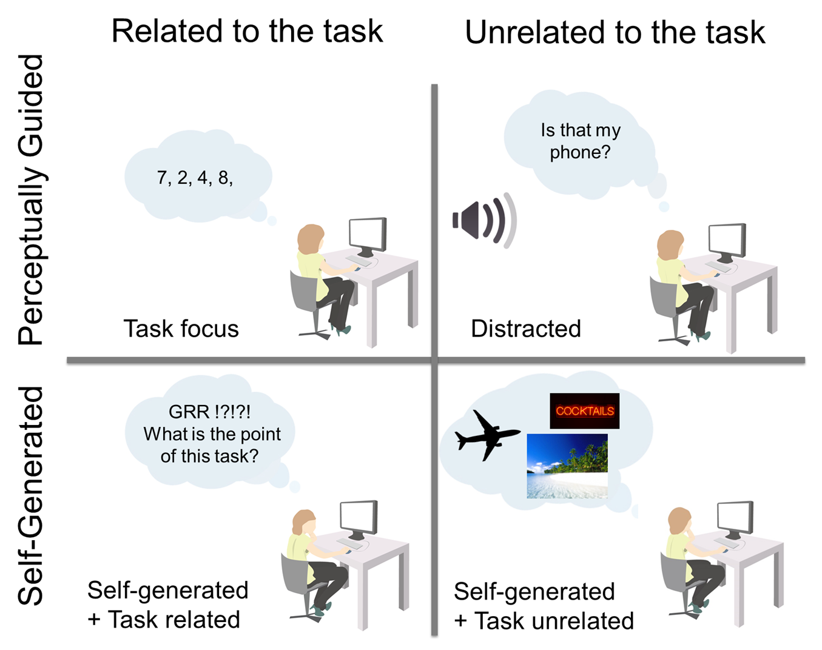
Figure One
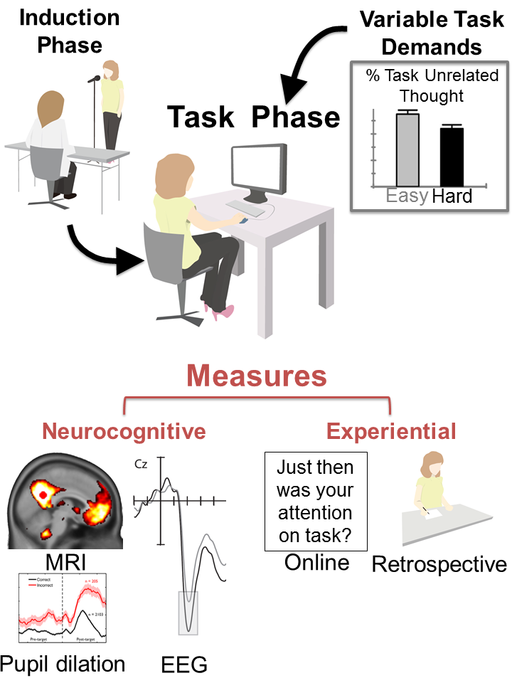
Figure Two
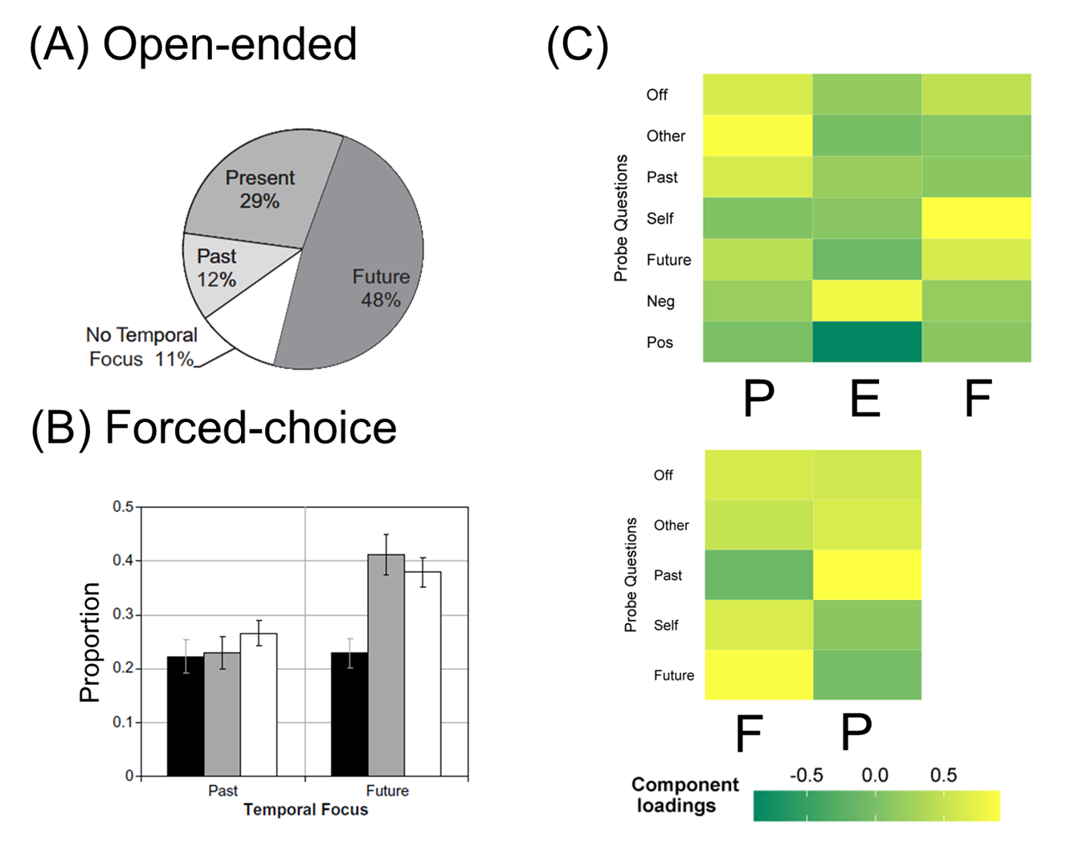
Figure Three
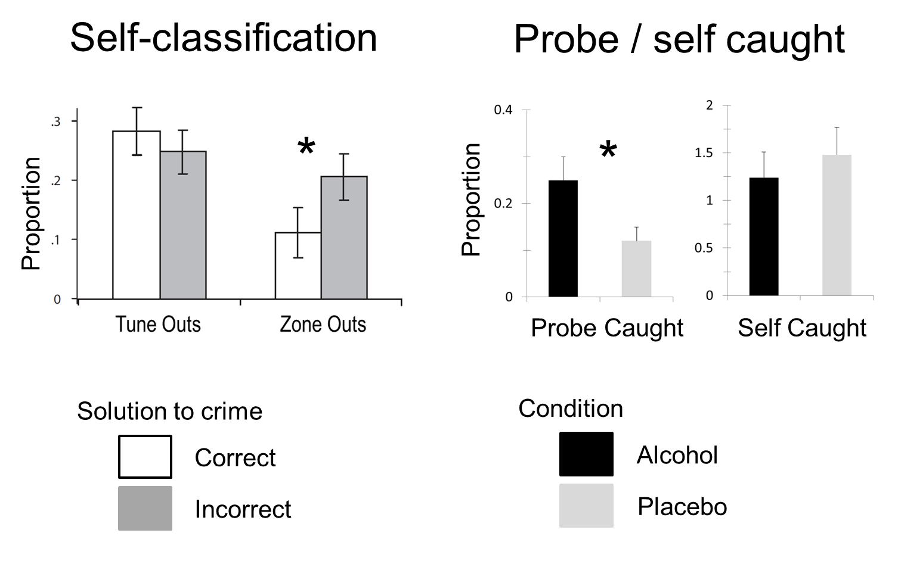
Figure Four
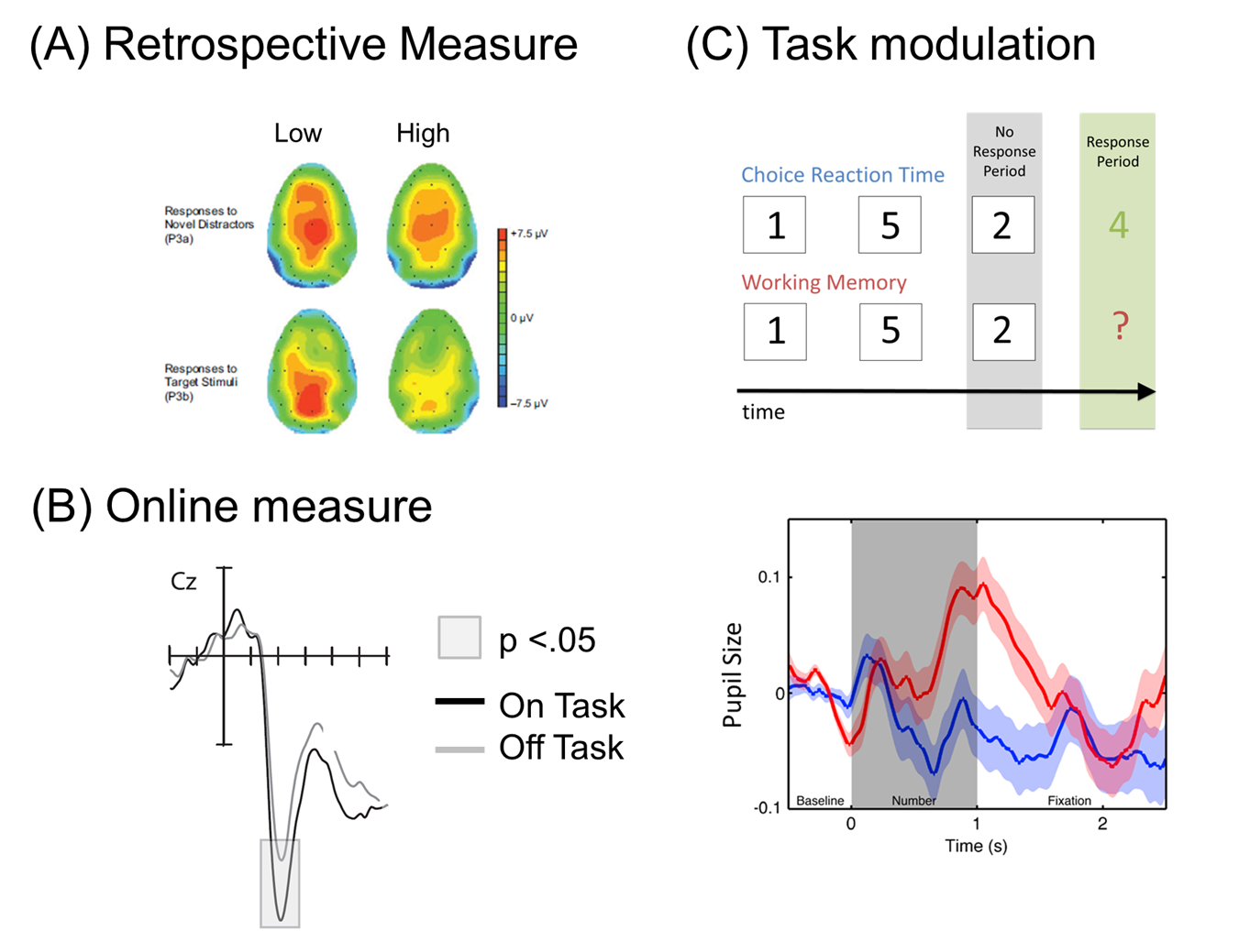

Figure Five
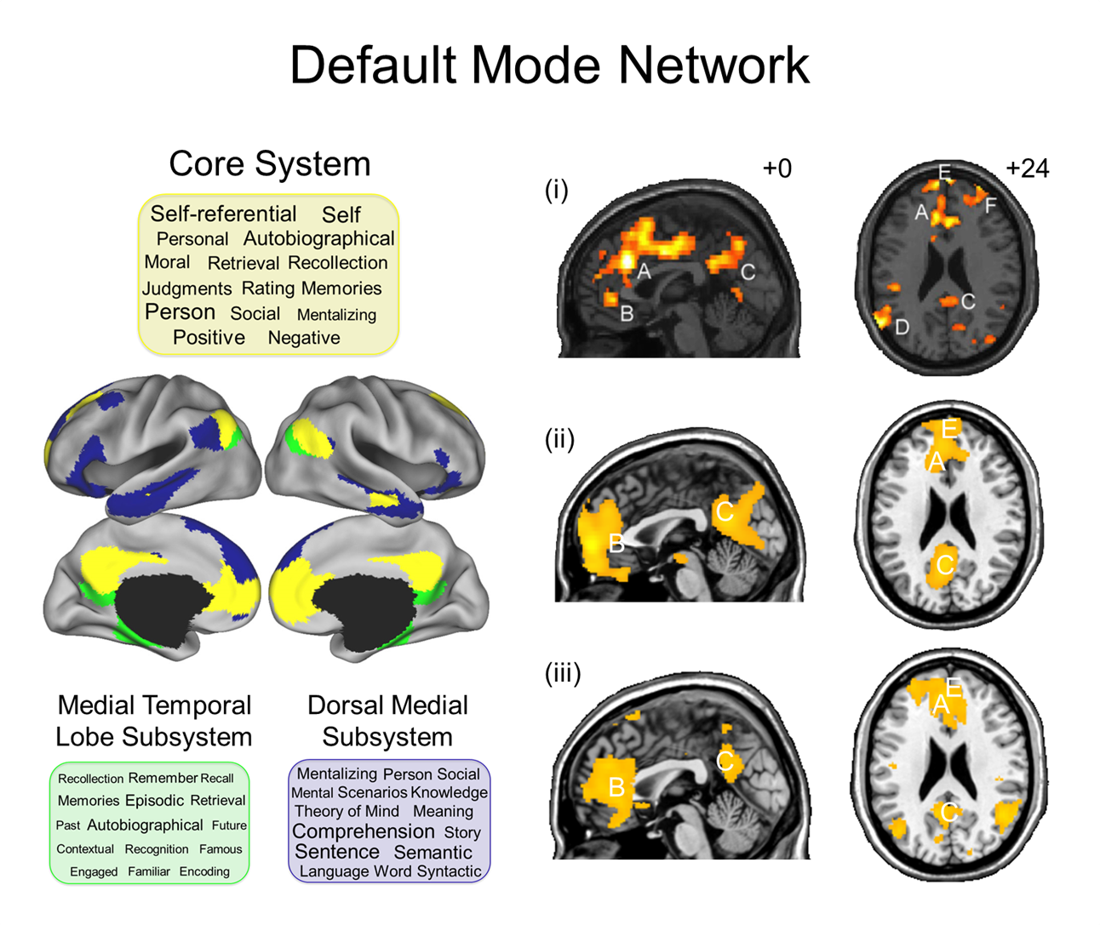
Figure Six

