## *New Phytologist* Supporting Information

Article title: Anatomical constraints to C4 evolution: light harvesting capacity in the bundle sheath

Authors: Chandra Bellasio and Marjorie R. Lundgren

Article acceptance date: Click here to enter a date.

The following Supporting Information is available for this article:

**Fig. S1** Example cross–sections

**Fig. S2** Example of RGB images

**Methods S1** A model for light penetration in a leaf

**Notes S1** Analytical integration of Eqn S1 and S2 after Gates (1980)

**Notes S2** Method to derive model inputs from the dataset of Christin et al (2013)

**Notes S3** Possible sources of error and comparison with other approaches

**Notes S4** Demonstration of Eqn 2

**Fig. S1** Example cross–sections of rice (A), wheat (B), *Homolepis aturensis* (C), C3–C4 *Alloteropsis semialata* (C), maize (D), and C4 *Alloteropsis semialata* (E), scale bars are 100 μm.

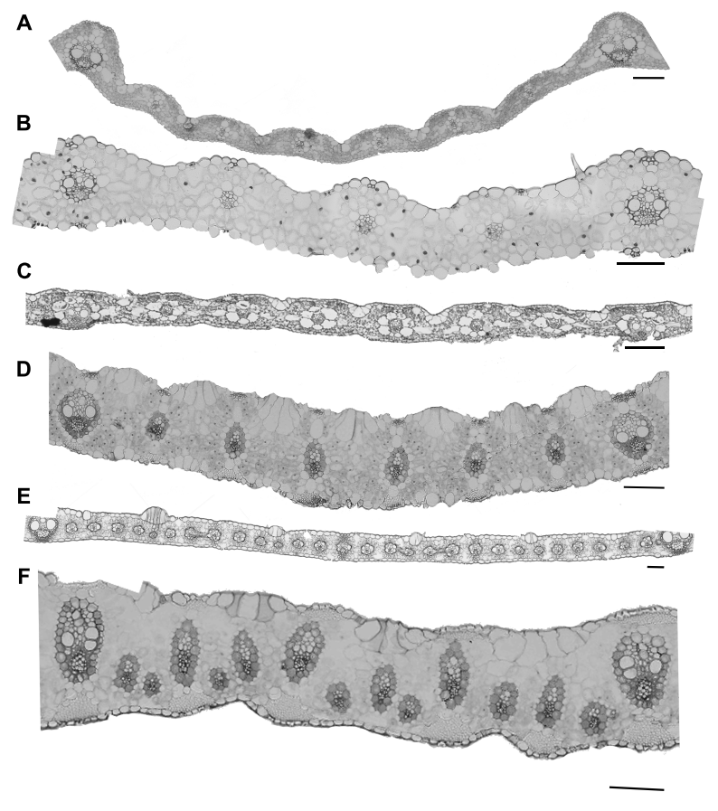

**Fig. S2** Example of RGB images showing cross sections segments of rice, wheat, a range of *Alloteropsis semialata* strains differing for assimilatory physiology, and maize.



**Methods S1** A model for light penetration in a leaf

A model for light penetration in a leaf

Principles

Light is assumed incident at a perpendicular angle to the leaf, and can be directed either downward (this flux is called *I*) or upward (this flux is called *J*). The optical characteristics are defined in terms of an absorption coefficient *k*, physiologically representing the density of light harvesting machinery (pigmentation), and a scattering coefficient *s*. Light absorption results in a decrease in both *I* and *J*, while light scattering flips the flux direction, to result in an equal and opposite change in *I* and *J*. *n* is a particular layer in the profile, produced when the profile is divided in *N*=1000 finite layers. Mathematically, increments in *I* and *J* can be expressed as:

|  |  |
| --- | --- |
| $I_{n}=I_{n-1}-\left(k+s\right)I_{n-1}+sJ_{n}$, | S1 |

and

|  |  |
| --- | --- |
| $J_{n}=J_{n+1}-\left(k+s\right)J_{n+1}+sI_{n}$. | S2 |

The boundary layer conditions can be expressed as: *I(0)*=1 (incident light intensity); *J(0)*= *R* (reflectance); *I(N)*= *T* (transmittance); *J(N)*=*R*g*I(N)*, where *R*g is the reflectance of the last layer, kept constant at 0.06. *I(n)* and *J(n)* were computed differently in P1 and P2. In P1 they were continuous, as a result of keeping *k* constant throughout the profile, *k*MI, this allowed Eqn S1 and S2 to be integrated analytically (see *Note* 1 below) after Gates (1980). In P2 *I(n)* and *J(n)* were discontinuous, as they represented three different compartments: MAD, vein, and MAB. In P2 Eqn S1 and S2 were calculated using two values of *k*, one for MAD and MAB, *k*MA, and one for the vein, *k*V. These were related to *k*MI by the input parameters $\frac{k_{MA}}{k_{MI}}$ and $\frac{k_{V}}{k_{MI}}$, physiologically representing MA pigmentation (fraction of MA which is pigmented and not BSE), and the pigmentation of the vein (relative to interveinal M), respectively. For P2, Eqn S1 was calculated in first approximation using *J*(n) calculated for P1, results were used to calculate Eqn S2 and then iterated (3 iterations were sufficient). The overall leaf reflectance (*R*LEAF) was computed by weighting *J(0, P1)* and *J(0, P2)* over the fraction of IVD represented by P1 and P2 (through the input parameter *VEW*/*IVD*, see below). Similarly, overall leaf transmittance (*T*LEAF) was computed by weighting *I(N, P1)* and *I(N, P2)*. *k*MI and *s* were found iteratively by fitting both *R*LEAF and *T*LEAF to 0.1, which is typical of weakly absorbed (penetrating) light (Bellasio & Griffiths, 2014).

The absorbed light (*AB*) in a generic layer *n* resulted from:

|  |  |
| --- | --- |
| $$AB(n)=k\left(I_{n}+J_{n}\right)$$ | S3 |

Eqn S3 was calculated for each layer *n*, in both P1 and P2 profiles, using the appropriate value of *k* (*k*V, *k*MI, *k*MA). The absorbed light in the vein resulted from summing *AB(n)*, calculated for P2, for the *n*VEIN layers corresponding to the vein. This was taken as representative of the BS, which is the only absorbing portion of the vein. The absorbed light in M resulted from summing *AB(n)*,calculated forP2, for the *n*MAD and *n*MAB layers corresponding to MAD and MAB, plus *AB(n)* calculated for P1 over the *N* layers, corresponding the light absorbed in the interveinal M. Absorbed light was then put into leaf–level context by weighing the fractions of *IVD* represented by P1 and P2 (through the input parameter *VEW*/*IVD*, see below), thus resulting in light absorbed in BS, relative to M $\left(AB\frac{BS}{M}\right)$.

**Notes S1** Analytical integration of Eqn S1 and S2 after Gates (1980)

*I(n)* and *J(n)* were calculated as:

|  |  |
| --- | --- |
| $I=\frac{{\left(1+β\right)}^{2}e^{α\left(N-n\right)}-{\left(1-β\right)}^{2}e^{-α\left(N-n\right)}-R_{g}\left(1-β^{2}\right)\left[e^{α\left(N-n\right)}{-e}^{-α\left(N-n\right)}\right]}{{\left(1+β\right)}^{2}e^{αN}-{\left(1-β\right)}^{2}e^{-αN}-R_{g}\left(1-β^{2}\right)\left.\left(e^{αN}{-e}^{-αN}\right)\right.}$, | S4 |

and

|  |  |
| --- | --- |
| $J=\frac{\left(1-β^{2}\right)\left[e^{α\left(N-n\right)}{-e}^{-α\left(N-n\right)}\right]-R_{g}\left[{\left(1-β\right)}^{2}e^{α\left(N-n\right)}-{\left(1+β\right)}^{2}e^{-α\left(N-n\right)}\right]}{{\left(1+β\right)}^{2}e^{αN}-{\left(1-β\right)}^{2}e^{-αN}-R_{g}\left(1-β^{2}\right)\left.\left(e^{αN}{-e}^{-αN}\right)\right.}$, | S5 |

where $α^{2}=k\left(k+2s\right)$ and $β^{2}=\frac{k}{\left(k+2s\right)}$, and other quantities are defined above.

**Notes S2** Method to derive model inputs from the dataset of Christin *et al.* (2013)

This dataset included anatomical characteristics measured on leaves sections spanning an average of 11 veins, including secondary veins and veins of higher order. We averaged the measured traits over a section of leaf, and reduced it to an isosceles trapezoid. The measured height in correspondence of the vein (*T*1) was the long base of the trapezoid, the height of the M between veins (*T*2) was the short base of the trapezoid and 1/2*IVD* was the height of the trapezoid. We modelled the vein as a square, with an area resulting from summing the measured IBS area + OBS area, and a side length: $VEH=VEW=\sqrt{IBSarea+OBSarea }$ 
. The area of the vasculature was not included in this calculation to account for the relatively larger metaxylem present in secondary veins. The trapezoid was reduced to a rectangle with a length equivalent to measured *IVD*, and a height *H* calculated as: $H=T_{1}-\frac{\left(T_{1}-T_{2}\right)VEW}{2IVD}$ 
,

MA area was calculated as *VEW*∙(*H*-*VEW*), *n*MAD and *n*MAB resulted from: $n_{MAD}=n_{MAB}=1000∙\frac{H-VEH}{2H}$ 
; *n*VEIN resulted from: $n_{VEIN}=1000∙\frac{VEH}{H}$ 
.

*K*MA/*K*MI was calculated as a ratio between MA area, and the measured unpigmented area (the sum of BSE area plus area of unpigmented extraxylary fibres). As the latter values are unpublished, we are releasing the group average only, with permission of Colin Osborne and Emanuela Samaritani, but the full dataset was confidentially made available to reviewers. ARA was estimated using the linear regression shown in Figure 3 ($ARA=\frac{\frac{VEW}{MW}-0.153}{0.353}$). *f*cycBS was assumed 1 for C4 species, and 0.375 for C3 species (see main text for the rationale).

**Notes S3** Possible sources of error and comparison with other approaches

The computational error was evaluated as the difference between the input quantity 1-*R*-*T* (where, *R* and *T* are leaf reflectance and transmittance, set at 0.1), and the output leaf absorptance (calculated by integrating Eqn S3), and was on average 2% for the 9 accessions of this study and 5% across the 145 accessions of the large dataset. Although not directly quantifiable, error is generated by the simplifications inherent to the model formulation. Firstly, the model assumes uniform pigment distribution and does not account for a phenomenon known as the ‘sieve effect’, which was visually explained by Terashima *et al.* (2009). In brief, because of the exponential nature of light absorption, uniformly diluted pigments absorb more than lumped pigments. Since leaf–level transmittance and reflectance were set, the sieve effect mainly influences the sub–leaf partitioning of absorbed light. In particular: a) BSE absorption would be overestimated at low BSE pigmentation, i.e. the real benefit of a small BSE may be slightly greater than we estimated; b) neglecting the presence of unpigmented vasculature within the vein [and, in some photosynthetic types, of a relatively pale layer of outer bundle sheath (see Fig. S1)] may result in overestimating the light absorbed in BS, and may affect the comparison between different orders of veins with less/more vasculature, hence the choice of limiting the study to tertiary veins (see main text). Secondly, the model does not account for horizontal scattering. In uniform mesophyll, right–and left–directed fluxes balance out, but highly scattering vertical layers of cells within the leaf profile (see Fig. S1) may facilitate lateral light penetration to BS (Roth-Nebelsick *et al.*, 2001). Finally, the model only takes vertical direction into account and does not consider the effects of leaf angle.

Despite these caveats, the model we used is simple and allows for relatively straightforward modifications to account for different leaf anatomy or varied optical properties. Confirming our findings by direct experimental validation or by means of a more sophisticated model, may be complex. Measuring light penetration in leaves has challenged investigators for decades. Microprobes directly measure light intensity by puncturing the leaf (DeLucia *et al.*, 1992), however, until recently (Karabourniotis *et al.*, 2000) their use was limited to studying the relatively softer M, and no attempt was reported on non–C3 systems. Indirect techniques such as chlorophyll fluorescence were applied with success to C3 leaves (Vogelmann & Evans, 2002; Brodersen & Vogelmann, 2010), however, because of the different fluorescence yield of BS and M, evidence for C4 plants is just qualitative (Evans *et al.*, 2007). With a stochastic photon–tracing approach (Disney *et al.*, 2000), the position of individual cells (or chloroplasts), is specified, and the fate of each incoming photon within the leaf is followed. For instance, ray tracing has been used to study light penetration in a 3×3–cell portion of a C3 leaf (Ho *et al.*, 2016), whose 3D structure had been determined through X–ray tomography. Nevertheless, applying such techniques to the BS/M interactions in the C3 to C4 continuum may require unreasonable effort.

**Notes S4** Demonstration of Eqn 2

*J*ATP can be produced either by linear or cyclic electron flow (LEF and CEF respectively):

|  |  |
| --- | --- |
| $J_{ATP}=J_{ATP CEF}+J_{ATP LEF}$. | S6 |

If η is the overall conversion efficiency of light absorbed by the photosystems (*AB*) into *J*ATP, it can be written:

|  |  |
| --- | --- |
| $J_{ATP}={AB}_{LIN }η_{LIN}+{AB}_{CEF }η_{CEF}$. | S7 |

If *AB=AB*CEF*+AB*LIN, and *rAB*CEF=*AB*CEF/*AB*, it can be written:

|  |  |
| --- | --- |
| $J_{ATP}={AB }_{ }η_{LIN}\left(1-{rAB}_{CEF}\right)+{{rAB}_{CEF} AB }_{ }η_{CEF}$, | S8 |

Rearranging,

|  |  |
| --- | --- |
| $J_{ATP}={AB }_{ }η_{LIN}\left(1+{rAB}_{CEF}\left(\frac{η_{CEF}}{η_{LIN}}-1\right)\right)$. | S9 |

Eqn 2 results from dividing Eqn S9 written for BS by Eqn S9 written for M, when $η_{LIN BS}=η_{LIN M}$, and LEF is exclusive in M (Meierhoff & Westhoff, 1993; Kramer & Evans, 2011).

References

**Bellasio C, Griffiths H. 2014.** The operation of two decarboxylases (NADPME and PEPCK), transamination and partitioning of C4 metabolic processes between mesophyll and bundle sheath cells allows light capture to be balanced for the maize C4 pathway. *Plant Physiology* **164**: 466-480.

**Brodersen CR, Vogelmann TC. 2010.** Do changes in light direction affect absorption profiles in leaves? *Functional Plant Biology* **37**(5): 403-412.

**Christin P-A, Osborne CP, Chatelet DS, Columbus JT, Besnard G, Hodkinson TR, Garrison LM, Vorontsova MS, Edwards EJ. 2013.** Anatomical enablers and the evolution of C4 photosynthesis in grasses. *Proceedings of the National Academy of Sciences* **110**(4): 1381-1386.

**DeLucia EH, Day TA, Vogelman TC. 1992.** Ultraviolet-B and visible light penetration into needles of two species of subalpine conifers during foliar development. *Plant, Cell & Environment* **15**(8): 921-929.

**Disney MI, Lewis P, North PRJ. 2000.** Monte Carlo ray tracing in optical canopy reflectance modelling. *Remote Sensing Reviews* **18**(2-4): 163-196.

**Evans JR, von Caemmerer S, Vogelmann TC 2007.** Balancing light capture with distributed metabolic demand during C4 photosynthesis. In: Sheehy JE, Mitchell PL, Hardy B eds. *Charting new pathways to C4 rice*. Los Baños, Philippines: IRRI International Rice Research Institute.

**Gates DM. 1980.** *Biophysical Ecology*. New York: Springer Verlag.

**Ho QT, Berghuijs HNC, WattÉ R, Verboven P, Herremans ELS, Yin X, Retta MA, Aernouts BEN, Saeys W, Helfen L, et al. 2016.** Three-dimensional microscale modelling of CO2 transport and light propagation in tomato leaves enlightens photosynthesis. *Plant, Cell & Environment* **39**(1): 50–61.

**Karabourniotis G, Bornman JF, Nikolopoulos D. 2000.** A possible optical role of the bundle sheath extensions of the heterobaric leaves of *Vitis vinifera* and *Quercus coccifera*. *Plant, Cell & Environment* **23**(4): 423-430.

**Kramer DM, Evans JR. 2011.** The Importance of Energy Balance in Improving Photosynthetic Productivity. *Plant Physiology* **155**(1): 70-78.

**Meierhoff K, Westhoff P. 1993.** Differential biogenesis of photosystem-II in mesophyll and bundle-sheath cells of monocotyledonous NADP-malic enzyme-type C4 plants - the nonstoichiometric abundance of the subunits of photosystem-II in the bundle-sheath chloroplasts and the translational activity of the plastome-encoded genes. *Planta* **191**(1): 23-33.

**Roth-Nebelsick A, Uhl D, Mosbrugger V, Kerp H. 2001.** Evolution and function of leaf venation architecture: a review. *Annals of Botany* **87**(5): 553-566.

**Terashima I, Fujita T, Inoue T, Chow WS, Oguchi R. 2009.** Green light drives leaf photosynthesis more efficiently than red light in strong white light: revisiting the enigmatic question of why leaves are green. *Plant and Cell Physiology* **50**(4): 684-697.

**Vogelmann TC, Evans JR. 2002.** Profiles of light absorption and chlorophyll within spinach leaves from chlorophyll fluorescence. *Plant, Cell & Environment* **25**(10): 1313-1323.