Article for Green Journal

Ben Jackson and Andy Godden

February 2015

Apprentice Leaders in Training - ‘Talking the Walk’

Introduction

In 2012 a working group of South Yorkshire General Practice educators and first 5 GPs came together to consider how to build upon the well-received post-CSA leadership groups¹ to deliver training that better nurtured leadership and change management skills for all trainees in Health Education Yorkshire and the Humber (HEYH). This process involved deriving a new ‘skill set’ of trainable leadership skills from the Medical Leadership Competency Framework, subsequently refined further by the GP school curriculum team in HEYH². During this work a shift occurred in the thinking within the group, when the assumption that the majority of such training would take place within small groups at release programs was challenged by a recognition that the experience during practice placements was the vital component³. The notion of GP training as an apprenticeship in leadership was born. This was supported in subsequent discussion at trainer’s workshops and with program directors but tempered with a clear message that trainers’ awareness and confidence would need addressing to incorporate this into training. We describe the contribution of GP trainers to this debate from a series of CPD sessions in HEYH focusing on how to train to this new leadership skill set.

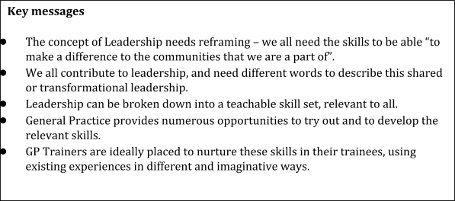

Beyond MRCGP - Leaders in Waiting?

The CPD sessions were advertised as opportunities to look beyond the standard formal assessments to consider how to revisit work-place training to better help trainees prepare for their future careers, and participants were a self-selected group of GP trainers from the school of General Practice. There was general agreement that GP training doesn’t always prepare young doctors for a role outside their training practice, and this is reinforced by the Fisrt5 voice³. Nevertheless, a significant minority described some ambivalence and scepticism that anything more could be covered in an already crammed and busy training program.

The first session in May 2014 was a half day workshop which, following feedback requesting more time, was extended to a full day in the autumn. The morning session explored the groups understanding of leadership, introduced the NHS Medical Leadership Competency Framework⁴ and took the group through a process of identifying examples of skills in everyday practice that mapped to the framework. Work on leadership from across the region² was then introduced and trainers were asked to consider what they were doing already to nurture leadership skills and what additional opportunities were available within their practices to teach these skills. Discussion focused on a shift in our thinking around leadership from a traditional view of “born” or hierarchical leaders, to one of shared transformational leadership in which all have a part to play, and that a different language was required to help describe this. All trainers could see this at work in their practices and found the reframing helpful, even the sceptics in the group. It became clear that there is no need fit in new activities, rather a need to look at current experiences through a different lens, with a leadership perspective.
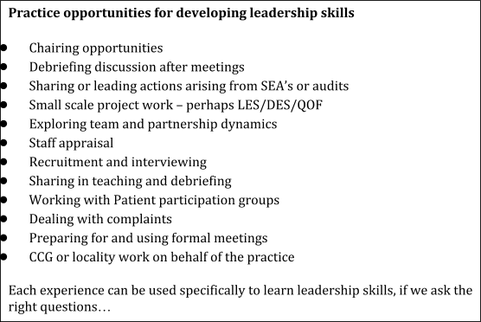

The afternoon session was used to try out ways of helping trainees learn these leadership skills. A practice SEA meeting was set up as a role play, and observers then used the experience to “teach” aspects of leadership in a debrief setting. All trainers found that they already had the skills and insights necessary to make use of the experience, though each took a different route – debriefing the process, the team dynamics, the SEA content, the action planning and so on. This model has been used in trainer’s workshops since and has been warmly received. Another exercise involved helping a trainee plan a practice based project (again as a role play), exploring the preparation required, the anticipation of potential blocks and enablers (including other team members!), steps along the way, motivations and assessing outcomes. We also started to consider the resources available to support trainers – models, frameworks, tools and internet resources, so that they can feel better prepared for these leadership discussions.

Trainers were enthusiastic about the potential to move away from a narrower assessment based view of teaching, towards helping trainees grow as effective enablers of change. Trainer expertise as both leaders and educators makes them ideally placed to “mentor” their apprentices in these skill areas.

Discussion

We have described how postgraduate GP trainers inherently recognise the need for the training experience to cover areas not easily met within current assessments. Additionally the idea that they might ‘pass on’ some of their skills and experience in managing and developing primary care services was welcomed. Initially, confidence that anything significant could be achieved within the current training structures was limited but opportunities for learning within current practice activities were identified, where trainers were already regularly demonstrating leadership skills without explicitly discussing these skills with trainees.

Fowler and Gill² describe how trainees reports contrast with those from educators in that they consider these areas are covered in much less frequency and depth, suggesting these skills remain part of a ‘hidden curriculum’. Young GP’s have vocalised the need to “translate the implicit experience of leadership into the explicit language of leadership skills” ³. Exploring everyday leadership and management experience with all trainees is therefore critical for all trainees to have the opportunity to develop such skills, even when they don’t come naturally.

As with teaching consulting skills, focusing on developing a suite of skills (supported by a body of theoretical models, tools and teaching experience), ensures that the skills of leadership can be acquired by all. General Practice Trainers are commonly leaders amongst their teams and well placed to encourage trainees to reflect on the day to day experience of the practice from a different perspective, using experiences to develop leadership skills. There is a wealth of material available to support trainers in translating their personal expertise into teachable skills e.g. how to chair a meeting, understanding interpersonal dynamics in a meeting, planning significant change and the HEYH GP curriculum team have developed a webpage to collate further ideas.

The learning and teaching guide for the MRCGP curriculum⁵ describes the importance of the apprentice model during GP training. We suggest that GP training can incorporate an apprenticeship in leadership for all trainees. This is best achieved through explicitly discussing experiences during practice placements with a focus on the development of a skill set already demonstrated by educators.

References –

1. Patterson D, Godden A, Rughani, A and Smithson WH (2013) A leadership programme in GP training: and actions learning approach Education for Primary care 24: 65-68

2. Fowler I and Gill A (2015) xxxxxxxxxxxx Education for Primary Care

3. Ward et al (2015) xxxxxxxxxxxx Educaiton for Primary Care

4. http://www.leadershipacademy.nhs.uk/wp-content/uploads/2012/11/NHSLeadership-Leadership-Framework-Medical-Leadership-Competency-Framework-3rd-ed.pdf

5. Royal College of General Practice 2009 Learning and teaching guide version 3.3 RCGP publications London, UK

